Boundary Density Effects on TAR & SAR
Straight line fits with random-chance baselines (dotted)
X-axis: Boundary Density (1/k) | Each section: one task | Left: 7B | Right: 32B

Character Substitution
Qwen2.5-7B | Qwen2.5-32B
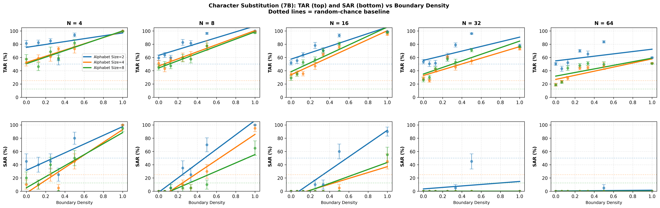 | 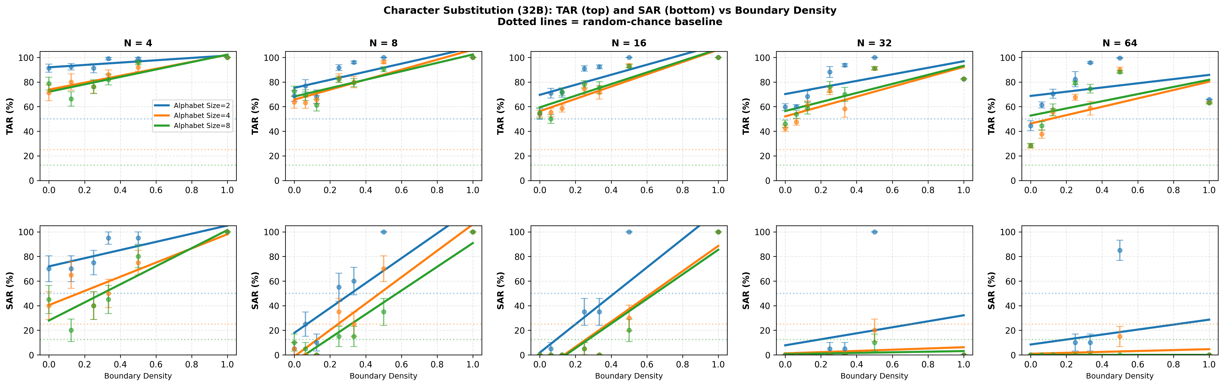

What This Shows:
- Strong upward slopes across all N: TAR and SAR both improve substantially with boundary density—boundaries help this task significantly
- Position-local structure enables boundary benefit: No long-range dependency means boundaries provide pure structural benefit without interference
- Dramatic SAR improvement: SAR climbs from ~10-30% at density 0 to ~90% at density 1
- 32B ceiling effect: 32B starts near 100% TAR at density 0, limiting visible room for improvement
- Key insight: Position-local tasks are where boundaries work BEST

Running Sum Local
Qwen2.5-7B | Qwen2.5-32B
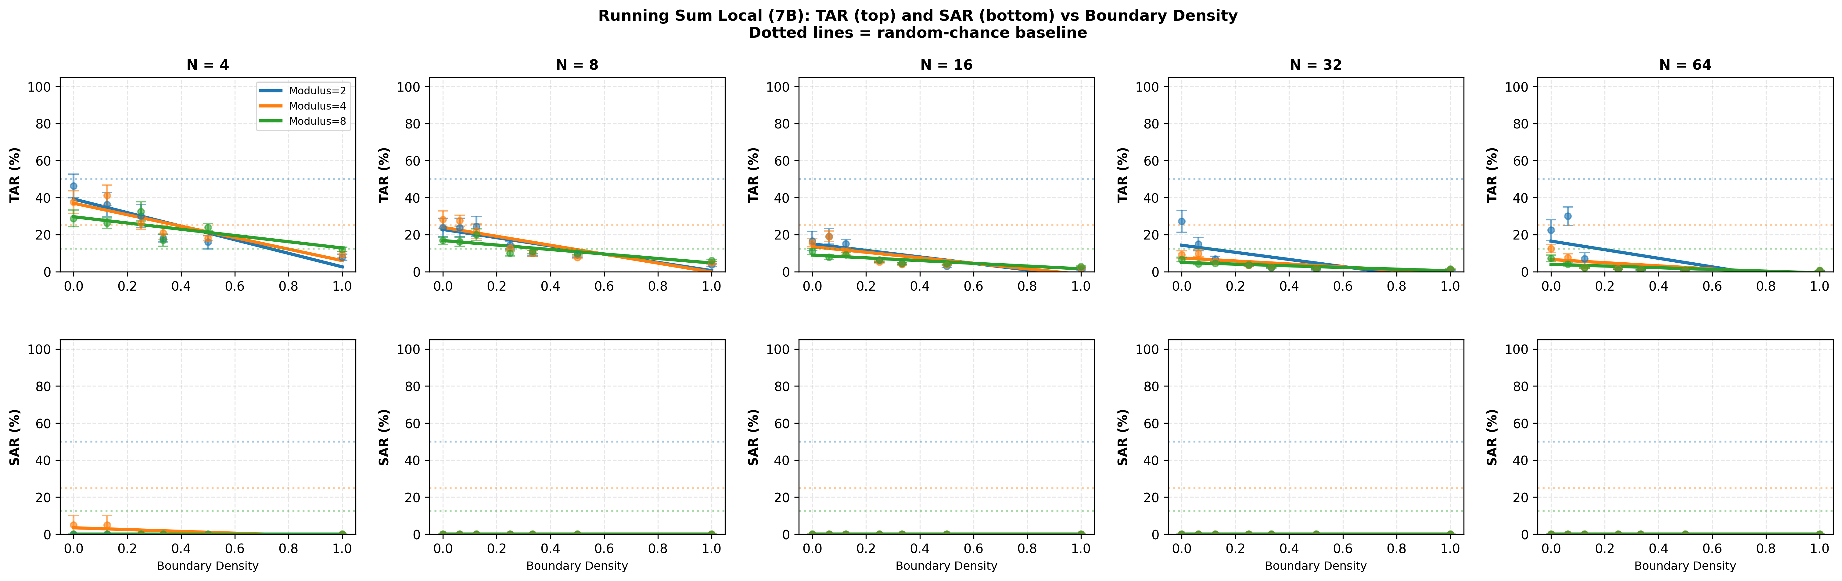 | 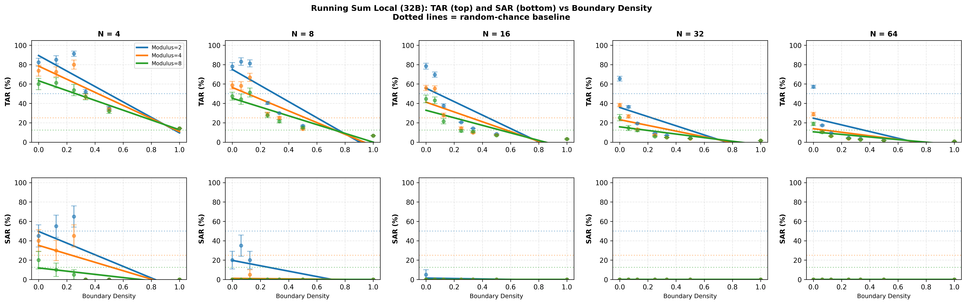

What This Shows:
- Downward slopes across all N: TAR degrades as boundary density increases—boundaries actively hurt this task
- Base (density=0) is best: No boundaries outperform maximum boundaries at every sequence length
- 7B slopes steeper than 32B: Smaller models are hurt more by boundaries
- Key insight: Window-1 dependencies are harmed by boundary disruption

Modsum
Qwen2.5-7B | Qwen2.5-32B
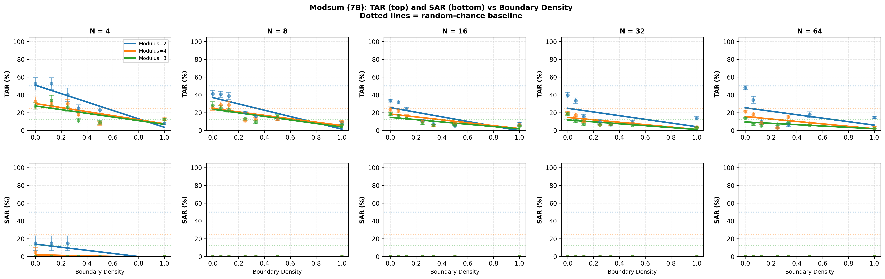 | 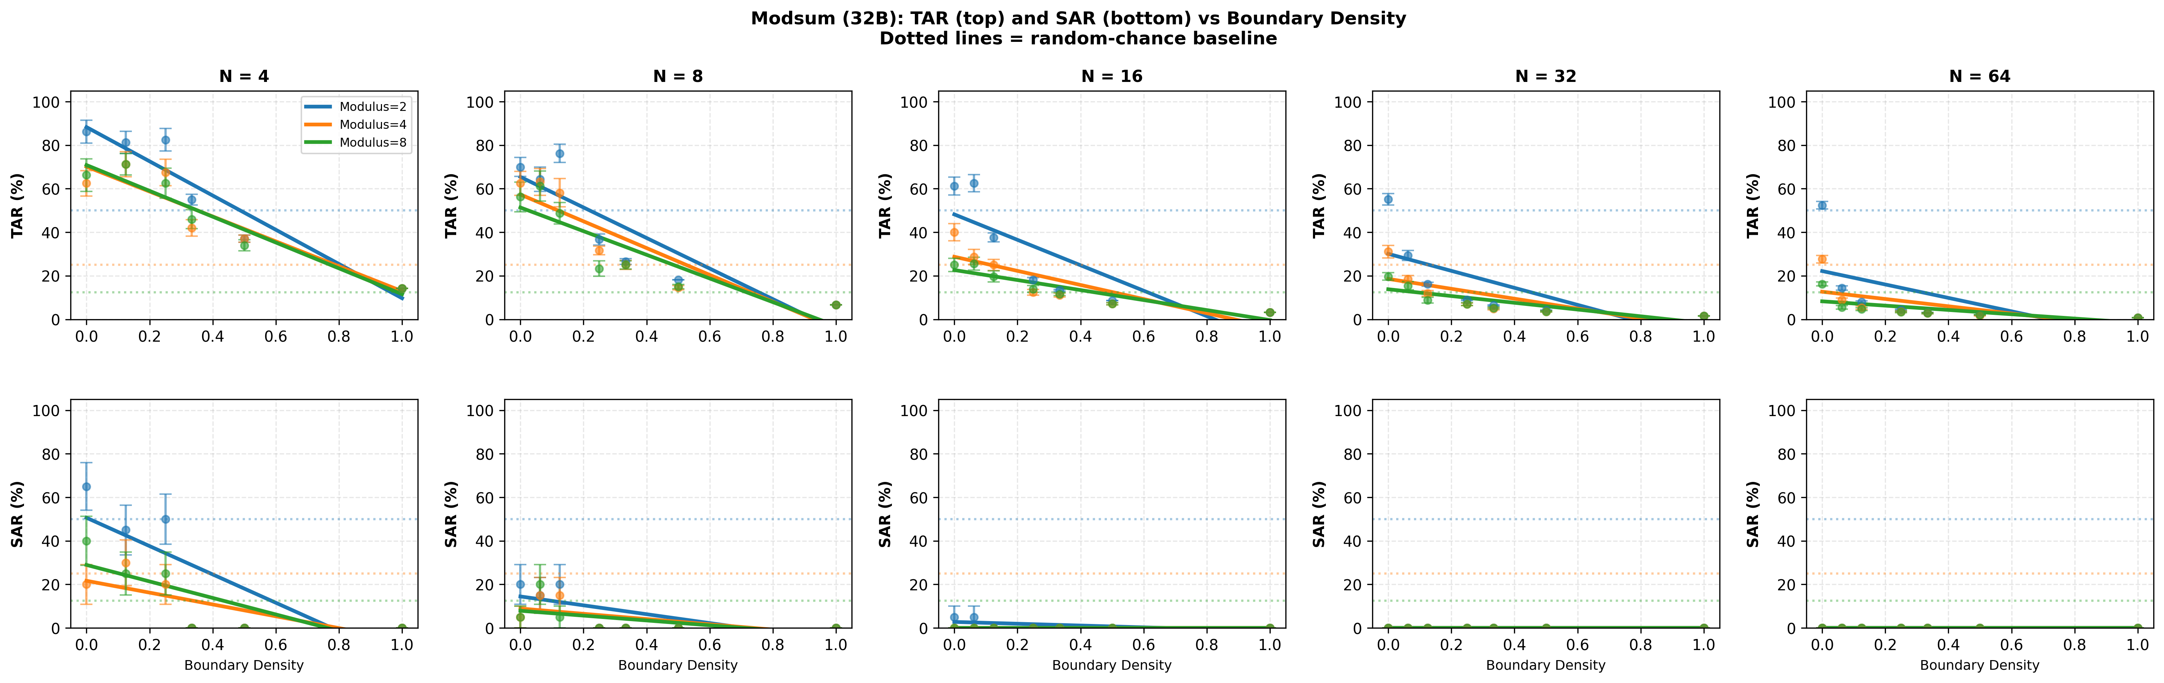

What This Shows:
- Flat or slightly downward lines: Boundaries don't help performance
- Global state requirement: Task requires tracking ALL prior values exponentially
- 7B and 32B similar degradation: Model scale doesn't overcome the fundamental mismatch
- Key insight: It's a capacity problem, not a structural one

Integer Addition
Qwen2.5-7B | Qwen2.5-32B
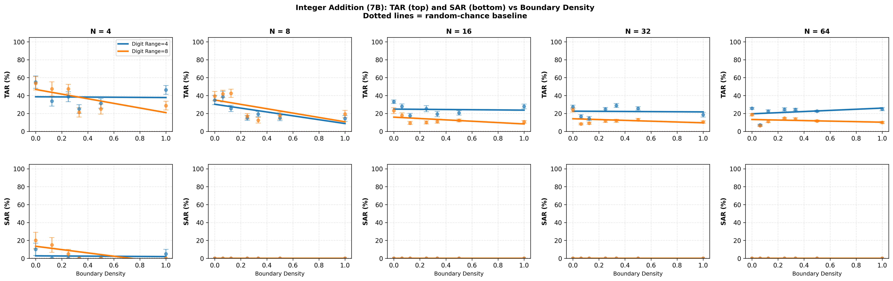 | 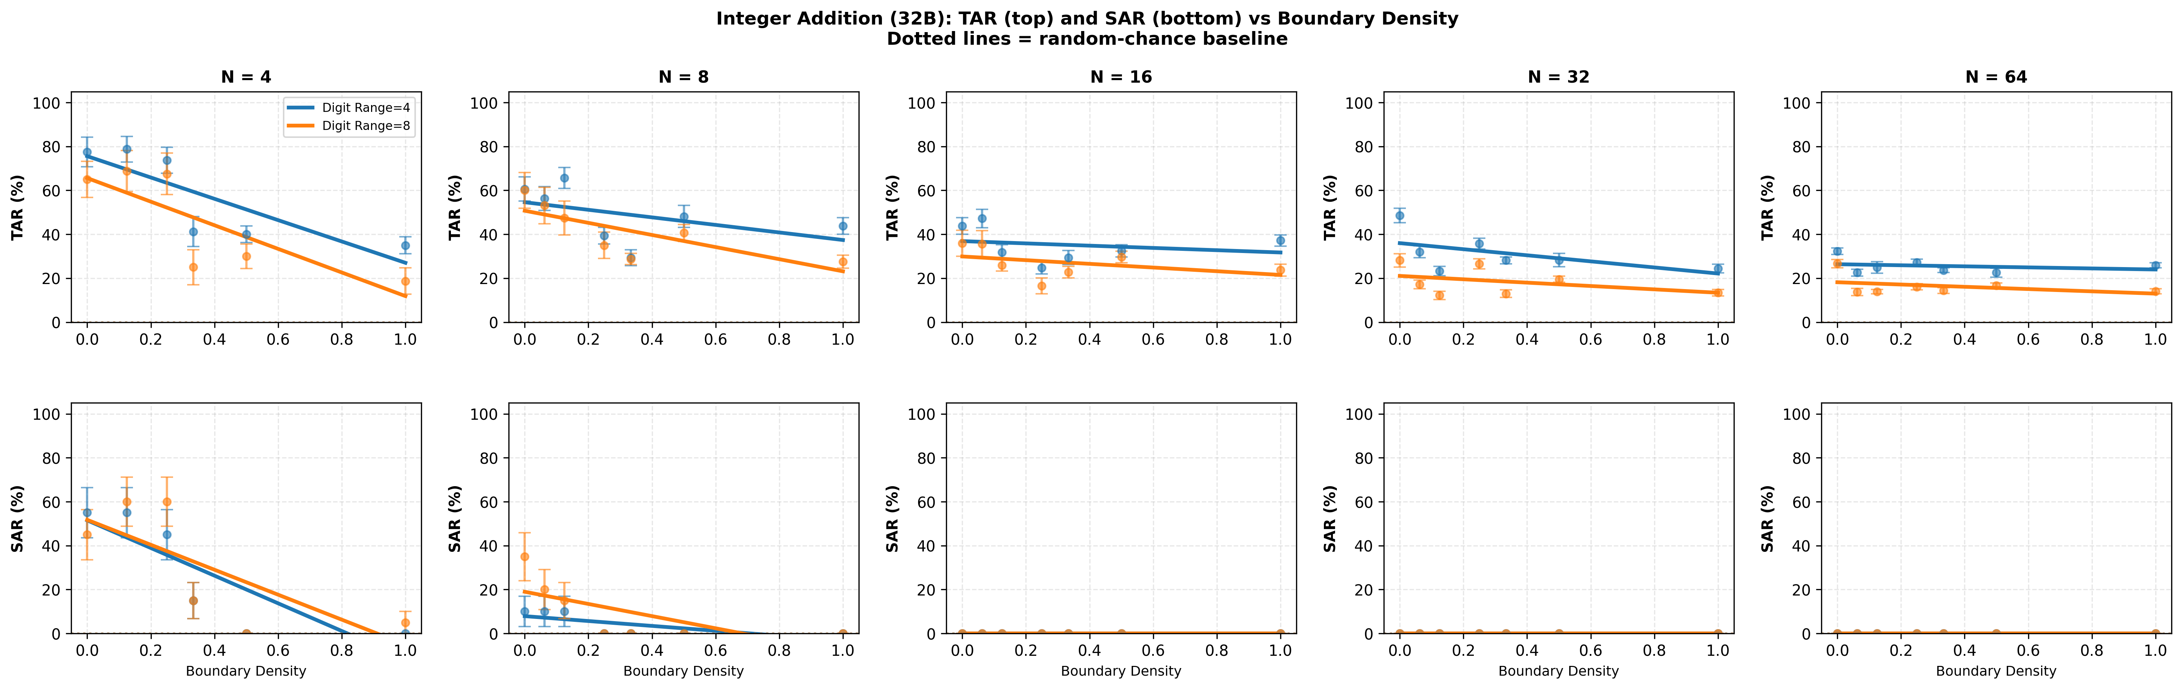

What This Shows:
- Downward or flat slopes: Boundaries don't help addition performance
- Carry propagation is robust to disruption: Carry chains persist even when broken
- 32B slightly less affected than 7B: Larger models maintain performance slightly better
- Key insight: Boundaries can't break carry chains

Running XOR
Qwen2.5-7B | Qwen2.5-32B
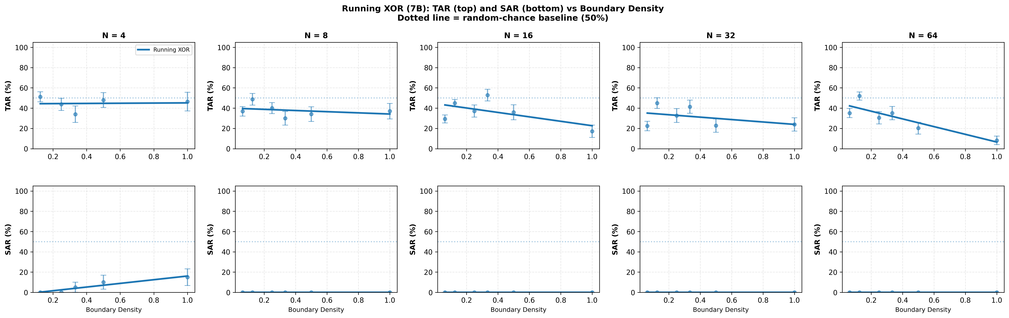 | 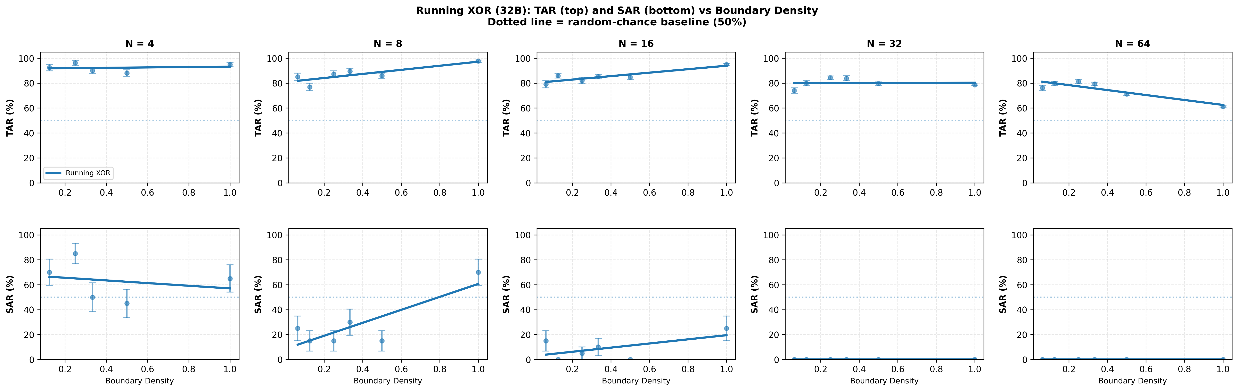

What This Shows:
- Downward slopes for 7B across N≥8: TAR degrades with boundary density
- Window-1 dependency: XOR depends on inputs at i and i-1 only
- Consistent degradation pattern: N=8 slopes down, N=64 severe down (~48%→8%)
- Key insight: Window-1 extends the "any dependency negates boundary benefit" pattern

Summary: Monotonic Locality Story

Window-0 (Position-Local)
- Character Substitution: UPWARD (boundaries help)

Window-1 Dependencies
- Running Sum Local: DOWNWARD (boundaries hurt)
- Running XOR: DOWNWARD (boundaries hurt)

Longer Dependencies
- Modsum: FLAT/DOWN (global state incompatible)
- Integer Addition: DOWNWARD (carry chains resist disruption)

Key Finding:
Boundaries benefit ONLY position-local tasks (window=0). ANY real dependency window—even window=1—negates that benefit. Clean monotonic locality story extending Section 3.21 systematically.

