**Appendix**

Table 1: Variables of adult.data

|  |  |  |
| --- | --- | --- |
| Variable | Description | Example |
| “age” | Participant’s age | 20,21 |
| “workclass” | Participant’s type of work | Private, self-emp-inc |
| “fnlwgt” | Final weight: It represents how many participant with same chrematistic in the real world | 10,11 |
| “education” | Participant’s education level | Bachelors, Some-college |
| “education_num” | Represent Participant’s education level by number | 13, 10 |
| “marital_status” | Participant’s marital status | Divorced, Never-married |
| “occupation ” | Participant’s occupation | Tech-support, Craft-repair |
| “relationship” | Participant’s social relationship | Wife, Own-child |
| “race” | Participant’s race | White, Asian-Pac-Islander |
| “sex” | Participant’s sex | Female, Male |
| “capital_gain” | Participant’s increase in capital assets | 20, 21 |
| “capital_loss” | Participant’s loss in capital assets | 20, 21 |
| “hours_per_week” | Participant’s work how many hours per week | 20, 21 |
| “native_country” | Participant’s native country | United-States, Cambodia |
| “Earning” | Participant’s income per year | <=50K, >50K |
| “numeric_earning” | Represent Participant’s earning level by binary number | 0, 1 |
| “age_group” | Group different age range | 1, 2 |

Table 2: One-way ANOVA by Levene’s Test for equal variance

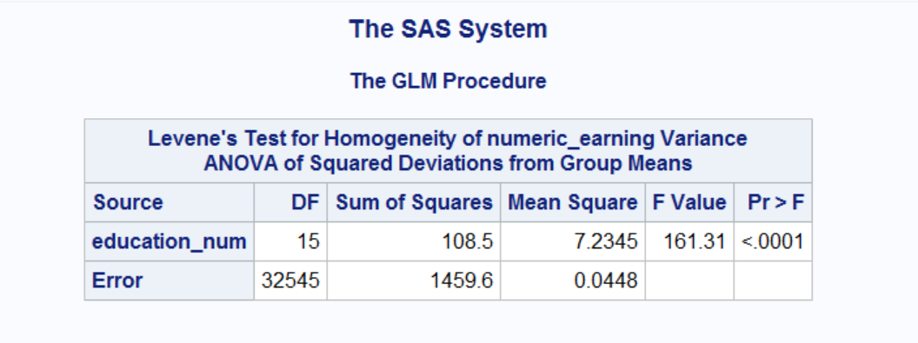

Table 3: Overall test by two-way ANOVA

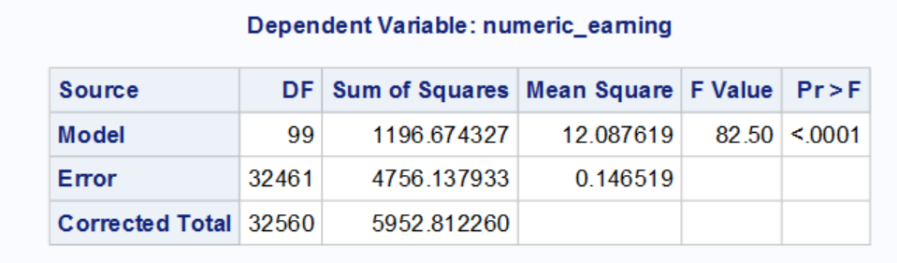

Table 4: Two-way ANOVA table with interaction

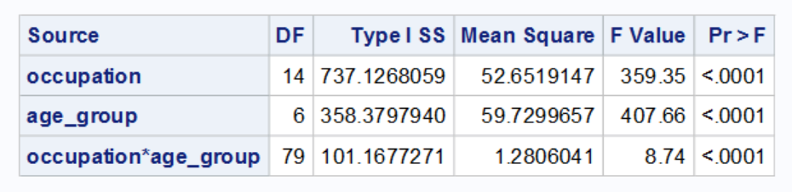

Table5: Multiple linear regression output

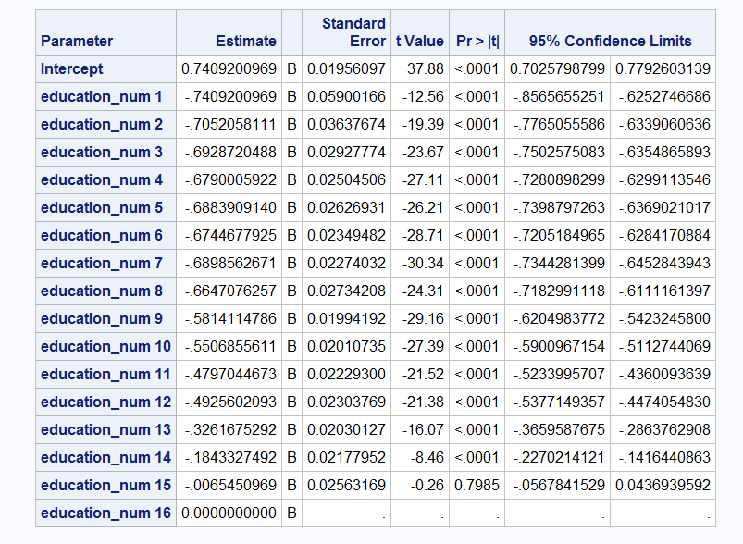

Figure 1: Box-plot of different education level’s income

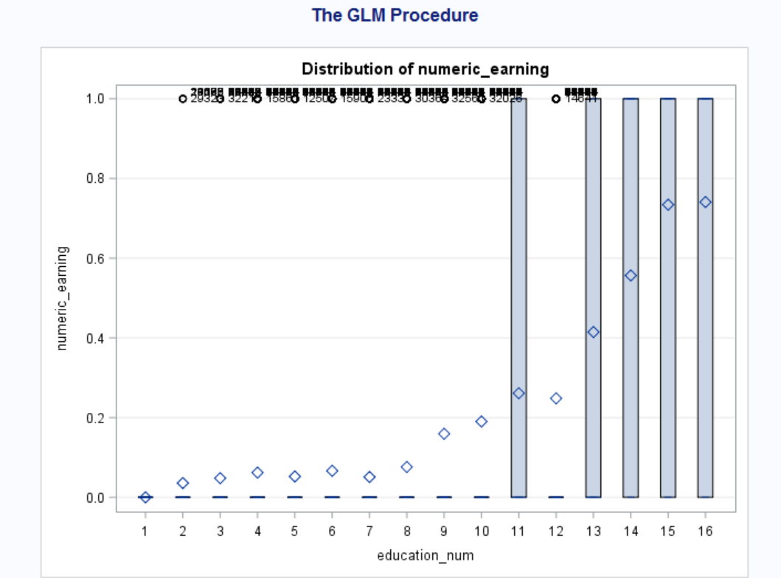

Figure 2: interaction plot for numeric_earning by different occupation and different age groups

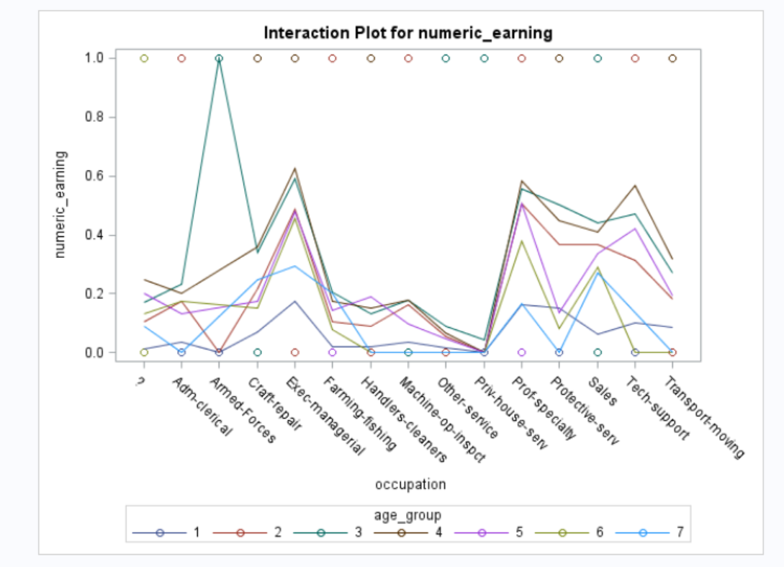

Reference:

Dua, D. and Graff, C. (2019). UCI Machine Learning Repository [http://archive.ics.uci.edu/ml]. Irvine, CA: University of California, School of Information and Computer Science.