**Object Name:** Thorny mushroom tree.

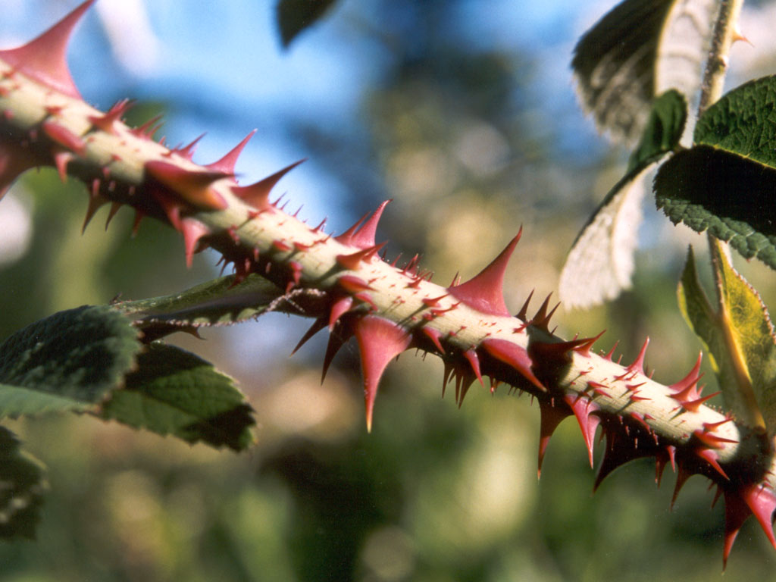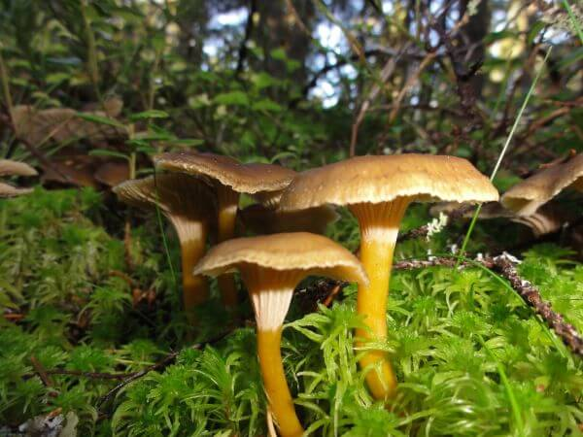

**Object Type:** Static Mesh.

**Colors:**

*Main:* Tan/Green.

*Secondary:* red.

*tertiary:* Purple.

**Description:** Large, Tall mushroom the size of a tree. Has a thorny stem and a flat mushroom cap. Tips if thorns will be a mixture of purple and red. And the stem and cap are tan/green.

**Information:**

* *Not Animated*
* *Large in size*