The University Of Northampton

NAMI College

Web Assignment

Name: Raj Kumar Phagami

UN ID:16418523

Submission date: 4th April, 2017

Github link:

Contents

Starting of the assignment 3

Designs 3

Sketches 3

Homepage 3

About me page 4

My CV page 4

Contact me page 5

Prototypes 6

Screen mock-ups 6

Homepage 6

About me page 6

My CV page 7

Contact me page 7

My logo 8

Responsive mock-up 8

Navigation bar 9

Navigation Diagram 9

My Working Progress 9

Github Committing 9

Github link 9

Checking speed of my website on GTmetrix 9

Checking errors 10

Time I took to complete my assignment 10

Sources for code I used 10

Conclusion 11

Reference 11

# Starting of the assignment

In the beginning of making my personal webpage I was in a dilemma about what kind of portfolio I should create. Firstly, I looked the website of Joel Stanford whose example was given in the assignment brief in NILE. Then, I searched other people’s portfolios in the internet. I went through 4 or 5 portfolios of some people and I got some ideas to create my web page. So according to the criteria given by the University I started creating my web page using only HTML and CSS. The time to make my web page was 3 weeks after completion of course of first semester which was of 12 weeks. So I have used the properties of HTML and CSS that I have learned in the 12 weeks of time. And this made me easier to make my portfolio effective.

The websites that I visited were:

> http://applecrumbs.com

> http://www.helloimcody.com/

> http://www.janmense.de/

> http://www.mikereda.com/

> http://joel.sh/about

# Designs

For this part I have drawn rough sketches of homepage, about me page, my cv page and contact me page.

## Sketches

### Homepage

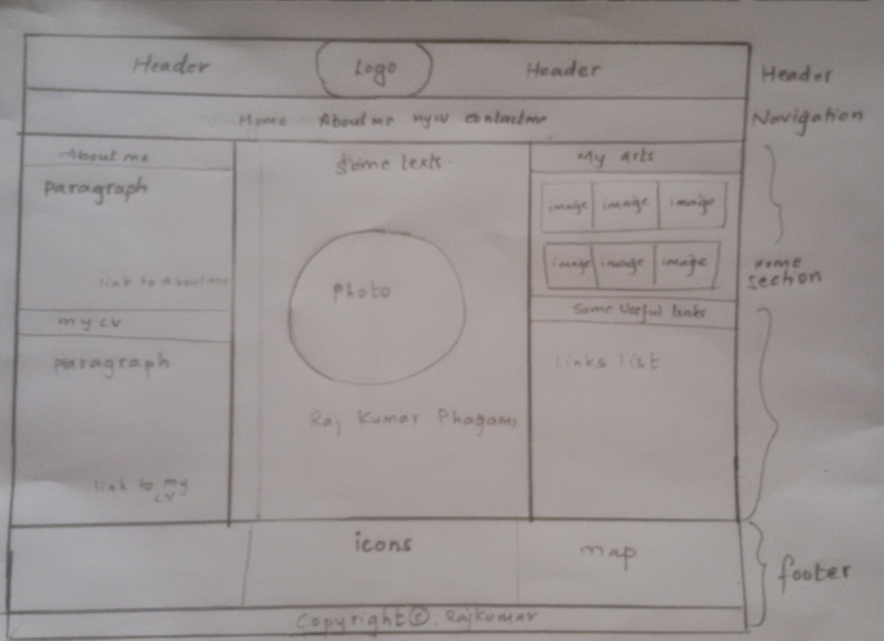

I have made my homepage simple looking. I have used many divs here. I have put maroon colour in background of header and navigation part and light grey in background of section part. I have put the logo in the middle of the header. I have provided the users to navigate to other pages of my portfolio. I have divided the section into three main divs. The first and last div of section is again divided two divs. In the middle div I have added my photo and when the users click on it is transformed into small one. The footer part is at the bottom of homepage which is dark blue in color. I have put the icons and map with their links so that the users can follow me on those social websites as exactly in above sketch. The colour of the font is also maroon.

### About me page

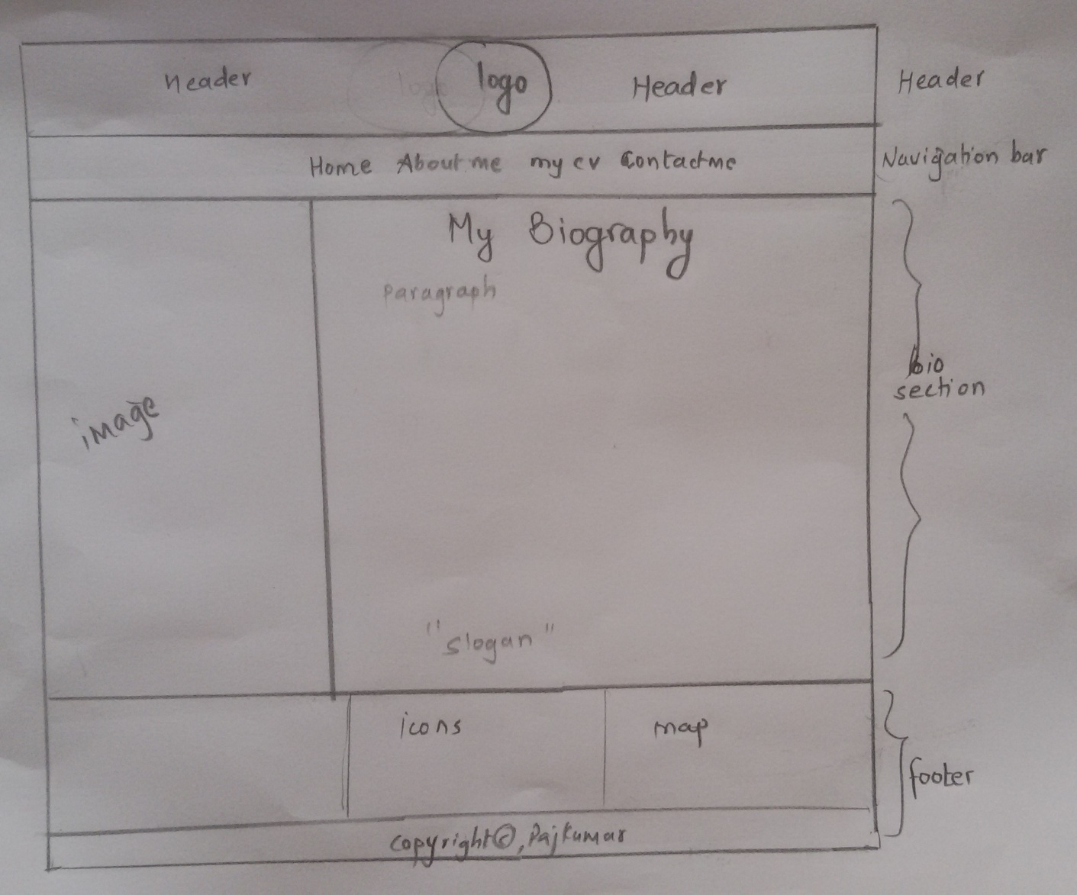

In about me page I have put the header, navigation bar and footer as same as of homepage so that the user wouldn’t feel that they are visiting different websites. Here I have divided the section into two divs. I have put my own image on image div and I have written about myself on next div.

### My CV page

In this page, the header, navigation bar and footer are same as of homepage. I have divided the section into two parts in column. And then the second div is again divided into the two parts in row. I have written the curriculum vitae about myself personal, then my education level well as skills and experience, at last I have written languages that I speak as you can see in sketch

below.

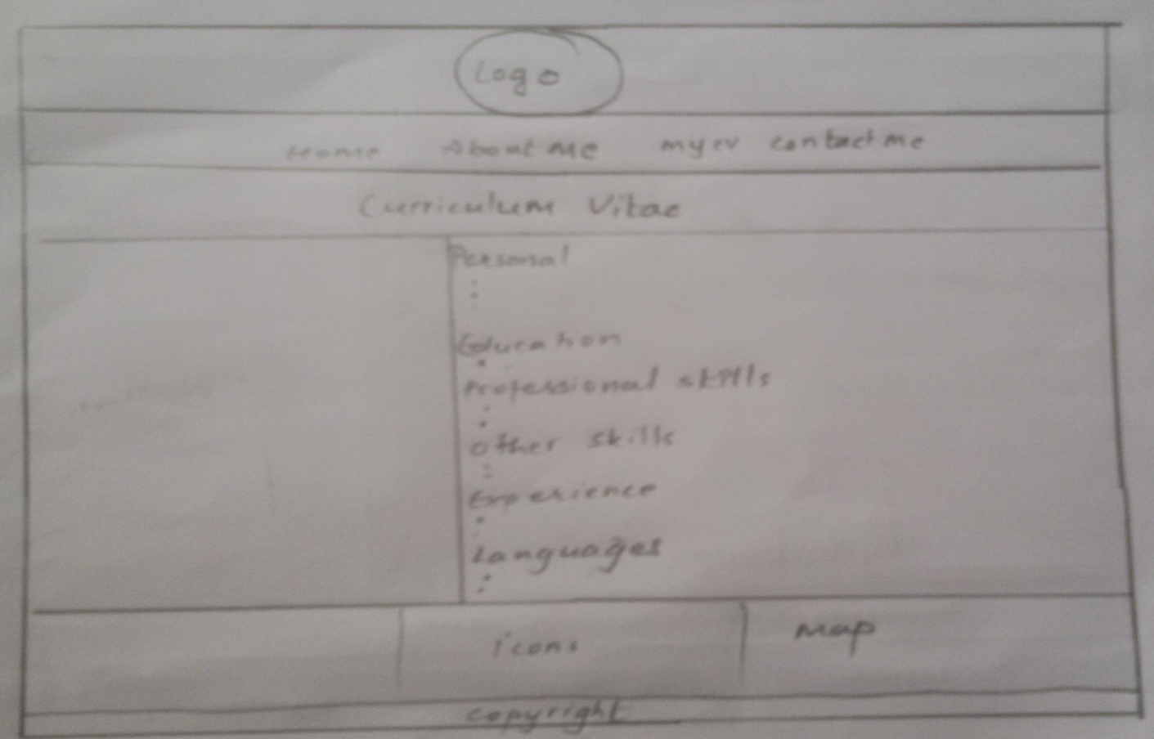

### Contact me page

In this page, the header, navigation bar and footer are as same as of homepage. Here, I have divided the section into two divs in the row direction. In first div I have put my contact details and my own image. On next div I have used the form property to insert form so that users can send me messages through emails. The background colour of this section is same as that of hiomepage section. The sketch for this is given below.

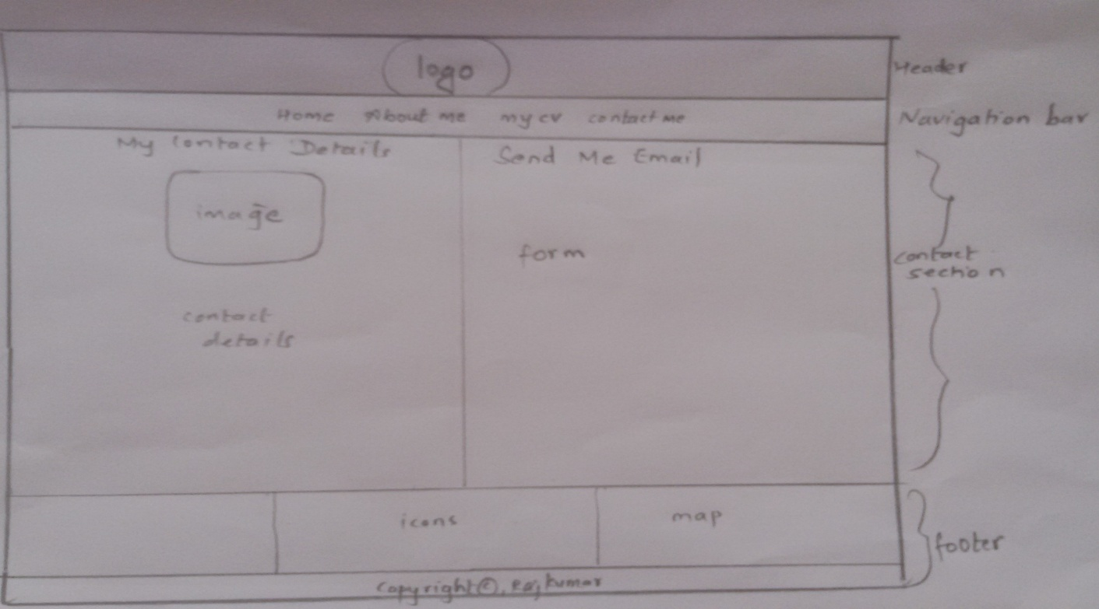

# Prototypes

## Screen mock-ups

### Homepage

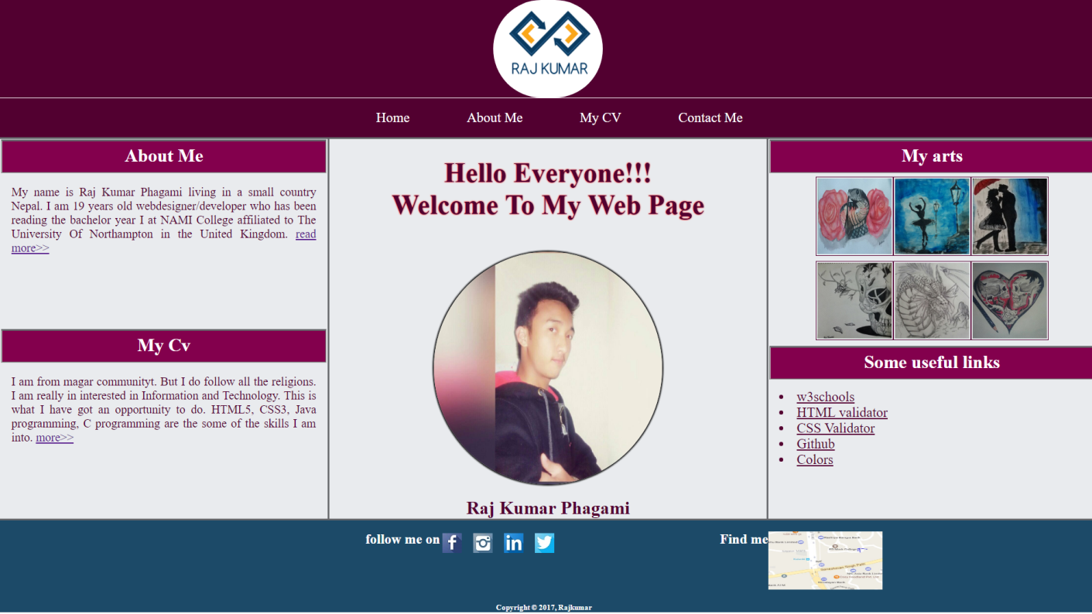

### About me page

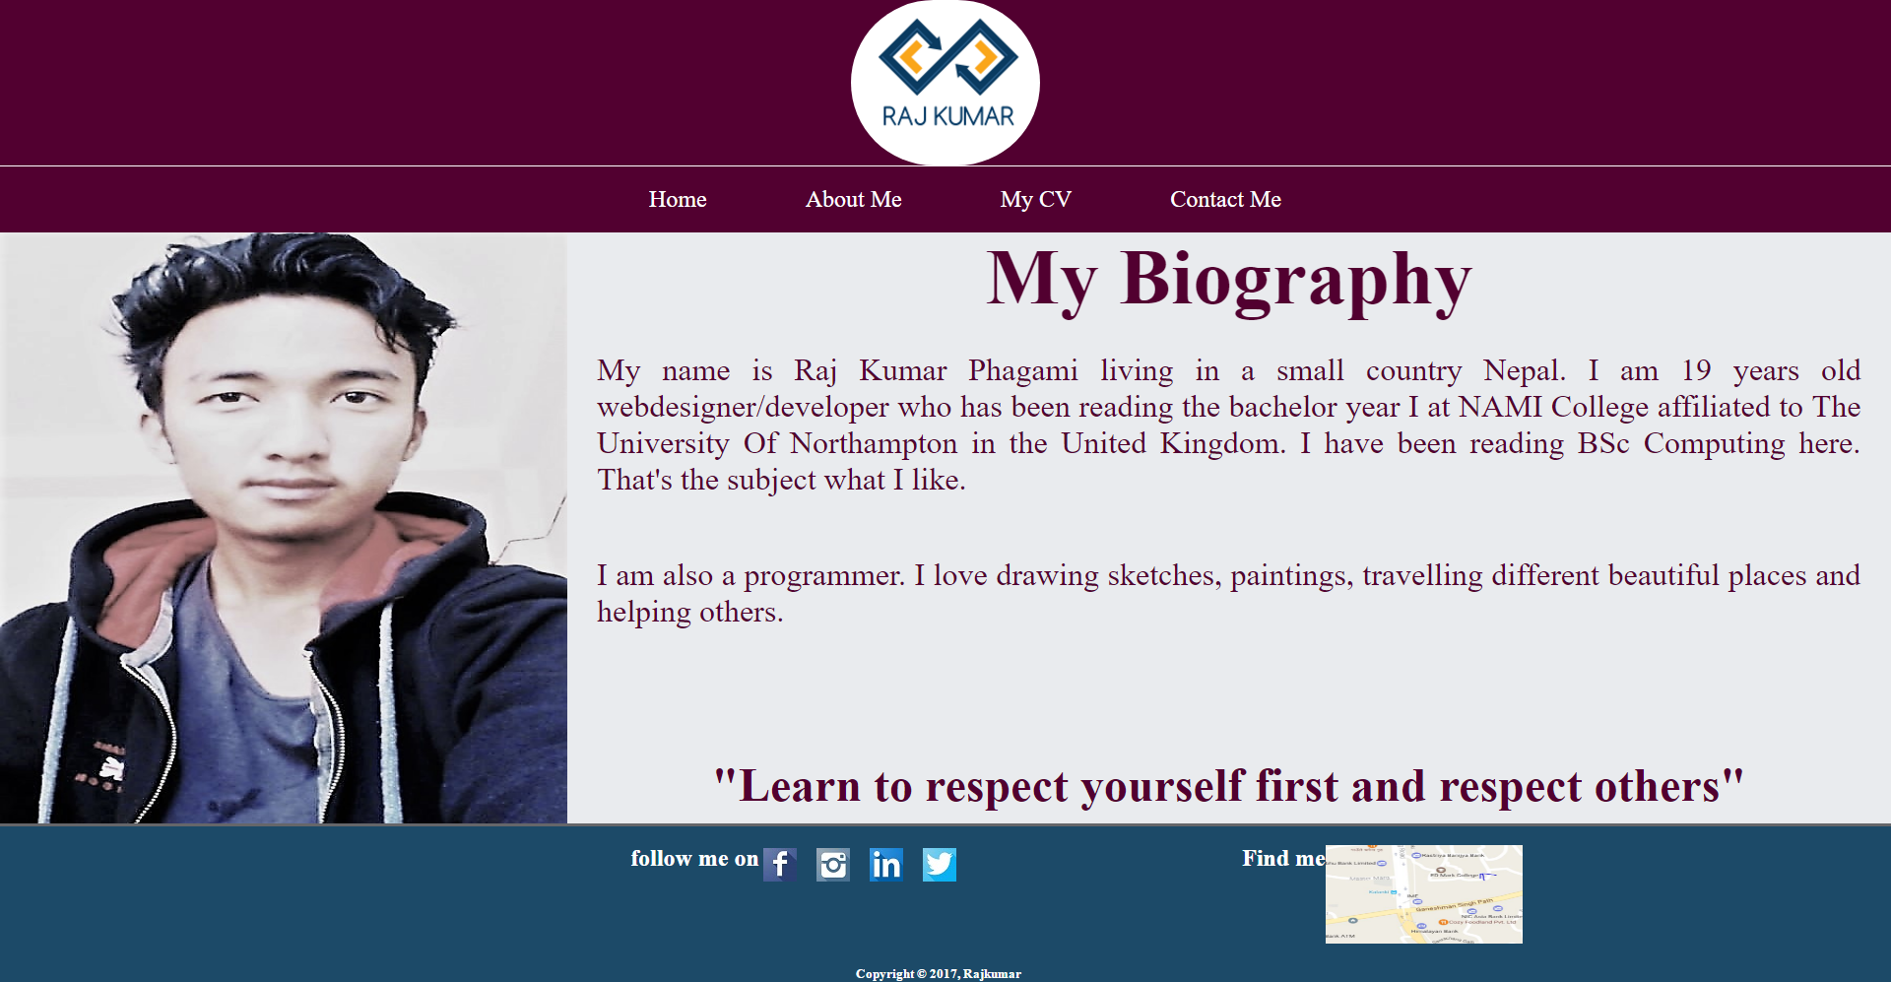

### My CV page

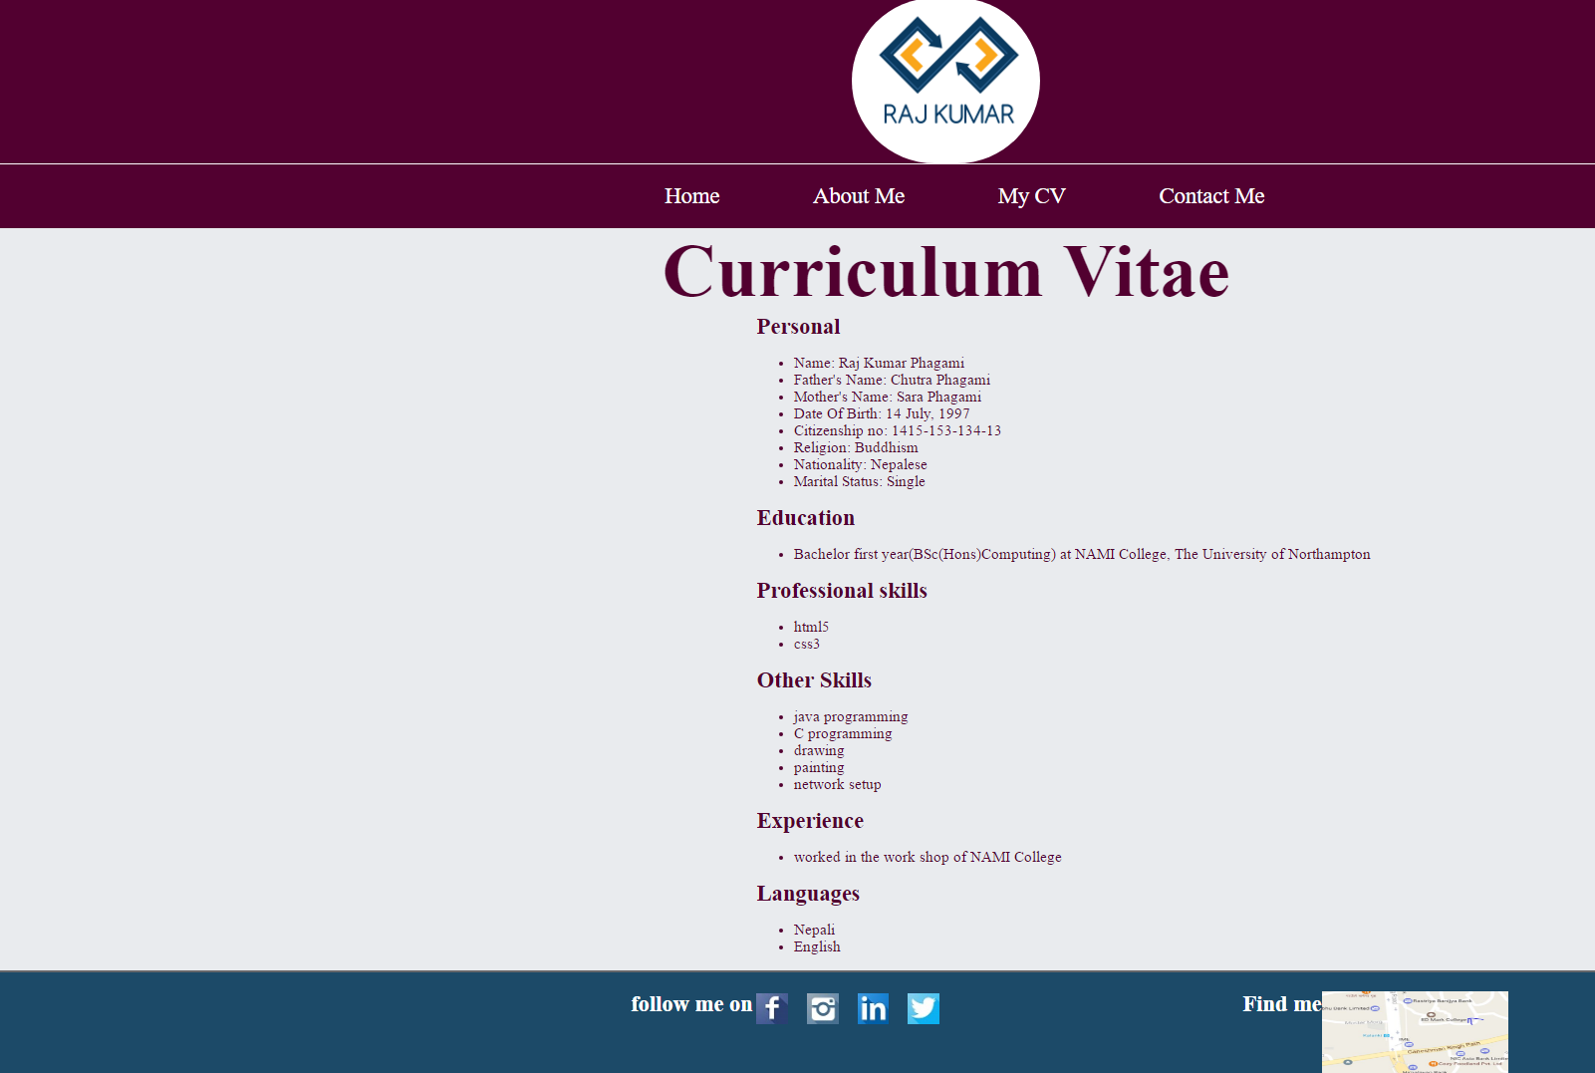

### Contact me page

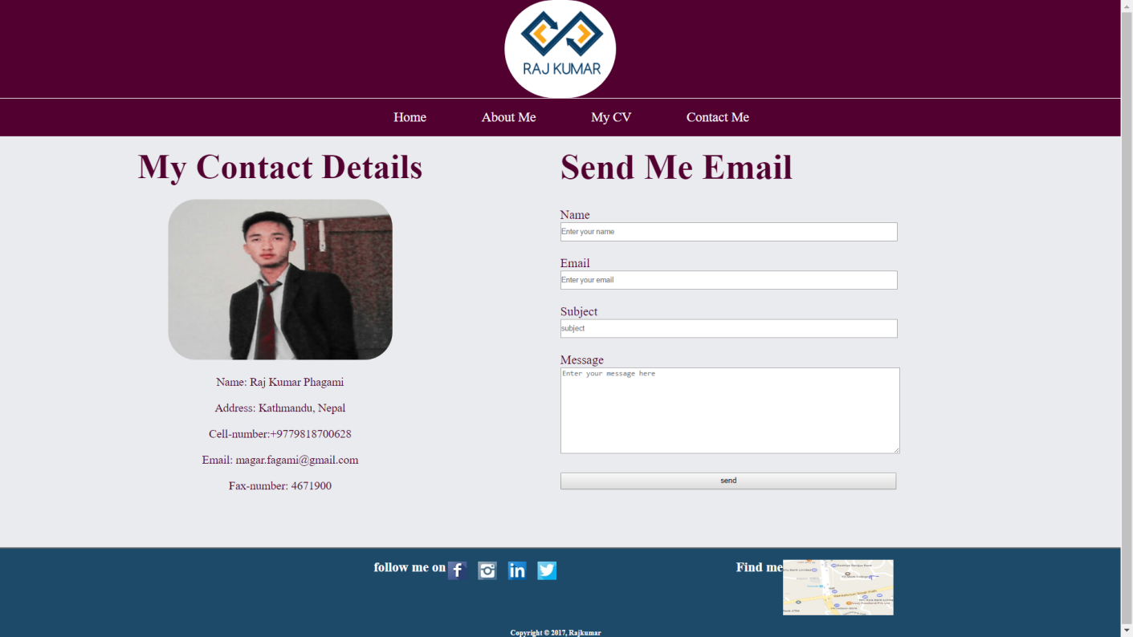

These are the four web pages that I have made for portfolio.

## My logo

The picture shown below is the logo I have made by using adobe photoshop cs6. The quality of the picture is optimized. I have put this in the middle of header.



## Responsive mock-up

I also have made my web site responsive. One of the webpages in a small screen is shown below

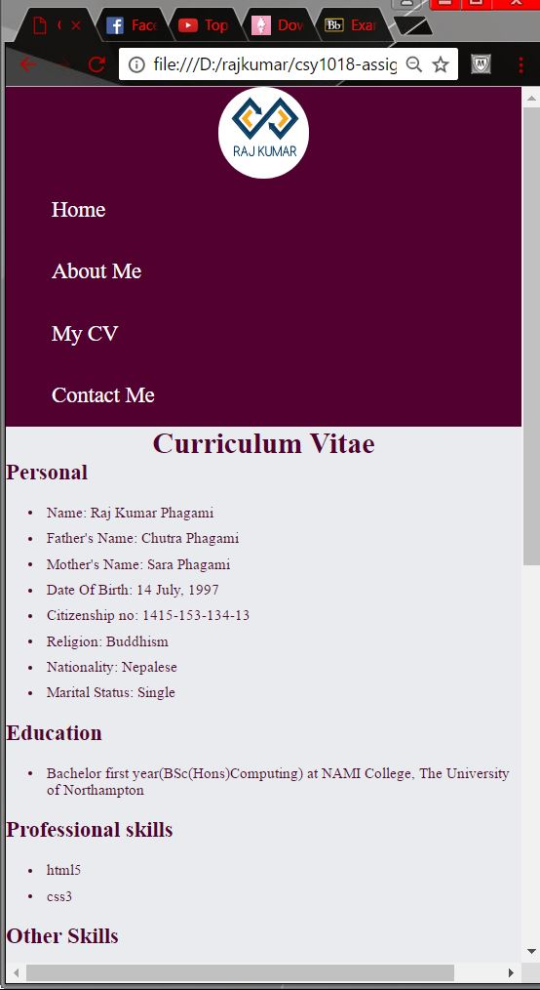

# Navigation bar

The navigation bar is shown below.



## Navigation Diagram

Contact me

**About me**

**Home**

**Home page screen**

**My CV**

Since the header footer and navigation bar is same for all the pages of my portfolio, it will be easier for users to navigate from one screen to another screen.

# My Working Progress

## Github Committing

At first, I made a repository project on github. Then I cloned on command prompt through git commands. Then I started creating my portfolio.

## Github link

## Checking speed of my website on GTmetrix

I have been checking the speed of my wesite on different sites like Gtmetrix so that I could optimise and make my web site faster for users. I put the github link on this site <https://gtmetrix.com/> after commiting my works on github and saw the result until I get good result.

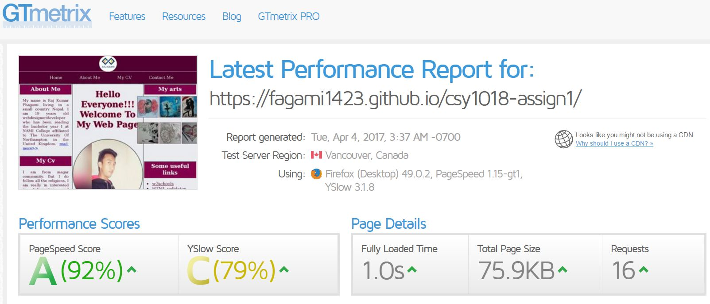

## Checking errors

I checked the errors and validation on <https://jigsaw.w3.org/css-validator/> and <https://validator.w3.org/> each time after I committed on git so that I could correct the errors. It helped me a lot during my assignment time.

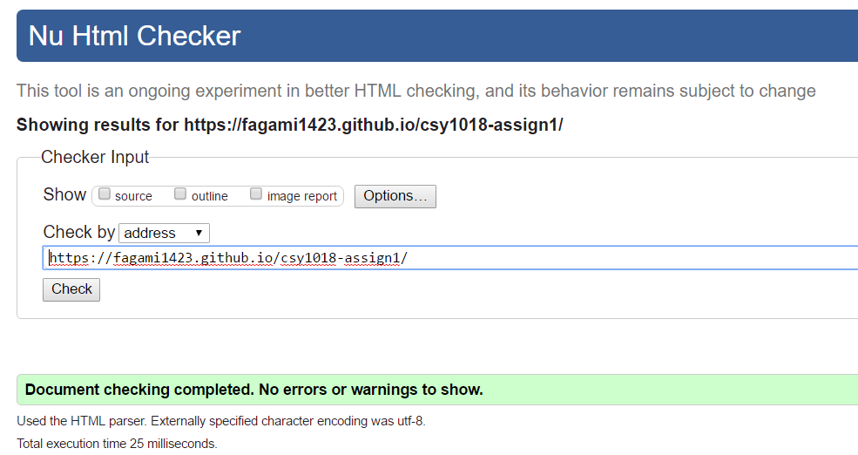 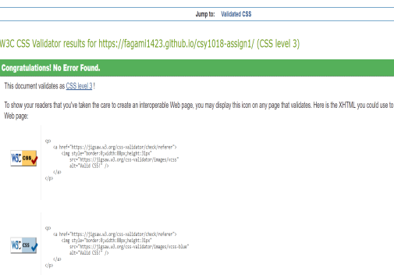

## Time I took to complete my assignment

As the time was 3 weeks for me to make, I completed it in around two weeks and the time I took was around 24 hours.

## Sources for code I used

* <https://www.w3schools.com/>
* <https://www.youtube.com/watch?v=3k1I4KJKdK4>

# Conclusion

So in overall, I have made my website simple looking with good combination of colours. And I have made my website faster with average speed of 450ms. Images have been optimised to provide fast mechanism to the users. And I have made my website responsive as well. Besides, I could make my website more effective by adding search icons on the right side on header. Making navigation bar fixed while scrolling would make my website even better and be more consistent.

# Reference

nile.northampton.ac.uk. 2016. *SupportingDocs-Example-1*. [ONLINE] Available at: <https://nile.northampton.ac.uk/webapps/blackboard/execute/content/file?cmd=view&content_id=_3320137_1&course_id=_64602_1>. [Accessed 4 April 2017].

nile.northampton.ac.uk. 2016. *SupportingDocs-Example-2*. [ONLINE] Available at: <https://nile.northampton.ac.uk/webapps/blackboard/execute/content/file?cmd=view&content_id=_3320138_1&course_id=_64602_1>. [Accessed 4 April 2017].