ABARESdocs test report

An open source document production system

Neal Hughes

2 December 2016

Table of Contents

# Introduction

This document serves as both a user guide and demonstration of 'ABARESdocs' or at least it will if I ever get around to finishing it.

# Text

## Dot points

* Dot points look like this
  + and also like this
  + and this

## Linked statistics

* ABARESdocs allows the author insert in-text references to statistics, linked to an underlying data file. Here are some examples:
  + Winter crop production in Victoria in 2014-15 was 5,531.7 kilotonnes.
  + Summer crop area planted in Queensland in 2015-16 was 1,417.0 '000 Ha.

## References

ABARESdocs (via Pandoc) supports citations / referencing linked to Endnote or Bibtex libraries. Here is an example:

Climatic conditions are the single most important factor affecting the productivity of Australian cropping farms (Kokic et al. 2006, Hughes et al. 2011). Australia's climate is highly variable, with lower mean rainfall and higher rainfall variability than other comparable regions (Peel et al. 2004). As a result, Australian agriculture is subject to more revenue volatility than almost any other country in the world (Keogh 2012).

A bibliography is then automatically inserted at the end of the document.

## External links

ABARESdocs allows for external references. Check out this cool football team, the [Geelong Cats](http://www.geelongcats.com.au).

## Internal links

ABARESdocs also supports internal document links. For example, the Charts section below shows how insert charts with ABARESdocs.

## Math

ABARESdocs (via Pandocs) supports mathematical notation using Latex syntax:

To control for the effect of climate on productivity we estimate a regression of the form:

where is the farm performance measure (i.e., *TFP* or *W_YIELD*) for farm in period , is a vector of farm specific climate variables, a vector of farm characteristics and is an unknown function. Here is a subset of the 60 climate variables defined in section 3 and includes *LAT*, *LONG*, *AREA*, *LIVESTOCK*, *AGE*, *IRRIG2*, *FLOOD20*, *FLOOD5* and *FLOOD1_5* (and *W_AREA* in the wheat yield model).

Equation numbering is also supported, check out eq. 1:

# Charts

ABARESdocs uses some Python scripts to generate nicely formated chart images. For more information on how this works see the charts folder.

Once chart image files and table text files have been generated they can be inserted as below. Pandoc supports numbering and cross-referencing of tables and charts.

## Simple charts

Here is a line chart (Figure 1)

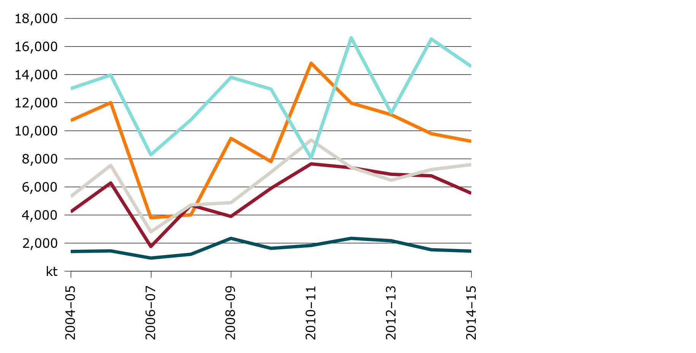

Figure 1: Line chart showing winter crop production in Australia, 2004-05 to 2014-15

Here is an area chart (Figure 2)

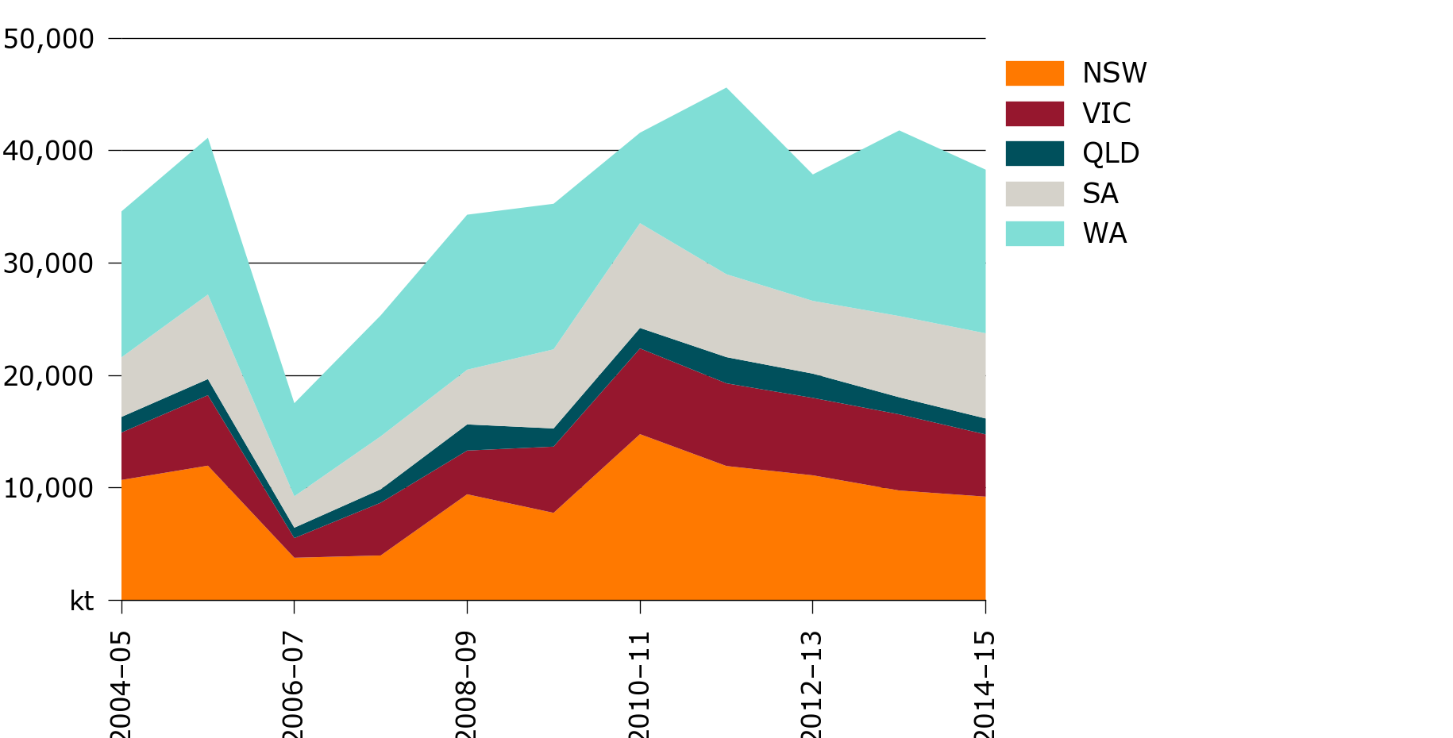

Figure 2: Area chart showing winter crop production in Australia, 2004-05 to 2014-15

Here is a bar chart (Figure 3)

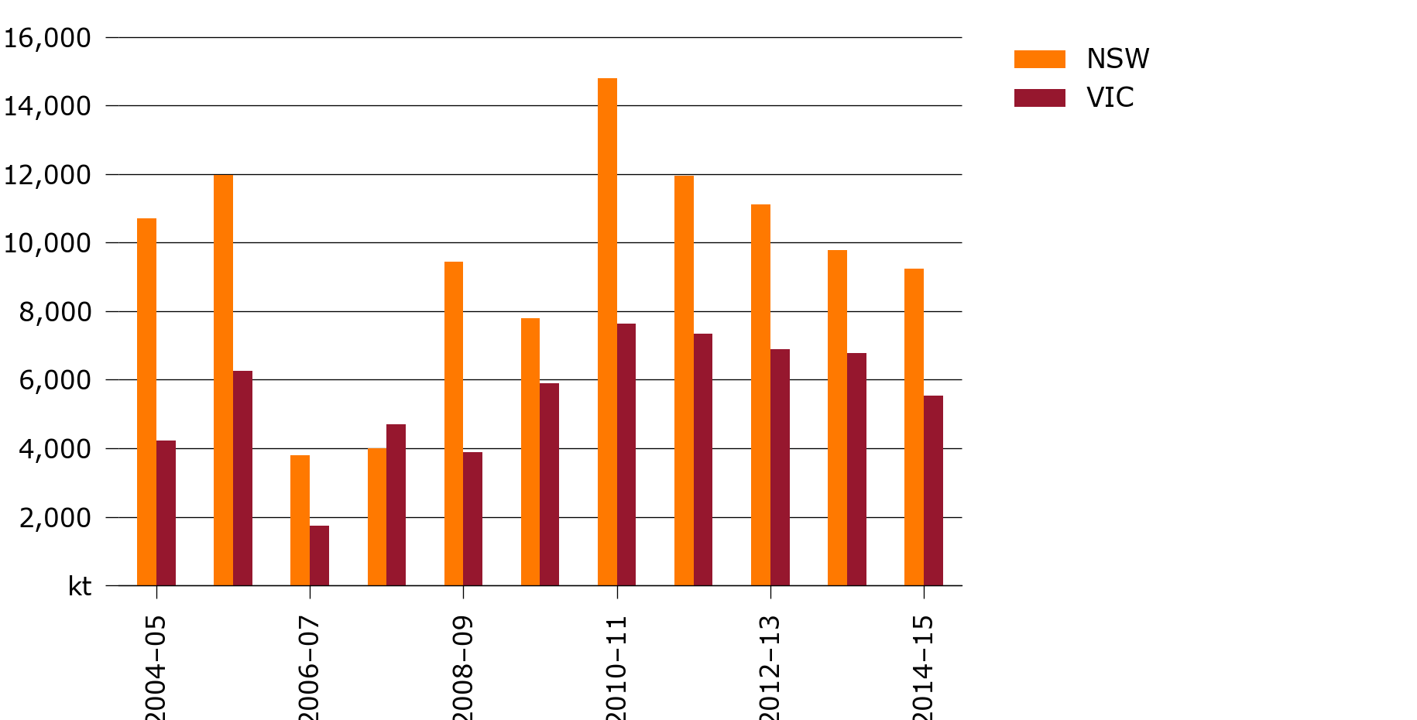

Figure 3: Bar chart showing winter crop production in Australia, 2004-05 to 2014-15

Here is a horizontal bar chart (Figure 4)

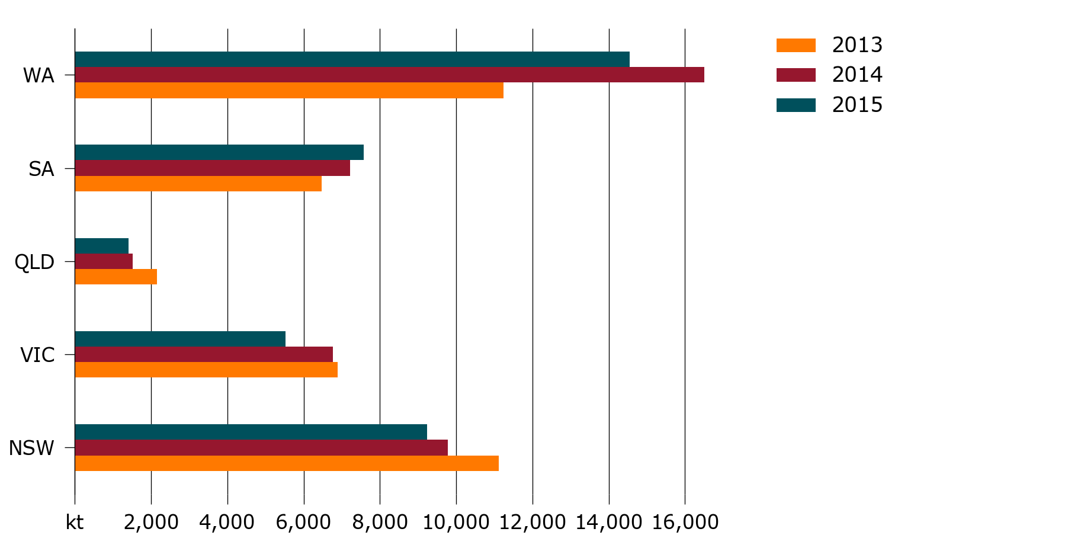

Figure 4: Horizontal Bar chart showing winter crop production in Australia, 2012-13 to 2014-15

Here is a stacked bar chart (Figure 5)

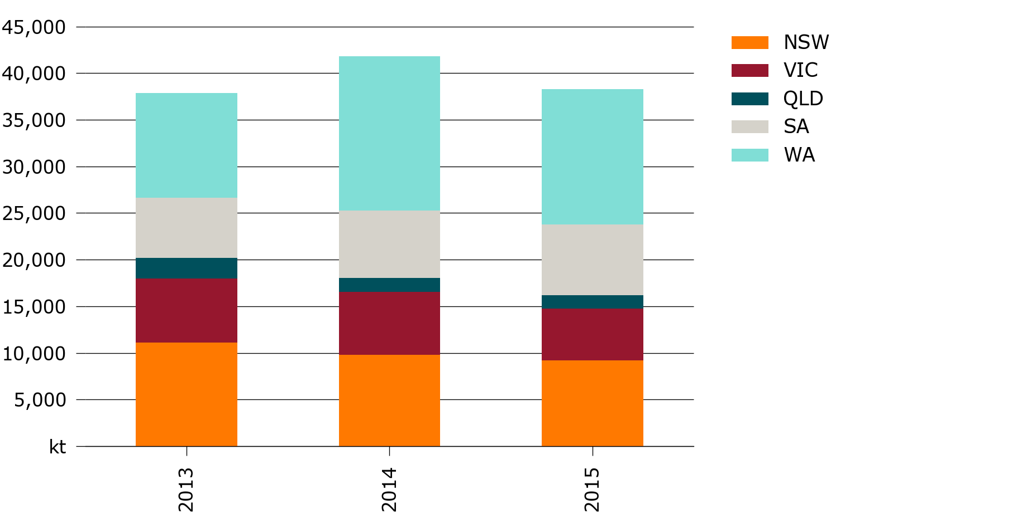

Figure 5: Stacked bar chart showing winter crop production in Australia, 2012-13 to 2014-15

Here is a scatter chart (Figure 6)

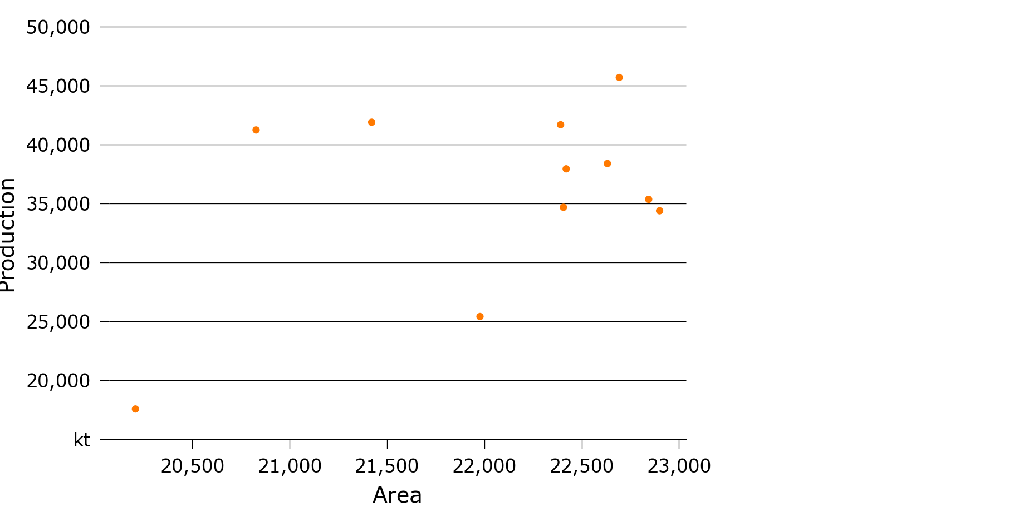

Figure 6: Scatter chart showing winter crop production in Australia against area, 2004-05 to 2014-15

Here is a multi-scatter chart (Figure 7)

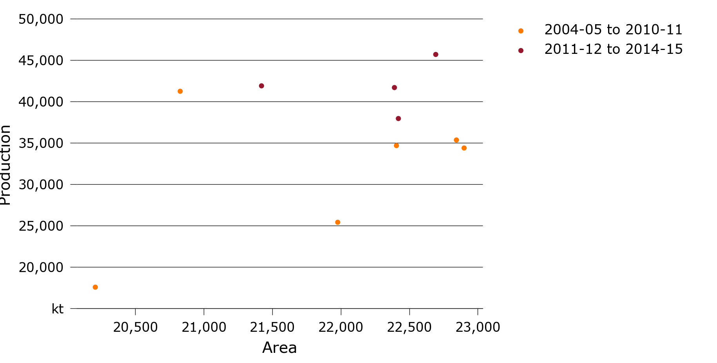

Figure 7: Multi-scatter chart showing winter crop production in Australia against area, 2004-05 to 2014-15

## Combo charts

Here is a line chart with secondary y-axis (Figure 8)

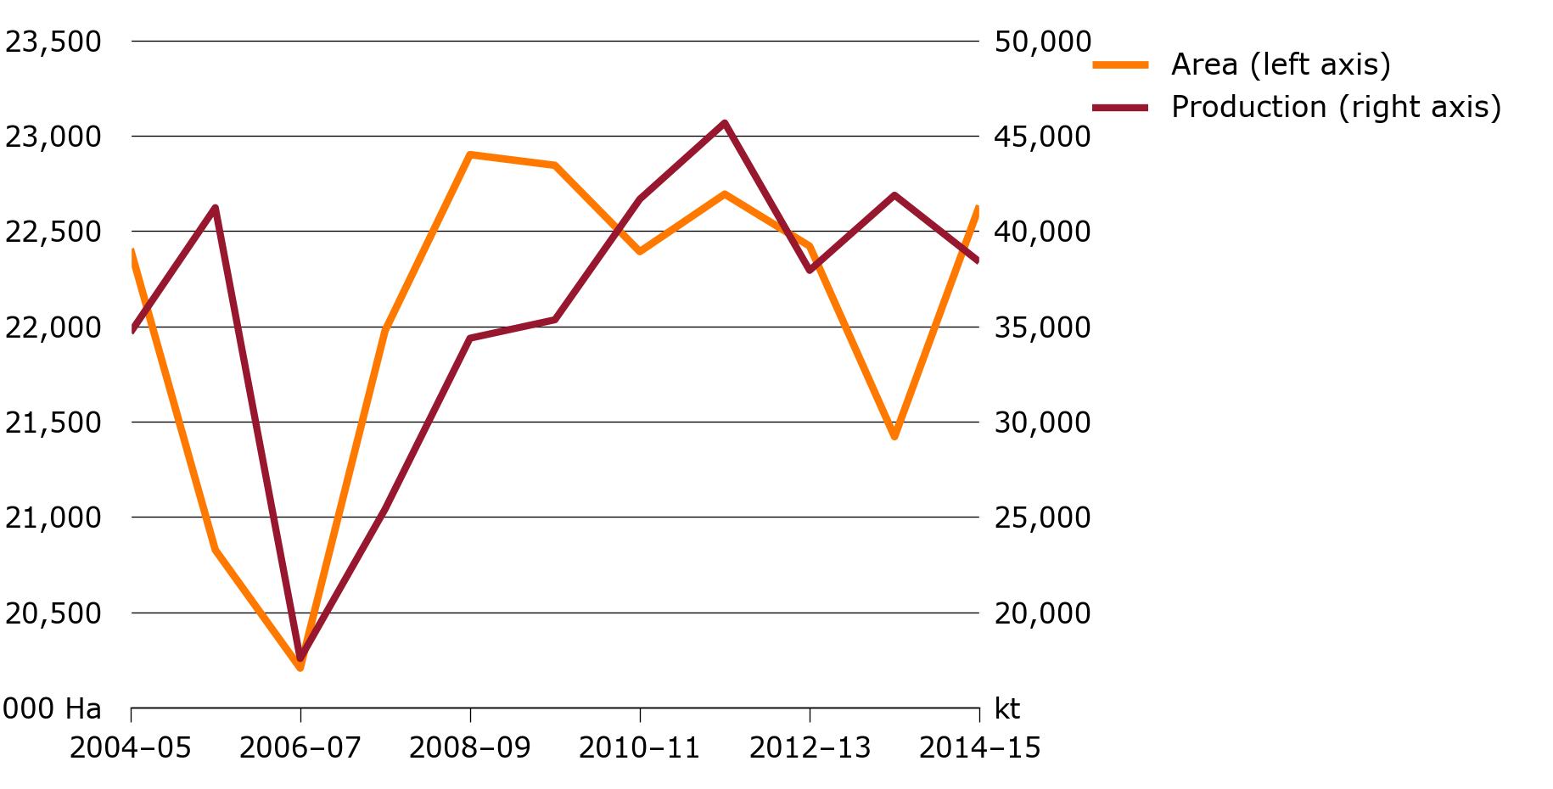

Figure 8: Line chart with secondary y-axis showing winter crop production and area in Australia, 2004-05 to 2014-15

Here is a bar and line chart with secondary y-axis (Figure 9)

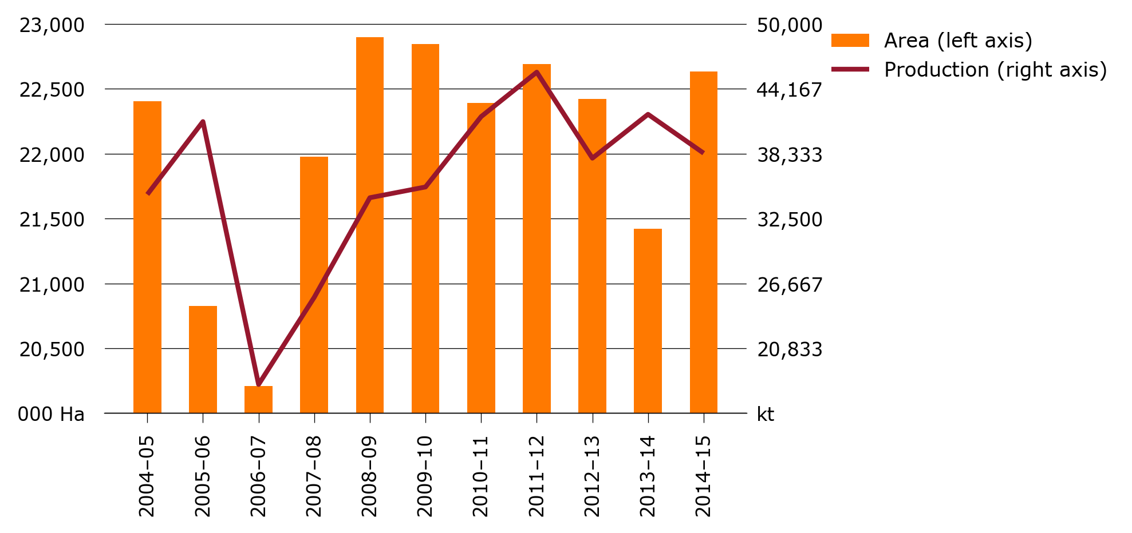

Figure 9: Bar and line chart showing winter crop production and area in Australia, 2004-05 to 2014-15

Here is an area and line chart with secondary y-axis (Figure 10)

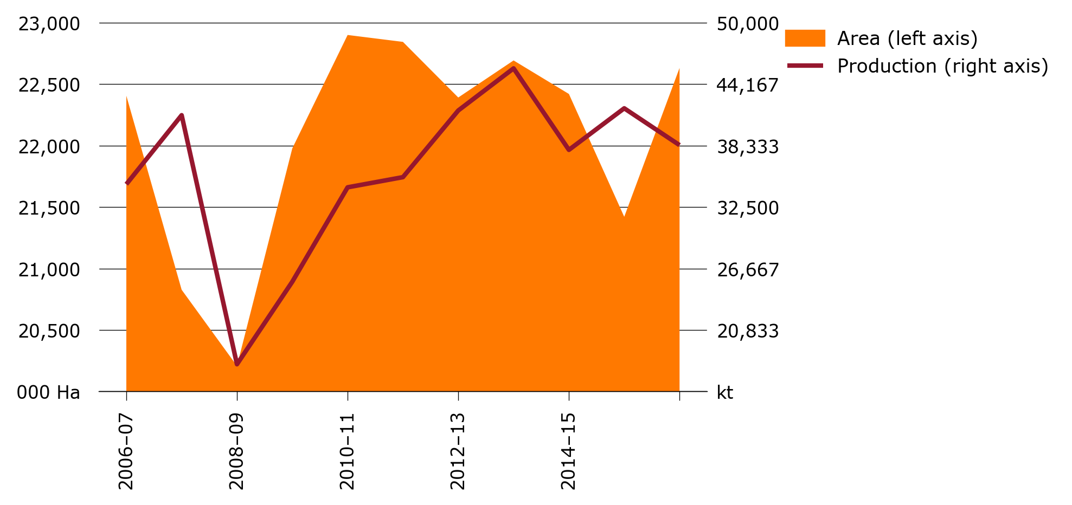

Figure 10: Area and line chart showing winter crop production and area in Australia, 2004-05 to 2014-15

## Panel charts

Here is a panel line chart (Figure 11)

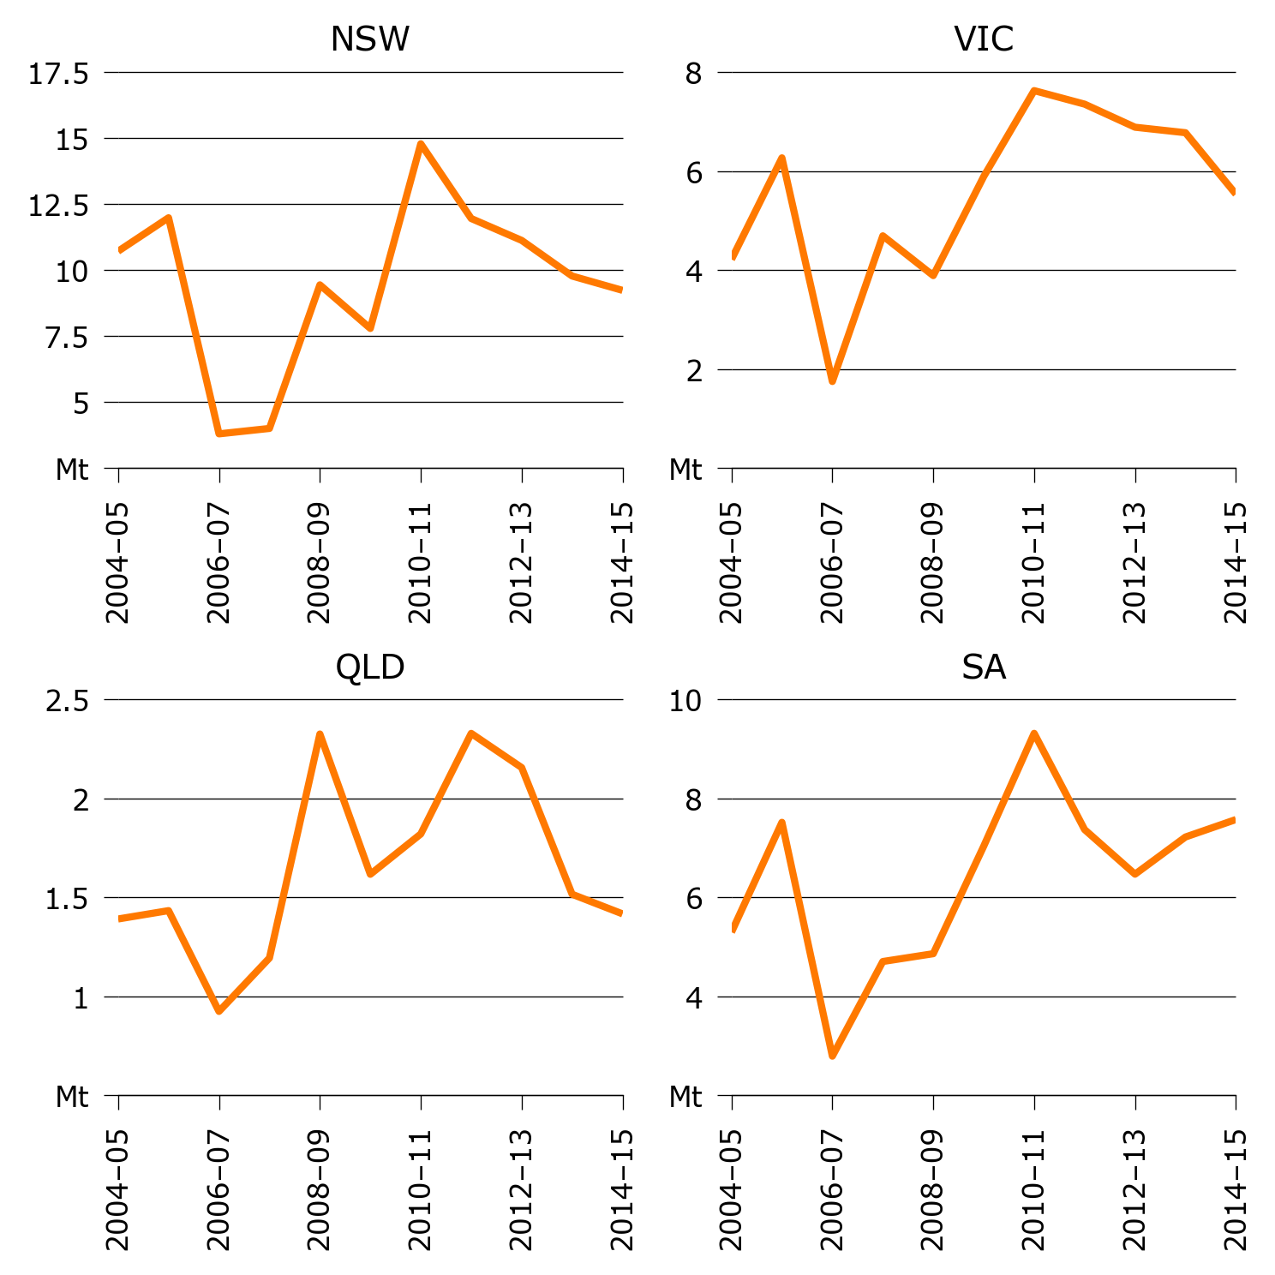

Figure 11: Panel chart showing winter crop production in Australia, 2004-05 to 2014-15

Here is a panel bar chart (Figure 12)

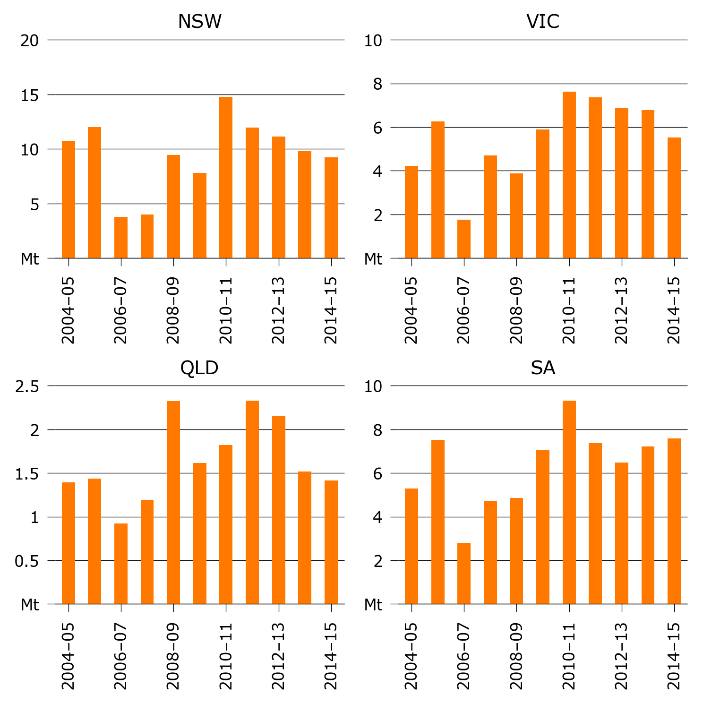

Figure 12: Panel bar chart showing winter crop production in Australia, 2004-05 to 2014-15

Here is a multi-panel chart (Figure 13)

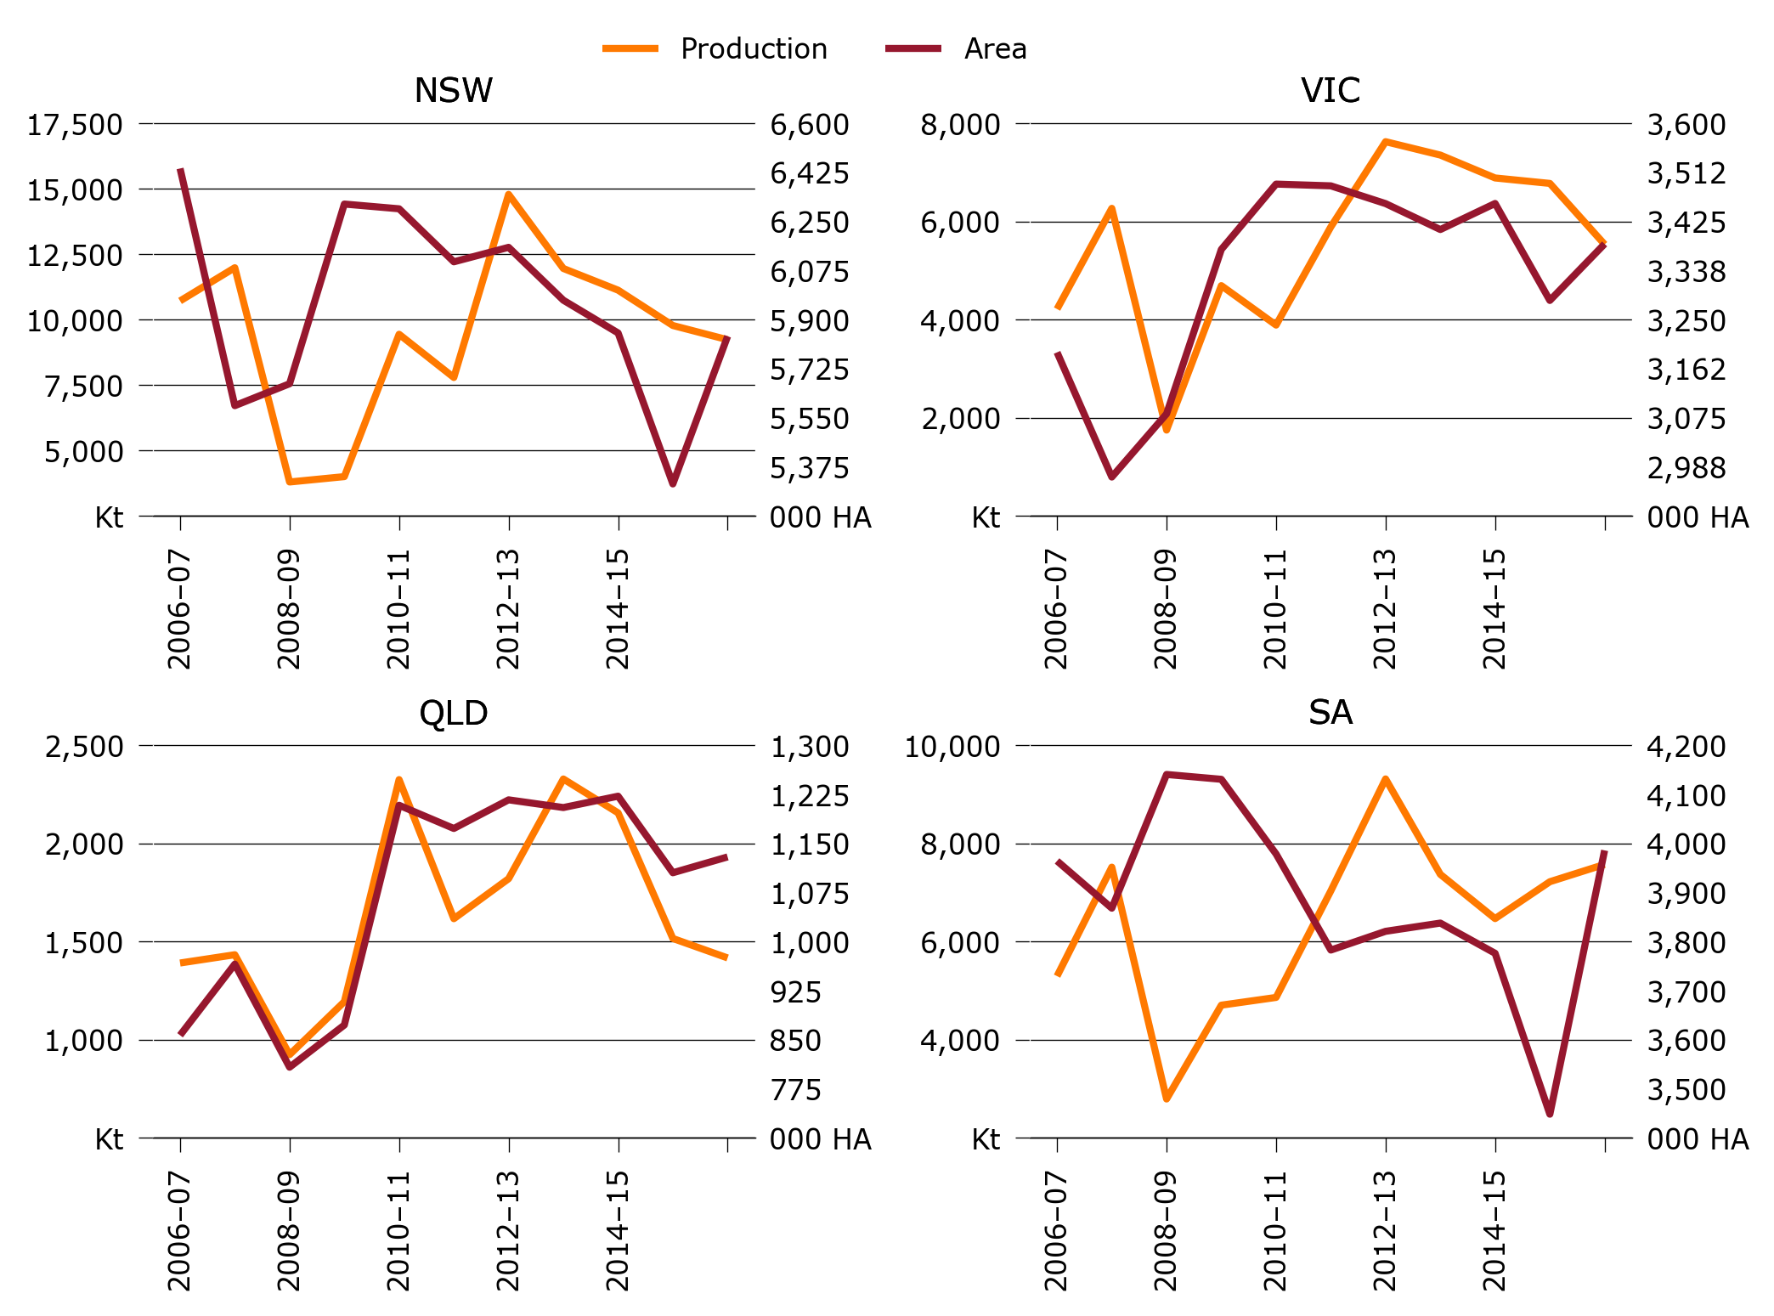

Figure 13: Multi panel chart showing winter crop production and area in Australia, 2004-05 to 2014-15

Here is a multi-panel bar / line chart (Figure 14)

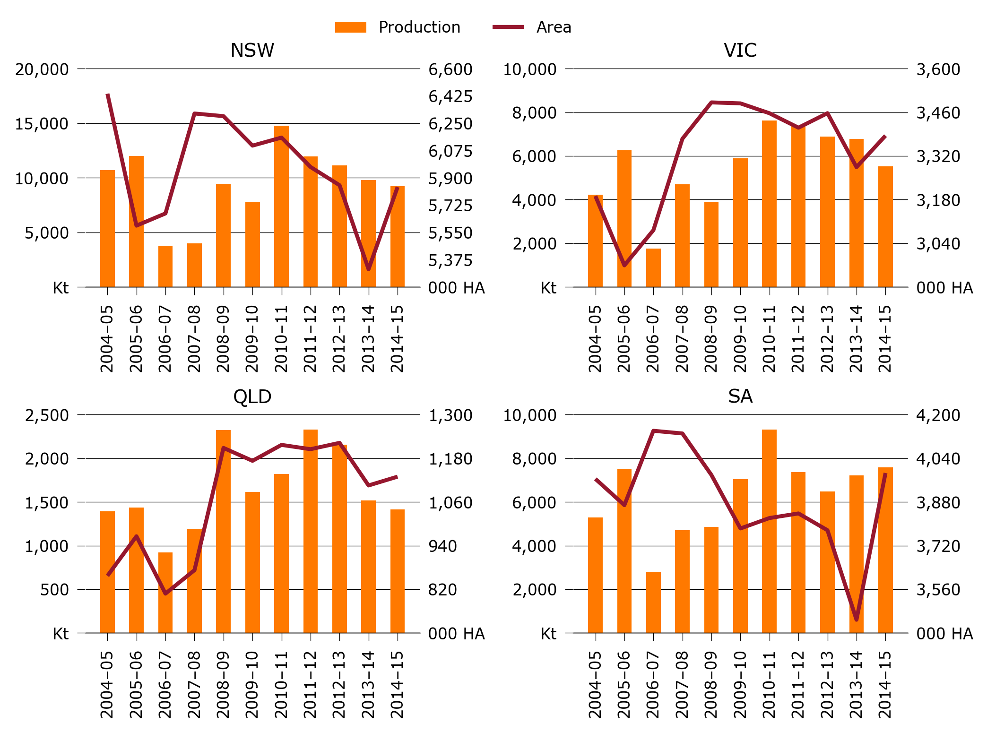

Figure 14: Multi panel bar/line chart showing winter crop production and area in Australia, 2004-05 to 2014-15

# Tables

ABARESdocs allows report tables to be linked to csv files. Here are some examples (Table 1, Table 2).

Table 1: winter crop production in Australia, 2004-05 to 2014-15

|  |  |  |  |  |  |
| --- | --- | --- | --- | --- | --- |
|  | NSW | VIC | QLD | SA | WA |
| 2005 | 10,712.2 | 4,214.4 | 1,391.2 | 5,297.5 | 12,977.8 |
| 2006 | 11,981.3 | 6,266.8 | 1,433.4 | 7,517.9 | 13,944.6 |
| 2007 | 3,794.1 | 1,747.9 | 924.2 | 2,793.1 | 8,278.1 |
| 2008 | 3,999.2 | 4,691.7 | 1,194.1 | 4,705.7 | 10,760.5 |
| 2009 | 9,438.4 | 3,887.4 | 2,325.6 | 4,863.4 | 13,784.6 |
| 2010 | 7,787.0 | 5,889.1 | 1,616.9 | 7,035.5 | 12,943.0 |
| 2011 | 14,783.6 | 7,625.2 | 1,820.6 | 9,316.1 | 8,044.1 |
| 2012 | 11,952.1 | 7,352.0 | 2,328.7 | 7,371.5 | 16,600.0 |
| 2013 | 11,123.4 | 6,885.6 | 2,156.0 | 6,469.7 | 11,243.1 |
| 2014 | 9,773.0 | 6,774.6 | 1,516.2 | 7,221.3 | 16,509.8 |
| 2015 | 9,230.0 | 5,531.7 | 1,417.0 | 7,574.4 | 14,550.7 |

Table 2: winter crop area in Australia, 2004-05 to 2014-15

|  |  |  |  |  |  |
| --- | --- | --- | --- | --- | --- |
|  | NSW | VIC | QLD | SA | WA |
| 2005 | 6,438.8 | 3,191.5 | 856.9 | 3,964.5 | 7,932.2 |
| 2006 | 5,592.9 | 2,969.2 | 965.6 | 3,868.2 | 7,406.7 |
| 2007 | 5,671.1 | 3,081.9 | 808.1 | 4,140.7 | 6,477.2 |
| 2008 | 6,312.0 | 3,375.0 | 872.6 | 4,130.8 | 7,264.6 |
| 2009 | 6,295.0 | 3,491.6 | 1,208.5 | 3,978.7 | 7,899.3 |
| 2010 | 6,106.0 | 3,488.4 | 1,173.0 | 3,782.9 | 8,270.6 |
| 2011 | 6,157.6 | 3,456.8 | 1,216.7 | 3,821.1 | 7,715.1 |
| 2012 | 5,969.1 | 3,410.5 | 1,205.0 | 3,837.8 | 8,252.2 |
| 2013 | 5,852.2 | 3,457.0 | 1,222.3 | 3,776.3 | 8,097.2 |
| 2014 | 5,313.9 | 3,284.1 | 1,105.3 | 3,448.3 | 8,248.9 |
| 2015 | 5,840.5 | 3,384.9 | 1,129.5 | 3,986.0 | 8,271.5 |

You can also insert static tables directly with markdown syntax.

Table 3: Final meta-parameter values

|  |  |  |
| --- | --- | --- |
|  | TFP | W_YIELD |
| Number of samples per split | 50 | 5 |
| Number of trees | 1175 | 1475 |
| Learning rate | 0.045 | 0.032 |

# Appendix A: Tips and tricks

# References

Hughes, N et al. 2011,‘Productivity pathways: climate-adjusted production frontiers for the Australian broadacre cropping industry’, in, *2011 conference (55th), february 8-11, 2011, melbourne, australia*, Australian Agricultural; Resource Economics Society.

Keogh, M 2012,‘Including risk in enterprise decisions in Australia’s riskiest businesses’, in, *56th annual conference of the australian agricultural and resource economics society, perth, australia*, pp.8–10.

Kokic, P, Davidson, A, & Boero Rodriguez, V 2006, ‘Australia’s grains industry: factors influencing productivity growth’, *Australian Commodities: Forecasts and Issues*, vol. 13, no. 4, p. 705.

Peel, MC, McMahon, TA, & Finlayson, BL 2004, ‘Continental differences in the variability of annual runoff-update and reassessment’, *Journal of Hydrology*, vol. 295, no. 1, pp. 185–197.