# Chinmay Wyawahare

cnw282

N13289737

Mini Project 1: Graph Design (Geo)

1. Visualization 1:

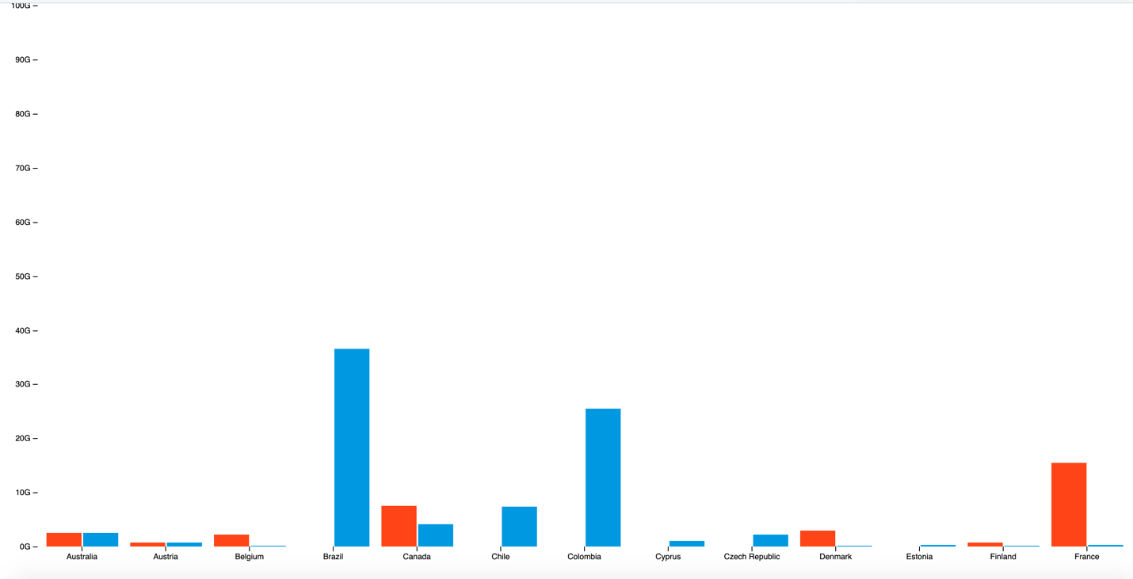

I have used grouped bar charts to visualize the donated and received amount for each of the countries using two colors: *blue* and *red* to represent received and donated amount for each of the country.

There are many countries which donate more than they receive. E.g. Belgium, Denmark, France, Germany, Japan, Netherlands, Norway, Sweden, Switzerland, United Kingdom, United States.

Some of the countries receive much more than they donate. E.g. Brazil, Chile, Colombia, Cyprus, Czech Republic, Hungary, India, Korea, Kuwait, Poland, South Africa, Taiwan, Thailand.

1. Visualization 2:

a) Do the countries that donate the most tend to cluster around specific geographical areas of the world?

* Countries in West Europe generally donate more than they receive unlike other parts of the world

b) Do the countries that receive the most tend to cluster around specific geographical areas of the world?

* The countries receiving the most are spread out across the world.

c) Are there neighboring countries that have radically different patterns in terms of how much they receive vs. how much they donate?

* Germany and Poland and Japan and Korea tend to show radically different patterns in terms of how much they receive vs how much they donate.

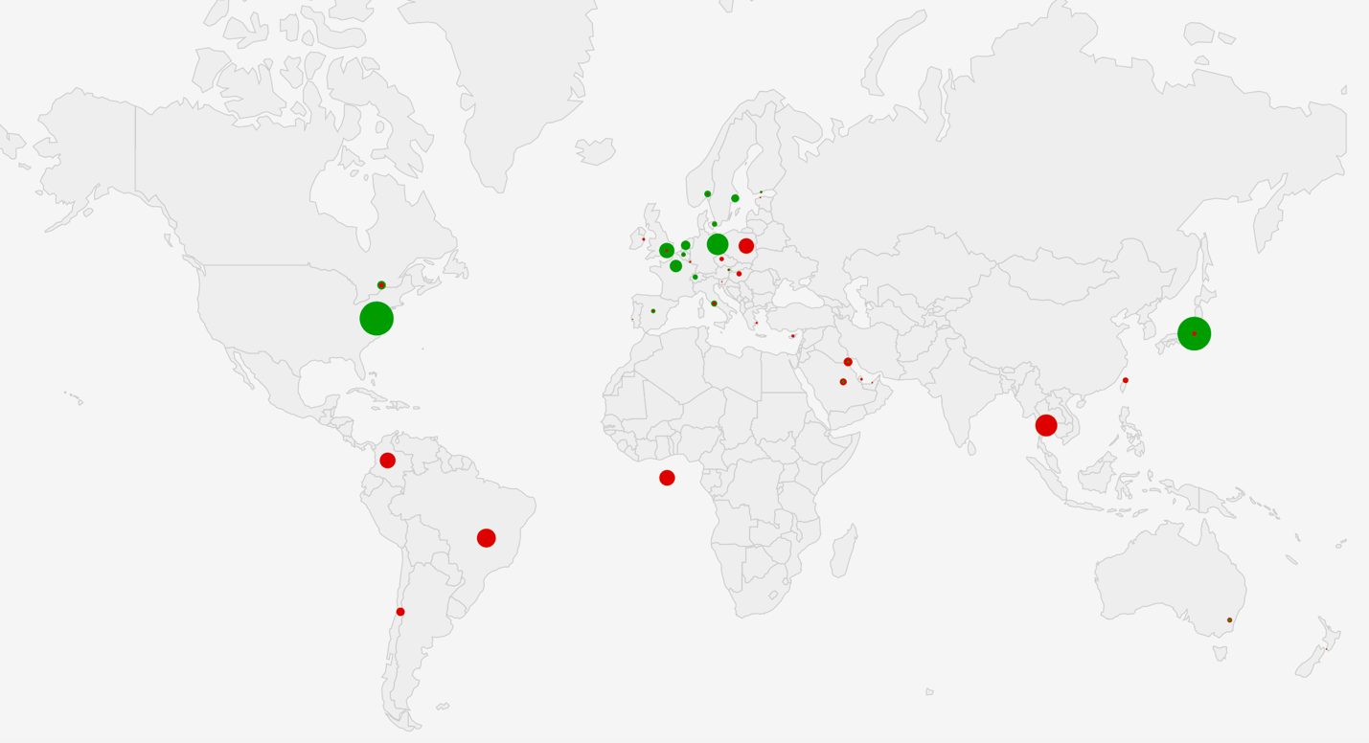

1. Visualization 3:

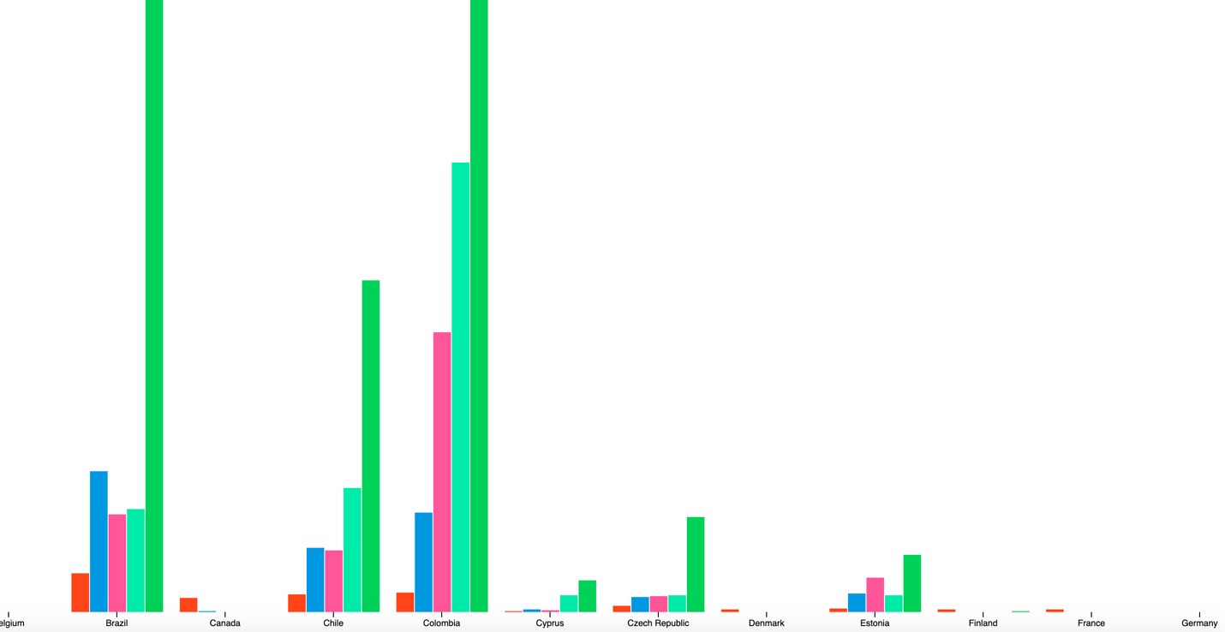

* 1. Are there any major differences in how the top 5 most frequent purposes of disbursements distribute geographically in terms of countries that receive donations?
     + The top 5 most frequent purposes of disbursement tend to distribute non-uniformly across the globe with some countries receiving more of certain type of disbursements.
  2. Are there countries that tend to receive more of certain type of donations than others?
     + Countries like Brazil, Chile, Columbia, Czech Republic, Estonia, Hungary, Poland, Saudi Arabia, Slovak Republic, Slovenia, Taiwan and United Arab Emirates have Social/welfare services as their most significant amount of donations received and Air transport as their least significant amount of donations received.

I feel I can improve this visualization by making use of pie charts and plotting them over centroid of each country to represent the distribution of top 5 most frequent purposes of disbursements for each country. I will resubmit the assignment with Dorling Cartogram for the third visualization