**Mini Project 1**

Chinmay Wyawahare

cnw282

N13289737

1. Visualization #1:

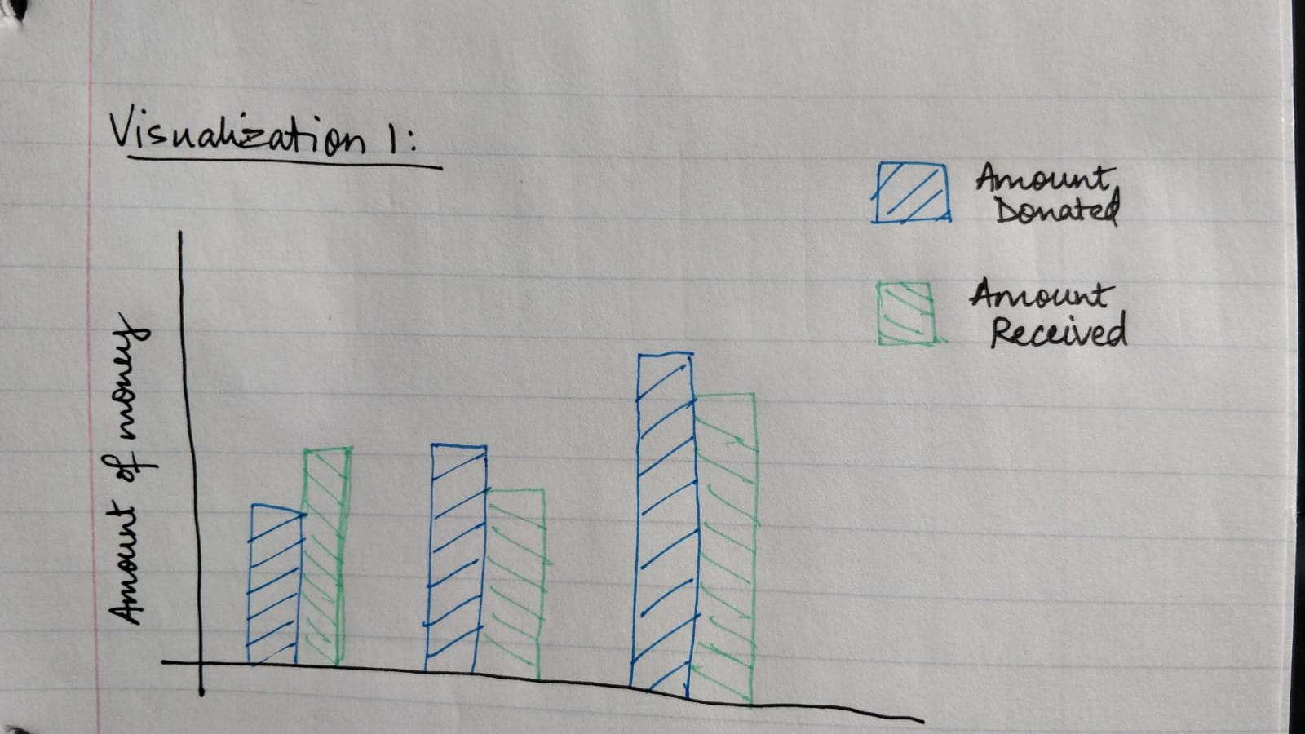

1. Visualization #2:

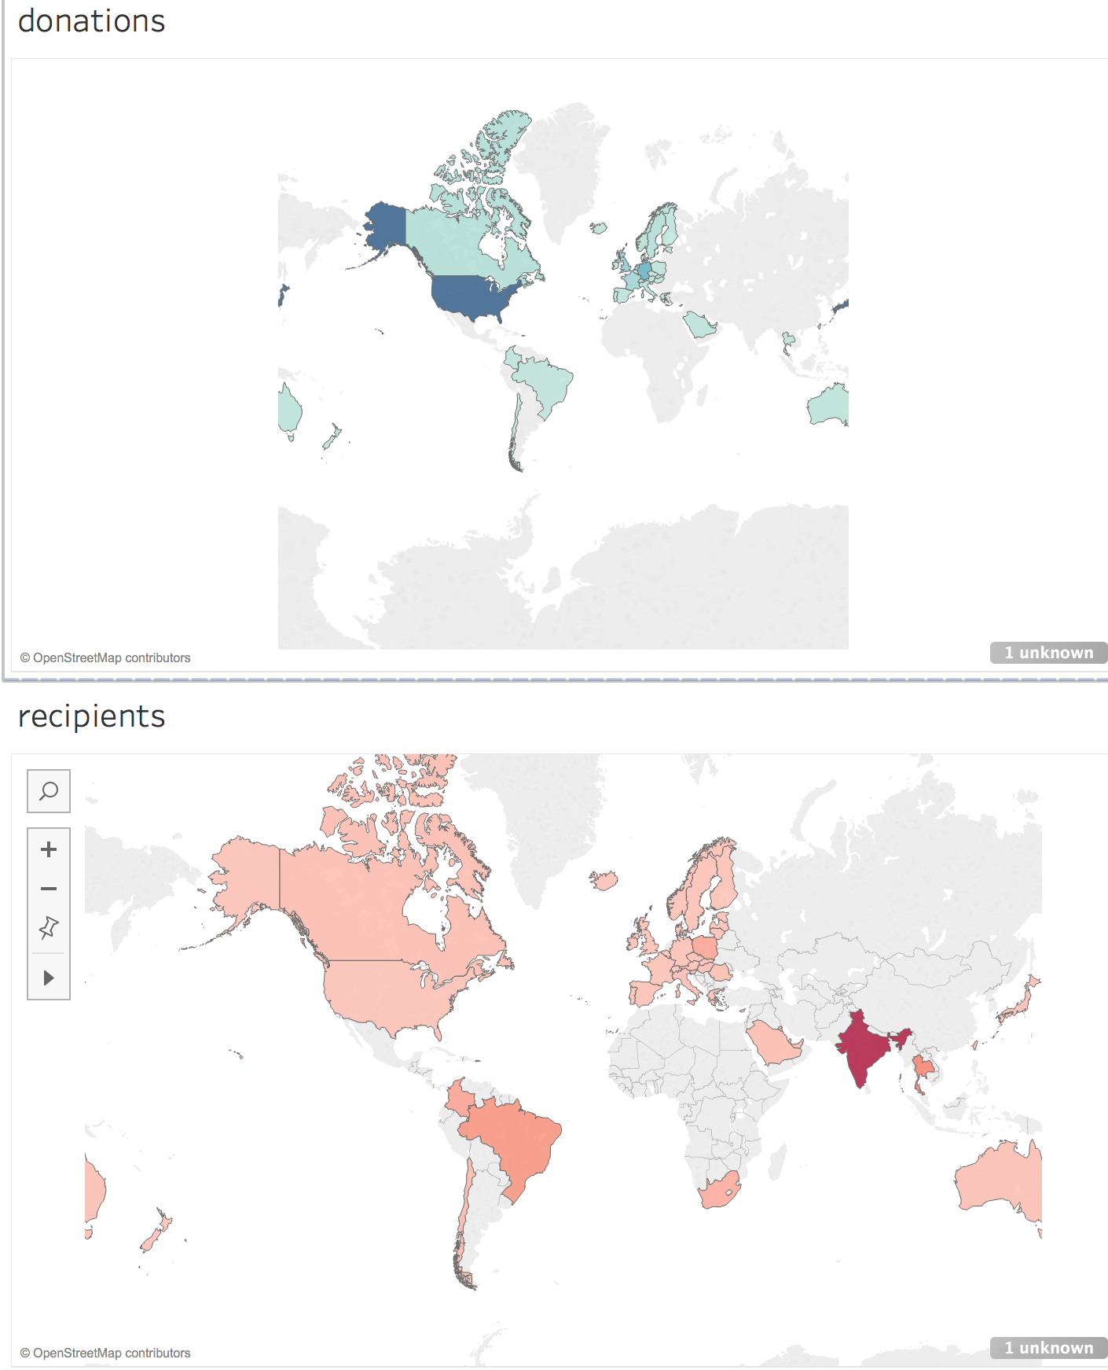

1. Visualization #3:

