# Chinmay Wyawahare

cnw282

N13289737

Mini Project 1: Graph Design (Networks)

1. Visualization 1:

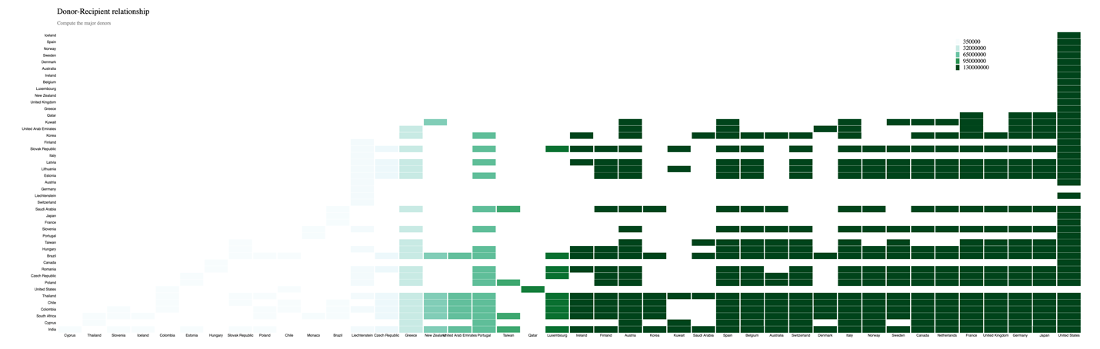

Fig 1. Donor-Recipient Relationship (Donated amount)

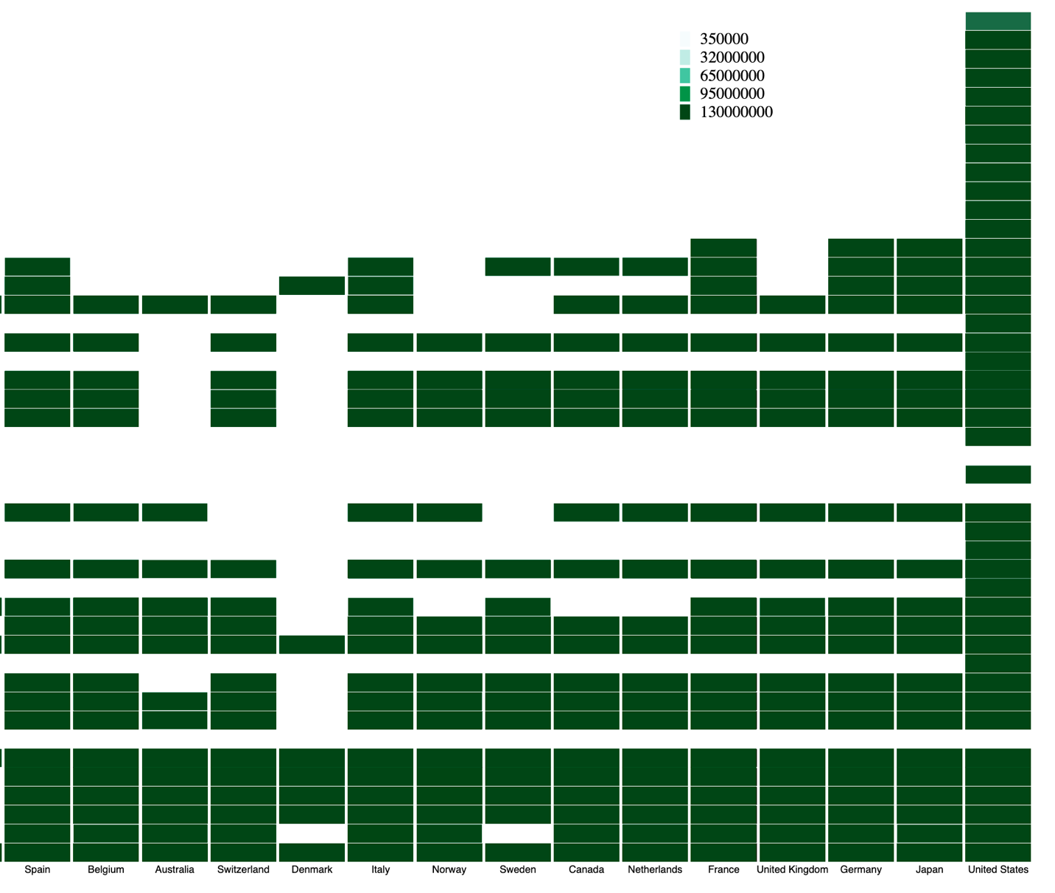

Fig 2. Donor-Recipient Relationship (Donated Amount) (Legend)

1. Who are the major donors and to which countries do they donate the most?

From the heatmap, it is evident that countries like United States, Japan, Germany, United Kingdom, France, Netherlands, Canada, Sweden, Norway, Italy, Switzerland, Australia, Belgium, Spain, Austria, Finland, Ireland are the major donors. United States donated the most to countries like India, Cyprus, South Africa, Colombia, Chile, Thailand, Poland, Czech Republic, Romania, Canada, Brazil, Hungarym Taiwan, Portugal, Slovenia, France, Japan, Saudi Arabia, Switzerland, Germany, Estonia, Lithuania, Latvia, Italy, Slovak republic, Finland, Korea, United Arab Emirates, Kuwait, Qatar, Greece, United Kingdom, New Zealand, Luxembourg, Belgium, Ireland, Australia, Denmark, Sweden, Norway, Spain, Iceland.

Other major donors like Italy, Norway, Sweden, Canada, Netherlands, France, United Kingdom, Germany, Japan donate to countries like Estonia, Lithuania, Latvia, Slovak Republic, Korea, Qatar, Greece, United Kingdom.

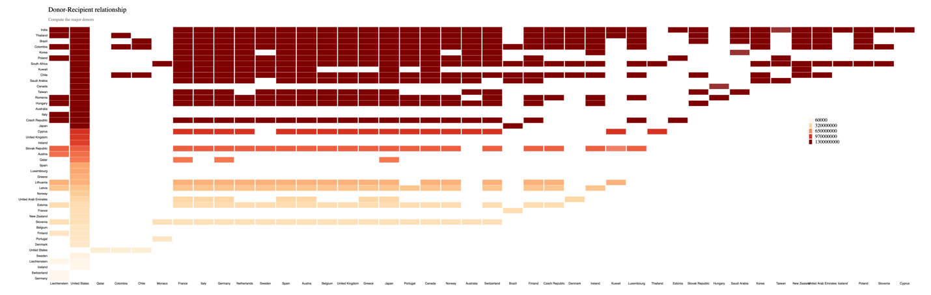

Fig 3. Donor-Recipient Relationship (Received amount)

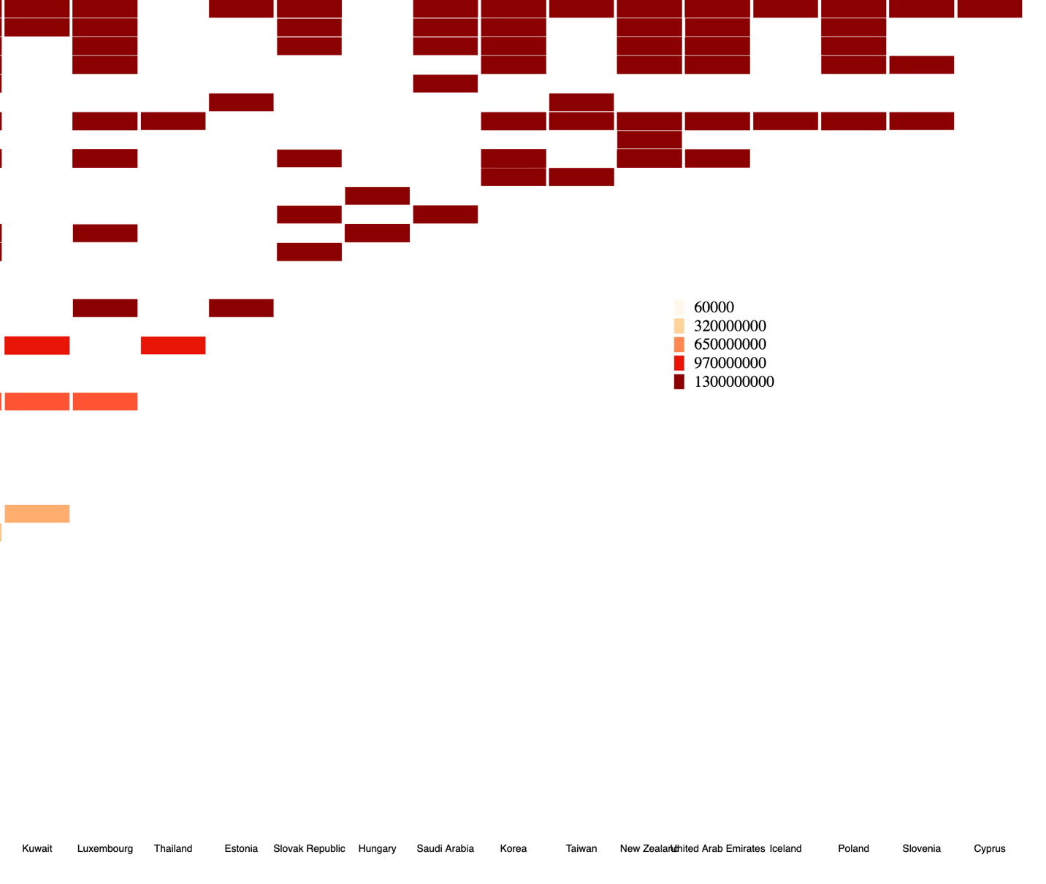

Fig 4. Donor-Recipient Relationship (Received amount) (Legend)

Who are the major receivers and which countries do they receive from the most?

From the above heatmap, it is evident that major receivers are India, Thailand, Brazil, Columbia, Korea, Poland, South Africa, Kuwait, Chile, Saudi Arabia, Canada, Taiwan, Romania, Hungary, Australia, Italy, Czech Republic, Japan and Cyprus. Countries which they receive the most are United States, Japan, Germany, United Kingdom, France, Netherlands, Canada, Sweden, Norway, Italy, Switzerland, Australia, Belgium, Spain, Austria, Finland, Ireland.

2) Are there groups of countries that tend to donate/receive to/from a similar set of countries?

Yes, we can identify the groups of countries that tend to donate/receive to/from a similar set of countries.

Countries like India, Thailand, Brazil, Columbia, Korea, Poland, South Africa, Kuwait, Chile, Saudi Arabia, Canada, Taiwan, Romania, Hungary, Australia, Italy, Czech Republic, Japan and Cyprus tend to receive from United States, Japan, Germany, United Kingdom, France, Netherlands, Canada, Sweden, Norway, Italy, Switzerland, Australia, Belgium, Spain, Austria, Finland, Ireland.

The group of ‘Major receivers’ can be found on the top-left corner of the receiver heatmap (Top values on y-axis in Fig 3). The group of ‘Major donors’ can be found on the bottom-right corner of the donor heatmap (Right most values on x-axis in Fig 1).

1. Visualization 3:

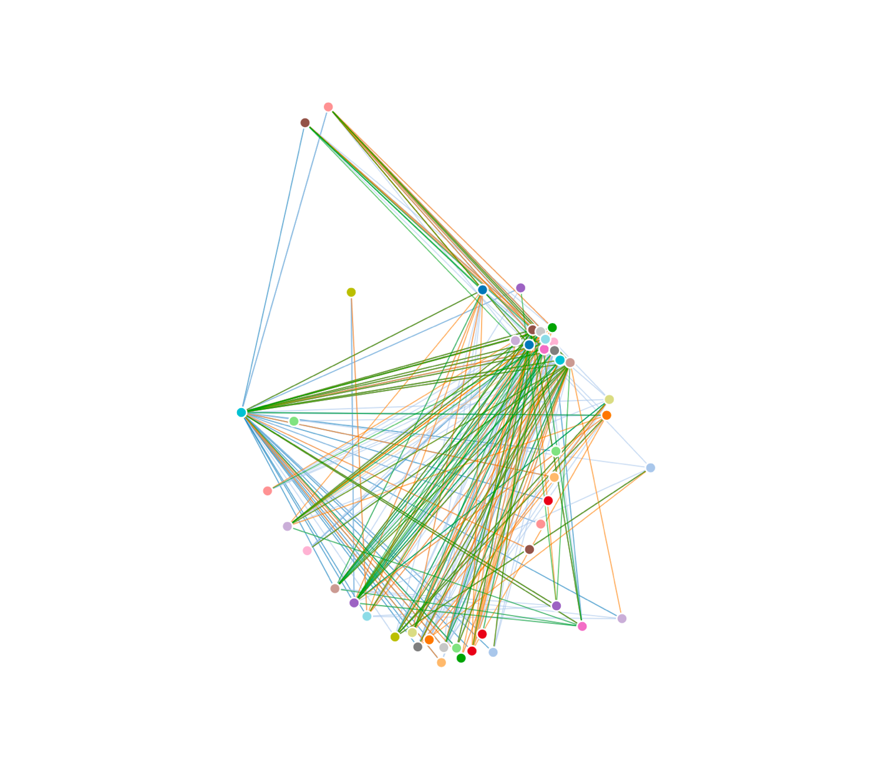

Force directed layout (Top 5 purposes)

I tried to visualize the relationship between countries in terms of top 5 purposes of donations. FDL for the aid-data becomes very cluttered as the data contains multiple donations for the same purpose between multiple countries. After looking at the FDL, it becomes very difficult by looking at the links between the nodes to figure out the number of donations between the countries due to huge dataset.

Instead I used an **adjacency matrix** to visualize the relationship between countries in terms of top 5 purposes of donations. Adjacency matrix makes it very clear to understand the relationship between countries in terms of top 5 purposes of donations. I have used **schemeCategory20b** to visualize the top 5 purposes of donations. The hue of **schemeCategory20b** handles the number of donations made for purpose between the countries. The adjacency matrix makes it easy to plot the countries on x-axis and y-axis and the matrix allows us to understand if there are any donations made between the countries for the top 5 purposes.

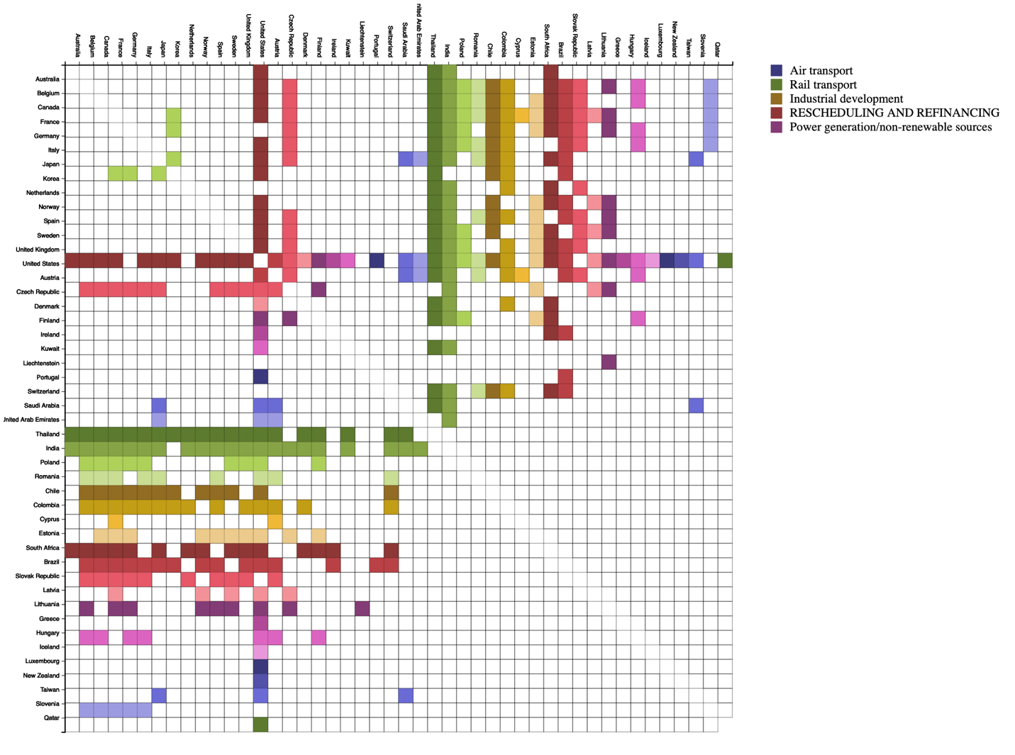

Fig 5. Top 5 purposes of donations

Legend: schemeCategory20b

Colors used:

#393B79 – Air transport

#637939 – Rail transport

#8C6D31 – Industrial development

#843C39 – Rescheduling and Refinancing

#7B4173 – Power generation/non-renewable sources

The above adjacency matrix has been created with the data that contains all the five purposes of donations but this matrix won’t be sufficient to answer all the questions as the visualization is doesn’t specifically tell us if a country to same country for different purposes. Therefore, I have created five adjacency matrices – one for each purpose to address this problem.

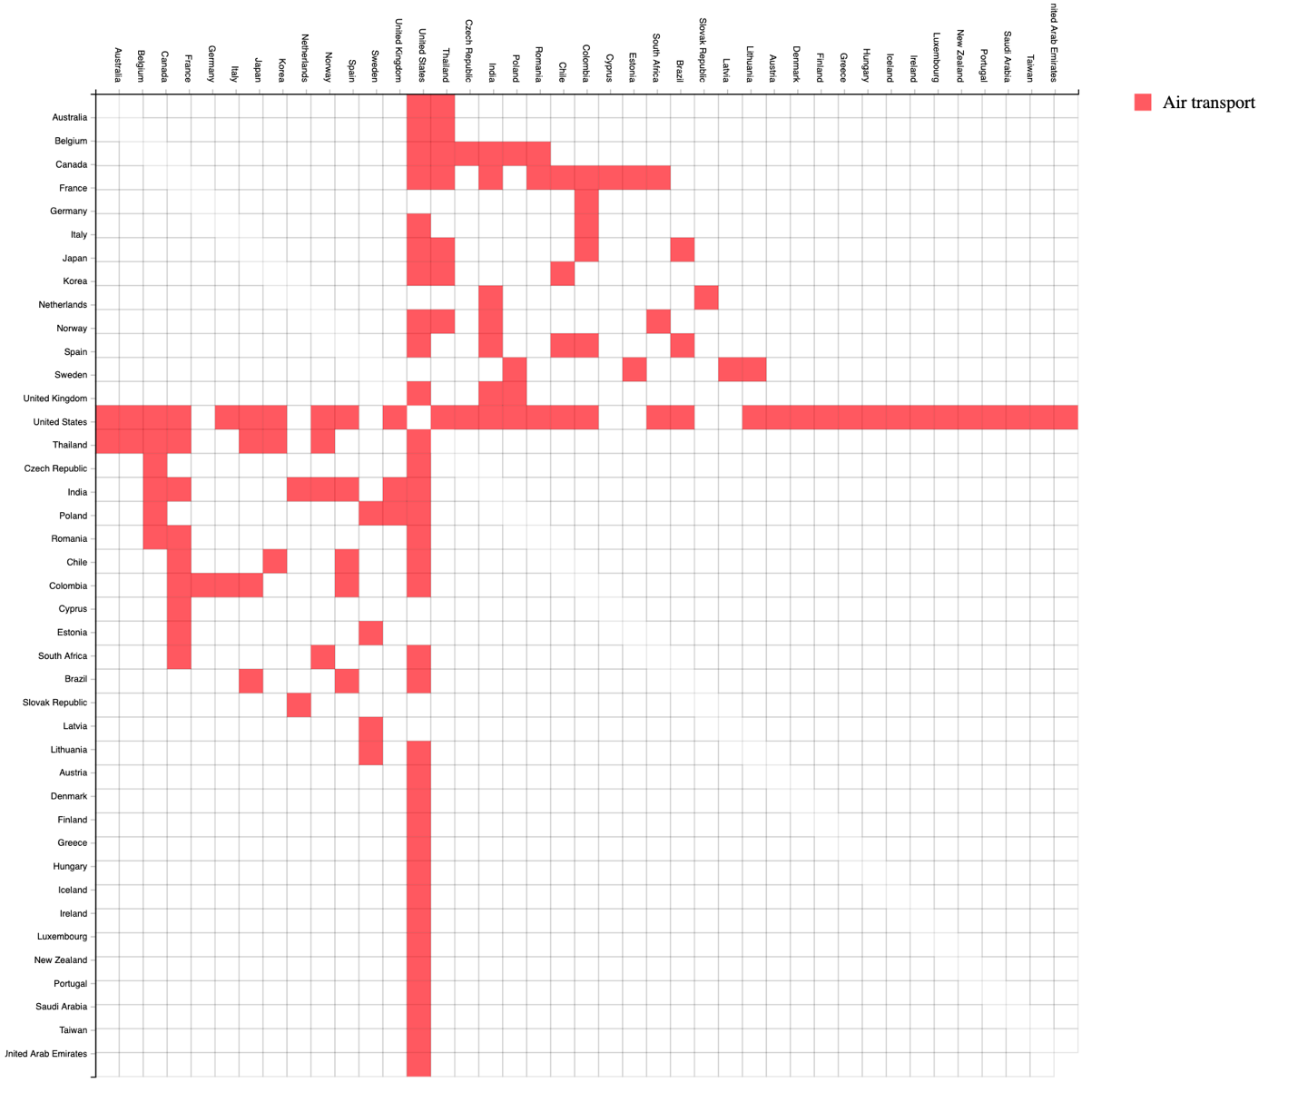

Fig 6. Top 5 purposes of donations – Air Transport

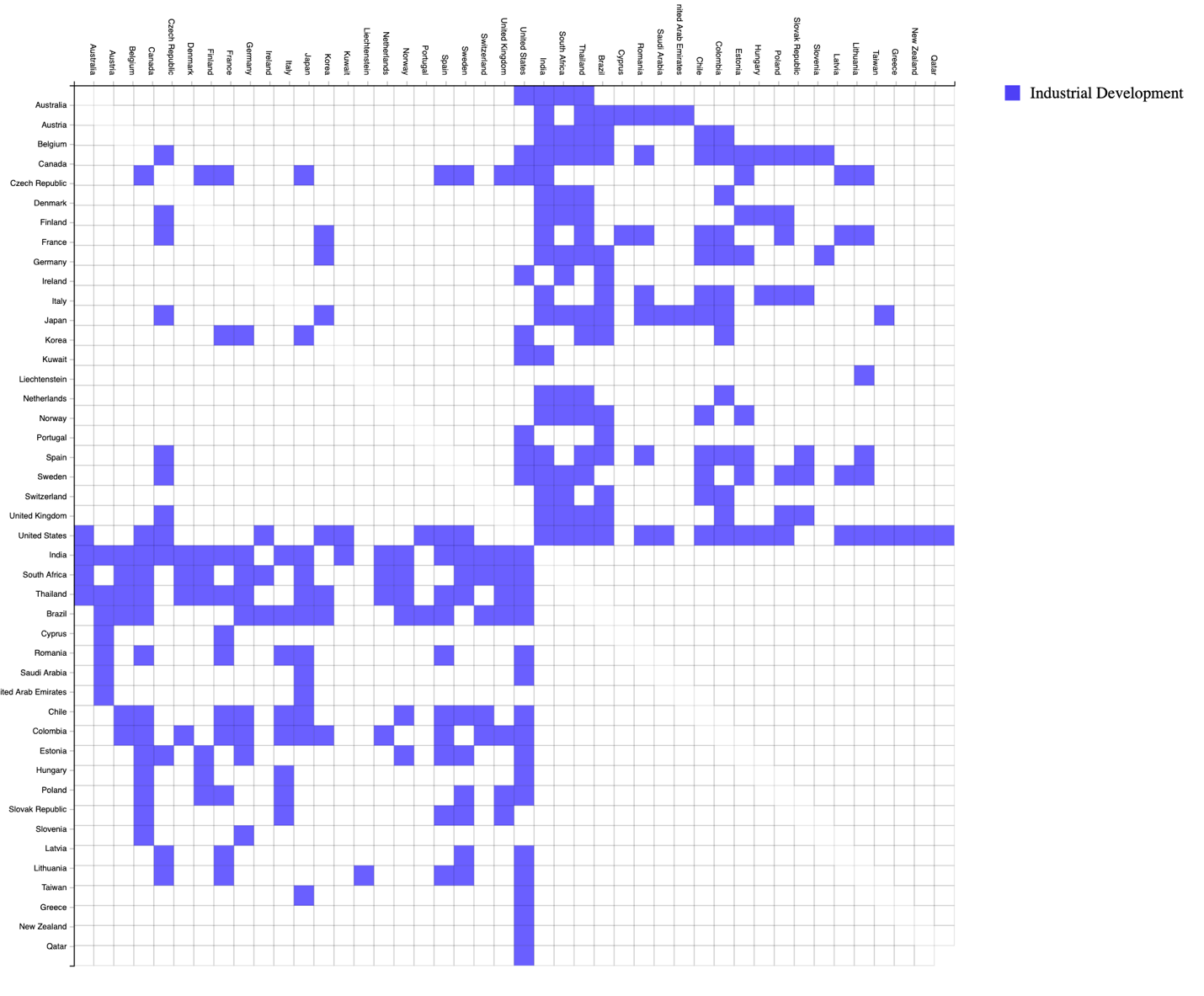

Fig 7. Top 5 purposes of donations – Industrial Development

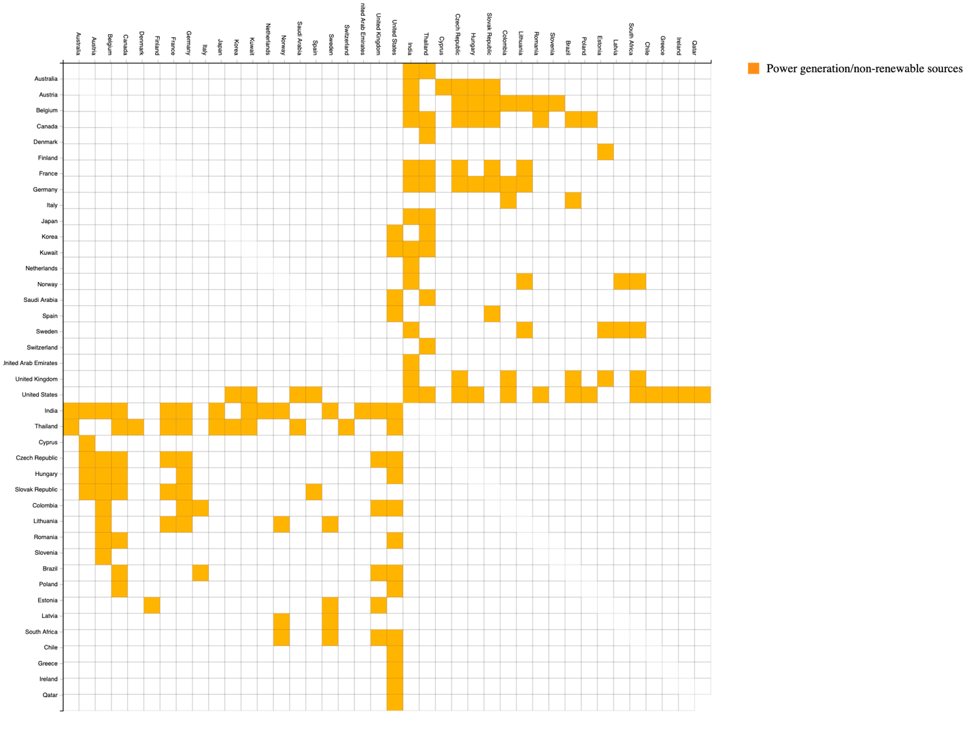

Fig 8. Top 5 purposes of donations – Power generation/non-renewable sources

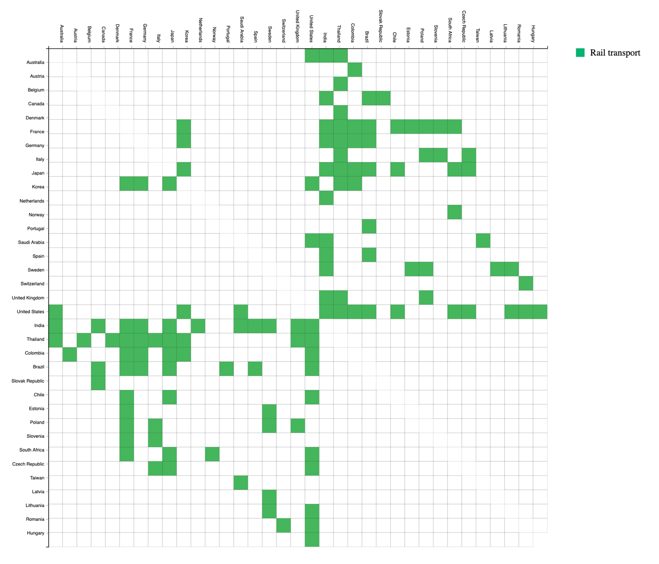

Fig 9. Top 5 purposes of donations – Rail Transport

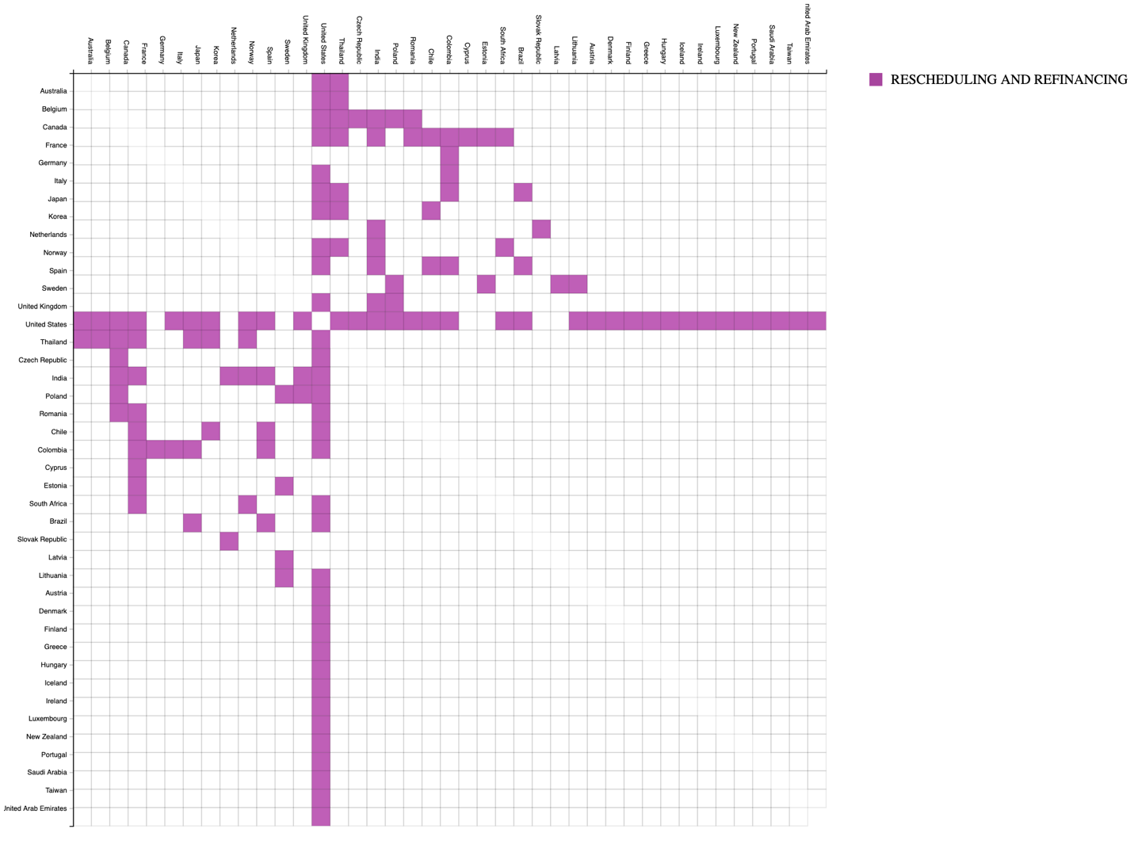

Fig 10. Top 5 purposes of donations – Rescheduling and Refinancing

1) What purposes do countries donate for to other countries?

Countries donate for purposes like ‘Air transport’, ‘Rail transport’, ‘Industrial development’, ‘Rescheduling and Refinancing’ and ‘Power generation/non-renewable sources’.

2) Are there countries that donate to a given country using multiple purposes or do counties always donate using one single purpose when donating to another country?

There are countries that donate to a given country using multiple purposes and there are countries that always donate using one single purpose when donating to another country. We have both the cases in the aiddata. We can get this information by looking at the five adjacency matrices and checking for if a country has donated for multiple purposes for the same country.

Eg. United States has donated to Chile for multiple purposes like Air transport, Industrial development, Power generation/non-renewable sources and Rail transport. France has donated to Korea for multiple purposes like Industrial development and Rail transport.

Countries like Belgium and Germany has donated to Poland for a single purpose – Rescheduling and refinancing.

Adjacency matrix makes it easier to address this problem of multiple donations as we can juxtapose the five adjacency matrices created for each purpose