Yi-Ping Tseng

Uni: yt2690

1. Downloading the neo4j server

2.1. What are some pros and cons of Graph Databases? Please give an example of when you would want to use a graph database, when you would want to use a traditional relational database.

Pros:

really fast queries when you are looking for relationships between nodes

really fast to traverse nodes

Can represent multiple dimensions

Cons:

Inappropriate for transactional information, like accounting records where relationships between records are simpler

Harder to do summing queries and max queries efficiently - counting queries not harder

Usually need to learn a new query language like CIPHER

Fewer vendors to choose from, and smaller user base, so harder to get support when you run into issues

Source: <https://www.quora.com/What-are-the-pros-and-cons-of-using-a-graph-database>

When to use a graph database?

When I need to build a recommendation engine, I will choose to use a graph database. It is important to know the relationship between each user for good recommendations.

When to use a relational database?

If join querying is used frequently, it is a good time to apply a relational database. I will use a relational database to store member information because it is easier for sales and IT to join some member data from different tables to meet their needs.

2.2. Please describe the following terms (2-3 sentences/bullets each):

Nodes: Nodes represent entities or instances such as people, businesses, accounts, or any other item to be tracked. They are roughly the equivalent of a record, relation, or row in a relational database, or a document in a document-store database. (source: <https://en.wikipedia.org/wiki/Graph_database#Labeled-property_graph>)

Labels: A label is a named graph construct that is used to group nodes into sets; all nodes labeled with the same label belongs to the same set. Many database queries can work with these sets instead of the whole graph, making queries easier to write and more efficient to execute. A node may be labeled with any number of labels, including none, making labels an optional addition to the graph. (source: <https://stackoverflow.com/questions/38479361/what-are-labels-in-graph-database>)

Relationships: relationships are the lines that connect nodes to other nodes; representing the relationship between them. Meaningful patterns emerge when examining the connections and interconnections of nodes, properties and edges. The edges can either be directed or undirected. In an undirected graph, an edge connecting two nodes has a single meaning. In a directed graph, the edges connecting two different nodes have different meanings, depending on their direction. Edges are the key concept in graph databases, representing an abstraction that is not directly implemented in a relational model or a document-store model. (source: <https://en.wikipedia.org/wiki/Graph_database#Labeled-property_graph>)

Properties: Properties are information germane to nodes. For example, if Wikipedia were one of the nodes, it might be tied to properties such as website, reference material, or words that starts with the letter w, depending on which aspects of Wikipedia are germane to a given database. (source: <https://en.wikipedia.org/wiki/Graph_database#Labeled-property_graph>)

2.3. What query language does neo4j use? Please list some similarities and differences between this query language and SQL.

**Neo4j uses Cypher.**

Similarities: Both uses `WHERE` to set the selection condition

Difference: The syntaxes are different. SQL uses `SELECT` to query. However, Cyther uses `Match`. In Cyther, we have to add `Return` at the end of query in order to get the result.

3.1 What does the following query return? Run it on your neo4j instance and include a screenshot below.

MATCH (n:Person)-[r:ACTED_IN]->(m:Movie) where n.name='Tom Hanks' return n.name, r.roles, m.title, m.released

3.2 Write a query to return every movie that Kevin Bacon was in between 1990 and 2000. Include your query and screenshot.

MATCH (n:Person)-[r:ACTED_IN]->(m:Movie) where n.name='Kevin Bacon' and m.released > 1990 and m.released < 2000 return n.name, r.roles, m.title, m.released

3.3 Find the director who directed both “The Da Vinci Code” and “Apollo 13”. Include your query and screenshot.

MATCH (n:Person)-[r:DIRECTED]->(m:Movie) where m.title='The Da Vinci Code' or m.title='Apollo 13' return n.name, m.title, m.released

3.4 Generate all of the reviews on “Cloud Atlas” include the name of the reviewer and what they said. Include your query and screenshot.

MATCH (n:Person)-[r:REVIEWED]->(m:Movie) where m.title='Cloud Atlas' return n.name, m.title, r.summary, r.rating

3.5 Find all movies in which someone involved was both a director and an actor. List the names of these people and their movies. There may be more than one person per movie or more than one movie per person! Include your query and screenshot.

MATCH (m:Movie)<-[:ACTED_IN]-(p:Person)-[:DIRECTED]->(m) RETURN p.name, m.title

3.6 Robin Williams wants to have a party with all of his co-actors across all of the movies that he has acted in (his A-list). He orders too much food and realizes he has to extend the guest list to make sure it is all eaten. His B-list of party invites now includes the co-actors of his co-actors. What actors are on the A-list and what actors are on the B-list. Be careful, no actor should be on both lists! Include your query and screenshot.

MATCH (a:Person{name:'Robin Williams'})-[:ACTED_IN]->(m1:Movie)<-[:ACTED_IN]-(A:Person) OPTIONAL MATCH(A:Person) -[:ACTED_IN]->(m2:Movie)<-[:ACTED_IN]-(B:Person) WHERE A.name<>B.name AND m1.title <> m2.title RETURN distinct A.name, B.name

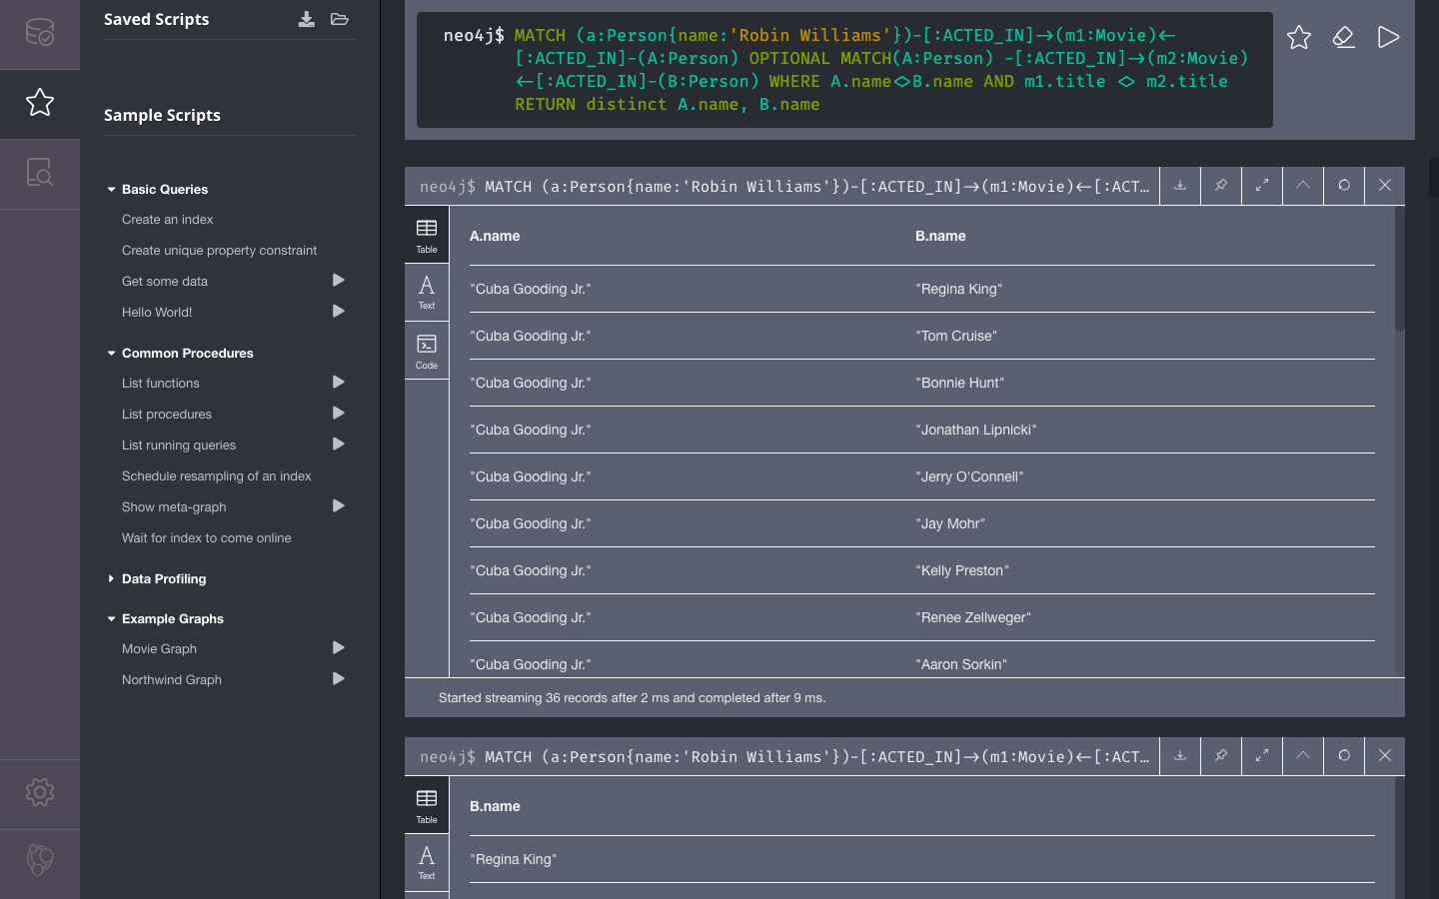

4. For the final portion of the homework, come up with a dataset that you think would be best represented as a graph database. You must include at least two different types of nodes and four different types of relationships and create a database in neo4j! Each node should have at least three properties.

4.1 Why is it better to write this data in a graph database instead of a SQL database?

Logistics data is better to write in graph database because it is easier to analyze the supply chain. The graph database makes it easier to evaluate the distance between nodes. Accordingly, we can give the best route to the drivers.

4.2 Write out the different types of nodes, properties and relationships

|  |  |  |  |
| --- | --- | --- | --- |
| node | Property 1 (purpose) | Property 2 (employee) | Property 3 (location) |
| Factory | Manufacture | Technician | Countryside |
| Warehouse | Store | Logistics officer | Suburb |
| Store | Sale | Sales | City |

Relations:

1. Distance (undirected): the distance between two nodes
2. Delivery capacity (undirected): the delivery capacity between two nodes
3. Demand (directed): the demand of product by one node to another one
4. Return (directed): the return of product by one node to another one

4.3 Write two example queries that someone looking at this dataset might need. Include the queries and the results that they yield.

the location between each node (factory, warehouse, and store)

See whether the delivery capacity covers the demand

MATCH (f:Factory)-[d1:DEMAND]->(w:Warehouse)-[d2:DEMAND]->(s:Store), (f)-[c1:DELIVERY_CAP]->(w)-[c2:DELIVERY_CAP]->(s) RETURN f.location, c1.unit-d1.unit, w.location, c2.unit-d2.unit, s.location

