**Data Analytics Pipeline Homework 1**

**UNI:** hv2197

**Name:** Harish Visweswaran

**Question 1)**

**Hello World Example Tornado App:**

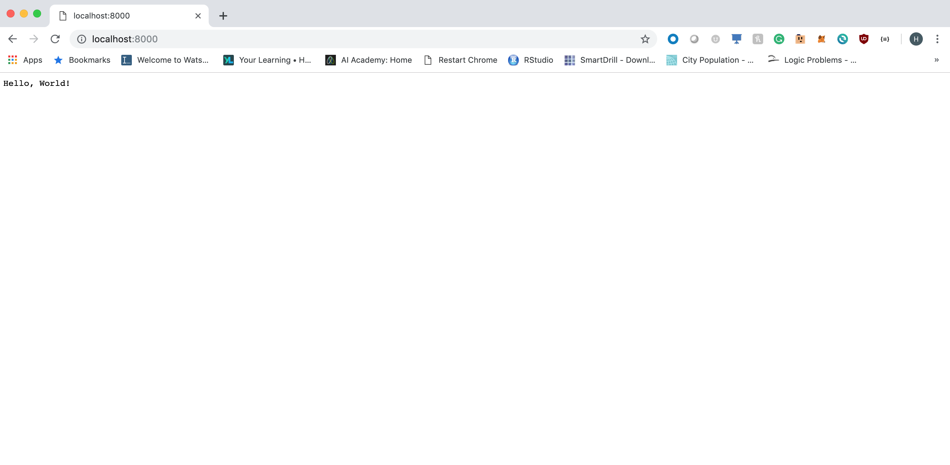

**Question 2)**

**Tornado App with Name Page**

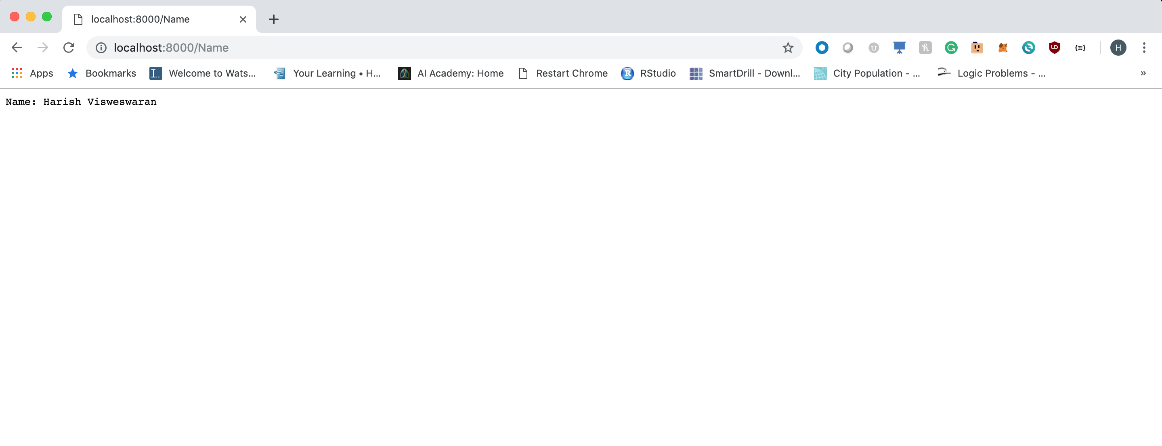

**Script for Question 1 and Question 2:**

import tornado.ioloop

import tornado.web

import logging

class MainHandler(tornado.web.RequestHandler):

def get(self):

self.write("Hello, World!")

class NameHandler(tornado.web.RequestHandler):

def get(self):

self.write("Name: Harish Visweswaran")

class Application(tornado.web.Application):

def __init__(self):

app_settings = {

'default_handler_args': dict(status_code=404),

}

app_handlers = [

(r'^/$', MainHandler),

(r'^/Name$', NameHandler)

]

super(Application, self).__init__(app_handlers, **app_settings)

if __name__ == "__main__":

port = 8000

address = '0.0.0.0'

logging_level = logging.getLevelName('INFO')

logging.getLogger().setLevel(logging_level)

logging.info('starting event logger on %s:%d', address, port)

http_server = tornado.httpserver.HTTPServer(

request_callback=Application(), xheaders=True)

http_server.listen(port, address=address)

tornado.ioloop.IOLoop.instance().start()

**Question 3)**

**Dash App with sample graph and graph of X vs X^2:**

**Screenshot 1:**

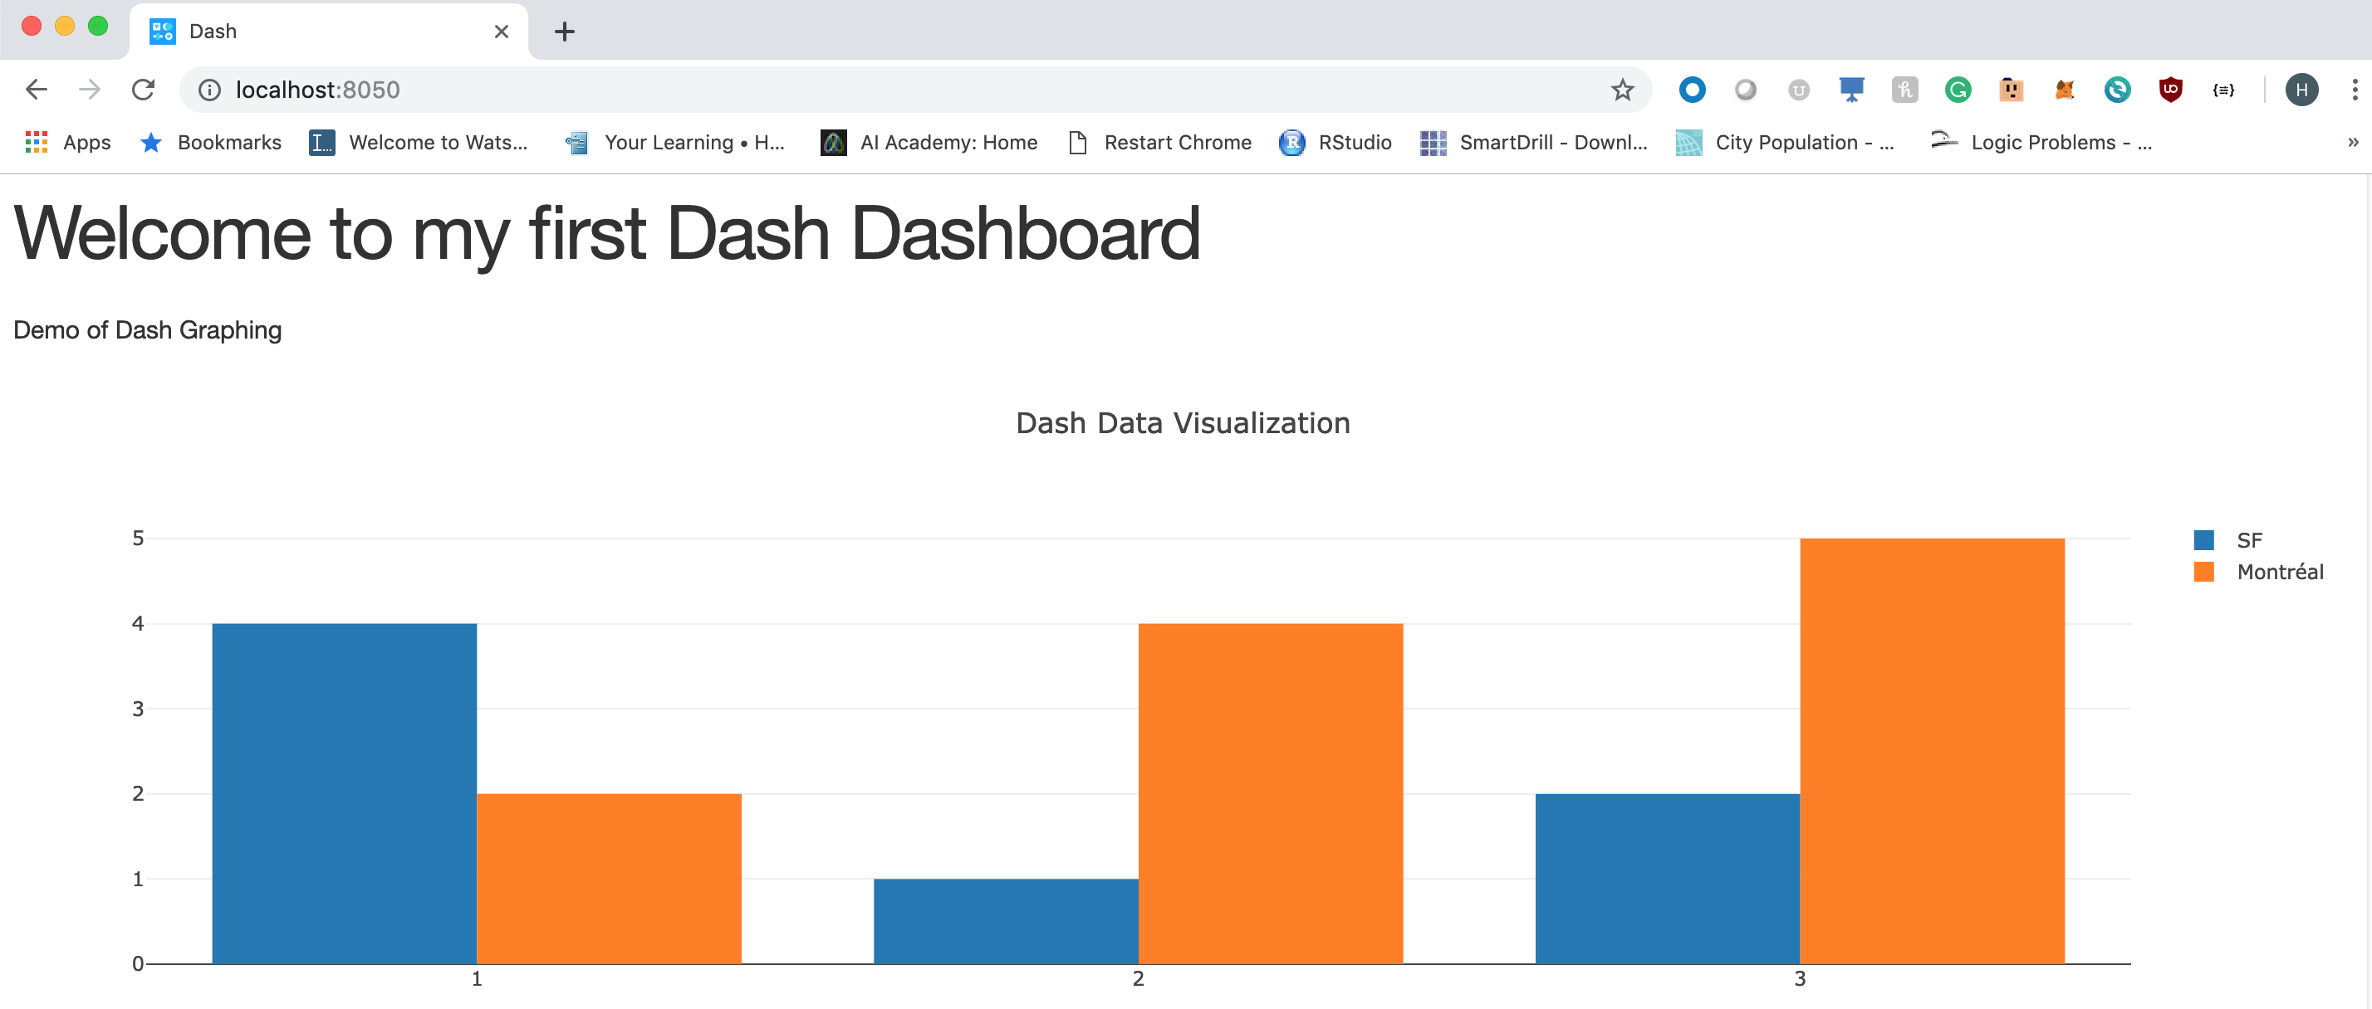

**Screenshot 2:**

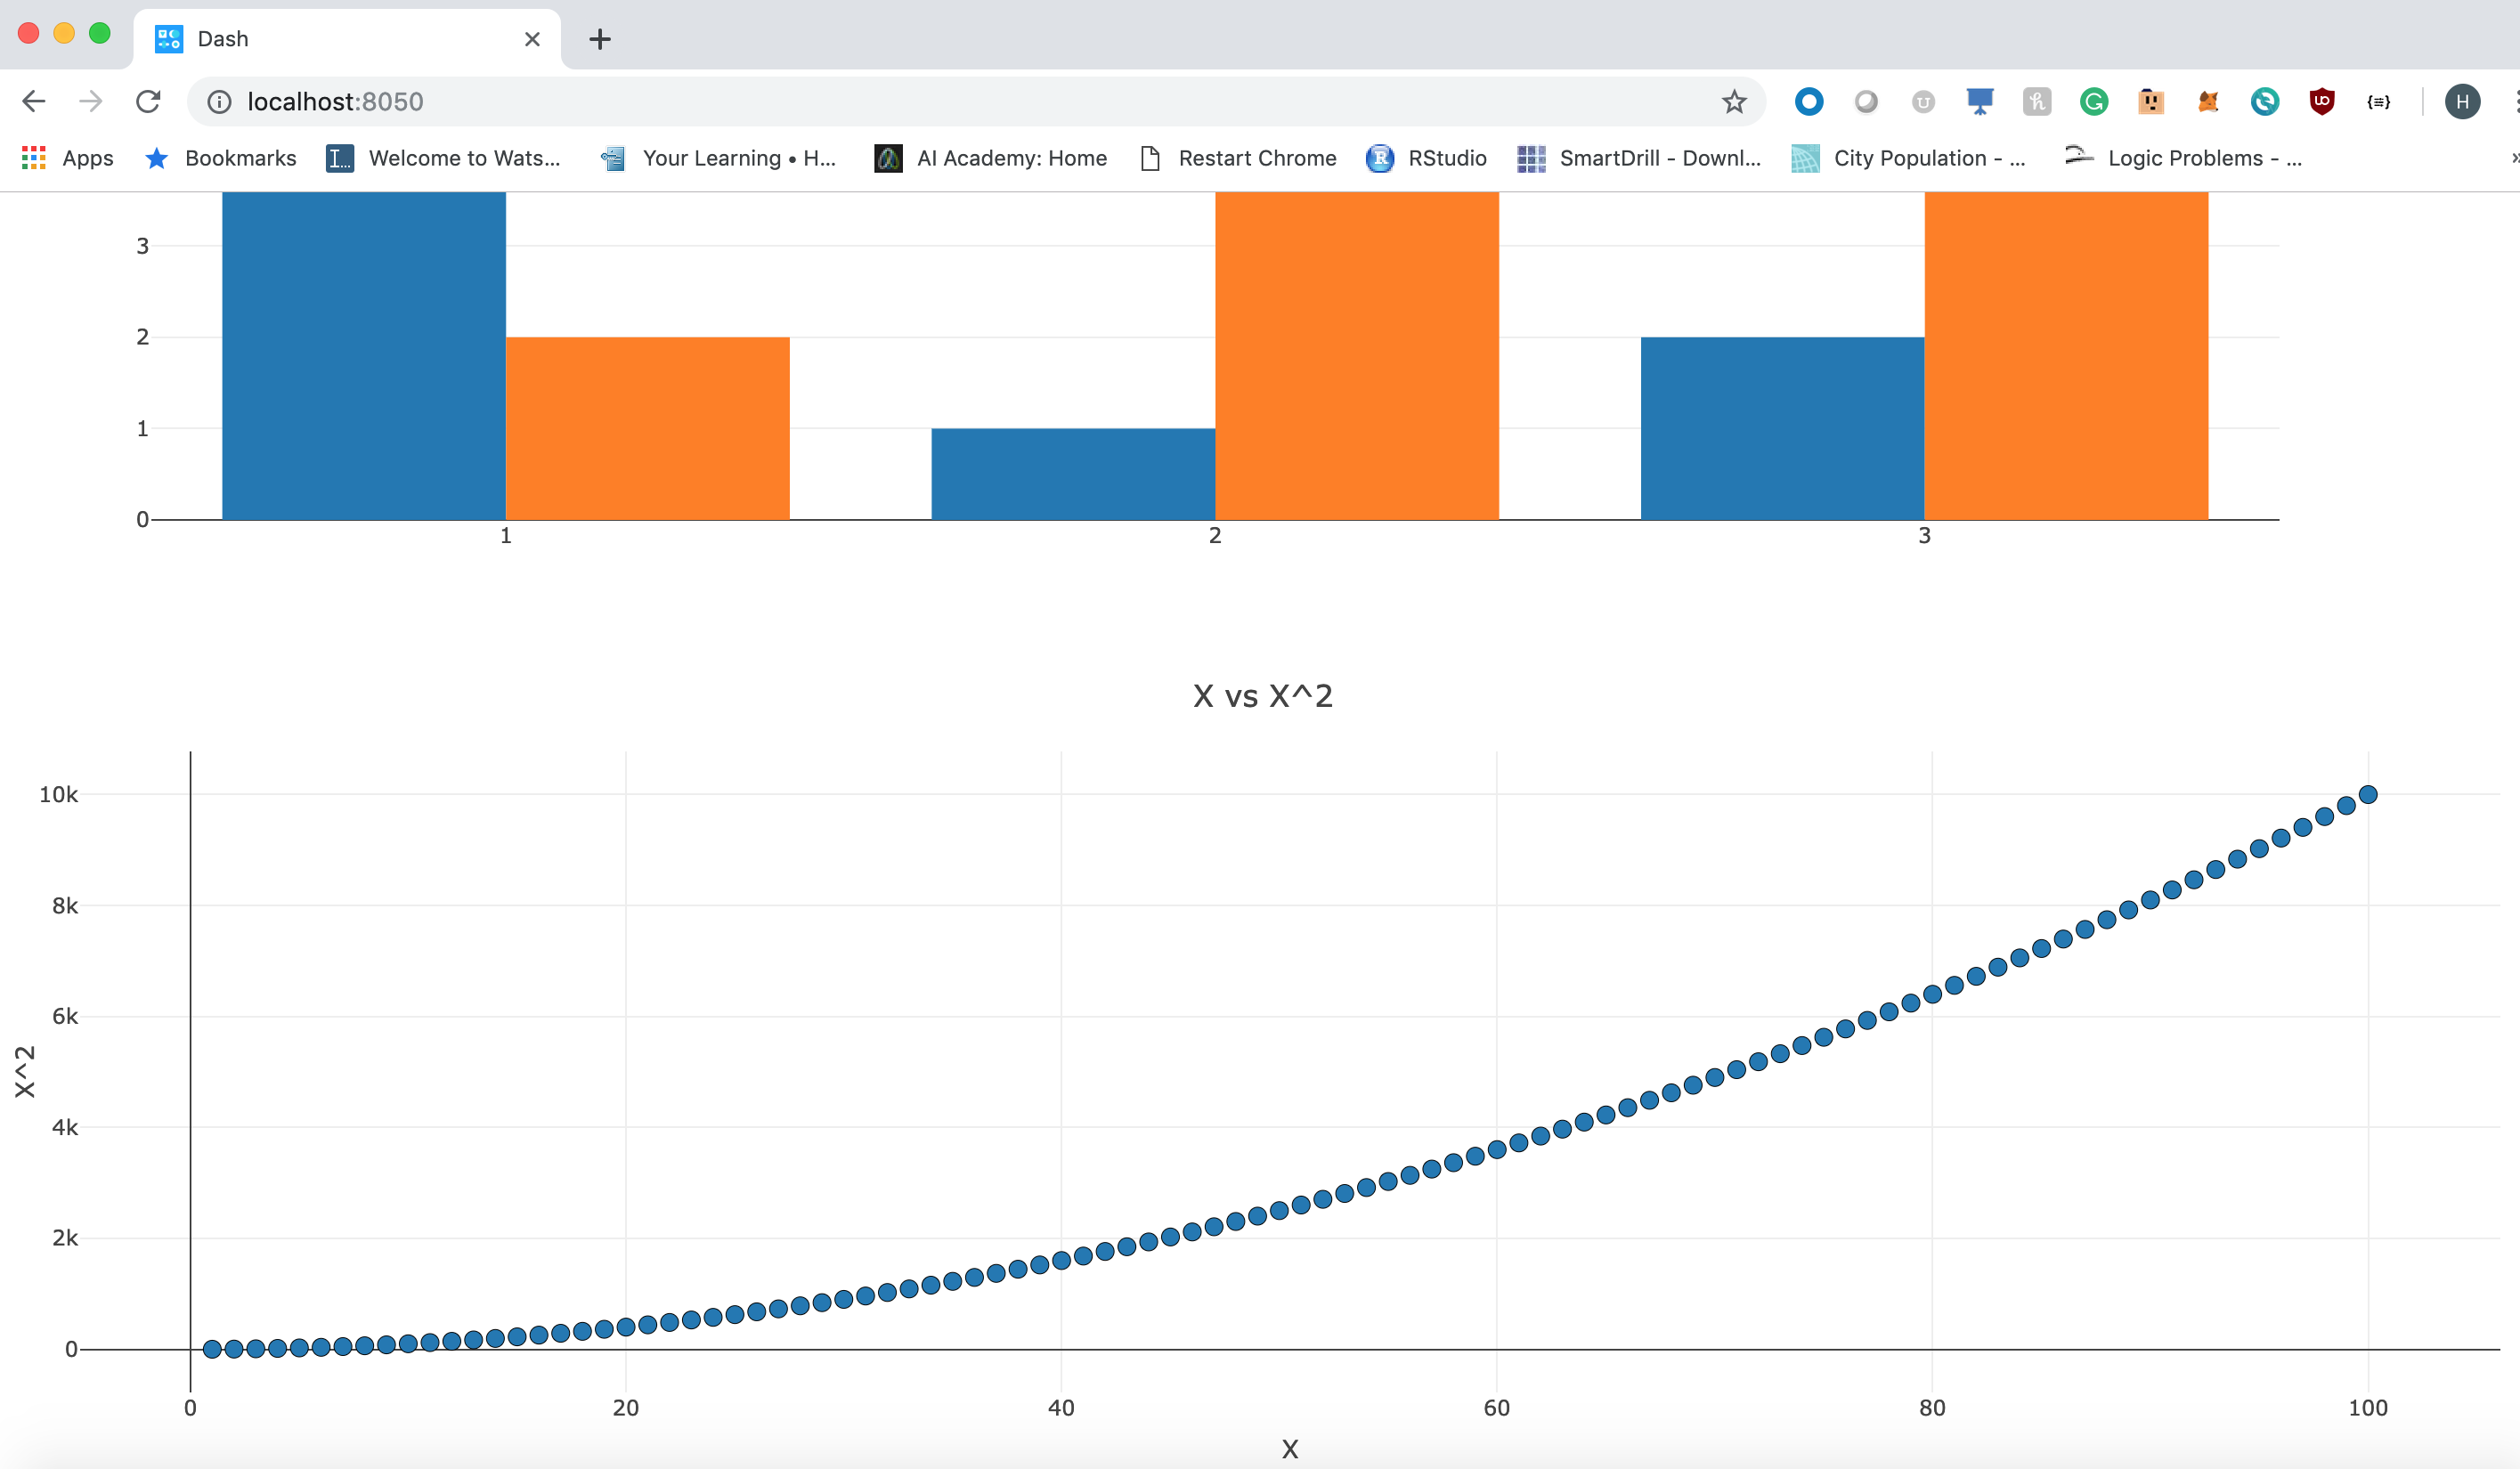

**Script for Question 3:**

import dash

import dash_core_components as dcc

import dash_html_components as html

import plotly.graph_objs as go

external_stylesheets = ['https://codepen.io/chriddyp/pen/bWLwgP.css']

app = dash.Dash(__name__, external_stylesheets=external_stylesheets)

x = list(range(1,101,1))

y = [x_val**2 for x_val in x]

app.layout = html.Div(children=[

html.H1(children='Welcome to my first Dash Dashboard'),

html.Div(children='''

Demo of Dash Graphing

'''

),

dcc.Graph(

id='example-graph',

figure={

'data':[

{'x': [1, 2, 3], 'y': [4, 1, 2], 'type': 'bar', 'name': 'SF'},

{'x': [1, 2, 3], 'y': [2, 4, 5], 'type': 'bar', 'name': u'Montréal'}

],

'layout':{

'title':'Dash Data Visualization'

}

}

),

dcc.Graph(

id='x_vs_x_squared',

figure={

'data':[

go.Scatter(

x=x,

y=y,

mode='markers',

marker={'size':10, 'line':{'width':0.5, 'color':'black'}}

)

# {'x': x, 'y': y, 'type': 'scatter', 'name': 'Scatter'}

],

'layout':

go.Layout(

xaxis={'type': 'linear', 'title': 'X'},

yaxis={'title': 'X^2'},

margin={'l': 40, 'b': 40, 't': 50, 'r': 10},

legend={'x': 0, 'y': 1},

hovermode='closest',

title='X vs X^2'

)

# 'title':'Dash Data Visualization'

}

)

])

if __name__ == '__main__':

app.run_server(debug=True, port=8050)

**Question 4)**

**Docker ps Output running the tornado app:**



**Script for Question 4:**

**Dockerfile:**

FROM python:3.6-slim

COPY . /app

RUN pip3 install --upgrade pip

RUN pip3 install -r /app/requirements.txt

CMD ["python", "/app/tornado_app.py"]