
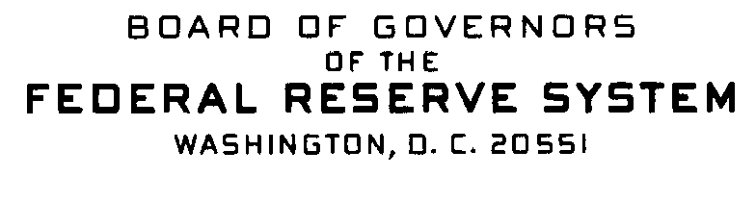


Correspondence Date: February 7, 2007

Dear Sir or Madam:

This notice serves as a reminder of previously announced information that relates to Home Mortgage Disclosure Act (HMDA) data collection for calendar year 2007 that will be reported in 2008.

Exemption threshold:

• The 2007 exemption threshold for depository institutions was changed to $36 million. Thus, depository institutions with assets of $36 million or less as of 12/31/2006 are exempt from 2007 data collection. The exemption thresholds for nondepository institutions have not changed.

Geographic Changes in the 2007 FFIEC Census file:

- Two new MSAs:
  - Lake Havasu City-Kingman, Arizona (MSA 29420, consisting of Mohave County, code 015);
  - Palm Coast, Florida (MSA 37380, consisting of Flagler County, code 035).

- Essex County, Massachusetts Metropolitan Division (MD 21604) was changed to Peabody, Massachusetts Metropolitan Division (code 37764). The only county in MD 37764 is Essex (code 009).

There were no changes to Regulation C or the Staff Commentary (except for the change to the exemption threshold). Therefore, the updates that will be included to the 2007 A Guide to HMDA Reporting: Getting it Right! are the above changes (appendices D and F) as well as clarification changes to appendix G and to pages 1 through 28, where appropriate. These changes to the Guide will be posted in the near future to the Web only.

Any questions or requests for additional information should be directed to:

Assistance Line: Internet E-Mail Address:
(202) 452-2016 hmdahelp@frb.gov

