
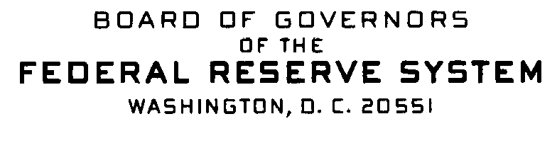

Correspondence Date: May 6, 2011

Dear Sir or Madam:

This notice serves as a reminder of previously announced information that relates to Home Mortgage Disclosure Act (HMDA) data collection for calendar year 2011 that will be reported in 2012.

Exemption threshold:

- The 2011 exemption threshold for depository institutions was changed to $40 million. Thus, depository institutions with assets of $40 million or less as of 12/31/2010 are exempt from 2011 data collection. The exemption thresholds for nondepository institutions have not changed.

Geographic Changes in the 2011 FFIEC Census file:

Three new counties in Alaska were added and two counties were deleted.

Added:
- Wrangell City and Borough (275)
  - Created from part of the former Wrangell-Petersburg Census Area (280) and part of Prince of Wales-Outer Ketchikan Census Area (201) (Meyers Chuck Area)
- Petersburg Census Area (195)
  - Created from the remainder of the former Wrangell-Petersburg Census Area (280)
- Prince of Wales-Hyder Census Area (198)
  - Created from the remainder of the former Prince of Wales-Outer Ketchikan Census Area (201) after part (Outer Ketchikan area) was annexed by Ketchikan Gateway Borough (130) and part (Meyers Chuck area) included in the new Wrangell City and Borough (275)
Deleted:
- Wrangell-Petersburg Census Area (280)
- Prince of Wales-Outer Ketchikan Census Area (201)

The 2010 A Guide to HMDA Reporting: Getting it Right! should be used for guidance on collection and reporting of calendar year 2011 HMDA data that will be reported by March 1, 2012. The Consumer Financial Protection Bureau (CFPB) will be making changes to the next Guide that will be posted to the Web.

Any questions or requests for additional information should be directed to:

Assistance Line: Internet E-Mail Address:
(202) 452-2016 hmdahelp@frb.gov

