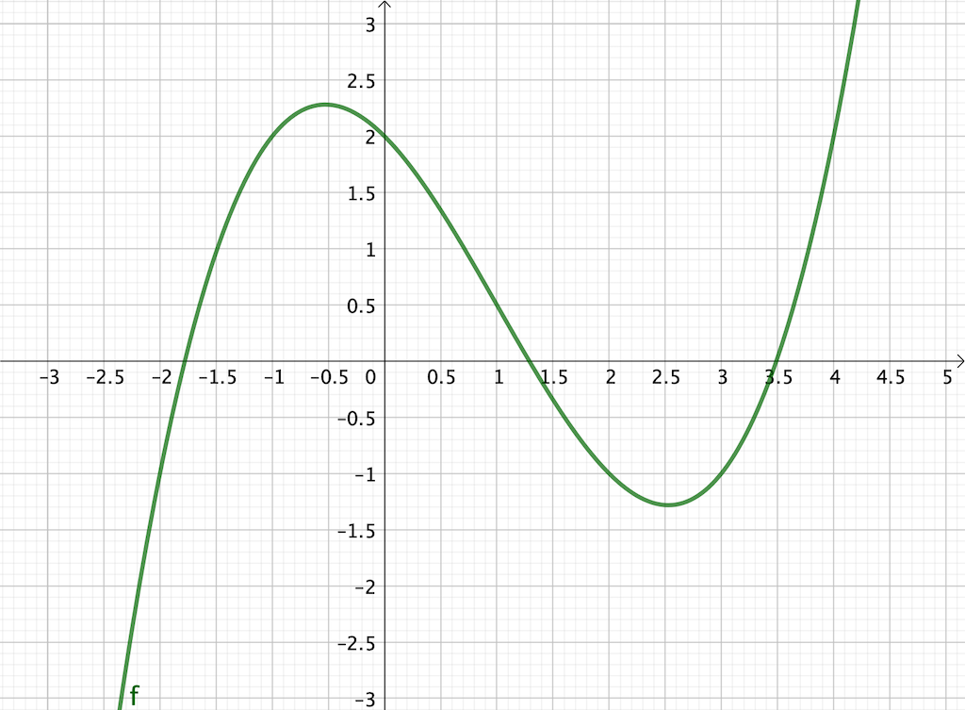

$$f\left(x\right)=\frac{1}{4}x^{3}-\frac{3}{4}x^{2}-x+2$$

|  |  |  |  |
| --- | --- | --- | --- |
| **a** | **b** | **x** | **f(x)** |
|  |  |  |  |
|  |  |  |  |
|  |  |  |  |
|  |  |  |  |
|  |  |  |  |