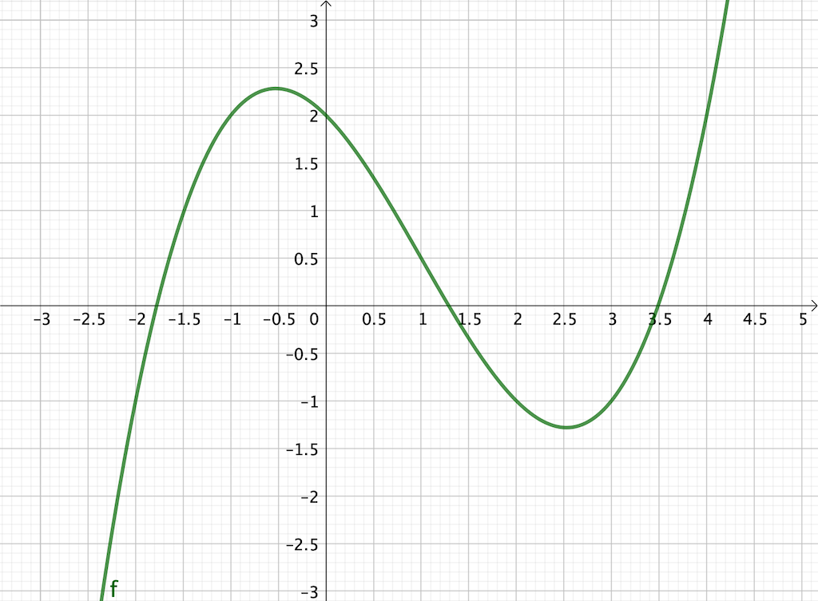

$$f\left(x\right)=\frac{1}{4}x^{3}-\frac{3}{4}x^{2}-x+2$$

|  |  |  |  |  |  |
| --- | --- | --- | --- | --- | --- |
| **a** | **b** | **f(a)** | **f(b)** | **x=(a+b)/2** | **f(x)** |
| 1 | 2 | 0,5 | -1 | 1,5 | -0,34375 |
| 1 | 1,5 | 0,5 | -0,34375 | 1,25 | 0,06641 |
| 1,25 | 1,5 | 0,06641 | -0,34375 | 1,375 | -0,14307 |
| 1,25 | 1,375 | 0,06641 | -0,14307 | 1,3125 | -0,03925 |
| 1,25 | 1,3125 | 0,06641 | -0,03925 | 1,28125 | 0,01337 |
| 1,28125 | 1,3125 | 0,01337 | -0,03925 | 1,296875 | -0,01298 |
| 1,28125 | 1,296875 | 0,01337 | -0,01298 | 1,2890625 | 0,00018 |