Computer organization

&

Assembly language

(Project)

Submitted by:

Name: Muhammad Fahad Shafique

Sap id: 29006

Name: Ali Murad

Sap id: 28948

Riphah School of Computing & Innovation

Faculty of Computing

Riphah International University, Lahore

Spring 2021

**Automatic room**

**Control via Bluetooth using PC or smart phone**

**Project report**

Sap id: 29006

Sap id: 28948

Abstract

The main objective of this project is to develop automatic room control by a PC or smart phone via a Bluetooth. As technology is going advance so houses are also getting smarter. Modern houses are converting to centralized control system form conventional switches with the passage of time. This technology make comfortable for elder person and physical handicapped people to on/off electronic switch in a house.

Introduction

In this modern days, we have remote controls for our television and electronic devices system that’s make our life comfortable and easy. Home automation is best for this condition, automatic room control is the application of home automation. Though this software we can control our room light bulb, Fan and other electronic appliances at home using a remote control. This is very valuable thing for especially elder persons and physically handicapped people. With the help of this software you can control your room lights, fan, television and other electronic appliances. You can turn on/off your room appliances with the help of Bluetooth in your smart phone.

Objective

The main purpose of the project is to design and construct a remote control system that will remotely switch on or off any room appliances connected to it, using a microcontroller, Bluetooth in your smart phone. Another purpose of this project is to implement a low cost, reliable and scalable remote control system that can be used to help people to on/off home appliance without any problem. In corona pandemic many old people and patients in hospital cannot move from their bed in order to switch the fan or fight. This system will be helpful for them. They can switch the fan and light using their mobile phone without any difficulty.

Project description

This project is based on At89C51 microcontroller using Bluetooth to help the user to control any electronic device using control app or Bluetooth in your smart phone. User sends commands to controller- at89c51, through wireless communication names as Bluetooth. The at89c51 microcontroller connected to the main PCB which have 3 relays, these 3 relays connect to 3 different electronic devices in a room. Device one is Fan, Device two is light bulb last but not the least led lights.

When the user press -> “2” it on the FAN

When the user press -> “1” it off the FAN

When the user press -> “4” is on the light BULB

When the user press -> “3” is off the light bULB

When the user press -> “6” is on the led light

When the user press -> “5” is off the led light

When the user press -> “7” is on the all connected devices.

When the user press -> “8” is off the connected devices.

Also the display screen show the running device name. More the buzzer will on and it show the device is on or it is running. We use even numbers to on the devices connect to relays and odd numbers to off the devices.

Microcontroller at89c51

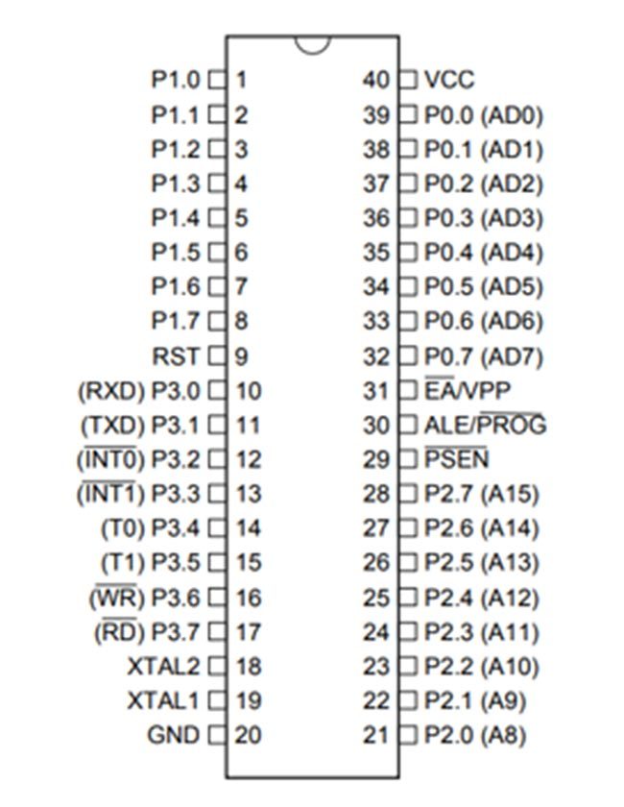

Proteous diagram :

Proteus diagram

Code:

|  |
| --- |
| #include<reg51.h>  sbit rs=P2^0;  sbit en=P2^1;  sbit fan=P2^2;  sbit bulb=P2^3;  sbit led=P2^4;  sbit buzzer=P2^5;    sbit r1 = P3^0;  sbit r2 = P3^7;  sbit r3 = P3^2;  sbit r4 = P3^3;  sbit c1 = P3^4;  sbit c2 = P3^5;  sbit c3 = P3^6;  unsigned int i;  unsigned char a[100];  sfr ldata=0x90;//port1  unsigned char input;  void delay(unsigned int i);  void lcd_cmd(unsigned char a);  void lcd_data(unsigned char b);  void lcd_init(void);  void lcd_str(unsigned char *str);  void clear(void);    void main()  {    buzzer=0;  lcd_init();  lcd_cmd(0x80);  lcd_str(" AUTOMATIC ROOM ");  lcd_cmd(0xc0);  lcd_str(" CONTROL ");  delay(65000);  delay(65000);  delay(65000);    while(1)  {  buzzer=0;  lcd_cmd(0x80);  lcd_str(" PRESS KEYS ");  lcd_cmd(0xc0);  lcd_str(" 1-8 ");  r1 = 0;  if(c1 == 0)  {  lcd_cmd(0x01);  lcd_cmd(0x80);  lcd_str(" FAN is OFF ");  lcd_cmd(0xc0);  fan=1; //fan off  buzzer=1;  delay(5000);  buzzer=0;  delay(65000);  }  if(c2 == 0)  {  lcd_cmd(0x01);  fan=0; //fan on  lcd_cmd(0x80);  lcd_str(" FAN is ONN ");  lcd_cmd(0xc0);  buzzer=1;  delay(5000);  buzzer=0;  delay(65000);  }  if(c3 == 0)  {  // bulb=1; //bulb off    lcd_cmd(0x01);  lcd_cmd(0x80);  lcd_str(" BULB is OFF ");  lcd_cmd(0xc0);  bulb=1; //bulb off  //lcd_str(a);  buzzer=1;  delay(5000);  buzzer=0;  delay(65000);  }  r2 = 0;  r1 = 1;  if(c1 == 0)  {  lcd_cmd(0x01);  lcd_cmd(0x80);  lcd_str(" BULB is on ");  lcd_cmd(0xc0);  bulb=0; // bulb on  //lcd_str(a);  buzzer=1;  delay(5000);  buzzer=0;  delay(65000);  }  if(c2 == 0)  {  // led=1; //led off    lcd_cmd(0x01);  lcd_cmd(0x80);  lcd_str(" led is OFF ");  lcd_cmd(0xc0);  led=1; // led off  buzzer=1;  delay(5000);  buzzer=0;  delay(65000);  }  if(c3 == 0)  {  //led=0; //led on  lcd_cmd(0x01);  lcd_cmd(0x80);  lcd_str(" led is on ");  lcd_cmd(0xc0);  led=0; // led on  buzzer=1;  delay(5000);  buzzer=0;  delay(65000);  }  r3 = 0;  r2 = 1;  if(c1 == 0)  {  lcd_cmd(0x01);  lcd_cmd(0x80);  lcd_str(" Everything is ON ");  lcd_cmd(0xc0);  fan=bulb=led=0; // all r on  buzzer=1;  delay(5000);  buzzer=0;  delay(65000);  }  if(c2 == 0)  {  lcd_cmd(0x01);  lcd_cmd(0x80);  lcd_str(" Everything is off ");  lcd_cmd(0xc0);  fan=bulb=led=1; // all r off  buzzer=1;  delay(5000);  buzzer=0;  delay(65000);    }  if(c3 == 0)  {    }  r4 = 0; r3 = 1;  if(c1 == 0)  {    }  if(c2 == 0)  {    }  if(c3 == 0)  {  }  r4 = 1;  }    }  //program for lcd_init  void lcd_init()  {  lcd_cmd(0x38);  lcd_cmd(0x0c);  lcd_cmd(0x01);  lcd_cmd(0x80);  }  void delay(unsigned int i)  {  unsigned int j,k;  for(j=0;j<i;j++);  for(k=0;k<980;k++);  }  void lcd_cmd(unsigned char a)  {  rs=0;  ldata=a;  en=1;  delay(5);  en=0;  delay(5);  }  void lcd_data(unsigned char b)  {  rs=1;  ldata=b;  en=1;  delay(5);  en=0;  delay(5);  }  void lcd_str(unsigned char *str)  {  while(*str)  {  lcd_data(*str++);  }  } |

Conclusion

The automatic remote control system has been experimentally proven to work satisfactorily by connecting sample appliances to it and the appliances were successfully controlled from a wireless mobile device.