EventSync – Event Management System
BCA / BCA (H) / iMCA Semester V PROJECT REPORT
BACHELORS OF COMPUTER APPLICATIONS
School of Computing
SUBMITTED TO

SUBMITTED BY
Name of Students | University Exam No.
Harsh Darji  Ikrama Kathiyara  Rudra Padhiyar  Fahad Shaikh  Krish Gohil | 2300941038  2300941093  2300941130  2300941233  2301061044

SUPERVISED BY
Sanjana Jaiswal
JG University
November 2025
JG UNIVERSITY
SCHOOL OF COMPUTING
BACHELORS OF COMPUTER APPLICATIONS

CERTIFICATE FROM INTERNAL SUPERVISOR

This is to certify that the project report compiled by Mr __________Darji Harshkumar Sachinkumar__________
student of BCA / BCA (H) / IMCA semester - V School of Computing, JG University, Ahmedabad is done under my guidance. To the best of my knowledge, this work is satisfactorily completed. During the tenure, he was found to be very hard working and sincere. He completed all the tasks assigned and suggested to him.
Comments:
1.

2.

Date: Internal Supervisor Signature
JG UNIVERSITY
SCHOOL OF COMPUTING
BACHELORS OF COMPUTER APPLICATIONS

CERTIFICATE FROM INTERNAL SUPERVISOR

This is to certify that the project report compiled by Mr_____Kathiyara Muhammed Ikrama Usmangani_____
student of BCA / BCA (H) / IMCA semester - V School of Computing, JG University, Ahmedabad is done under my guidance. To the best of my knowledge, this work is satisfactorily completed. During the tenure, he was found to be very hard working and sincere. He completed all the tasks assigned and suggested to him.
Comments:
1.

2.

Date: Internal Supervisor Signature

JG UNIVERSITY
SCHOOL OF COMPUTING
BACHELORS OF COMPUTER APPLICATIONS

CERTIFICATE FROM INTERNAL SUPERVISOR

This is to certify that the project report compiled by Mr________Padhiyar Rudra Siddharthbhai___________
student of BCA / BCA (H) / IMCA semester - V School of Computing, JG University, Ahmedabad is done under my guidance. To the best of my knowledge, this work is satisfactorily completed. During the tenure, he was found to be very hard working and sincere. He completed all the tasks assigned and suggested to him.
Comments:
1.

2.

Date: Internal Supervisor Signature

JG UNIVERSITY
SCHOOL OF COMPUTING
BACHELORS OF COMPUTER APPLICATIONS

CERTIFICATE FROM INTERNAL SUPERVISOR

This is to certify that the project report compiled by Mr___________Shaikh Fahad Ikramuddin_____________
student of BCA / BCA (H) / IMCA semester - V School of Computing, JG University, Ahmedabad is done under my guidance. To the best of my knowledge, this work is satisfactorily completed. During the tenure, he was found to be very hard working and sincere. He completed all the tasks assigned and suggested to him.
Comments:
1.

2.

Date: Internal Supervisor Signature

JG UNIVERSITY
SCHOOL OF COMPUTING
BACHELORS OF COMPUTER APPLICATIONS

CERTIFICATE FROM INTERNAL SUPERVISOR

This is to certify that the project report compiled by Mr___________Gohil Krish Jonibhai______________
student of BCA / BCA (H) / IMCA semester - V School of Computing, JG University, Ahmedabad is done under my guidance. To the best of my knowledge, this work is satisfactorily completed. During the tenure, he was found to be very hard working and sincere. He completed all the tasks assigned and suggested to him.
Comments:
1.

2.

Date: Internal Supervisor Signature

JG UNIVERSITY
SCHOOL OF COMPUTING
BACHELORS OF COMPUTER APPLICATIONS

DECLARATION

We hereby declare that the project entitled “EventSync – Event Management System” submitted for the Minor project BCA / BCA (H) / IMCA semester - V is our original work and the project has not formed the basis for the award of any degree or any other similar titles in any other University.

Signature of the Student:

Place:
Date:

ACKNOWLEDGEMENT

With immense pleasure, We present this report on the project title of “EventSync – Event Management System” developed as a partial fulfilment of requirements of BCA / BCA (H) / iMCA [SEM - V] at School of Computing, JG University.

We express my heartfelt thanks to our internal project guide Sanjana Jaiswal for her continuous support and guidance throughout the project. She provided us the wealth of technical Knowledge as well as Web Development Technology knowledge, which helped us, a lot during our project.

We extend whole hearted thanks to faculties of School of Computing especially Dr. S. Pushpalatha, for providing all facilities, valuable suggestion and constant supervision for the successful completion of the project.
- Harsh Darji
- Ikrama Kathiyara
- Fahad Shaikh
- Rudra Padhiyar
- Krish Gohil

INDEX

Contents | Page No.
Chapter 1: INTRODUCTION & PROBLEM STATEMENT
Problem Definition / Problem Abstract
Chapter 2: LITERATURE REVIEW
- Current System and its Drawbacks
- Proposed System and its features
- Scope of the Project
- Technical Specification
- Process Model
Chapter 3: REQUIREMENT ANALYSIS & DESIGN
- Gantt Chart
- Modules and Sub Modules
- System Side (Flowchart Diagrams)
  - Use Case Diagram
  - Class Diagram
- Data Dictionary
Chapter 4: SOFTWARE DESIGN & IMPLEMENTATION
(With Screen Shots)
- Screens / User Interface
- Code Snippets
- Reports

Chapter 5: CONCLUSION
Chapter 6: FUTURE ENHANCEMENT
References

Chapter 1: INTRODUCTION & PROBLEM STATEMENT

  - Introduction :

- EventSync is a web-based venue booking system designed to simplify the process of managing, scheduling, and tracking events.

- The system provides a structured and secure platform for users to create accounts, log in, and interact with event-related services.

1.2 Problem Definition :
- Organizing events such as weddings or birthdays involves multiple tasks like registration, venue booking, scheduling, and communication with participants.
- When these activities are managed manually, it often leads to errors, time delays, miscommunication, and data loss.

Chapter 2: LITERATURE REVIEW

2.1 Current System :
- venue organizers maintain information such as guest lists, bookings, schedules, and payments using paperwork, spreadsheets, or phone communication.

2.2 Drawbacks :
- Manual record keeping prone to errors.
- Lack of centralized user authentication.
- Difficulty in managing event data securely.
- Limited scalability and adaptability to different use cases.

2.3 Features :
- User registration and authentication.
- Venue booking
- Centralized booking management and scheduling.
- Database-driven design with MySQL.
- Role-based user access (admin, user).
- Responsive and accessible web interface.

2.4 Scope of the project :
- provide a centralized online platform for planning, organizing, and managing various types of events.
- The system allows admins, organizers, and users to manage event details efficiently — including registration, venue booking, scheduling, and communication.
- It will help automate the entire process, reduce manual effort, and improve coordination between organizers and participants.

2.5 Technical Specification :

Software : Hardware:
- HTML Minimum requirements:
- CSS Device : Any PC, Laptop, or
- Javascript smartphone
- MySQL Processor : 1GHz or faster
- Node.js RAM : 2 GB
Storage : ~200MB
Internet : At least 2 Mbps (~256KBps)

2.6 Process Model :
  - Requirement Analysis : Identify user needs: Create Booking, Cancel Booking
  - System Design : Design pages, forms, and database tables.
  - Implementation : Build the website using HTML, CSS, JS, MySQL and NodeJS.
  - Testing : Check Booking creation , cancellation and update.
  - Feedback & Improvement : Add categories, graphs, and other enhancements.
  - Deployment & Maintenance : Make website live and update regularly.

Chapter 3: REQUIREMENT ANALYSIS & DESIGN
3.1 Gantt Chart :
Activity | Duration (Weeks) | August |  |  |  | September |  |  |  | October |  |  |  | November
 |  | w-1 | w-2 | w-3 | w-4 | w-1 | w-2 | w-3 | w-4 | w-1 | w-2 | w-3 | w-4 | w-1 | w-2 | w-3 | w-4
Requirement Analysis | 2
System Design | 2
Database Design & Setup | 3
Implementation (Coding) | 4
Testing & Debugging | 2
Deployment & Documentation | 2

3.2 Modules and Sub Modules :
1. User Module:
User registration
Login/logout
Book Venues
Make Payment
Session management.
2. Database Module
Create and update bookings
Event scheduling
Event tracking.
3. Admin Module
User Management
Venue Management

3.3 System Side (Flowchart Diagrams)
(A) Use Case Diagram
1) User UseCase
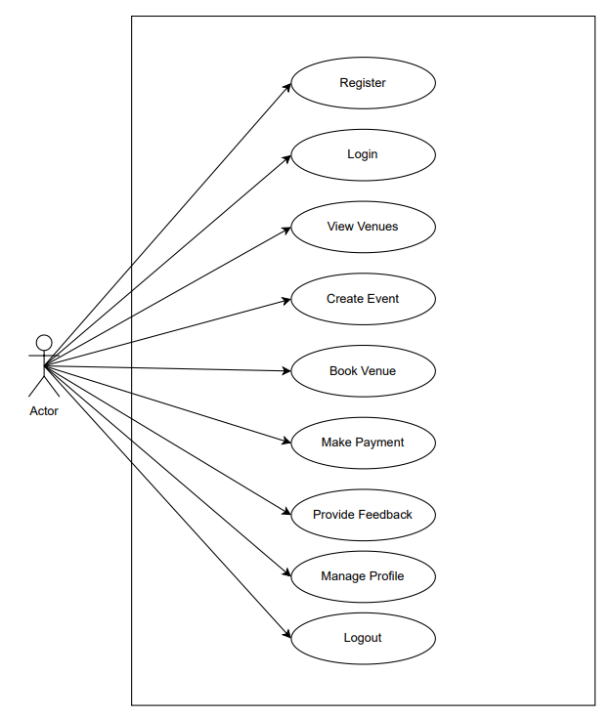

2) Admin UseCase

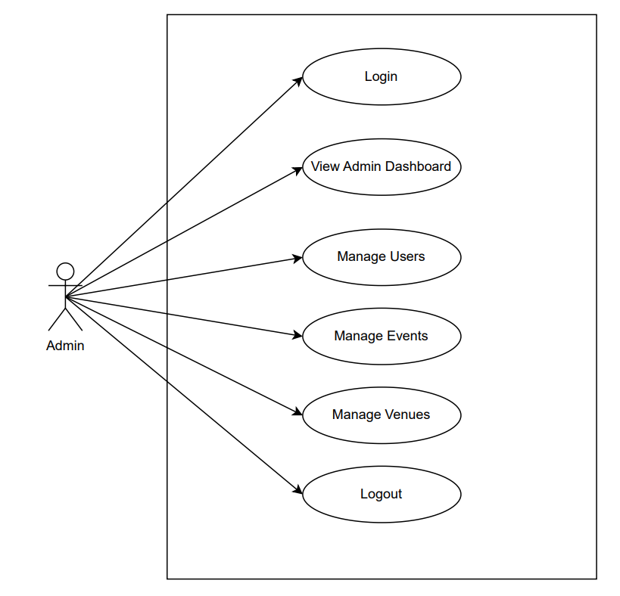
(B) Class Diagram

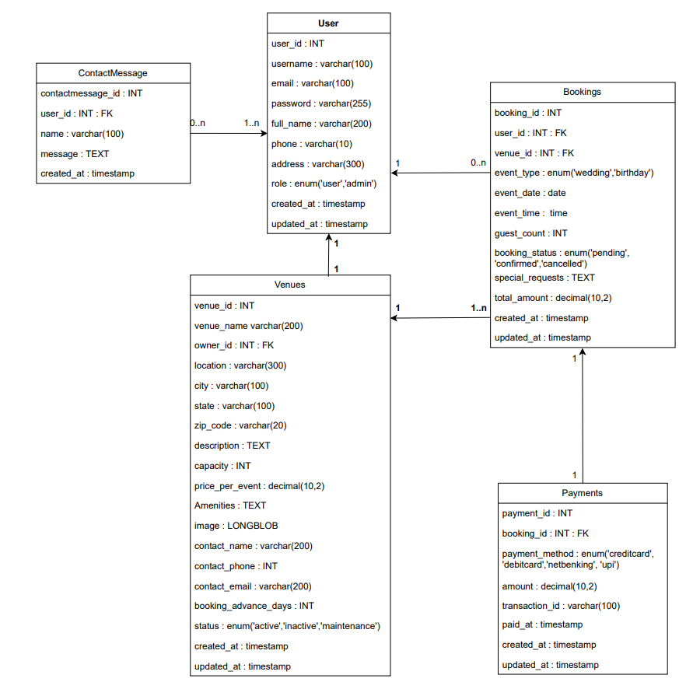
3.4 Data Dictionary :

Users
User_id | INT | NOT_NULL | PRIMARY_KEY | Unique identifier for each user.
Userame | VARCHAR(100) | NOT_NULL | - | Userame of the user.
Email | VARCHAR(255) | NOT_NULL | UNIQUE | Unique email address.
Password | VARCHAR(255) | NOT_NULL | - | Encrypted User Password.
Full_Name | VARCHAR(200) |  | - | Full Name of the user.
Phone | VARCHAR(10) |  | - | Contact Number of the user.
Address | VARCHAR(300) |  | - | Address of the user.
Role | ENUM(‘user’ ,‘admin’) |  | DEFAULT(‘user’) | Defines User Role(User,Admin).
Created_At | TIMESTAMP |  | DEFAULT(CURRENT_TIMESTAMP) | Record Creation Timestamp.
Updated_At | TIMESTAMP |  | DEFAULT(CURRENT_TIMESTAMP) | Record update Timestamp

ContactMessages
Contactmessage_id | INT | NOT_NULL | PRIMARY_KEY | Unique identifier for  each contact message.
user_id | INT | NOT_NULL | FOREIGN_KEY  User(User_id) | ID of the user who contacted
Name | VARCHAR(100) | NOT_NULL | - | Name of the person  sending the message.
Message | TEXT | NOT_NULL | - | The actual message content.
Created_At | TIMESTAMP |  | DEFAULT(CURRENT_TIMESTAMP) | Timestamp when the  message was created  (Default = Current time)

Bookings
Booking_id | INT | NOT_NULL | PRIMARY_KEY | Unique ID for each booking.
User_id | INT | NOT_NULL | FOREIGN_KEY  User(User_id) | ID of the user who made the booking (foreign key).
Venue_id | INT | NOT_NULL | FOREIGN_KEY  Venue(Venue_id) | ID of the venue being booked (foreign key).
Event_type | ENUM('Wedding', 'Birthday') | NOT_NULL | - | Type of event (Wedding/Birthday).
Event_Date | DATE | NOT_NULL | - | Date of the event.
Event_Time | TIME | NOT_NULL | - | Time of the event.
Guest_Count | INT | NOT_NULL | - | Number of guests expected.
Booking_Status | ENUM('Pending', 'Confirmed', 'Cancelled',) |  | DEFAULT ('Pending') | Current status of booking (Pending/Confirmed/Cancelled).
Special_Requests | TEXT |  | - | Additional requests from the user.
Total_Amount | DECIMAL(10, 2) | NOT_NULL | - | Total cost of the booking.
Created_at | TIMESTAMP |  | DEFAULT (CURRENT_TIMESTAMP) | Timestamp when the booking record was created.
Updated_at | TIMESTAMP |  | DEFAULT (CURRENT_TIMESTAMP) | Timestamp when the record was last updated.

Venues
Venue_id | INT | NOT_NULL | PRIMARY_KEY | Unique ID for each venue.
Venue_name | VARCHAR(200) | NOT_NULL | - | Name of the venue.
Owner_id | INT | NOT_NULL | FOREIGN_KEY  User(User_id) | ID of the user who owns the venue (foreign key).
Location | VARCHAR(300) | NOT_NULL | - | Full address/location of the venue.
City | VARCHAR(100) |  | - | City where the venue is located
State | VARCHAR(100) |  | - | State where the venue is located.
Zip_Code | VARCHAR(20) |  | - | Postal/ZIP code of the venue.
Description | TEXT |  | - | Detailed information about the venue.
Capacity | INT | NOT_NULL | - | Maximum number of guests the venue can hold.
Price_per_event | DECIMAL(10, 2) | NOT_NULL | - | Cost to book the venue for an event.
Image | LONGBLOB |  | - | URLs of venue image
Contact_Name | VARCHAR(200) |  | - | Name of the contact person for the venue.
Contact_Phone | INT |  | - | Phone number of the contact person.
Contact_Email | VARCHAR(200) |  | - | Email of the contact person.
Available_Dates | TEXT |  | - | Dates when the venue is available.
Booking_Advance_Days | INT |  | DEFAULT(30 Days) | Days before the event that booking must be made (default 30 Days).
Status | ENUM('active', 'inactive', 'maintenance') |  | DEFAULT ('active’) | Current venue status (active/inactive/maintenance).
Created_at | TIMESTAMP |  | DEFAULT (CURRENT_TIMESTAMP) | Timestamp when the booking record was created.
Updated_at | TIMESTAMP |  | DEFAULT (CURRENT_TIMESTAMP) | Timestamp when the record was last updated.

Payments
Payment_id | INT | NOT_NULL | PRIMARY_KEY | Unique ID for each payment.
Booking_id | INT | NOT_NULL | FOREIGN KEY  Booking(booking_id) | Links payment to a booking (foreign key).
Payment_method | ENUM('Credit_card', 'Debit_card', 'Net_banking', 'UPI') |  | DEFAULT ('Credit_card') | Mode of payment used (Credit card, UPI, etc.).
Payment_status | ENUM('Pending', 'Completed', 'Failed', 'Refunded') |  | DEFAULT ('Pending') | Current state of payment (Pending, Completed, etc.).
Amount | DECIMAL(10, 2) | NOT_NULL | - | Total payment amount.
Transaction_id | VARCHAR(100) |  | - | Unique transaction reference number.
Paid_at | TIMESTAMP |  | - | Time when payment was made.
Created_at | TIMESTAMP |  | DEFAULT (CURRENT_TIMESTAMP) | Record creation timestamp.
Updated_at | TIMESTAMP |  | DEFAULT (CURRENT_TIMESTAMP) | Record update timestamp.

Chapter 4: SOFTWARE DESIGN & IMPLEMENTATION (With Screen Shots)

4.1 Screens / User Interface
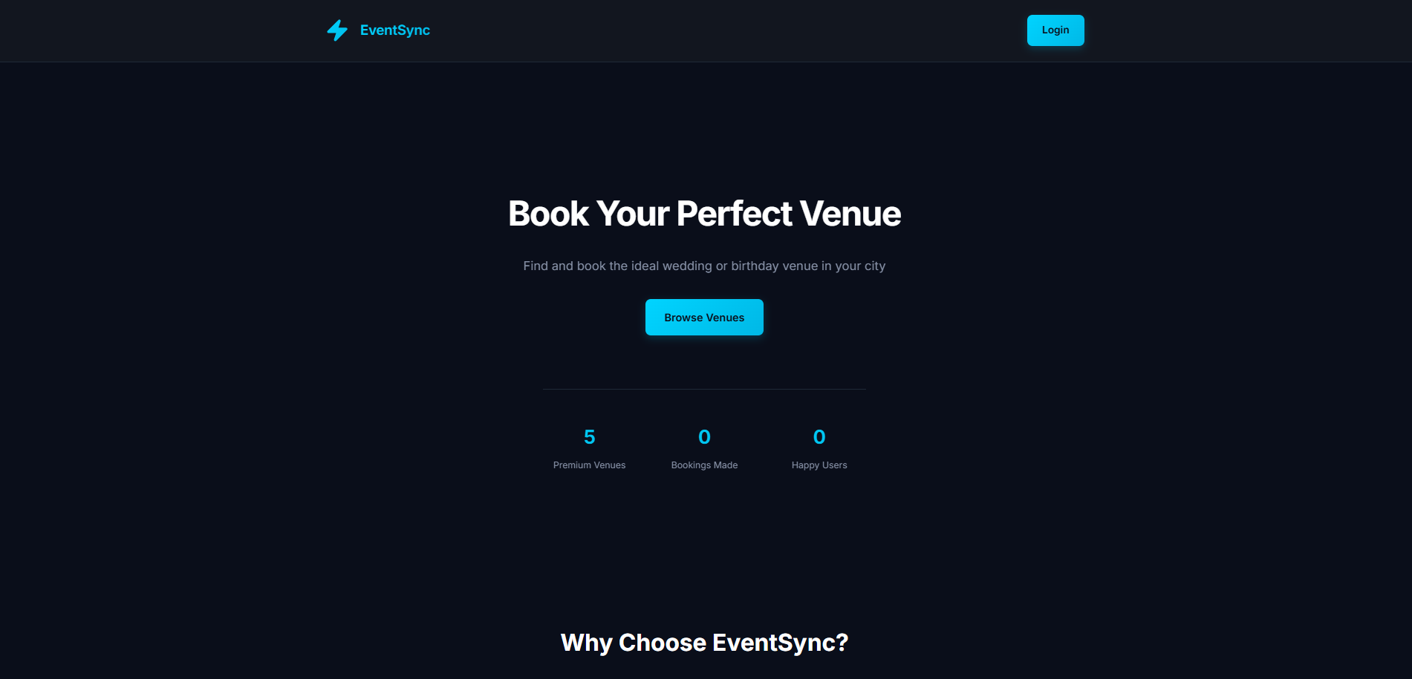
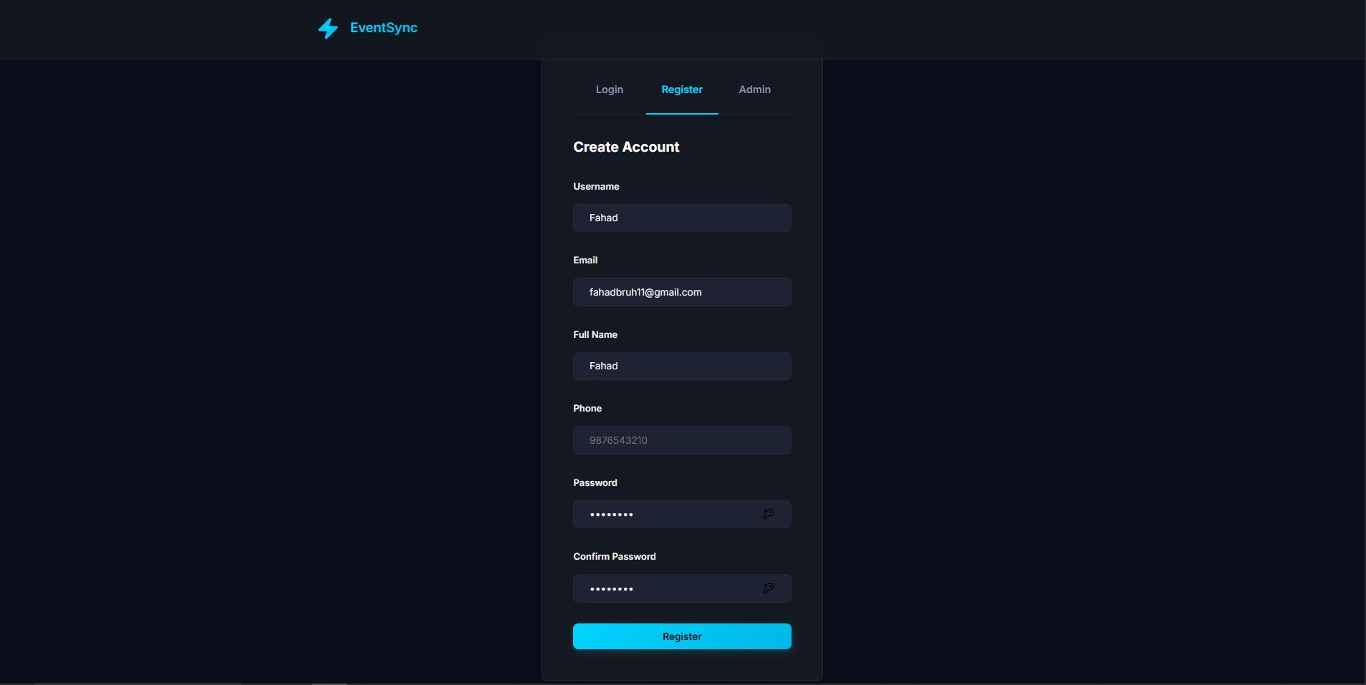
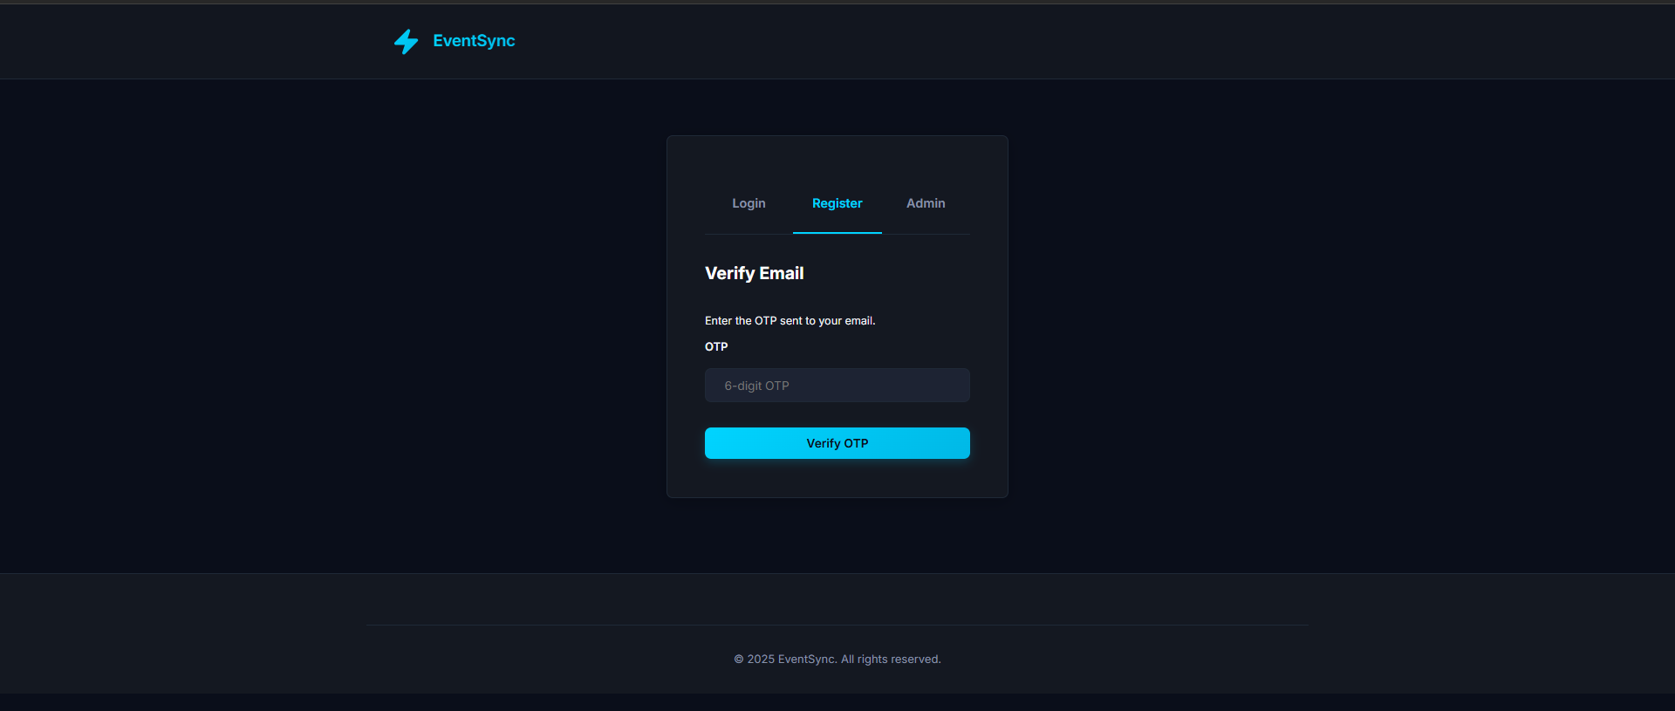
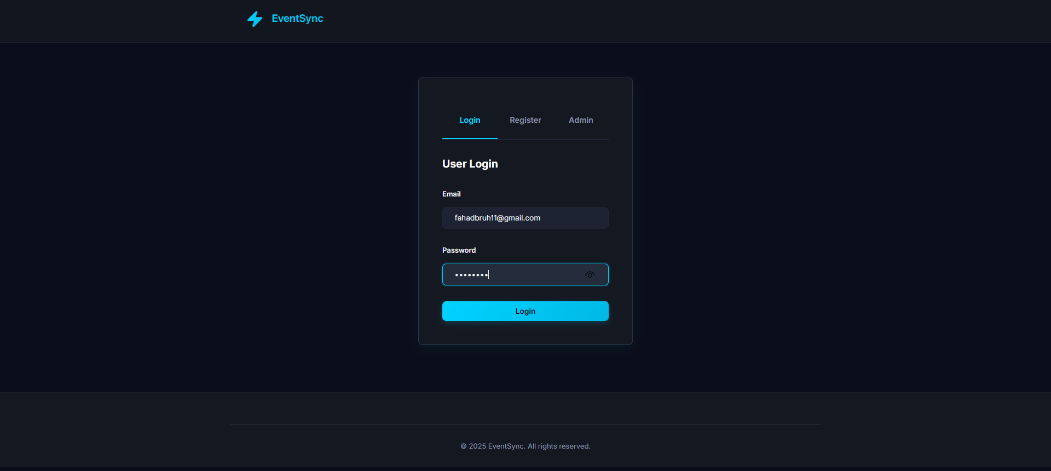
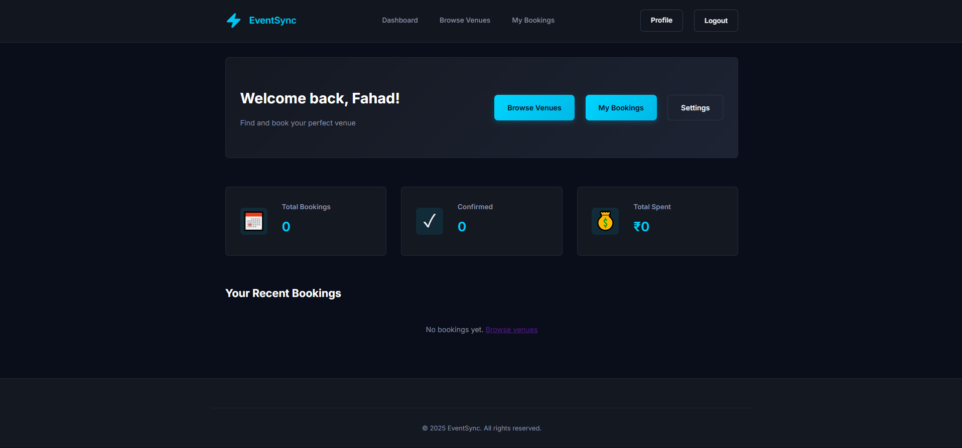
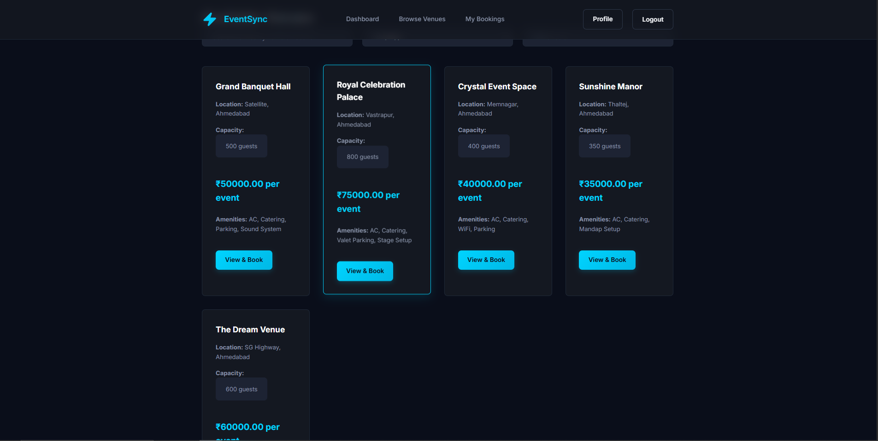
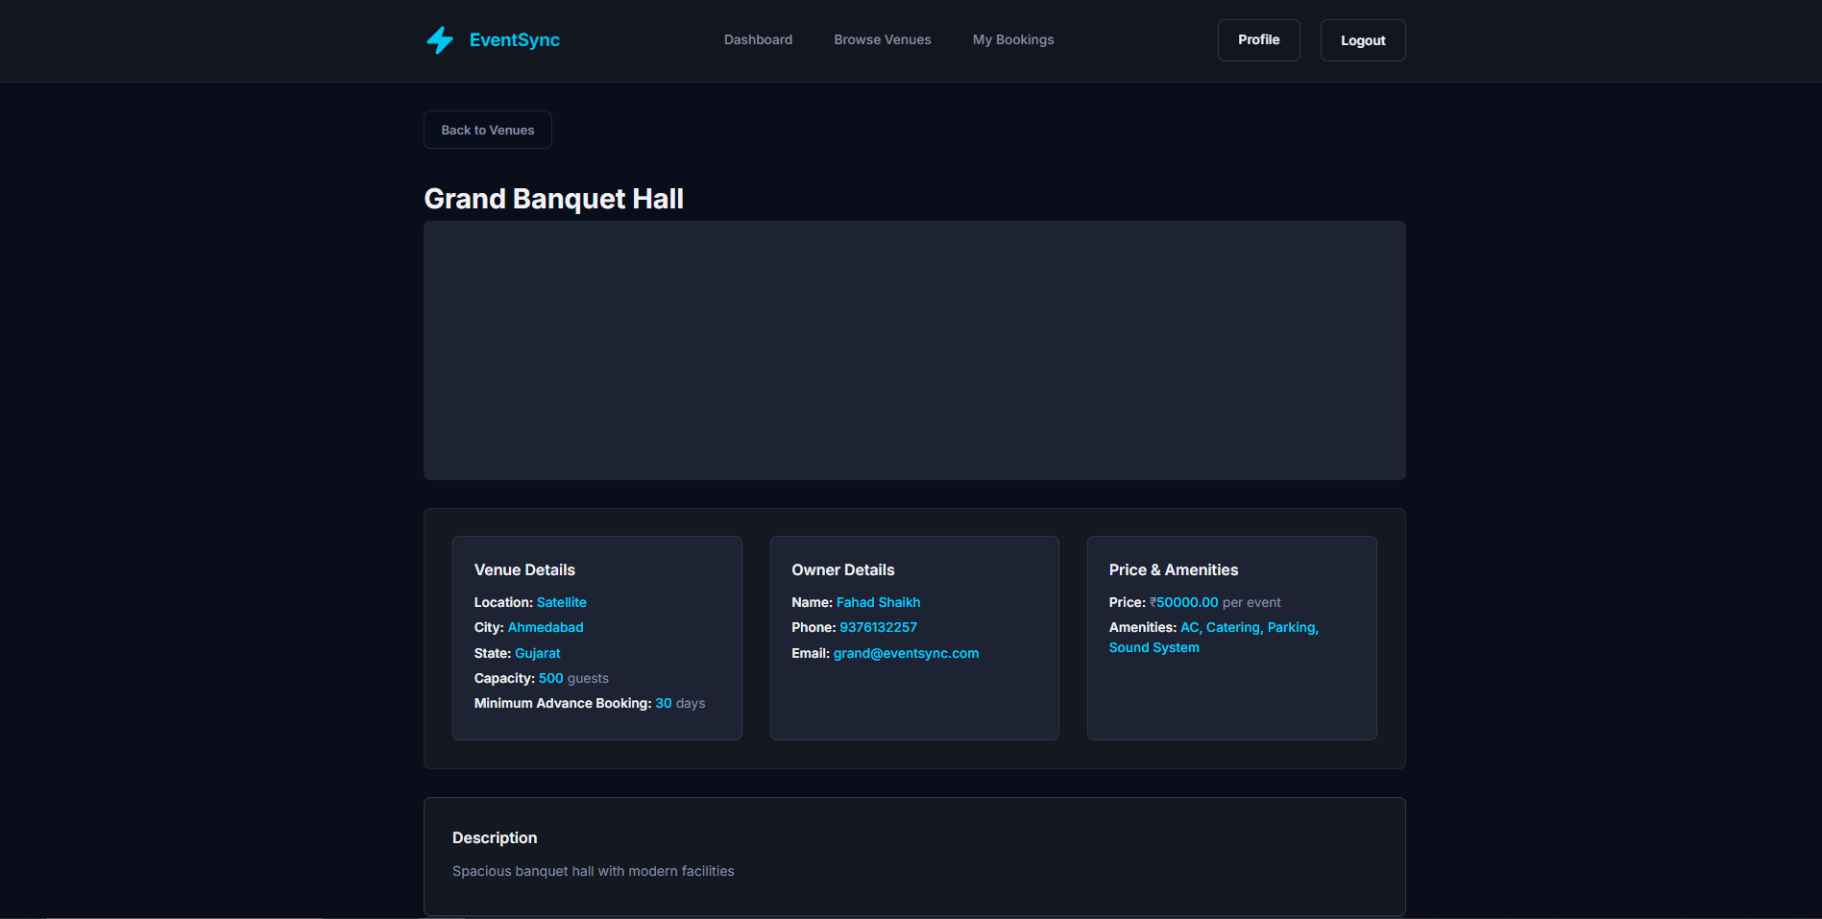
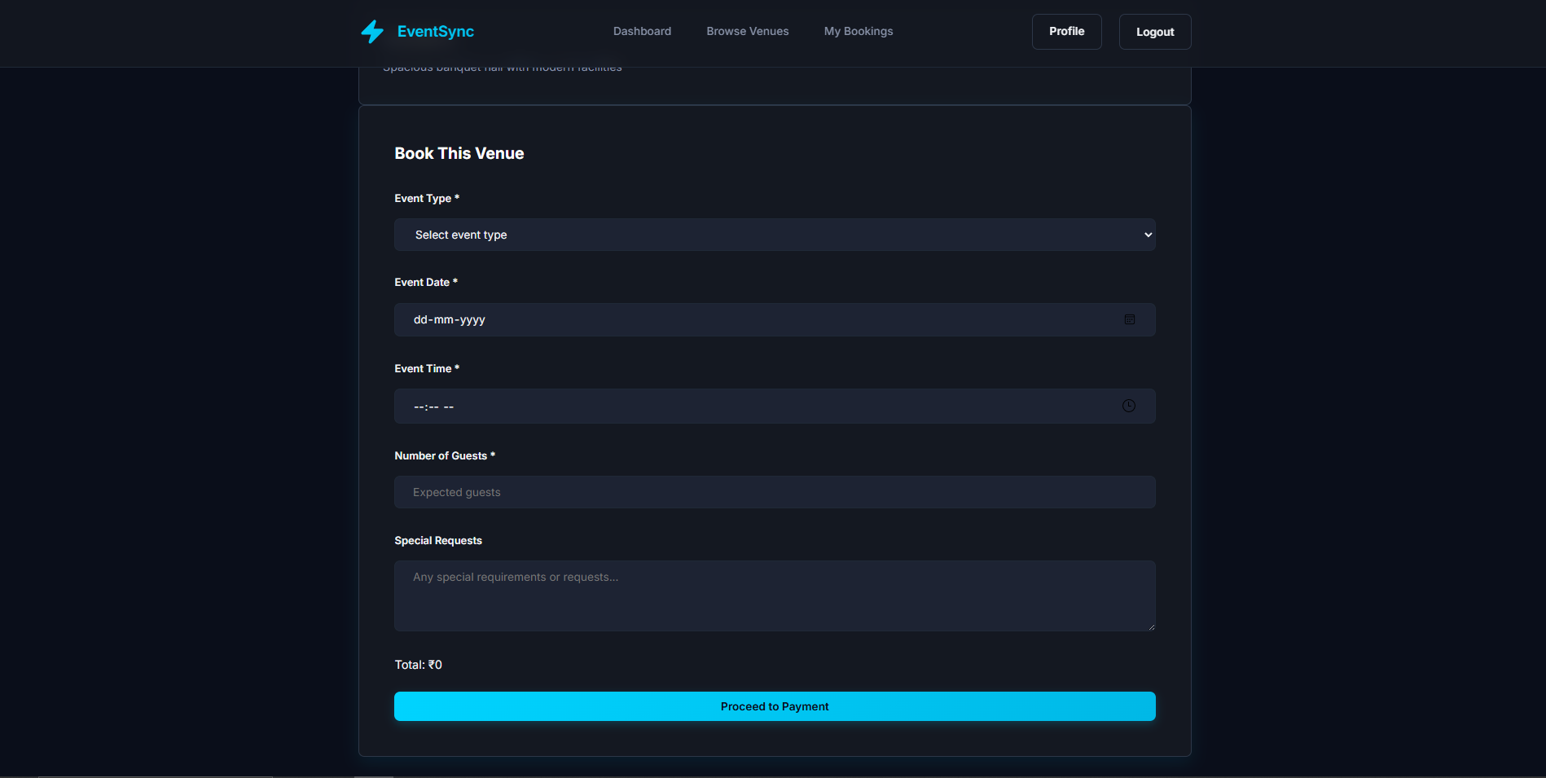
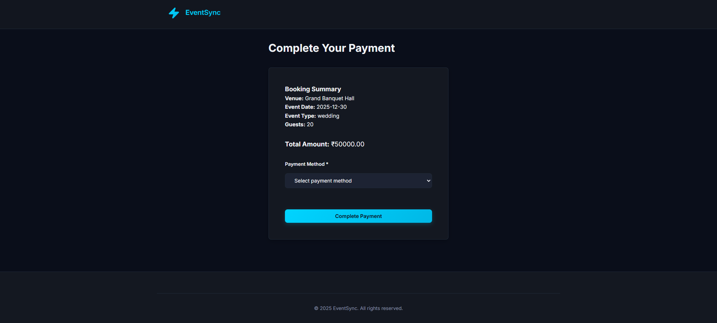
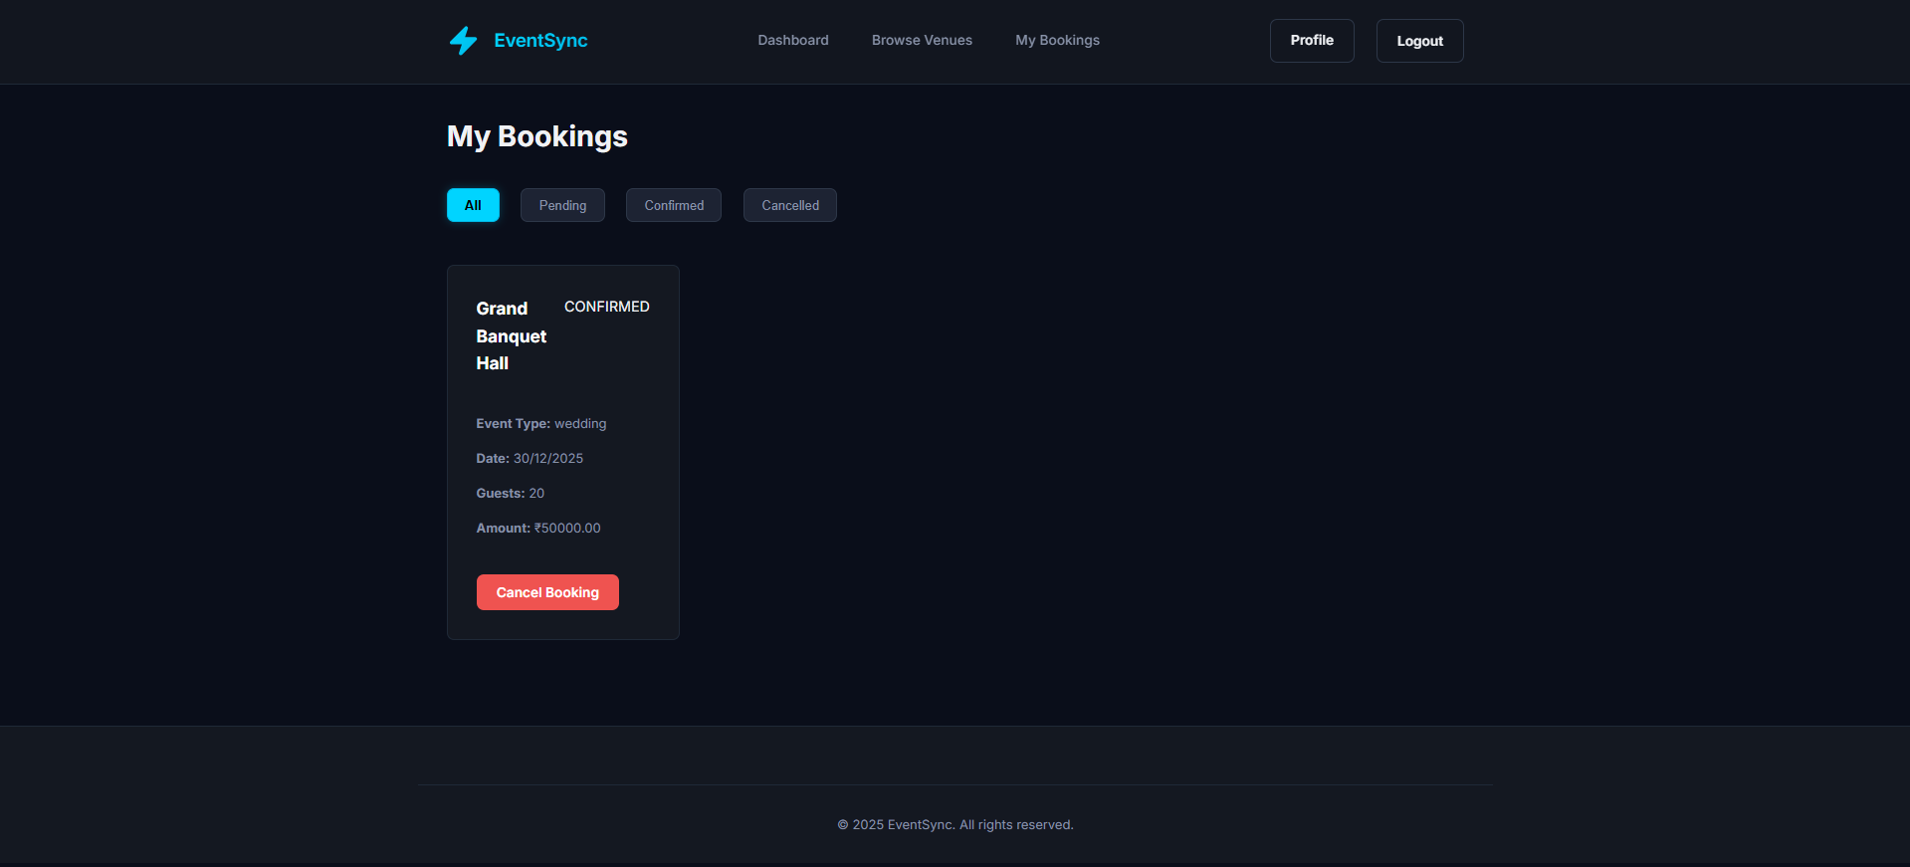
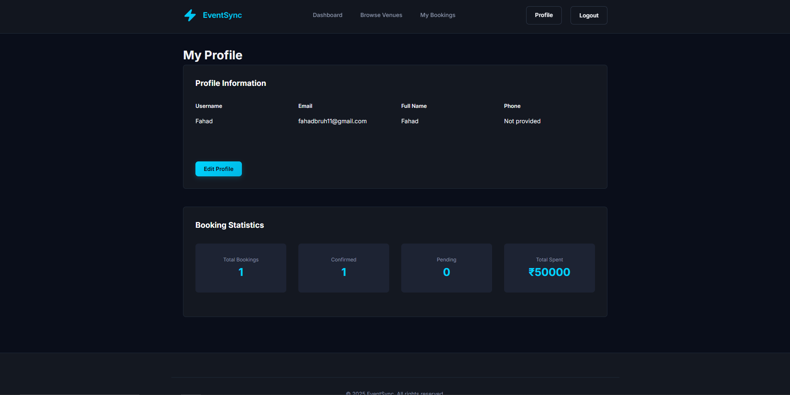
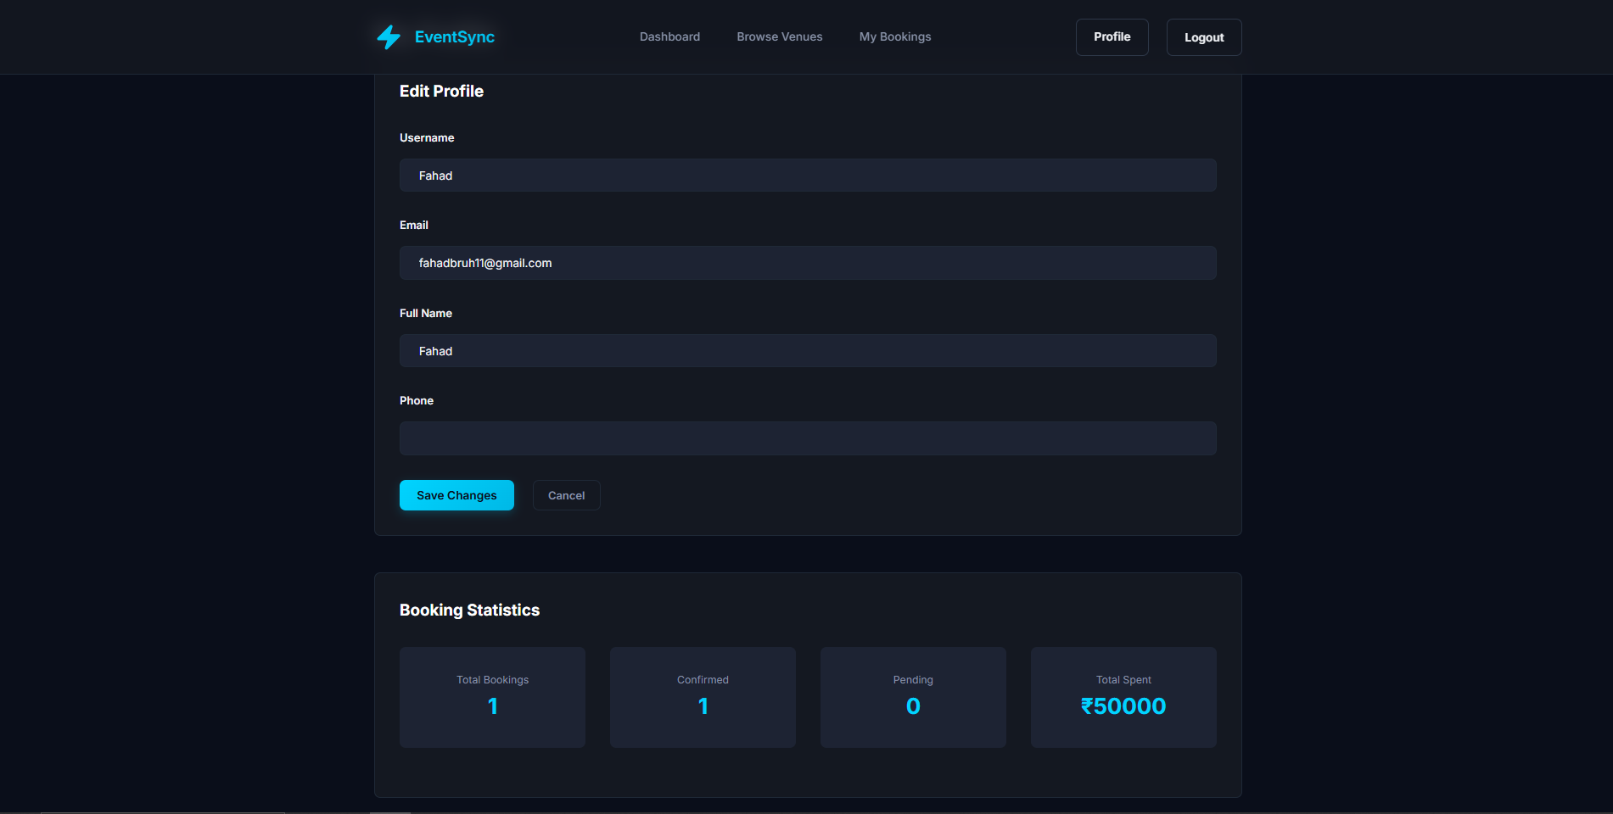

4.2 Code Snippets
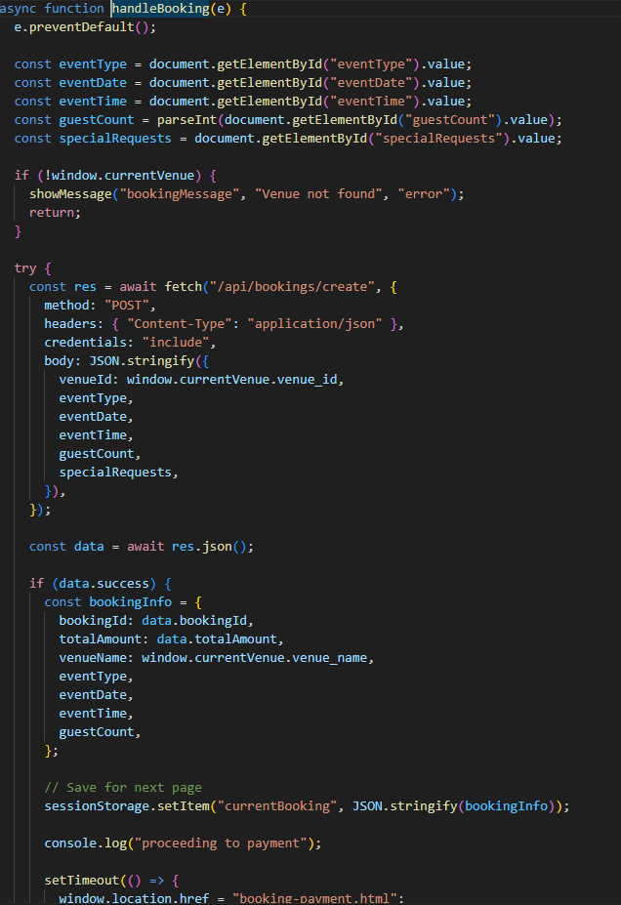
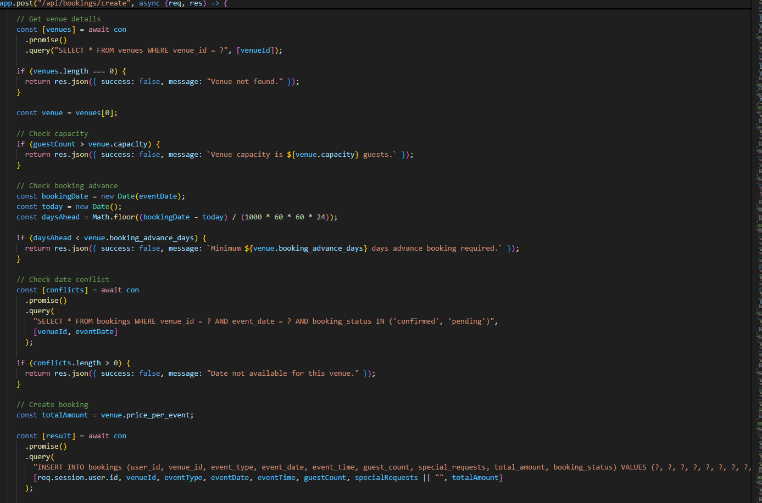
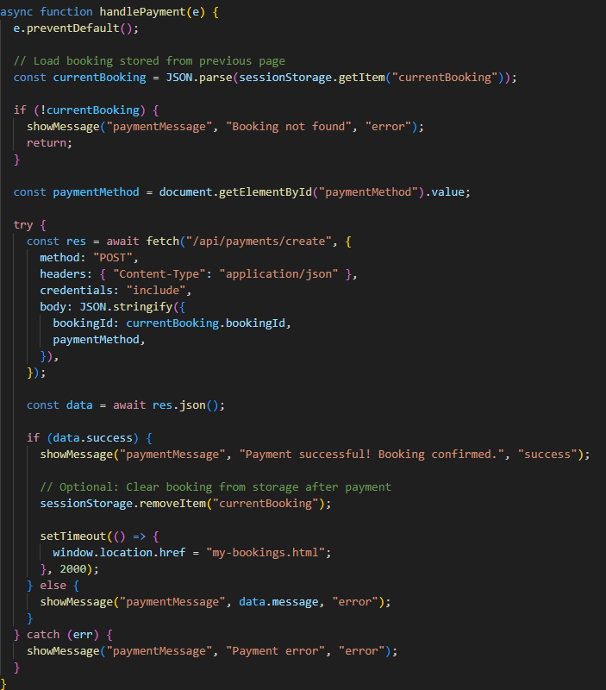

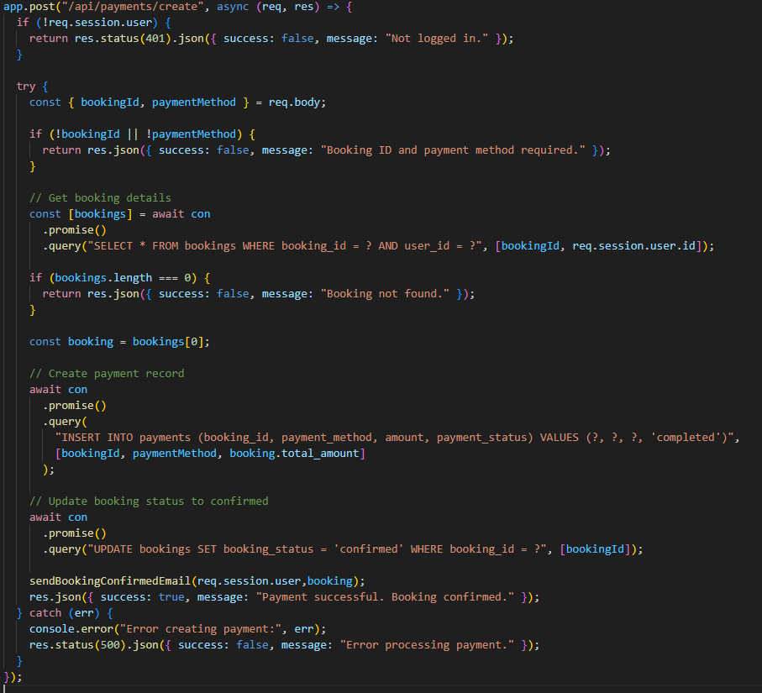
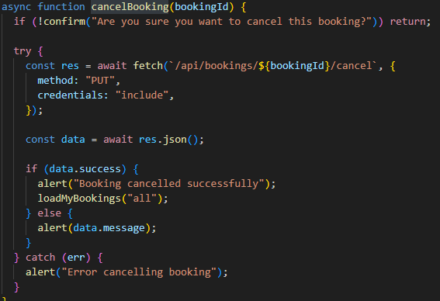
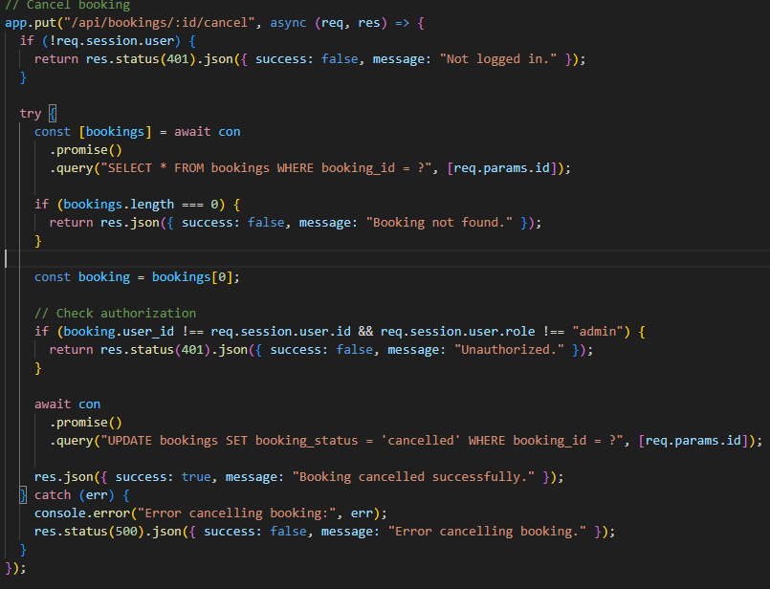

4.3 Reports
- User Registration Report----Lists all registered users with roles (Attendee/Organizer), registration dates, and contact info.
- Event Summary Report---Provides details of each event including title, category, organizer, date, time, and location.
- Attendance Report----Tracks which users attended which events, including timestamps and ticket codes.
- Ticket Issuance Report---Shows ticket generation details: ticket ID, code, registration ID, and issue timestamp.
- Notification Log Report----Displays all notifications sent to users with message content and timestamps.
- Category Usage Report-----Analyzes how frequently each event category is used across the platform.
- Feedback Report----Compiles user feedback per event, including ratings, comments, and contact details.
Chapter 5 : CONCLUSION

- This Event Management System is designed to streamline how people create, discover, and participate in events especially in group settings.
- By offering powerful tools for both collaborative and hosted events, this system solves real problems in event coordination, participation tracking, and social engagement, making it a practical and much-needed solution for communities, student groups, and professionals alike.

Chapter 6 : FUTURE ENHANCEMENT

1.Automated Notifications & Reminders
2.Mobile Application
3.Multi-language Support
4.Enhanced Security:

