EventSync
BCA / BCA (H) / iMCA Semester V PROJECT REPORT
BACHELORS OF COMPUTER APPLICATIONS
School of Computing
SUBMITED TO


SUBMITTED BY
Name of Students | University Exam No.
Harsh Darji  Ikrama Kathiyara  Rudra Padhiyar  Fahad Shaikh  Krish Gohil | 2300941038  2300941093  2300941130  2300941233  2301061044

SUPERVISED BY
Sanjana Jaiswal
JG University
November 2025

JG UNIVERSITY
SCHOOL OF COMPUTING
BACHELORS OF COMPUTER APPLICATIONS

CERTIFICATE FROM INTERNAL SUPERVISOR

This is to certify that the project report compiled By Mr./Ms.___________________________________________
student of BCA / BCA (H) / IMCA semester - V School of Computing, JG University, Ahmedabad is done under my guidance. To the best of my knowledge, this work is satisfactorily completed. During the tenure, he/she was found to be very hard working and sincere. He/she completed all the tasks assigned and suggested to him/her.
Comments:
1.

2.

Date: Internal Supervisor Signature

JG UNIVERSITY
SCHOOL OF COMPUTING
BACHELORS OF COMPUTER APPLICATIONS

DECLARATION

I hereby declare that the project entitled “_______________________________________________” submitted for the Minor project BCA / BCA (H) / IMCA semester - V is my original work and the project has not formed the basis for the award of any degree or any other similar titles in any other University.

Signature of the Student:

Place:
Date:

ACKNOWLEDGEMENT

With immense pleasure, I present this report on the project title of
“_____________________________________________________” developed as a partial fulfilment of requirements of BCA / BCA (H) / iMCA [SEM - V] at School of Computing, JG University.

I express my heartfelt thanks to my internal project guide Sanjana Jaiswal for her continuous support and guidance throughout the project. She provided me the wealth of technical Knowledge as well as Web Development Technology knowledge, which helped me, a lot during our project.

I extend whole hearted thanks to faculties of School of Computing especially Dr. S. Pushpalatha, for providing all facilities, valuable suggestion and constant supervision for the successful completion of the project.
- Harsh Darji
- Ikrama Kathiyara
- Fahad Shaikh
- Rudra Padhiyar
- Krish Gohil

INDEX

Contents | Page No.
Chapter 1: INTORDUCTION & PROBLEM STATEMENT
Problem Definition / Problem Abstract
Chapter 2: LITERATURE REVIEW
- Current System and its Drawbacks
- Proposed System and its features
- Scope of the Project
- Technical Specification
- Process Model
Chapter 3: REQUIREMENT ANALYSIS & DESIGN
- Gantt Chart
- Modules and Sub Modules
- System Side (Flowchart Diagrams)
  - Use Case Diagram
  - Class Diagram
- Data Dictionary
Chapter 4: SOFTWARE DESIGN & IMPLEMENTATION
(With Screen Shots)
- Screens / User Interface
- Code Snippets
- Reports

Chapter 5: CONCLUSION
Chapter 6: FUTURE ENHANCEMENT
References

Chapter 1: INTRODUCTION & PROBLEM STATEMENT

  - Introduction :

- EventSync is a web-based event management system designed to simplify the process of managing, scheduling, and tracking events.

- The system provides a structured and secure platform for users to create accounts, log in, and interact with event-related services.

1.2 Problem Definition :
- Organizing events such as weddings or birthdays involves multiple tasks like registration, venue booking, scheduling, and communication with participants.
- When these activities are managed manually, it often leads to errors, time delays, miscommunication, and data loss.

Chapter 2: LITERATURE REVIEW

2.1 Current System :
- Event organizers maintain information such as guest lists, bookings, schedules, and payments using paperwork, spreadsheets, or phone communication.

2.2 Drawbacks :
- Manual record keeping prone to errors.
- Lack of centralized user authentication.
- Difficulty in managing event data securely.
- Limited scalability and adaptability to different use cases.

2.3 Features :
- User registration and authentication.
- Secure password handling with bcrypt.js.
- Centralized event management and scheduling.
- Database-driven design with MySQL.
- Role-based user access (admin, registered user).
- Responsive and accessible web interface.

2.4 Scope of the project :
- provide a centralized online platform for planning, organizing, and managing various types of events.
- The system allows admins, organizers, and users to manage event details efficiently — including registration, venue booking, scheduling, and communication.
- It will help automate the entire process, reduce manual effort, and improve coordination between organizers and participants.

2.5 Technical Specification :

Software : Hardware:
- HTML Minimum requirements:
- CSS Device : Any PC, Laptop, or
- Javascript smartphone
- MySQL Processor : 1GHz or faster
- Node.js RAM : 2 GB
Storage : ~200MB
Internet : At least 2 Mbps (~256KBps)

2.6 Process Model :
  - Requirement Analysis : Identify user needs: Create Event, Join event
  - System Design : Design pages, forms, and database tables.
  - Implementation : Build the website using HTML, CSS, JS, MySQL and NodeJS.
  - Testing : Check Event join and create the event.
  - Feedback & Improvement : Add categories, graphs, and other enhancements.
  - Deployment & Maintenance : Make website live and update regularly.

Chapter 3: REQUIREMENT ANALYSIS & DESIGN
3.1 Gantt Chart :
Activity | Duration (Weeks) | Week 1-2 | Week 3-5 | Week 6-8 | Week 9-10 | Week 10-11 | Week 11-12
Requirement Analysis | 2
System Design | 3
Database Design & Setup | 3
Implementation (Coding) | 2
Testing & Debugging | 1
Deployment & Documentation | 1

3.2 Modules and Sub Modules :

1. User Module:
    - User registration
    - Login/logout functionality
    - Session management.

2. Database Module
    - Create and update events
    - Event scheduling
    - Event tracking.

3.3 System Side (Flowchart Diagrams)
(A) Use Case Diagram
1) User UseCase
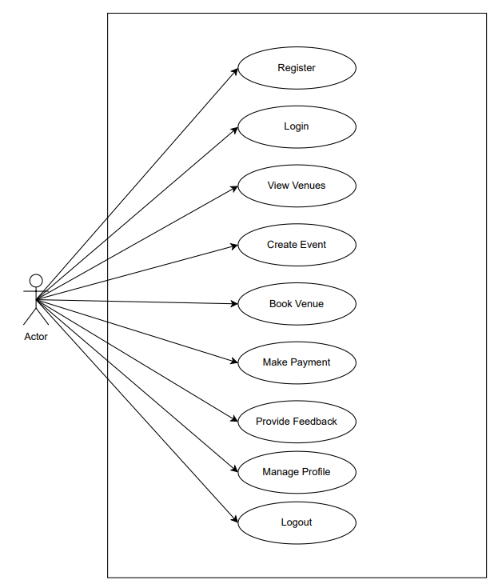

2) Admin UseCase

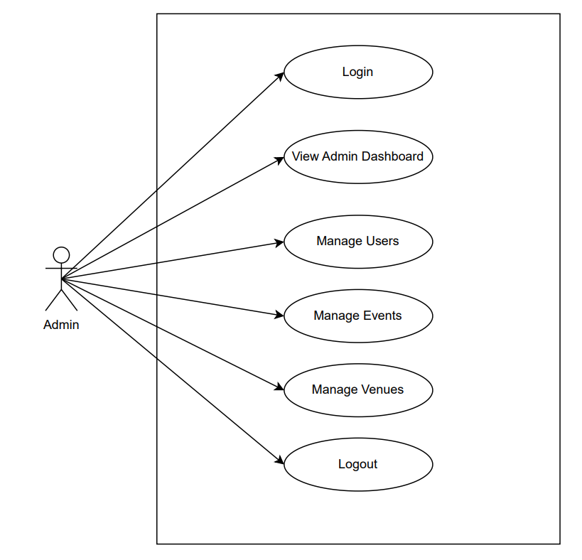
(B) Class Diagram

3.4 Data Dictionary :
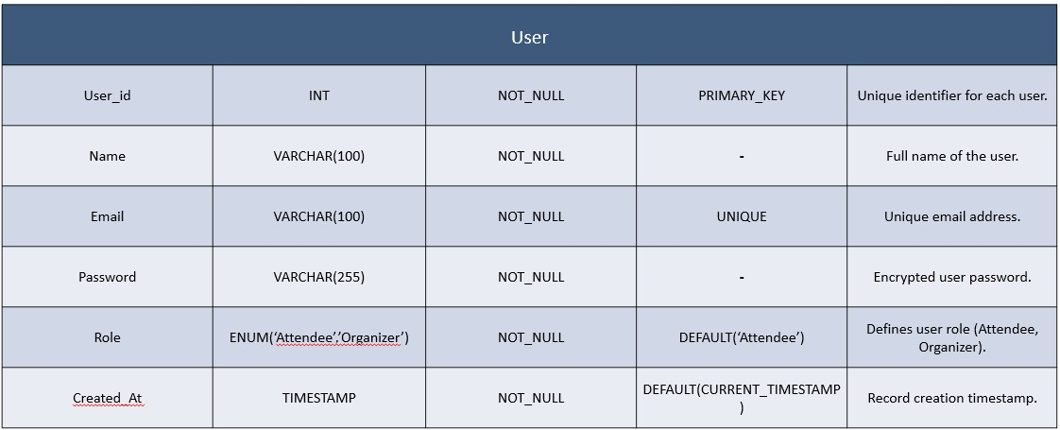
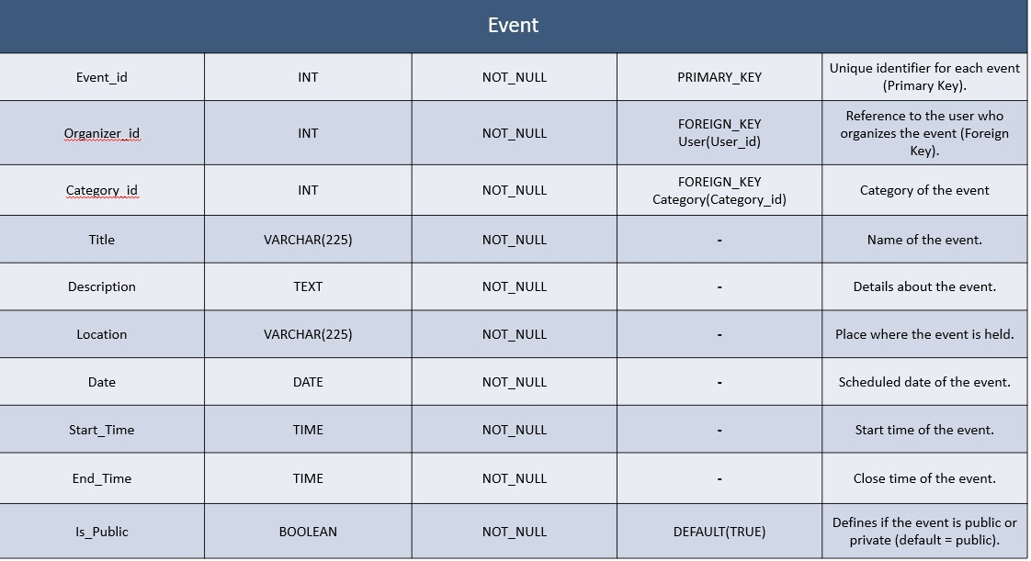
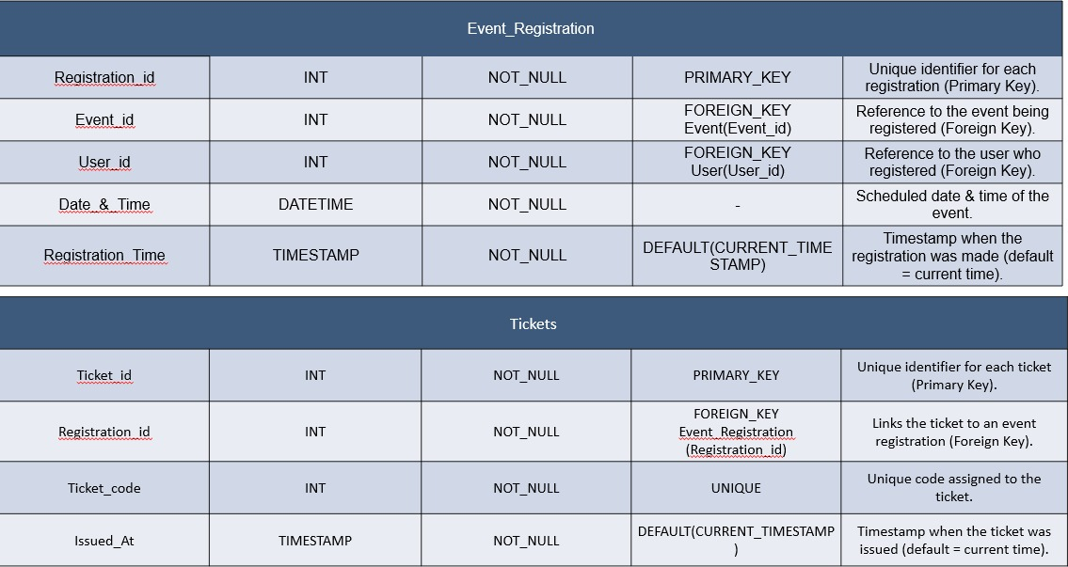
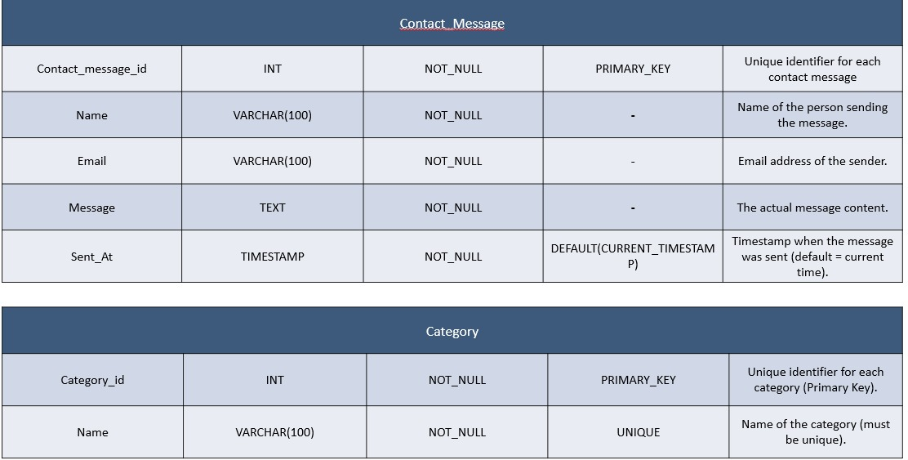
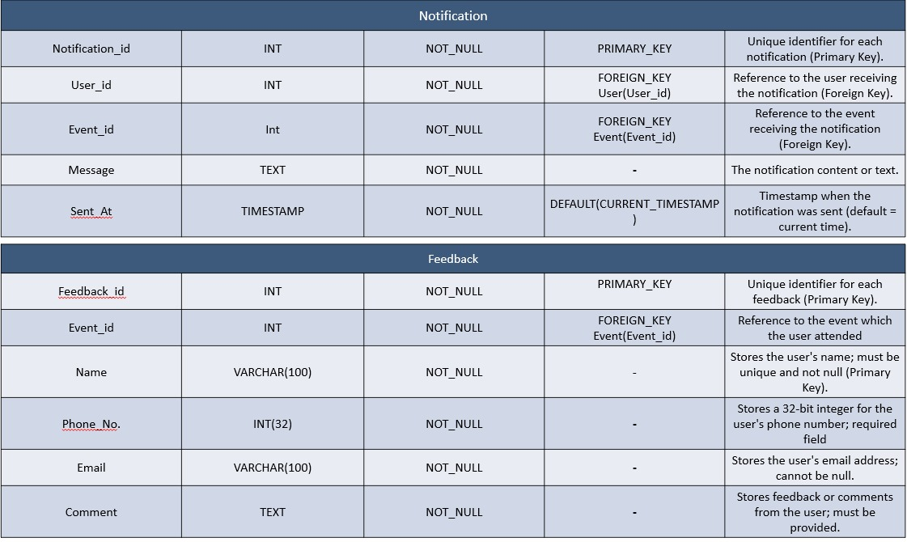

Chapter 4: SOFTWARE DESIGN & IMPLEMENTATION (With Screen Shots)

4.1 Screens / User Interface

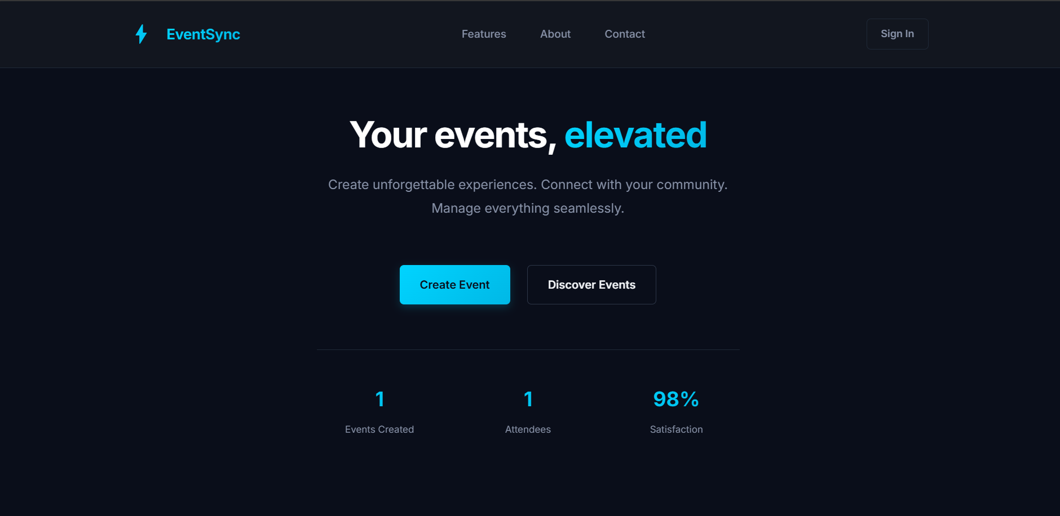
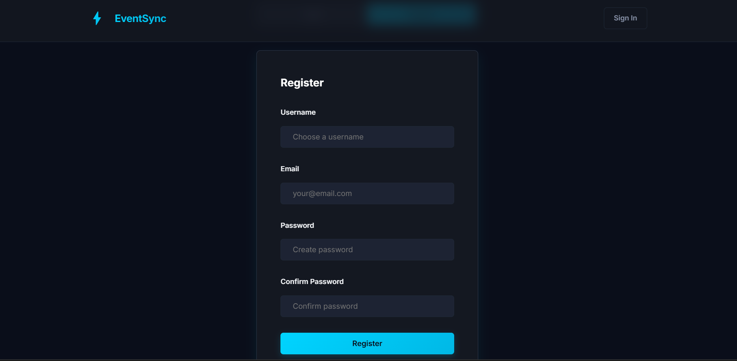

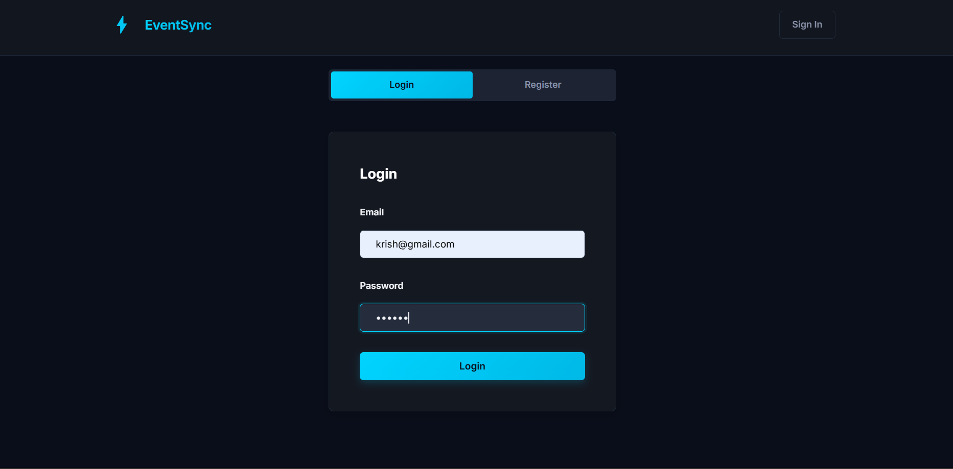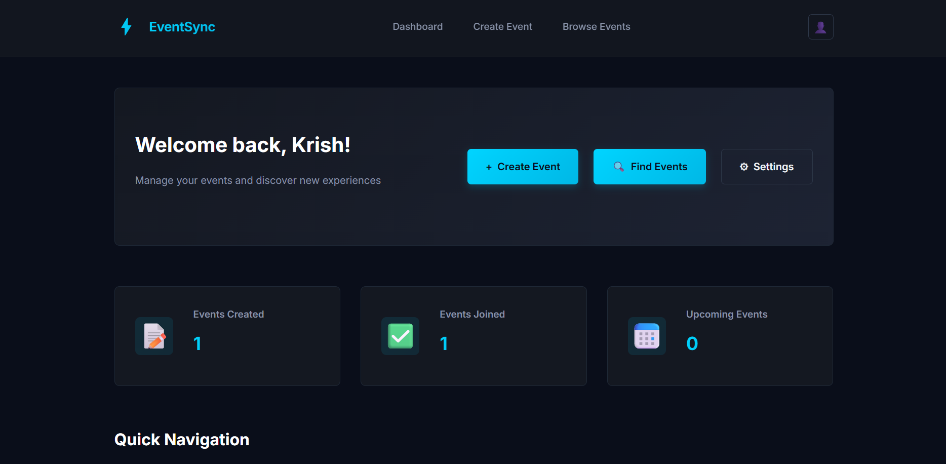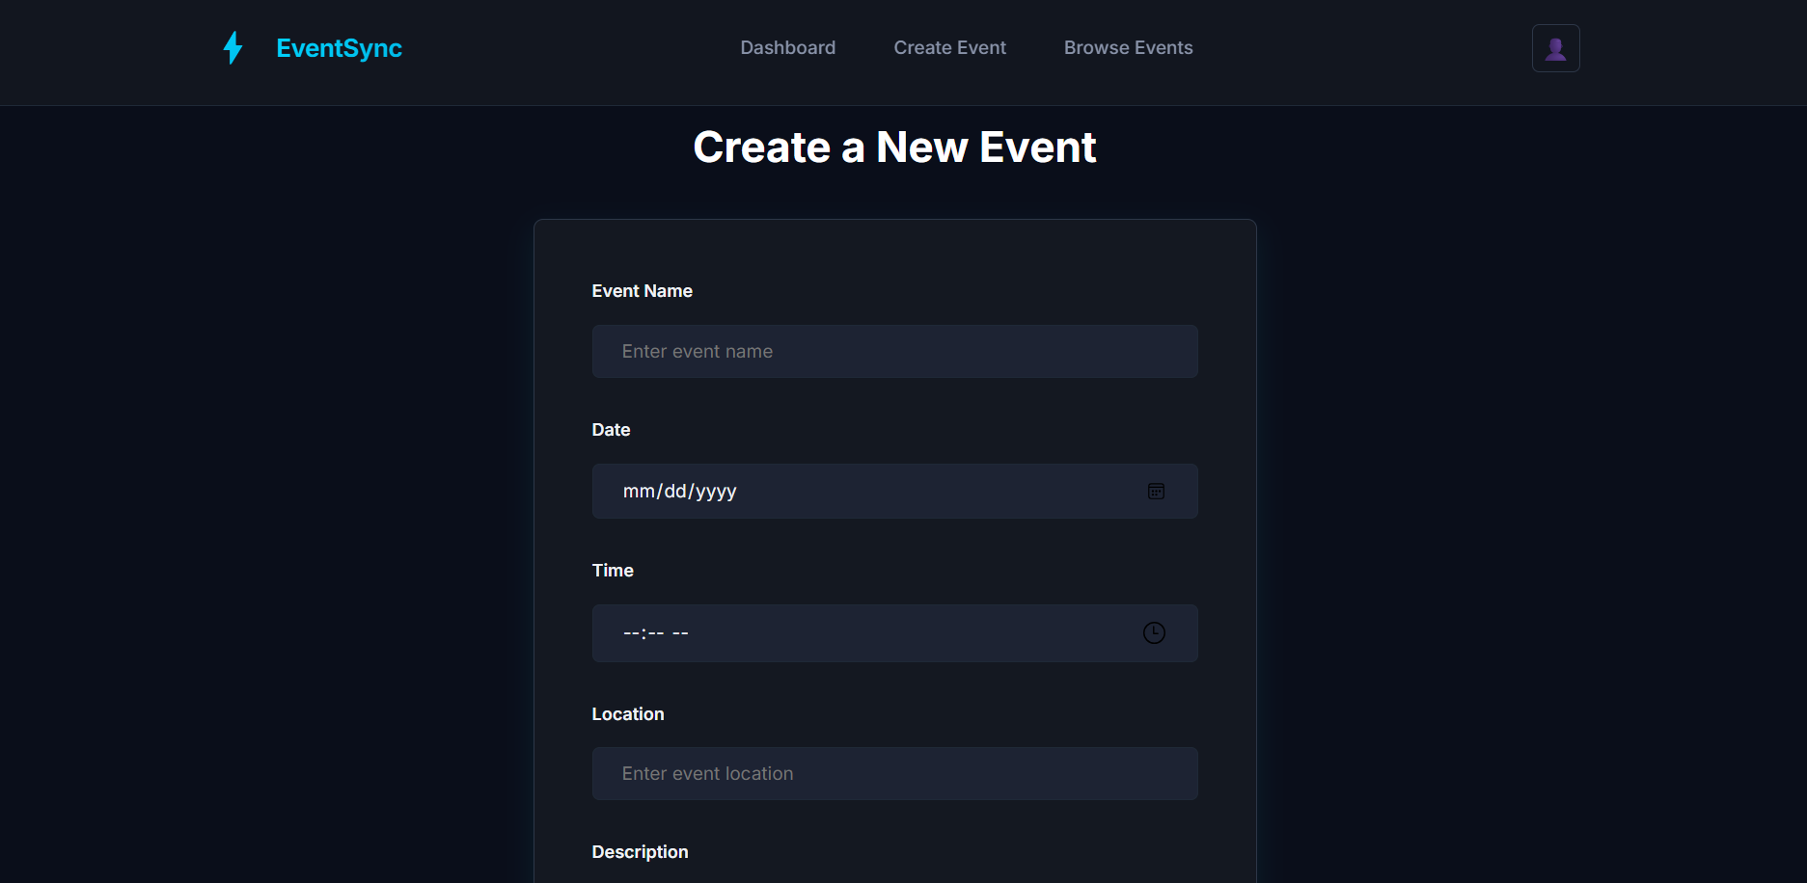
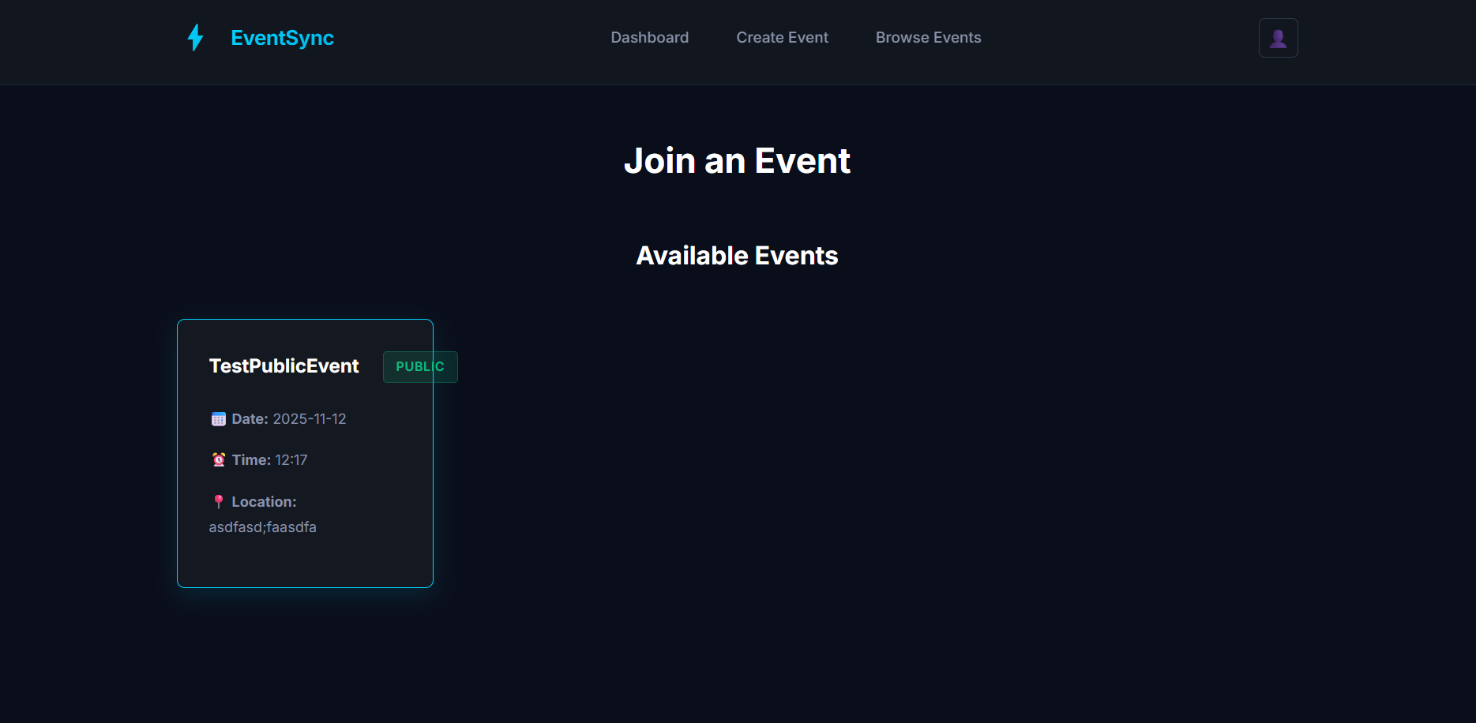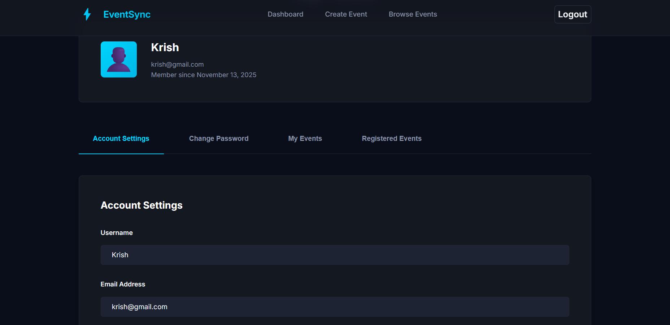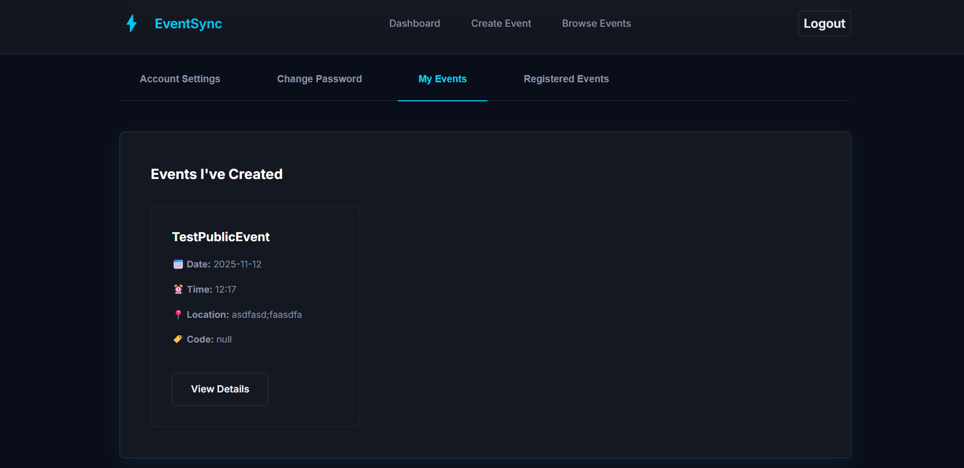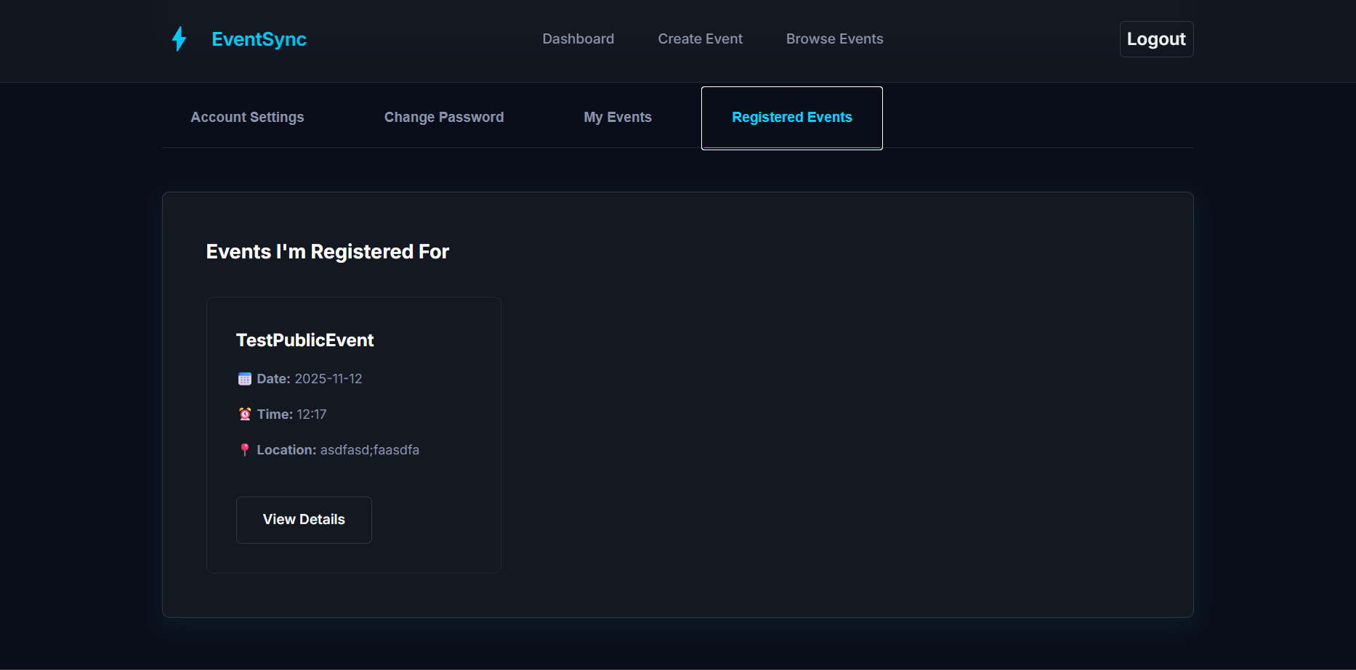

4.2 Code Snippets

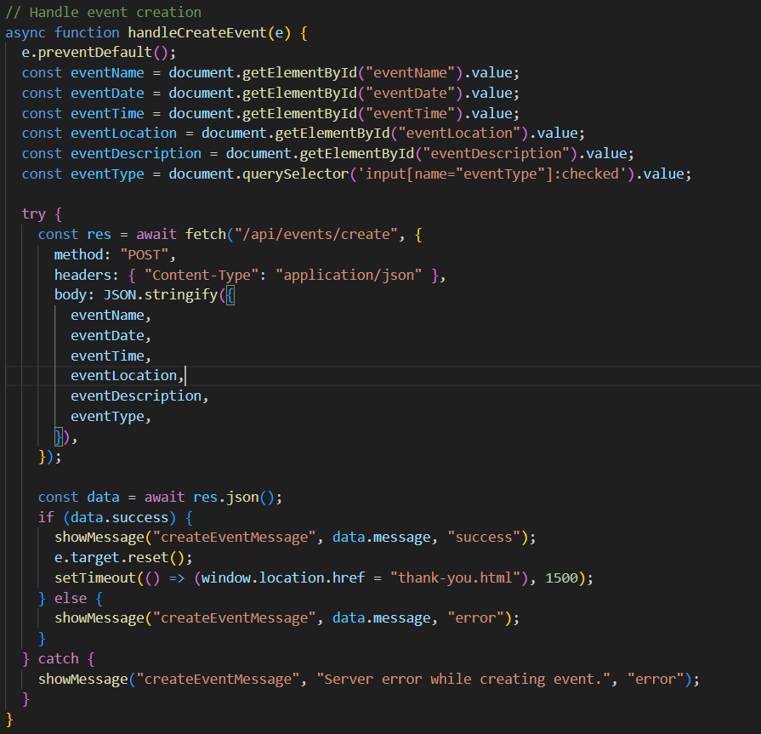
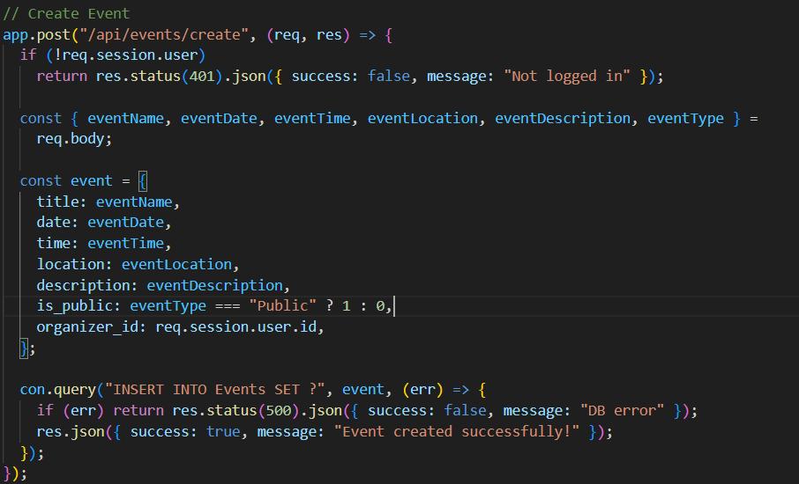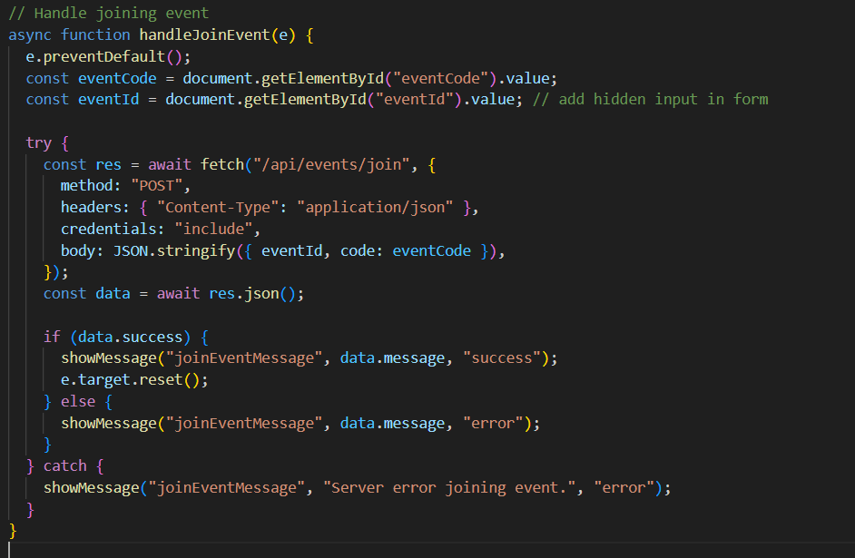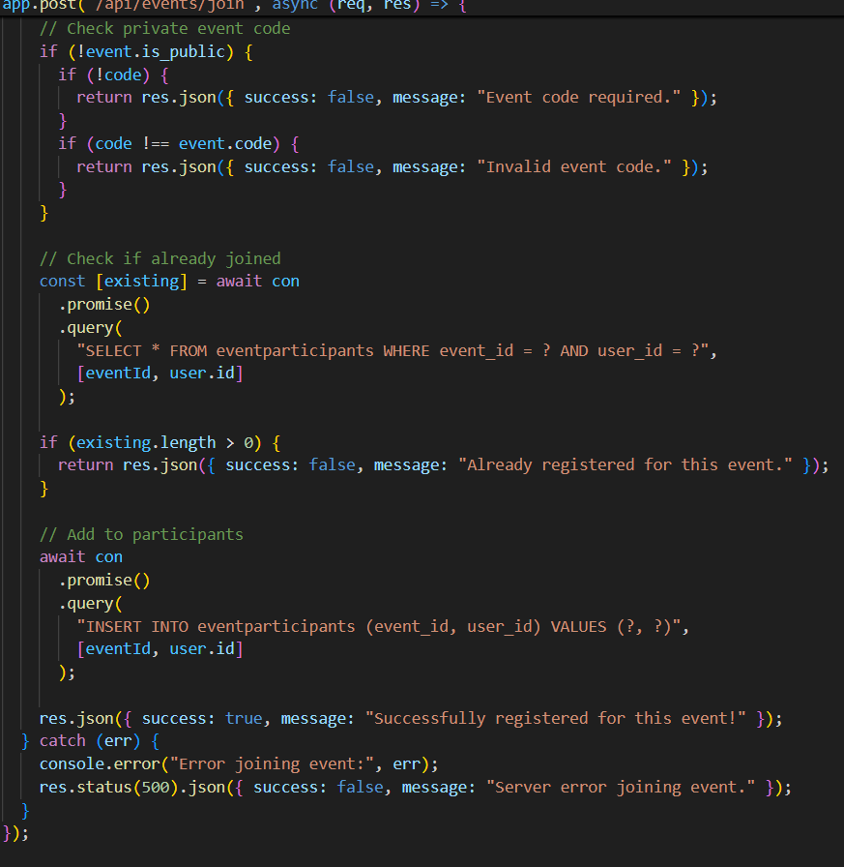

4.3 Reports

Chapter 5 : CONCLUSION

- This Event Management System is designed to streamline how people create, discover, and participate in events especially in group settings.
- By offering powerful tools for both collaborative and hosted events, this system solves real problems in event coordination, participation tracking, and social engagement, making it a practical and much-needed solution for communities, student groups, and professionals alike.

Chapter 6 : FUTURE ENHANCEMENT

1.Automated Notifications & Reminders
2.Mobile Application
3.Multi-language Support
4.Enhanced Security:

