# A Project Report On

**Photo Competition**

**BY**

**Prof.Ajinkya R.Abhang (Software Engineer)**

**Precident (Eagle’s Technomania)**

**Prof.Vishal D. Auti (Software Engineer)**

**Vice precident(Eagle’s Technomania)**

**Eagle’s Technomania**

**(Software Development )**

**ACKNOWLEDGEMENT**

It is our pleasure to be indebted to various people, who directly or indirectly contributed in the development of this work and who influenced our thinking, behavior, and acts during the course of study.

We are thankful to Prof. . and Prof. .(Project Guide) for his support, cooperation, and motivation provided to me during the Study of project.

We also extend my sincere appreciation to Prof. who provided his valuable suggestions and precious time in accomplishing my project report.

We are also thankful to my friends, colleagues and all our instructors for helping in the project.

**Contents**

|  |  |  |  |  |  |
| --- | --- | --- | --- | --- | --- |
| **Sr.No.** | **Name** | | | **Page No.** | |
| 1. | **Introduction** | | | 6 | |
| 2. | **Problem Definition** | | | 7 | |
| 3. | **Need of the System** | | | 8 | |
| 4. | **Scope of the System** | | | 9 | |
| 5. | **Requirement Analysis**  5.1Software Specifications  5.2 Hardware Specification | | | 10 | |
| 6. | **Feasibility Study**   * 1. Technical Feasibility   2. Operational Feasibility   3. Economical Feasibility | | | 11-13 | |
| 8. | | **Data Tables & Data Dictionary** | 14-16 | |
| 9. | | **Diagrams**  9.1 Class Diagram  9.2 Use-Case Diagram  9.3 Activity Diagram  9.4 Sequence Diagram  9.5 Data Flow Diagram (DFD)  9.6 ER Diagram | 17-25 | |
| 10. | | **Screenshots** | 26-38 | |
| 11. | | **System testing** | 39 | |
| 12. | | **Limitations** | 40 | |
| 13. | | **Future Enhancement** | 41 | |
| 14. | | **Bibliography** | 42 | |

**Introduction**

Photo Competition is the web based tool which helps in photo competition to make the selection process easy to both side users

This site can be accessed throughout the world with proper login provided. This system can be used to take part in photo competition. We can send images using this software. This software provides easy service to the competitor as well as examiner. Examiner easily can judge the pictures and can declare the winner by choosing capable competitor as a winner.

**Problem Definition**

**Advantages:**

* Admin can check that Photos submitted belongs to that person only.
* It gives Boost for the new comers in this field.
* Result can be chosen by users, so there is no cheating, or blames on admin.

**Disadvantages:**

* Each Photographer have to register to upload the photos,

**Need of the System**

* This system can be used in a Social Networking website.
* This System can be even used as standalone website for young and talented photographers.

**Scope of the Proposed System**

We usually come across areas where a photographer can show his skills and win some award, but it was not properly portrayed. Using our System Admin / can conduct contest based on a topic. Admin can Choose the winner by 2 ways, No of Like on Photograph, Or Admin can directly select the winner. Admin can remotely view the images through, and select for best one, Photographer can register them self to this, so that they get notification of the completion (By Mail or SMS), Photographer’s will be notified One week before the contest, If entries exceed the required, admin will first select top images and then users will vote for best one, One User will be allowed to vote for 3 photos only, Winner of the contest will be notified by (Mail or SMS), The role of admin is to check that images belong to that photographer only, and he has not taken it from other sources

**Requirement Analysis**

Requirement analysis produces in the specification of software operational characteristics:

It indicates software interface with other system element.

It establishes constraint that should accomplish.

* Requirement analysis provides information, function & behavior that can be translated into architectural interface & component level design.
* This translation is performed during construction of analysis model.
* It includes:
* It decides and adds all important function which is maintained in the requirements.
* It decides and adds important function which is not maintained in the requirements, but it is essential to build.

It defines all interfaces of the software to be developed

* **Software Requirements**

Operating System : Windows ,Linux or Further

Languages : Java, HTML

Front End : Java script.

Platform : Java

Web Servers : Glassfish Server

Backend : My SQL

* **Hardware Requirements**

Processor : Pentium III or Any Advanced Processor

RAM : 256 MB or More

Hard disk : 40 GB or more

**Feasibility Study**

Preliminary investigation examine project feasibility, the likelihood the system will be useful to the organization. The main objective of the feasibility study is to test the Technical, Operational and Economical feasibility for adding new modules and debugging old running system. All system is feasible if they are unlimited resources and infinite time. There are aspects in the feasibility study portion of the preliminary investigation:

* Technical Feasibility
* Operation Feasibility
* Economical Feasibility

**3.1. Technical Feasibility**

The technical issue usually raised during the feasibility stage of the investigation includes the following:

* Does the necessary technology exist to do what is suggested?
* Do the proposed equipment have the technical capacity to hold the data required to use the new system?
* Will the proposed system provide adequate response to inquiries, regardless of the number or location of users?
* Can the system be upgraded if developed?
* Are there technical guarantees of accuracy, reliability, ease of access and data security?

Earlier no system existed to cater to the needs of ‘Secure Infrastructure Implementation System’. The current system developed is technically feasible. It is a web based user interface for audit workflow at NIC-CSD. Thus it provides an easy access to the users. The database’s purpose is to create, establish and maintain a workflow among various entities in order to facilitate all concerned users in their various capacities or roles. Permission to the users would be granted based on the roles specified. Therefore, it provides the technical guarantee of accuracy, reliability and security. The software and hard requirements for the development of this project are not many and are already available in-house at NIC or are available as free as open source. The work for the project is done with the current equipment and existing software technology. Necessary bandwidth exists for providing a fast feedback to the users irrespective of the number of users using the system.

**3.2. Operational Feasibility**

Proposed projects are beneficial only if they can be turned out into information system. That will meet the organization’s operating requirements. Operational feasibility aspects of the project are to be taken as an important part of the project implementation. Some of the important issues raised are to test the operational feasibility of a project includes the following: -

* Is there sufficient support for the management from the users?
* Will the system be used and work properly if it is being developed and implemented?
* Will there be any resistance from the user that will undermine the possible application benefits?

This system is targeted to be in accordance with the above-mentioned issues. Beforehand, the management issues and user requirements have been taken into consideration. So there is no question of resistance from the users that can undermine the possible application benefits.

The well-planned design would ensure the optimal utilization of the computer resources and would help in the improvement of performance status.

**3.3. Economic Feasibility**

A system can be developed technically and that will be used if installed must still be a good investment for the organization. In the economical feasibility, the development cost in creating the system is evaluated against the ultimate benefit derived from the new systems. Financial benefits must equal or exceed the costs.

The system is economically feasible. It does not require any addition hardware or software. Since the interface for this system is developed using the existing resources and technologies available at NIC, There is nominal expenditure and economical feasibility for certain.

**Data Dictionary**

**Database Name: PhotoCompetition**

***Table Name: Login***

|  |  |  |
| --- | --- | --- |
| **Field Name** | **Data Type** | **Description** |
| Login_Id | Varchar(10) | Primary Key |
| full_name | Varchar(100) | Name |
| Email | Varchar(40) | Email-ID |
| Password | Varchar(20) | Password |
| Phone_no | Varchar(10) | Phone_no |
| login_flag | Integer | Flag set to 1 if photo is uploaded successfully |

Indexes:

"login_pkey" PRIMARY KEY, btree (login_id)

Referenced by:

TABLE "photo_register" CONSTRAINT "photo_register_login_id_fkey" FOREIGN KEY (login_id) REFERENCES login(login_id) ON UPDATE CASCADE ON DELETE CASCADE

TABLE "winner" CONSTRAINT "winner_login_id_fkey" FOREIGN KEY (login_id) REFERENCES login(login_id) ON UPDATE CASCADE ON DELETE CASCADE

***Table Name: Photo_Register***

|  |  |  |
| --- | --- | --- |
| **Field Name** | **Data Type** | **Description** |
| photo_id | Varchar(10) | photo_id |
| photo_description | Varchar(500) | Photo Descriotion |
| Photo | Varchar(500) | Photo |
| Shutter | Varchar(10) | Shutter |
| Aparture | Varchar(10) | Aparture |
| Iso | varchar(10) | Iso |
| mega_pixel | Varchar(10) | mega_pixel |
| Like_Count | Integer | Like_Count |
| Like_Status_of_Current_user | Integer | Like status of Current User |
| Theme_id | Varchar(10) | ThemeId |
| Login_Id | Varchar(10) | LoginId |

Foreign-key constraints:

"photo_register_login_id_fkey" FOREIGN KEY (login_id) REFERENCES login(login_id) ON UPDATE CASCADE ON DELETE CASCADE

"photo_register_theme_id_fkey" FOREIGN KEY (theme_id) REFERENCES theme(theme_id) ON UPDATE CASCADE ON DELETE CASCADE

***Table Name: Theme***

|  |  |  |
| --- | --- | --- |
| **Field Name** | **Data Type** | **Description** |
| Theme_id | Varchar(10) | Primary Key NOT NULL |
| Name | Varchar(50) | Name |
| theme_description | Varchar(300) | ThemeDescription |
| theme_Photo | Varchar(200) | ThemePhoto |
| start_date | Date | StartDate |
| to_date | Date | ToDate |
| current_theme_flag | Int | CurrentThemeFlag |

Indexes:

"theme_pkey" PRIMARY KEY, btree (theme_id)

Referenced by:

TABLE "photo_register" CONSTRAINT "photo_register_theme_id_fkey" FOREIGN KEY (theme_id) REFERENCES theme(theme_id) ON UPDATE CASCADE ON DELETE CASCADE

TABLE "winner" CONSTRAINT "winner_theme_id_fkey" FOREIGN KEY (theme_id) REFERENCES theme(theme_id) ON UPDATE CASCADE ON DELETE CASCADE

***Table Name: Winner***

|  |  |  |
| --- | --- | --- |
| **Field Name** | **Data Type** | **Description** |
| winner_id | Varchar(10) | WinnerId |
| login_id | Varchar(10) | LoginId |
| Theme_id | Varchar(10) | ThemeId |

Indexes:

"winner_pkey" PRIMARY KEY, btree (winner_id)

Foreign-key constraints:

"winner_login_id_fkey" FOREIGN KEY (login_id) REFERENCES login(login_id) ON UPDATE CASCADE ON DELETE CASCADE

"winner_theme_id_fkey" FOREIGN KEY (theme_id) REFERENCES theme(theme_id) ON UPDATE CASCADE ON DELETE CASCADE

**Diagrams**

**Class Diagram:**

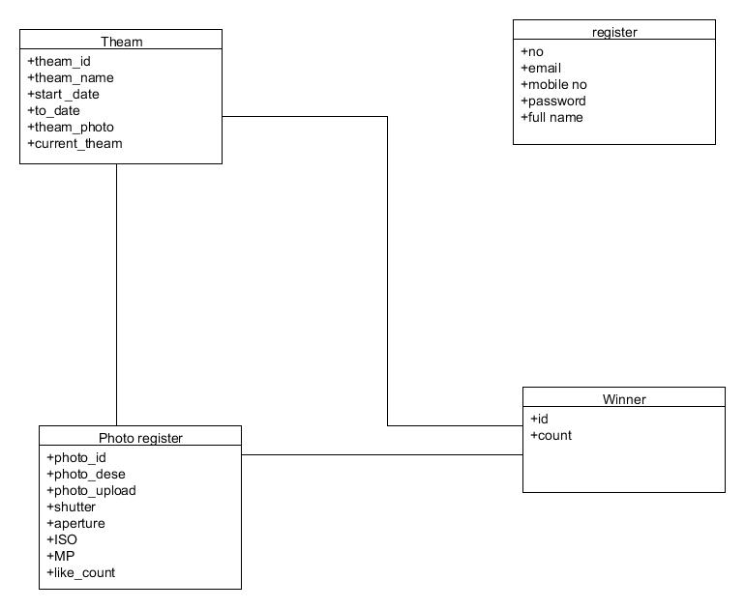

**Use-Case Diagram:**

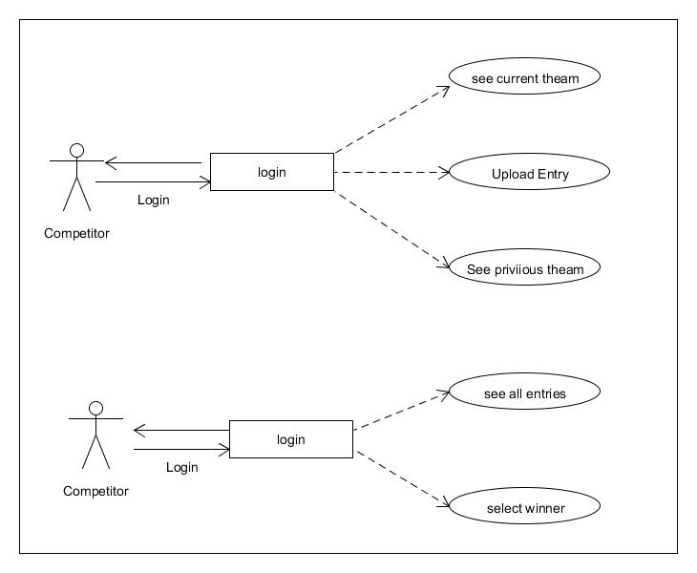

**Activity Diagram**

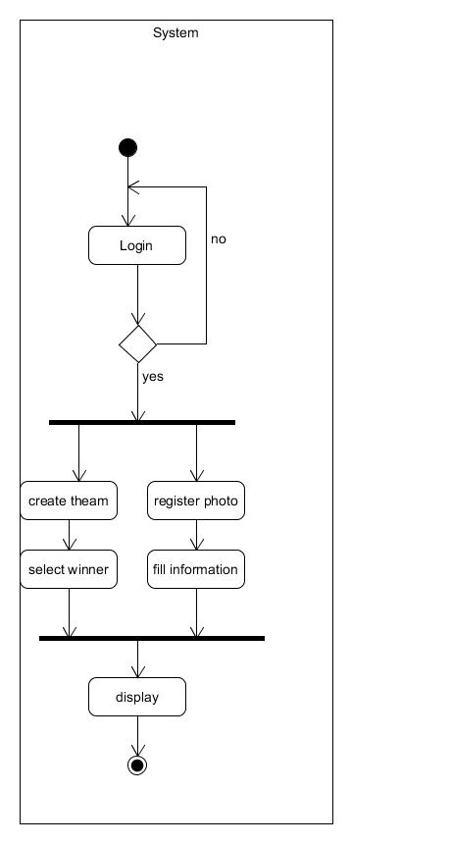

**Sequence Diagram:**

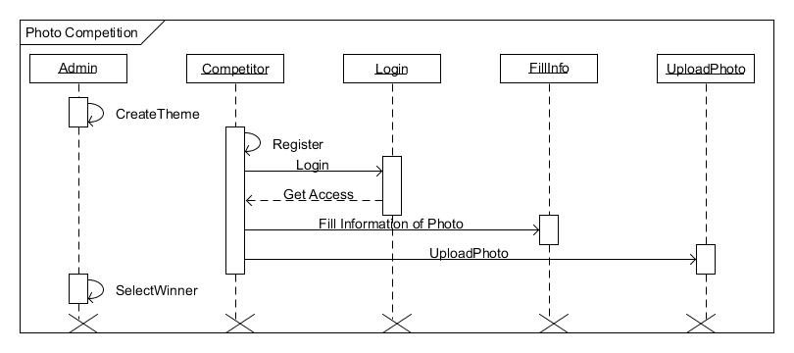

**Data Flow Diagram (DFD)**

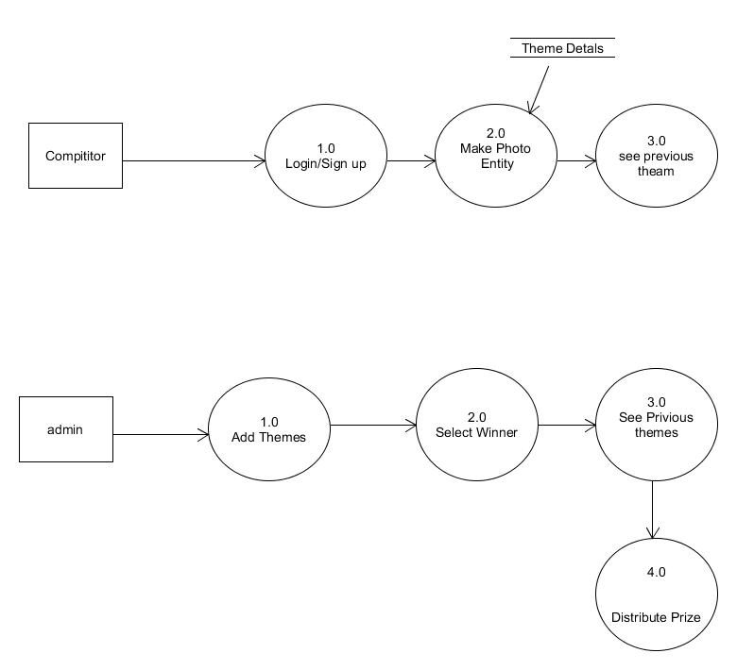

**Screenshots**

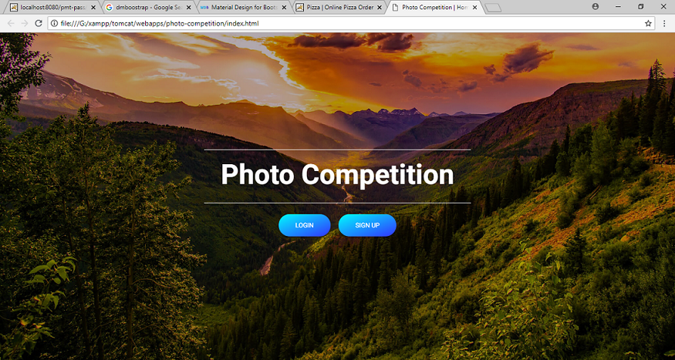

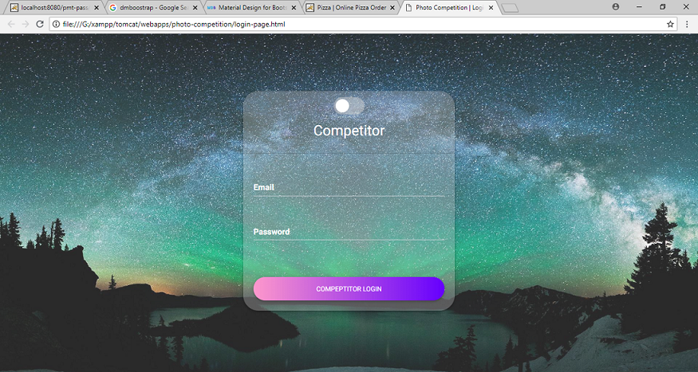

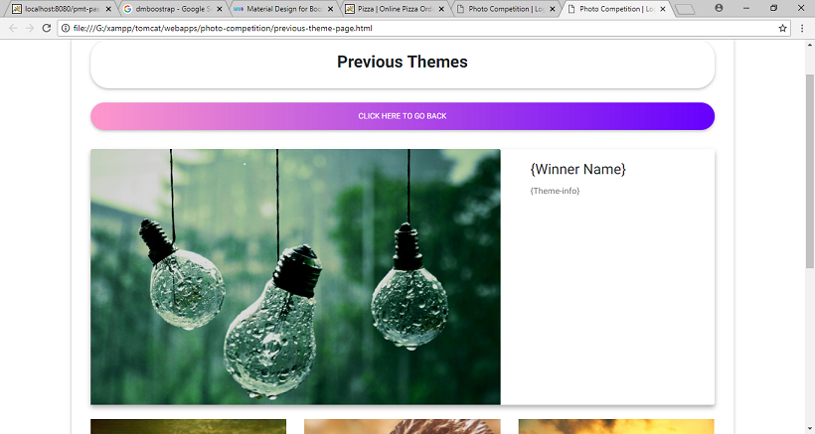

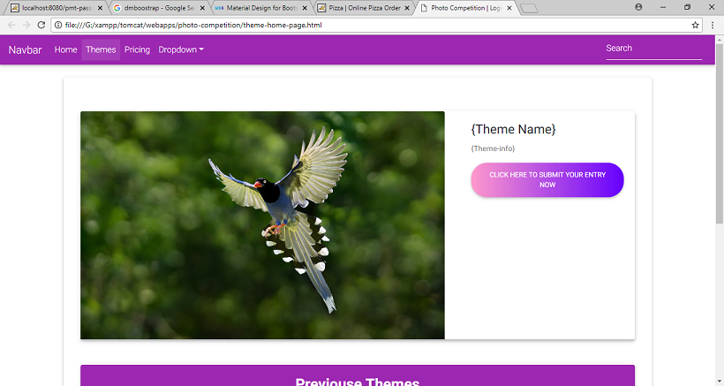

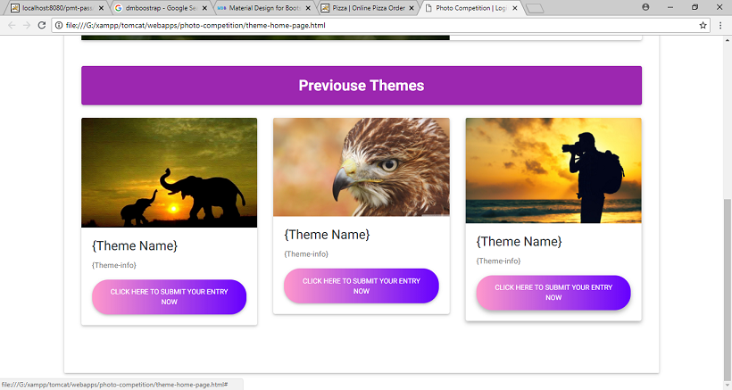

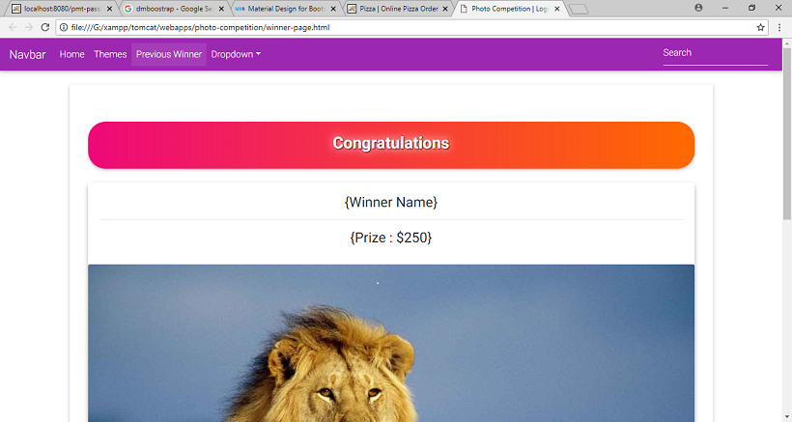

**System Testing**

* The system was tested with usual test routines with the intent of finding an error to detect bugs and to test the quality of the software.
* There are three main kinds of system testing:-
* **Alpha testing** was conducted at the developer side by the end users.
* **Beta testing** was carried out by the selected group of friendly customers, conducted at the end user side.
* **Acceptance testing** was performed by the customer himself to determine whether the system should be accepted or rejected.
* The system begins its first test by **unit testing** one & only one unit is tested as such.
* Testing procedures were carried following the **Bottom-up testing approach**. According to the Bottom-up approach each unit is tested as and when it developed. This units are combining into modules are also individually tested. And finally all the modules are integrated to form the entire system.
* **Integrated testing** is then performed on this developed system.
* An entire code is return in java. The system is object oriented. Thus the entire code is encapsulated into classes so it was easy to perform the testing procedure system was developed progressively taking one module at a time. Finally when all the modules were ready they were integrated to form the entire system.
* Finally when all the modules were integrated and the entire system was ready, I/Otesting ,performance testing and stress testing was carried out to test for all the conditions, exception handling capabilities, etc.
* **Input/output testing** was carried to check whether the system generated consistent files of the desired format. Also Input / Output testing helped to confirm whether the files were successfully uploaded at the server or downloaded from the server.

**Limitations**

* The size of the database increases day-by-day, increasing the load on the database back up and data maintenance activity.
* Training for simple computer operations is necessary for the users working on the system.
* Cyber-crimes are increasing day by day, so advance data security is needed to implement.

**Future Enhancement**

* This System being web-based and an undertaking of Cyber Security Division, needs to be thoroughly tested to find out any security gaps.
* Cyber-crimes are increasing day by day, so advance data security will be implemented in future.
* More searching options will be provided to the employer (company) in the future.

**Bibliography**

* Software Engineering
* HTML & Web Designing

**ONLINE REFERENCE:**