
Green University of Bangladesh
Department of Computer Science and Engineering (CSE)
Faculty of Sciences and Engineering
Semester: (Fall, Year:2023), B.Sc. in CSE (Day)

Lab Report NO # 01
Course Title: Engineering Drawing
Course Code: CSE-208 Section: 221-D2

Lab Experiment Name: Implementation of 2D drawing.

Student Details

Name |  | ID
1. | Md.Fahad Nakib | 221902149

Lab Date : 20-10-23
Submission Date : 24-10-23
Course Teacher’s Name : Md Naimul Pathan

Lab Report Status
Marks: ………………………………… Signature:.....................
Comments:.............................................. Date:..............................

1. TITLE OF THE LAB EXPERIMENT
Implementation of 2D drawing.

2. OBJECTIVES
- It will help us to gain knowledge about 2D or 3D drawing platform Auto cad and how to use this software.
- We can learn about 2D drawing technique and uses of line, rectangle, circle, etc.
- In this experiment we will implement a provided figure using 2D drawing technique.

3. TOOLS AND TECHNOLOGIES

1. line:
Line command draws a straight line from one point to another.
Shortcut Key: L
2. Circle:
Circle helps us to draw a circle. We can draw circle in many ways like using radius, diameter, tan-tan radius, etc.
Shortcut Key: C
3. Trim:
It is used for cutting unwanted line and edges.
Shortcut Key: Tr
4. Ellipse:
Ellipse helps us to draw a Ellipse. We can draw Ellipse in many ways like using radius of both side, using diameter and half ellipse using different point.
5. Angle:
Angle helps us to draw line using different angle. To implement this first we have to select line then press ‘Shift+@’ and give line diameter then press ‘<’ give angle (45) and then press ‘Enter’.
6. Offset:
Offset helps us to create same line in a particular disance.

4. IMPLEMENTATION

- Draw a line and make an offset line using distance between 95cm. Identify the distance in main line and mark it. Then draw a line and draw two ellipse using intersect point as center.

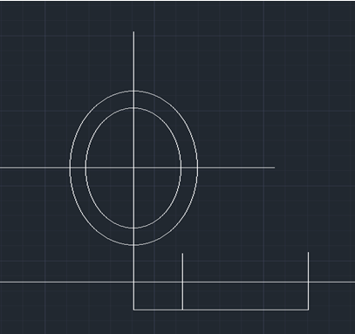
Figure : 01

- Draw another Ellipse and a one at the bottom.

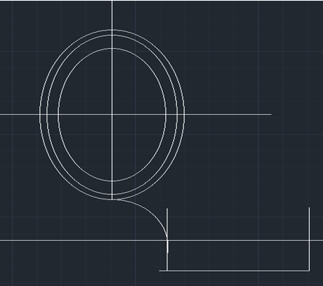
Figure : 02

- Draw four 45 degree angle from x axis in each quadrant and draw two ellipse in each quadrant.
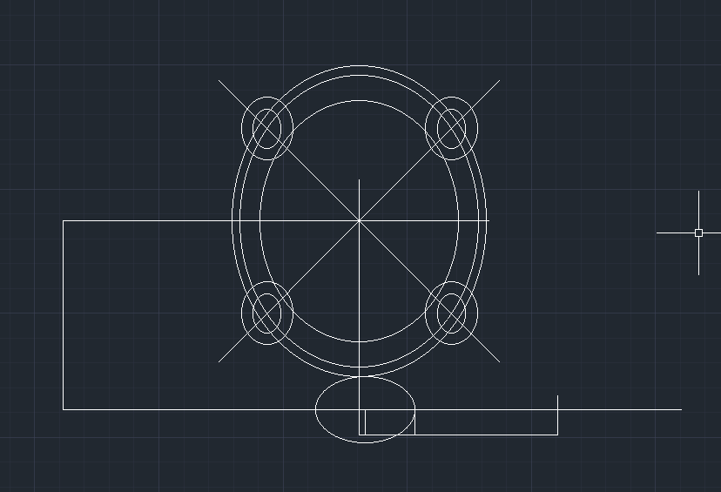
Figure : 03

- Trim the unnecessary lines.

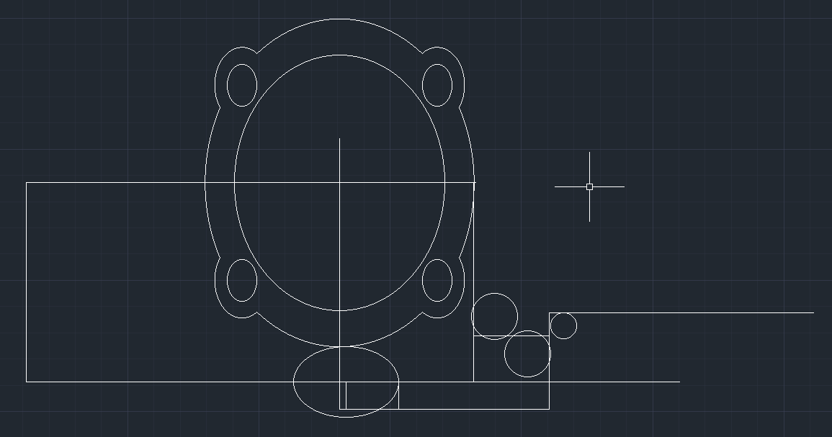
Figure : 04
- Draw rest of the ellipse determining actual distance from given figure and trim unnecessary lines.
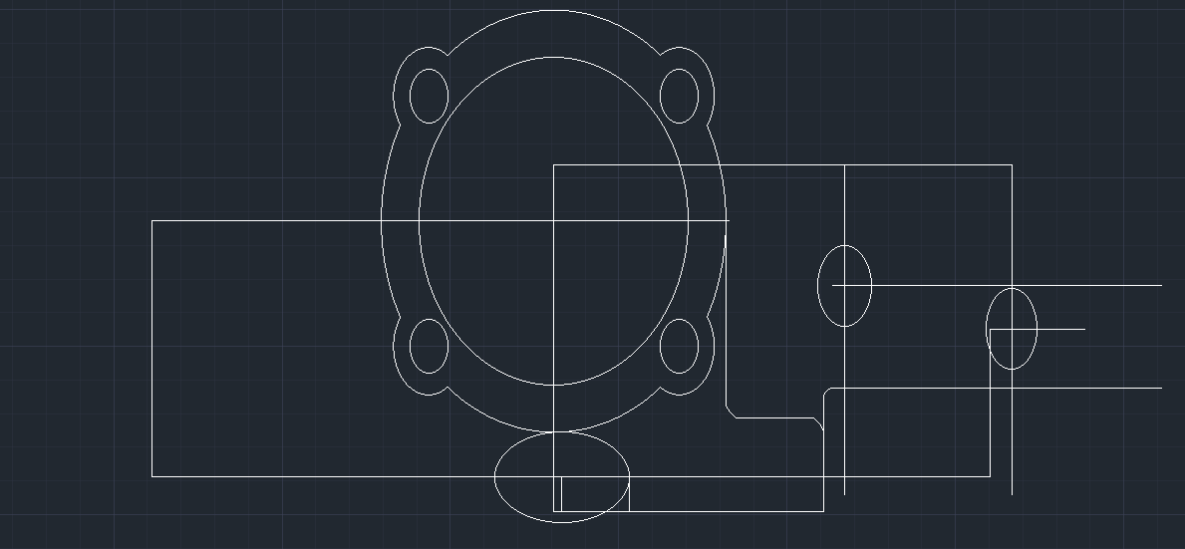
Figure : 05

- Complete all ellipse then draw the tangent of the ellipse and connect together.

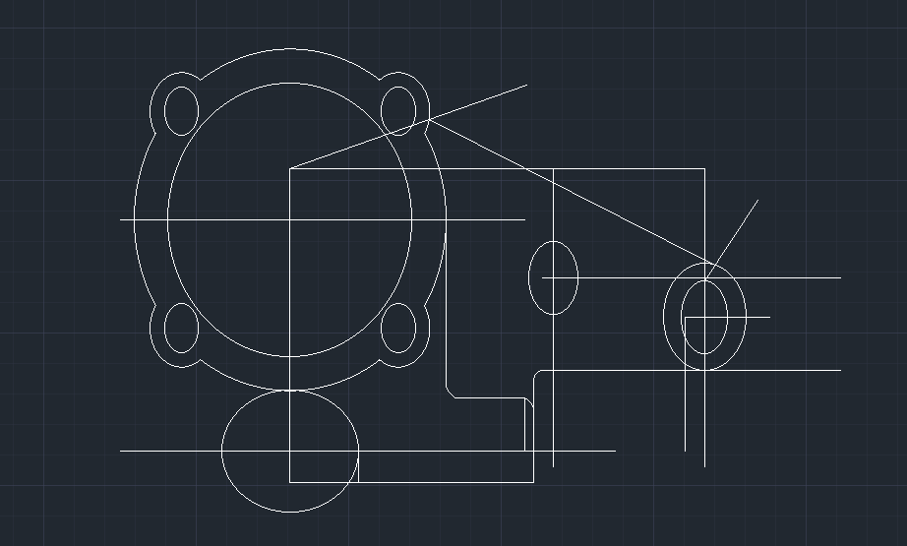
Figure : 06
- Now trim all unnecessary lines from the figure.

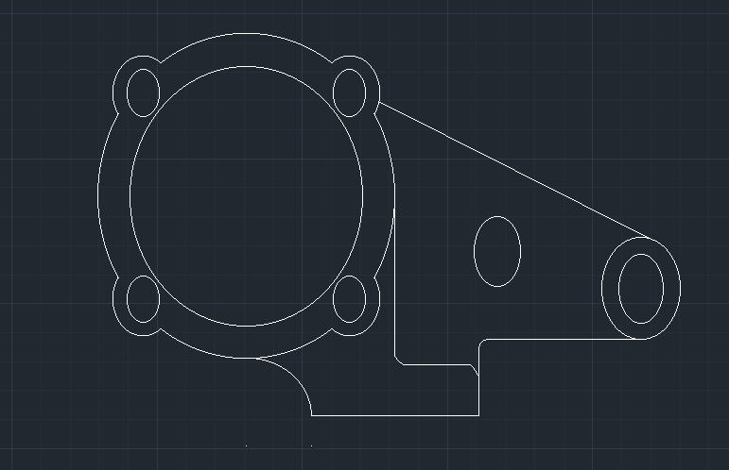
Figure : 07

6. FINAL OUTPUT

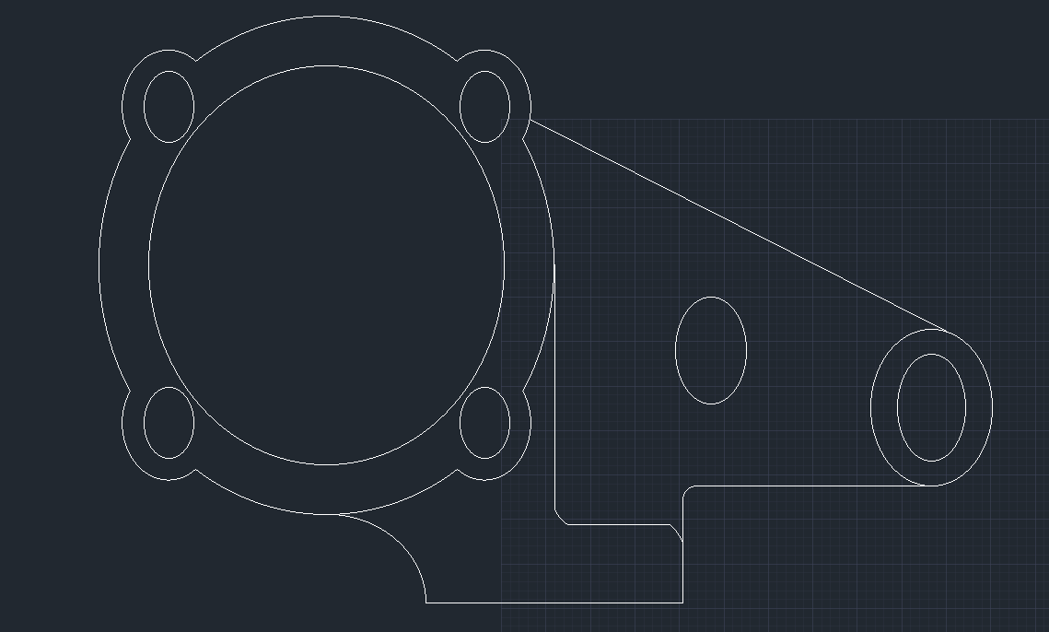
Figure : 08
7. ANALYSIS AND DISCUSSION
- This experiment helps us to learn about basic Auto Cad operations such as create lines, circle, rectangle, ellipse, etc.
- In this experiment I was facing some trouble while drawing the angle in each quadrant. When I give 45 degree as angle input in 2nd, 3rd or 4th quadrant from X axis, each time the line get fixed in 1st quadrant. When I put 45, 135, 225, 315 degree in particular quadrant then it works fine.
- By this experiment we obtain the knowledge about 2D drawing technique and we can implement these tools to implement real life object.

