A

**Project Report**

on

**Mobile and Home Accessories Delivery App**

Submitted in the fulfillment of the requirement for Semester Project of Mobile Computing

**Session (2023-2027)**



**Professor: Submitted By:**

**Mr. Danial Haider Muhammad Fahad 232448**

**Muhammad Bilal 232442**

***DEPARTMENT OF COMPUTING AND ARTIFICAL INTELLIGENCE***

***AIR UNIVERSITY, ISLAMABAD, PAKISTAN***

**DECLRATION**

I Muhammad Fahad, and Muhammad Bilal, students of BSCS in the Department of Computer Science, Air University, Islamabad, under class Roll No. 232448, AND 232442, for the session 2023-2027, hereby, declare that the project entitled “Mobile and Home Accessories Delivery App” has been completed by us during 3rd Semester.

Date : Muhammad Fahad  
 (Roll No. 232448)

Muhammad Bilal  
 (Roll No. 232442)

It is certified that the above statement to the best of my knowledge.

Date: Danial Haider  
 (Lecturer in CS)

Date: Mr.Saddam Hussain

(co-ordinator)

**CONTENTS**

**Topic Page No.**

Candidate’s Declaration 2

Introduction to Project 4

Motivation 4

About Project 5

Functionality 5-6

System Requirements 6

Tools and Technologies 7

Advantages 7

Disadvantages 7

Screenshots

**INTRODUCTION TO PROJECT**

In today’s fast-paced, tech-driven world, convenience shapes consumer behavior. The demand for accessible and efficient online shopping platforms has surged, especially post-pandemic, as people increasingly seek to shop for essentials and luxuries from home.

The **Mobile and Home Accessories Delivery** App addresses this need by offering a seamless platform for browsing, purchasing, and receiving products like phone chargers, earphones, decorative lamps, storage organizers, and smart gadgets—all delivered to your doorstep.

With features like intuitive navigation, personalized recommendations, secure payments, and fast delivery, the app simplifies shopping and eliminates common frustrations like limited store hours and long delivery times. It also supports local businesses by providing them with a digital marketplace to display their products.

Built using modern technologies like Flutter and Android Studio, the app ensures cross-platform compatibility and a consistent user experience. By integrating real-time delivery, tracking the app redefines shopping convenience for its users.

**MOTIVATION**

The project was chosen to meet the rising need for convenient and reliable delivery services for essential, often overlooked items like mobile and home accessories. It fills a niche in the market, ensuring accessibility and efficiency for users.

* **Ease of Access**: Many customers struggle to find quality mobile and home accessories locally. This app bridges the gap by offering a platform where users can conveniently browse and purchase high-quality items, eliminating the need for extensive searching or compromising on quality.
* **Rising E-Commerce Trends**: The growth of online shopping has shifted consumer expectations, with more people relying on digital platforms for their purchasing needs. By aligning with these trends, the app positions itself in a thriving market, leveraging this demand for a streamlined shopping experience.
* **Unique Focus**: Unlike broad e-commerce platforms that cater to various categories, this app focuses exclusively on mobile and home accessories. This specialization allows it to provide a curated selection of products and faster delivery, enhancing user satisfaction by addressing specific needs efficiently.

**ABOUT PROJECT**

1. **Light & Dark Mode:** A customizable user interface offering both dark and light themes for optimal visibility and user comfort.
2. **Login Page:** A secure gateway for users to access their accounts using credentials or social logins.
3. **Register Page:** A simple form for new users to sign up with personal details and create an account.
4. **Menu Drawer:** A side navigation bar providing quick access to app features like Home, Settings, and Profile.
5. **Settings Page:** A dedicated section where users can customize theme modes.
6. **Cart Page:** Displays selected items, allowing users to review, update quantities, and proceed to checkout.
7. **Payment Page:** A secure interface for completing purchases via multiple payment methods.
8. **Receipt Page:** Summarizes the completed transaction, displaying order details and payment confirmation.

**Functionality**

* **User Registration and Login**

- Allows users to create an account or log in using email, phone number, or social media credentials.

- Ensures secure authentication and personalized experience.

* **Product Browsing and Search**

- Users can browse categories and search for specific mobile or home accessories.

* **Order Management**

- Users can add items to their cart, edit quantities, and proceed to checkout.

- Real-time tracking of order status (e.g., Processing, Dispatched, Delivered).

* **Payment Integration**

- Multiple payment options such as credit/debit cards, digital wallets, and cash on delivery.

- Secure payment gateway to protect user information.

* **Notifications**

- Provides order confirmations, delivery updates, and promotional offers via notifications or email.

**System Requirements**

1. **Hardware Requirements**

* Smartphones with Android 6.0+ or iOS 10.0+
* Server with sufficient capacity to handle multiple simultaneous requests.

1. **Software Requirements**

* Smartphones with Android 6.0+ or iOS 10.0+
* Server with sufficient capacity to handle multiple simultaneous requests.

**Tools and Technologies**

* **Flutter:** Cross-platform UI toolkit for building natively compiled applications.
* **Android Studio:** Integrated development environment for Android app development.
* **Firebase:** For authentication, cloud storage, and real-time database services.

**ADVANTAGES OF THE PROJECT**

* Users can shop for mobile and home accessories anytime, anywhere, without the need to visit physical stores. However, this system modification of old specification can be altered very easily.
* Offers a wide range of products, catering to various needs in one place.
* Multiple payment options with enhanced security ensure a safe shopping experience.
* Users can track orders in real-time, offering transparency and peace of mind.

**DISADVANTAGES OF THE PROJECT**

* + Requires a stable internet connection, limiting usability in areas with poor connectivity.
  + Users cannot physically inspect or test products before purchase, which may lead to dissatisfaction.
  + Technical glitches or server downtime can disrupt shopping and delivery processes.

**SCREENSHOTS**

* **Light Mode:**

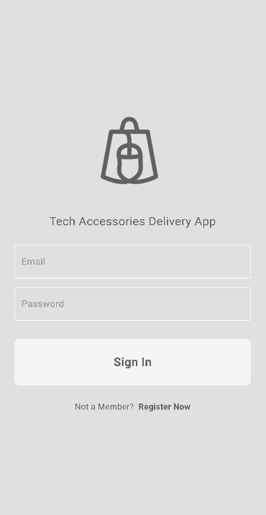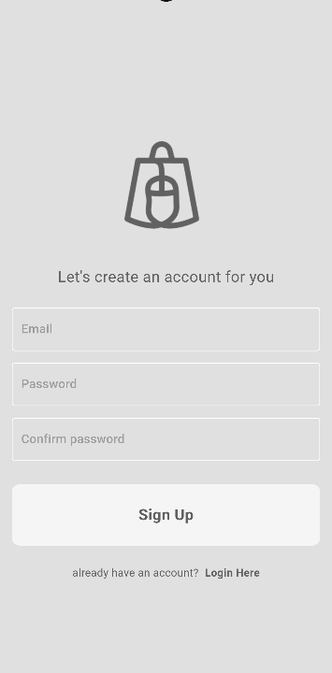

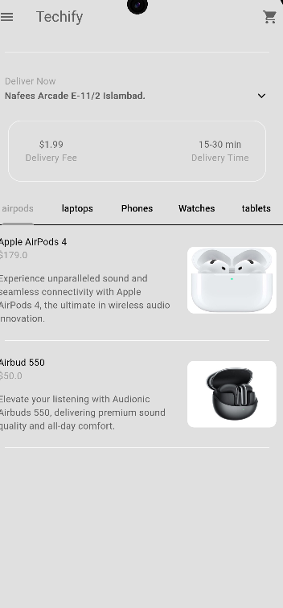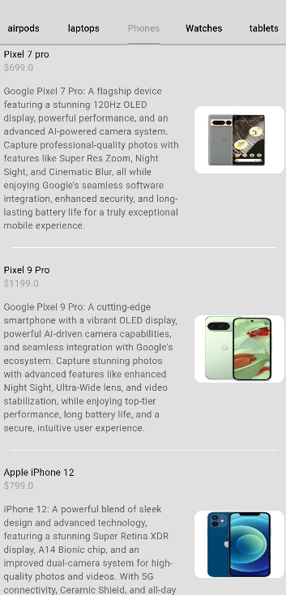

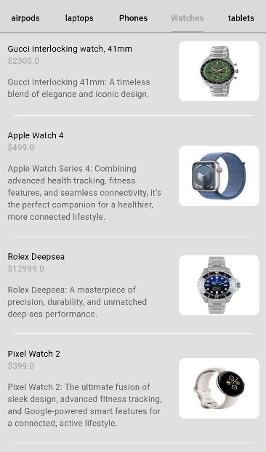 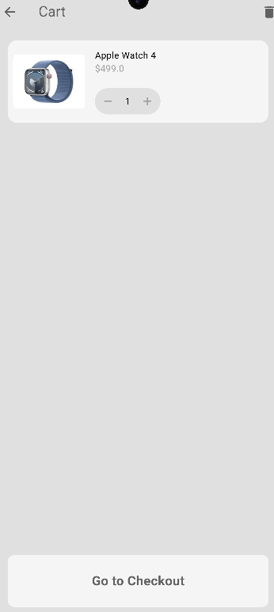

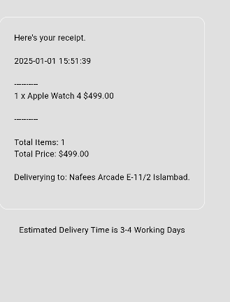

* **Dark Mode:**

