PHP Links
PHP Links
PHP Links
1

Requirements
In order to use PHP Links, you will need to have the following features on your server:
• PHP version 4.3 or later (Works on PHP5 with MySQL5 also)
• MySql 4.x or later
• PHP with php setting Register Globals turned Off.
• PHP with php setting Safe Mode Off.
The program works under the following platforms:
• Linux (Apache)
• Windows (IIS5/Apache)
• BSD/Unix variants with Apache.
Note that if your web host does not have register_globals turned off for all sites, it is possible to run with
register_globals off for all programs in a specific directory by creating a file named .htaccess (with a dot in
front) which includes the line: php_register_globals off. Your host must then have settings that allow the use
of .htaccess files. Please ask your web host about this.
The reason for running the program with register_globals turned off is because of security issues.
Tip: If you do not know your PHP version or settings, you can find them by following these steps:
Steps to find if you meet requirements
1. Create an empty file named test.php and place the file in a public available directory on your
webserver. For instance, put it in /home/USER/public_html/test.php.
2. Edit test.php, and put this content into the file:
<? phpinfo(); ?>
3. Access http://www.yourdomain.com/test.php
4. You should now get a screen like this:
Requirements
2

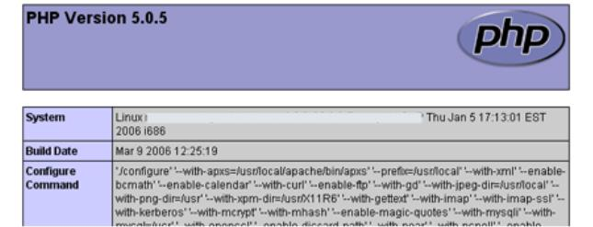
5. If you do not get a screen like this, you do not have PHP configured, and you must fix that before you
can install the program. You can now search (using your browsers Find menu-item) for
register_globals and magic_quotes and see their value.
Please note that you will see two columns a bit furher down. One is the setting that is specially
configured for the local directory THIS FILE is in (local value, to the left). The column to the rigth is
the system default value. If you place test.php in a directory where you have activated
register_globals for instance, your left column will show Off, and maybe the rigth column is On.
Then, the local value (to the left) is the one used for all php files in that directory!
Requirements
3

Download and install
Get the latest version from the download page, and unpack it into your local computer. If you are using
Winzip, make sure that you select "Use folder names", as the image on the left shows.
Quick Install
For those who are familiar with PHP/MySql script installs.
1. Download and extract .zip file, upload to your server.
2. Access phplinks/install.php using your browser.
3. Follow instructions (setting permissions, creating a db etc.)
Detailed Install
1. Create a database in phpMyAdmin or telnet. Normally, if you are on a shared server which is most
common, this database is already created for you. To install this program you need your database
name, your db user name, db password, and your MySql host name. Host name can be localhost or a
name like mysql.isp.com.
2. Now upload local files to your web-server. Be default, WinZip extracts these files to a directory called
classifieds. Rename this directory to whatever you want, later this can not change.
3. If you have Linux, you will need to set write permissions to two directories:
/phplinks(root catalog)
/phplinks/admin
4. To do this on Linux servers, you can do it in one of two ways:
1. Through FTP
If you have a ftp client like cute-FTP, right-click the directories and select CHMOD. You will get a
dialog box that says "Change file attributes". Type in 777 in the "Manual:" text field and click OK. If
you get Internal Server Error when accessing the /admin directory later, the problem might be that
your host does not allow higher permissions than 755. If so, type in 755 instead.
Download and install
4

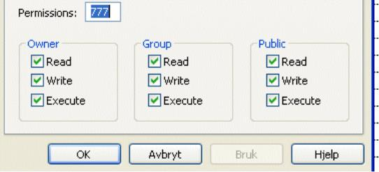
2. Through SSH / Telnet / Shell
To do this in Telnet/SSH, go to classifieds directory (cd /home/user/public_html/phplinks) and type in
the lines below, followed by enter for each line:
chmod 777 phplinks
chmod 777 phplinks/admin
Important: If you have a Linux system with PHP, and have PHP running as cgi-binary (PHP
Suexec) instead of the most common php-module, you need to set chmod to chmod 755 on the above
two catalogs. You will also need to edit install.php and change the 0777 to 0755. If you do not do this,
you will get Internal Server Error.
Now that file permissions are set, it is time to run the installer.
Access the installation with your web-browser, point it to
http://www.domain.com/phplinks/install.php.
5. You will now be confronted with license rules. Read them! Click Next.
6. Now, a list will appear with file permissions you have. At the button, the script will tell you if you
have made an error when doing chmod. If there are no errors (green text), chmod is done correctly,
otherwise you must check your permissions (chmod) again. The script will show which directory does
not have correct permissions. Note: Even though the program will show wrong permission on other
directories than /classifieds and /phplinks/admin, you do only need to set permission on those two
catalogs/directories. The program will be able to create all needed directories if you do that and
push refresh.
Click Continue.
7. The next screen will create your database file which will make sure that you can connect to MySql.
Enter host name (localhost), db user name, db password etc. When you are done, press the button. If
you get an error in this or the next screen, such as "Couldn't connect to MySql database", you have
either given the wrong host name, database name, user name or password (or your MySql might be
down). Click the back button in the browser and try again.
Download and install
5

8. Now, you must choose the name of the tables that PHP Links will use. This is up to you, but we
reccomend that you keep the default prefix. Note that a table named "template" will always be created
in addition. Click Next when finished.
9. If everything goes OK and there is no conflict with an existing database, you will get a Success
message.
10. Now you will get the settings-screen for path. Check that the path to your install is given correctly.
This is VERY important. The path should be the full path. The full path is something like
/home/username/public_html/phplinks, or /usr/www/htdocs/phplinks. This varies from host to host.
Also, type in your domain name withouth http:// and finally your emailaddress. You will see a list of
suggested tablenames. Let them be, and Click Continue. Configuration file is now created.
11. The program is now installed. But you are not done yet.
Follow the link to go to http://yourmain.com/phplinks/set.php. You will be redirected to a login page.
Default username/password is:
User: admin
Password: admin
In the menu to the left, visit General Settings and push Save. Then go to Option Settings and push
Save there too.
12. Important: Delete Install.php, and set permission on PHPLinks and PHPLinks/Admin dir to chmod
644. Then, you are done!
Download and install
6

Administration
Administration
7

Import Links
PHP Links supports import of Links from Dmoz.org. In order to select what Links to import, you need to use
a tool named Tulip Chain that lets you browse Dmoz.org locally and select categories to export to a html file.
The html file you make, is then imported into the category you choose in PHP Links.
If you do not have Java2 Runtime Environment 1.4, you must install that before running Tulip Chain. Read
more here: http://ostermiller.org/tulipchain/
After installing JRE above, follow the link to "Download the latest version of Tulip Chain" at the same page.
When you start the software, you need to spider the categories you want. This may take a long time! Choose
as deep category you want to avoid spidering more than the ones you need. When it is done, you can Export a
category to a dmoz.html file. Check that the dmoz.html contains links.
Now, you can access admin area in PHP Links and import the dmoz.html file. Choose Dry run the first time to
see that it is working OK.
Remember: if you use links from Dmoz/Open Directory project, you must use the html banner for Open
Directory Project. You will find the code commented out in footer.tpl file. Remove the <!-- and -->, and you
will now display the required logo/table.
Import Links
8

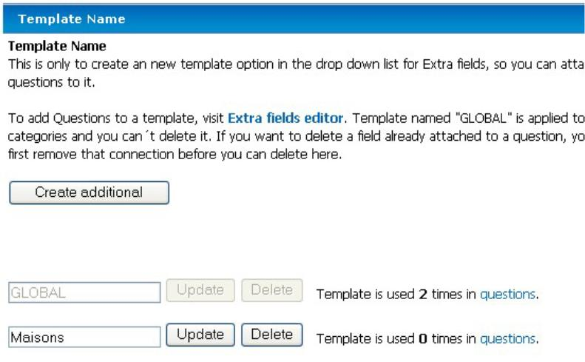
Field Template
A Category template is also called Field template. This is simply put a category that you can put all your
questions into. By default, we have created a super global field template named GLOBAL. This field template
is assigned by default to all categories and you can use {$e_1.value} in all lists to display answers to question
one (Like Best Rated, Most Viewed, Latest on frontpage etc). In detailed view, a super global template will
always show if the user has put a value into the field, you do not need to add anything in templates for it to
show. The same goes for custom templates.
However, in some cases, you may want to show different answers/questions based on what category you are
in. In order to do this, you click the Create additional, type in a random name or at least a name that makes it
easier for you to know what the category is about. It doesn´t matter what name you give it, as long as you
remember what it was called when you go into category administration afterwards and when you add
questions.
When you now go into category administration, you can assign this template to any categoryes you want.
When a user tries to submit an link in a category you have assigned this template to, the user will get
questions that you have defined.
Please note that your custom templates answer/questions will ONLY appear in those categories you have
spesified and they only appear if the user has put a value into the field and thereby answering your question.
Field Template
9

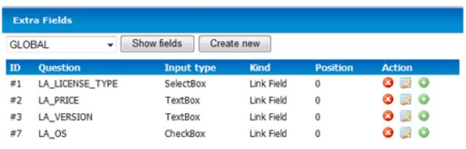
Extra Questions
How to use
You can create unlimited so called extra fields. This means that from inside the admin module you can create
different kinds of questions and each and every one of these questions will appear automatically on "add link"
screens and detailed view.If you create a so called Field Template you can have a set of questions that only
appear in certain categories.
STEP-BY-STEP TO ADD QUESTIONS TO A FIELD TEMPLATE
1. Access the admin area.
2. Click Extrafields under the Configuration caption.
You will now see this (in this example, I have already added four Questions):
In this screen, you see a dropdown button saying Global. This means that it currently is only showing
Questions that will appear in ALL categories. If you click Create new and keeps the Global selected
in the dropdown, you will create a new extra field that will appear in ALL categories. If you select
another so called Field Template and clicks Show fields, it will display the Questions included in the
Field Template selected.
If you intend to show a Question in only one or some selected categories, you must first create a so
called Field Template (see menu) and attach that category template to the categories you want. Then,
your new Field Template will be available in the dropdown menu in the screen above.
3. Click the button Create new. This will show a new row in the list.
First column is showing the extra field number, Question shows the language constant that will be
translated to the real text string. Input type shows what kind of form field to display.
Kind should only show Links.
Position determined in what order the extra field should appear.
Under Action, you have three options: Delete the question (and all answers), Edit the Question or Fill
the options. If you have a SelectBox (dropdown), checkbox or radio buttons, this is where you fill the
list of options. For textboxes, textareas etc, this makes no sense.
Extra Questions
10

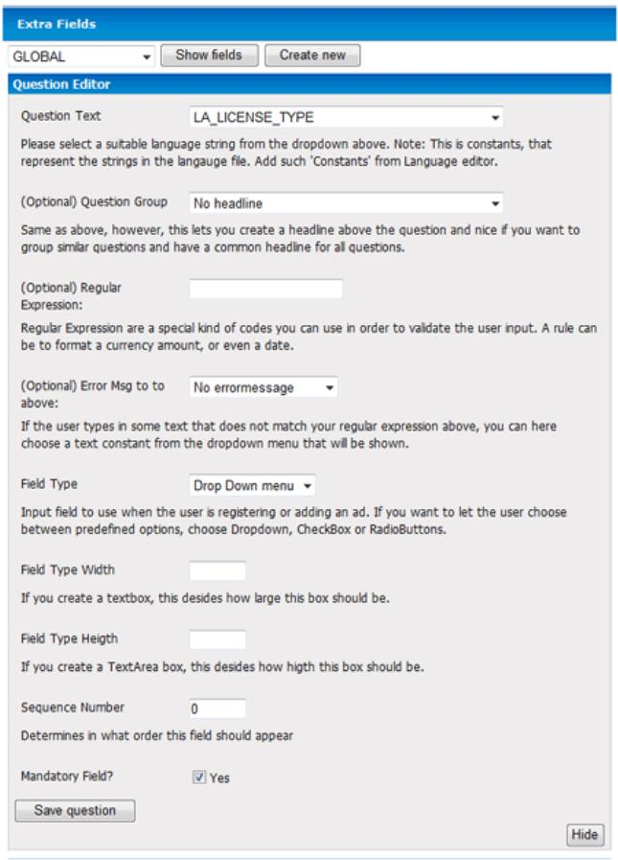
Click Edit Question icon in Actions column. You will see this:
Question Text*:
The question you want to ask the customer. For instance this could be price. However, what you see
is only keycodes (or language constants) that lists all variables in the default language file and your
custom language file. So here you need to choose a language-constant that match your wish. You can
add more language constants from the language file which would be normal to do when you add a
question. Then, go back here and choose that constant in the dropdown list.
Question Group (Category description) :
This will make a bold type/heading before the answer/question in detailed view. Nice if you want to
Extra Questions
11

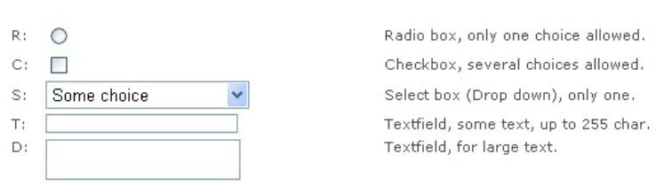
group your questions. If no heading is given, the extra fields will simply appear below each other. By
default, you will see all text-constants from the langauge file. But you can create more from langauge
editor.
Regular Expression:
This is a common way to make sure that users only input data you want to. For instance, you can type
in a "code" that will only let the user type in larger letters or a price formatted string. Read further
down in this manual for more information about this. The input you type here is a kind of code, you
need to format the string in a very special way, do not type normal text here.
Warning: Leave this empty if you do not understand what this field is for.
Read more about Regular Expressions
Error msg to above:
This is a text contant you choose from the dropdown menu. It is shown if the regular expression
above doesn´t match what the user typed.
Field Width (cols)*:
How many characters allowed in a text-field. For TextArea fields, this is how many columns you
should have.
Field Height (cols)*:
How many rows to show. If used with TextArea, it decides how many rows it will have.
Field type*:
This is what kind of box/interface this question will have.
Extra Questions
12

4.
Sequence:
What field to ask for/show first, second, third etc. If you want to have a question as the first one, you
must first move the question that has position one, since several questions cannot have same place. In
these cases, you must unlock a sequence/order number.
Mandatory field:
If you want to force the member to fill out this field, check this.
Extra Questions
13

Search Engine Optimize
You need to setup mod_rewrite like this:
RewriteEngine On
RewriteRule ^$ / [R]
RewriteCond %{REQUEST_URI} !screenshots.*
RewriteCond %{REQUEST_URI} !.gif
RewriteRule ^/(.*)/([0-9]+)(.*) /detail.php?id=$2&path=$1&action=$3 [L]
RewriteCond %{REQUEST_URI} !.*.php
RewriteCond %{REQUEST_URI} !.*.xml
RewriteCond %{REQUEST_URI} !.*.html
RewriteCond %{REQUEST_URI} !.*.txt
RewriteCond %{REQUEST_URI} !.*.js
RewriteCond %{REQUEST_URI} !.*.ico
RewriteCond %{REQUEST_URI} !screenshots.*
RewriteCond %{REQUEST_URI} !admin.*
RewriteCond %{REQUEST_URI} !tools.*
RewriteCond %{REQUEST_URI} !images.*
RewriteCond %{REQUEST_URI} !.gif
RewriteCond %{REQUEST_URI} !javascript.*
RewriteCond %{REQUEST_URI} !style.*
RewriteRule ^/(.*) /index.php?catname=$1 [L]
If you have PHP Links in a subdirectory, you may need to change it to this:
RewriteEngine On
RewriteRule
^phplinks$ / [R]
RewriteCond %{REQUEST_URI} !screenshots.*
RewriteCond %{REQUEST_URI} !.gif
RewriteRule ^/phplinks/(.*)/([0-9]+) /phplinks/detail.php?id=$2&path=$1 [L]
RewriteCond %{REQUEST_URI} !.*.php
RewriteCond %{REQUEST_URI} !.*.xml
RewriteCond %{REQUEST_URI} !.*.js
RewriteCond %{REQUEST_URI} !screenshots.*
RewriteCond %{REQUEST_URI} !admin.*
RewriteCond %{REQUEST_URI} !tools.*
RewriteCond %{REQUEST_URI} !images.*
RewriteCond %{REQUEST_URI} !.gif
RewriteCond %{REQUEST_URI} !javascript.*
RewriteCond %{REQUEST_URI} !style.*
RewriteRule ^/phplinks/(.*) /phplinks/index.php?catname=$1 [L]
#RewriteLog "/usr/local/apache/logs/rewrite.log"
#RewriteLogLevel 3
Search Engine Optimize
14

