

Off site SEO report
Search visibility and backlink audit
Where National Fostering Group stands in organic search today, the health of its backlink profile, and the priorities to act on next.
Prepared for National Fostering Group | September 2026

01 · Situation at a glance
Strong in search, thin in links.
This audit looks at what search engines see beyond NFG's own website. NFG punches well above its weight on the searches that bring in enquiries, but the link base that search engines use to judge trust is small and very new. Here are the four headline numbers, each with how NFG places among the ten fostering websites benchmarked.
Authority Score  36  A trust rating from 0 to 100. Above the competitor middle of 29.  Ranks 2 of 10 | Referring domains  420  Separate websites that link to NFG. The competitor middle is about 820.  Ranks 9 of 10
Organic traffic  15,906  Estimated monthly visits from unpaid search. Near the top of the set.  Ranks 2 of 10 | Organic keywords  4,028  Distinct search terms NFG ranks for in the UK.  Ranks 2 of 10

Read together, these tiles tell one story. On visibility and traffic NFG sits second only to the sector body theFosteringNetwork. On the count of websites linking in, it sits second from bottom. That single gap, off the page rather than on it, is what the rest of this report is about.
02 · The link base
A young and risky backlink profile.
A healthy link profile grows steadily over years and leans on trusted, relevant sites. NFG's did neither. It was flat for years, then jumped almost vertically, and much of what arrived carries the fingerprints of bought links.
Referring domains over time. Separate websites linking to NFG, month by month. The profile was negligible until February 2026, then spiked.
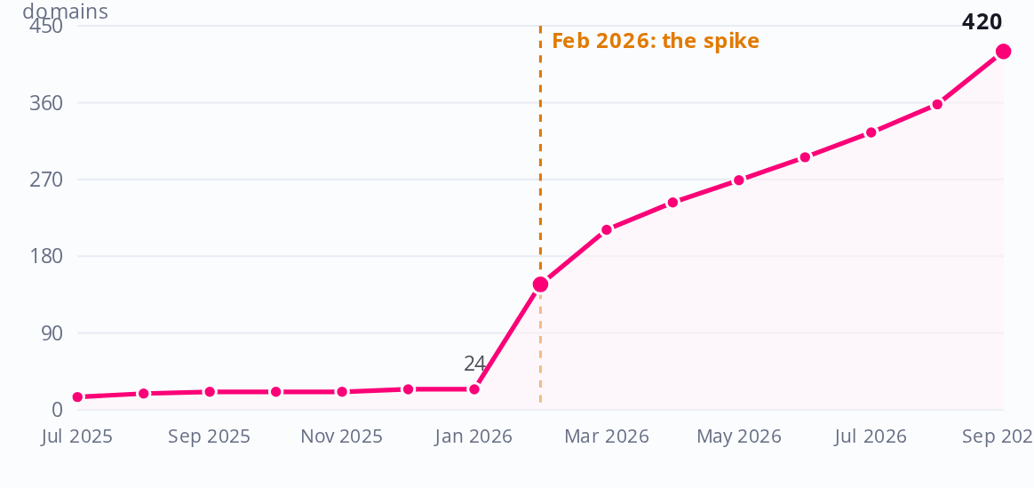
NFG's profile existed since 2024, but it was tiny: about 24 referring domains right through to January 2026. Then it spiked to 147 in February 2026 and reached 420 by September. Roughly 94 percent of the 420 referring domains were acquired in the last 8 months. A near vertical rise like this is the signature of an aggressive, bought campaign rather than earned reputation.
Why this matters
The high Authority Score of 36 is riding on that recent surge, not on a broad, earned base. Growth bought this quickly can be discounted by search engines later, so the score is more fragile than it looks.

Three toxicity signals stand out
A heavy low quality tail. About 67 percent of the referring domains sit in the lowest trust band, Authority Score 0 to 10. The competitor middle is around 54 percent, so NFG carries an unusually large weak tail.
Live link buying anchors. More than 100 referring domains carry link text that openly advertises paid schemes, for example offers of premium private blog network links and safe link velocity. That is a direct paid link footprint, not organic mentions.
Address clustering. Around 42 domains, roughly one in ten, share just two IP addresses, and a further 23 sit on a single Singapore subnet. Sharing addresses at this rate is a classic private blog network pattern, and it lines up in time with the February spike.
Referring domains by trust band. A healthy profile tapers like a pyramid. This one spikes in the weakest band (score 0 to 10, red).
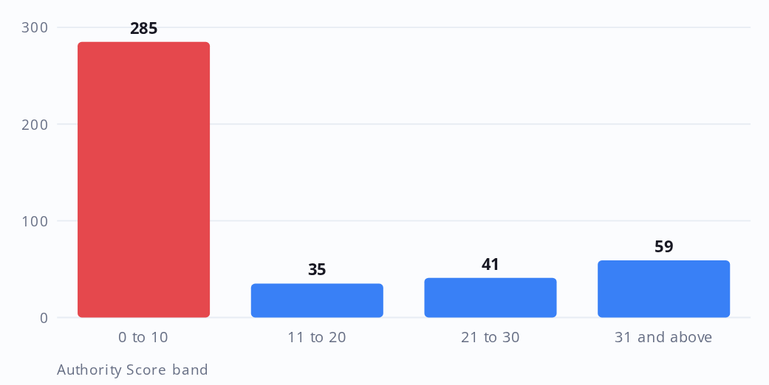
Handle the clean up carefully, not with a blunt tool
About 111 referring domains send dofollow links that openly advertise paid schemes, and are the clear disavow candidates. Only the dofollow spam is disavowed; nofollow spam is left alone because it passes no equity. The wider low trust tail should be sense checked by hand before any removal, because some low authority domains are genuine local council, charity or news sites worth keeping. Disavow is a scalpel here, not a hammer.

03 · The search terms
NFG already wins the commercial searches.
On the terms that turn into enquiries, the money terms, NFG is already strong. The real opening is elsewhere: high volume informational searches where NFG does not appear at all, but competitors do.
NFG owns the commercially valuable terms. It ranks at position 4 for fostering agencies, position 5 for foster carer salary, position 9 for become a foster carer. These are the searches a prospective carer runs when they are close to enquiring, and NFG is visible on them.
Where NFG is missing is the informational layer: the questions people ask earlier in their journey, long before they pick an agency. Those searches are large, winnable, and almost entirely unclaimed by NFG today.
What it means
The next content investment should go into informational topics, not more money term pages. The money terms are close to won. The informational demand is open ground that also builds the topical authority the whole site needs.

Where NFG sits, by search intent. A longer bar means a stronger ranking. Commercial terms in blue, informational in orange.
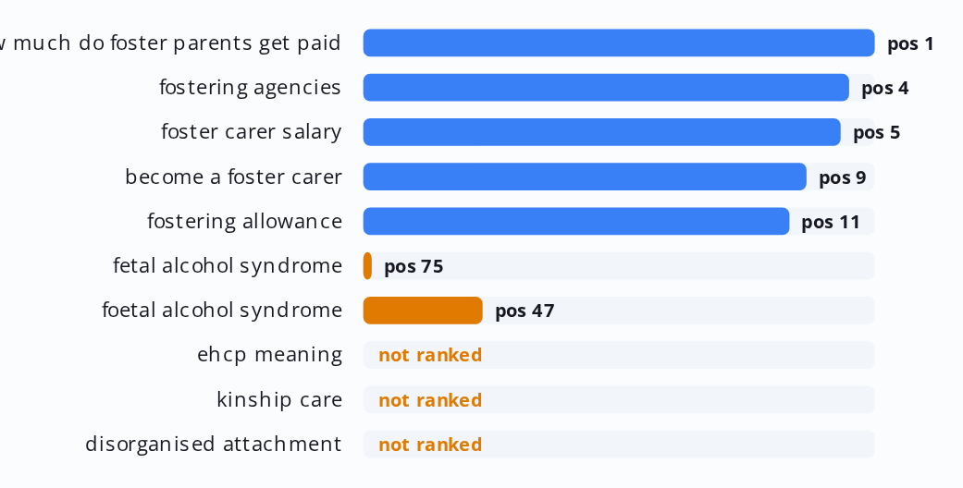
The open opportunity: monthly UK searches NFG does not rank for. Every cluster here is proven winnable, with at least one competitor already on page one.
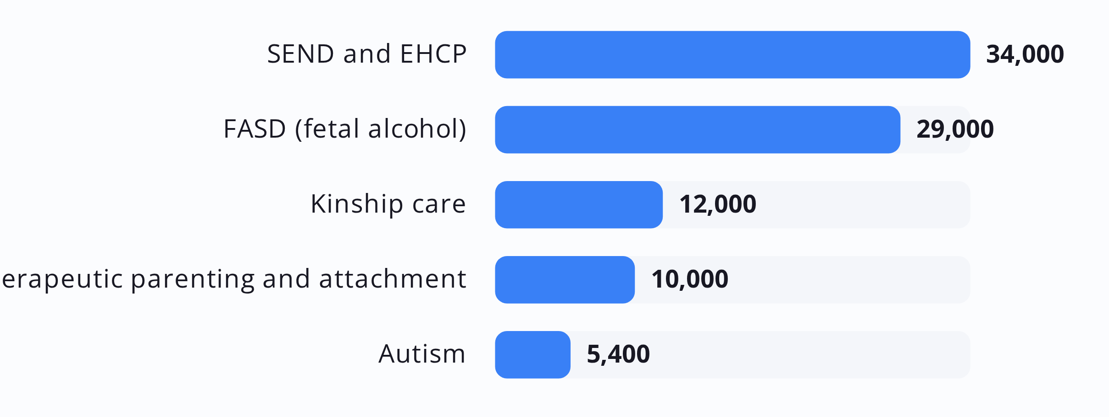
04 · The regional map
Where NFG is invisible: the regions.
Fostering demand is deeply local, and links from local news, councils and universities carry real weight. NFG is strong in a couple of regions and absent in others that competitors have already proven reachable, including places NFG genuinely operates.
Regional link strength: NFG versus the best competitor. NFG in pink, best single competitor in grey. Regions with a red dot are open ground.
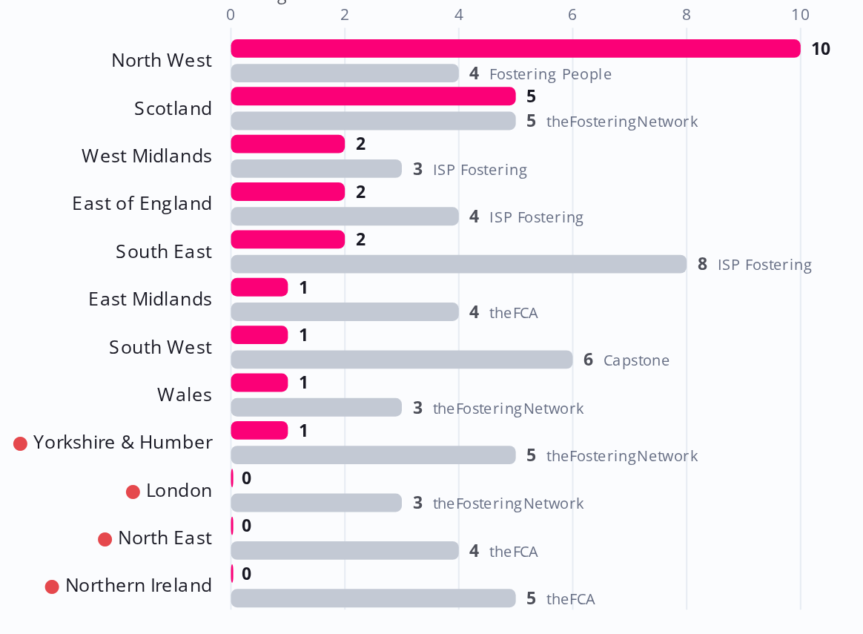
NFG leads in the North West with ten strong local links, and holds Scotland with five. But it has nothing in the North East and only a single link in Yorkshire and Humber. Both of those regions are proven attainable: the sector bodies theFCA and theFosteringNetwork hold four to five local links each there.
Crucially, both gaps sit inside NFG's real service geography. NFA North covers Yorkshire and Lincolnshire, and Reach Out Care covers the North East and Cumbria. So local pages and outreach here would rest on genuine on the ground presence, not thin doorway pages.
A starter set of regional targets already linking to competitors:
• chroniclelive.co.uk North East
• sunderlandecho.com North East
• leeds.ac.uk Yorkshire
• leeds.gov.uk Yorkshire
• hulldailymail.co.uk Yorkshire
• newcastleworld.com North East
05 · The competitive field
How NFG compares.
The same ten fostering websites, ranked on the four measures that matter. NFG, shown in pink, is top tier on three of them and last but one on the fourth. That fourth measure, referring domains, is the whole story in one picture.
The four measures across all ten websites. NFG highlighted in pink, competitors in grey.
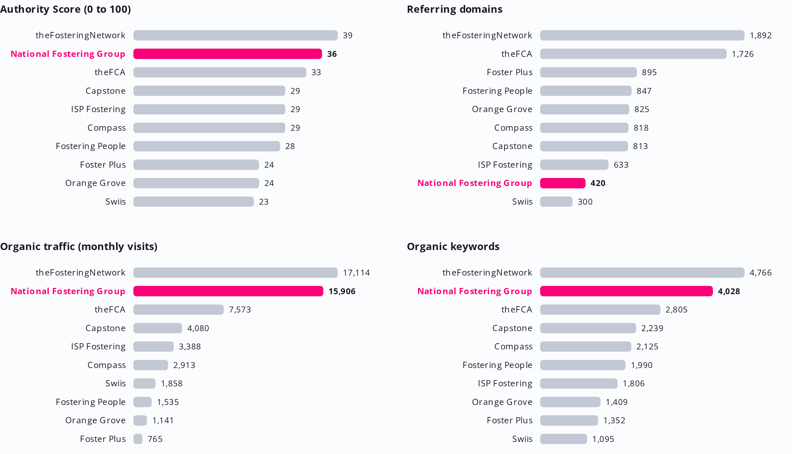
Reading the field
The pattern is the same across every panel. NFG sits in the top tier on Authority Score, Organic Keywords and Organic Traffic, but near the bottom on Referring Domains. Three strong pillars and one weak one.
That single weak pillar, referring domains, is the deficit. Closing it is the highest leverage work available, because the other three measures are already competitive.
06 · The plan
What to focus on next.
Four moves follow directly from the findings. They are sequenced so the defensive clean up protects the base while the growth work builds on it. Together they turn a fragile, narrow profile into a durable one.
MOVE 01  Clean the link base, with a scalpel  Disavow the 111 dofollow spam domains, then sense check the wider low trust tail by hand before touching it. This protects the group from the risk built into February's spike without discarding genuine local and charity links.  Defensive · do first | MOVE 02  Earn real regional links in Yorkshire and the North East  Target local news, councils and universities such as chroniclelive.co.uk, leeds.ac.uk and leeds.gov.uk, anchored to genuine presence through NFA North and Reach Out Care. This closes the clearest regional whitespace and grows the referring domain count where NFG is weakest.  Highest leverage
MOVE 03  Build the SEND and EHCP information hub  Create genuinely useful content around SEND and EHCP, about 34,000 searches a month, and extend it into FASD, kinship care and therapeutic parenting. This captures large, winnable informational demand and builds the topical authority the whole site benefits from.  Content growth | MOVE 04  Fix the fostering allowance quick win  The term fostering allowance sits at position 11, just off page one, with two competing NFG pages splitting the signal. Consolidate them onto one clear page and add internal links. A small fix on a term NFG nearly owns already.  Quick win

In short: NFG has earned strong visibility and already wins the searches that convert. The base underneath it is young and needs both protecting and broadening. Do the clean up, widen the regional link base where NFG genuinely operates, and open up the informational demand it is currently missing. Those three things compound, and the quick win pays for itself in weeks.

