
TEERTHANKER MAHAVEER UNIVERSITY
MORADABAD (U.P.)
FACULTY OF ENGINEERING & COMPUTING SCIENCES
PROJECT REPORT
on
Development of a Multiple Disease Prediction System Using Machine Learning

Submitted in Partial Fulfilment of the Requirement for the Degree of
Bachelors in Computer Application
(AI & Data Analytics)
By
SHORYA AGARWAL
Enrollment No.: TCA2568564
Semester – 5th | Section – G
September, 2026
Submitted To | Submitted By
Guide: Mr. Savood Ahmad  Guide: Ms. Sneha | Shorya Agarwal  TCA2568564
Faculty of Engineering & Computing Sciences | Bachelors in Computer Application
Teerthanker Mahaveer University, Moradabad | Section – G • September, 2026

FACULTY OF ENGINEERING & COMPUTING SCIENCES
TEERTHANKER MAHAVEER UNIVERSITY, MORADABAD

DECLARATION

I, Shorya Agarwal, student of Bachelors in Computer Application, Semester-5th, studying at Teerthanker Mahaveer University, Moradabad (U.P.), hereby declare that the Project Report / Dissertation entitled “Development of a Multiple Disease Prediction System Using Machine Learning” submitted in partial fulfilment of the requirement for the degree of BCA is an original work carried out by me.
The information and analysis presented in this report are true to the best of my knowledge. This Project Report / Dissertation has not been submitted to any other University for the award of any other Degree, Diploma or Fellowship.
I further declare that I have used open-source tools, publicly available datasets and a reference Streamlit implementation for academic demonstration, and that the documentation, system analysis, diagrams and report writing presented here are my own work for this submission.
Date: 17-09-2026
Place: Moradabad
Submitted By:
Shorya Agarwal
(TCA2568564)

CERTIFICATE

This is to certify that the Project Report / Dissertation entitled “Development of a Multiple Disease Prediction System Using Machine Learning” has been submitted in partial fulfilment of the requirement for the degree of BCA and has been carried out by the student whose name is listed below, under my / our supervision and guidance.
Submitted By:
Shorya Agarwal (TCA2568564)
Guide Name | Guide Signature
Mr. Savood Ahmad
Ms. Sneha
Date: 17-09-2026
Place: Moradabad
Faculty of Engineering & Computing Sciences
Teerthanker Mahaveer University, Moradabad

ACKNOWLEDGEMENT

I am thankful to all those who helped me complete this Project Report / Dissertation on “Development of a Multiple Disease Prediction System Using Machine Learning”.
First, I express my sincere gratitude to my Supervisor / Guide Ms. Sneha and Mr. Savood Ahmad, who supported me from the beginning of this work. Their guidance, suggestions and academic direction helped me organise the problem statement, the implementation description and the final report.
I also take this opportunity to express my deep sense of gratitude to the Hon’ble Principal and to the Faculty of Engineering & Computing Sciences, Teerthanker Mahaveer University, for providing an academic environment that made this work possible.
I express my sincere thanks to the Project / Dissertation Coordinator Ms. Sneha, TMU, for the interest taken and the help provided throughout the project. I am also grateful to my family and classmates for their encouragement during the preparation of this report.
Date: 17-09-2026
Shorya Agarwal (TCA2568564)

ABSTRACT

The Multiple Disease Prediction System is a machine-learning decision-support application developed to present three independent disease-prediction modules through one browser-based interface. Health-risk assessment often depends on disease-specific indicators, and a user would otherwise need separate tools, separate forms and separate model files for diabetes, heart disease and Parkinson’s disease. This project addresses that fragmentation by combining structured input forms, saved classification models and a consistent result display inside a single Streamlit application.
Three classification pipelines are used. Diabetes prediction is performed with a Support Vector Machine (linear kernel) trained on the PIMA diabetes dataset (768 records, 8 clinical features). Heart-disease prediction is performed with Logistic Regression trained on a heart-disease dataset (303 records, 13 cardiac features). Parkinson’s prediction is performed with a Support Vector Machine (linear kernel) trained on a voice-measurement dataset (195 records, 22 acoustic features). The trained estimators are stored as pickle artifacts (diabetes_model.sav, heart_disease_model.sav and parkinsons_model.sav) and loaded once when the application starts.
At runtime the user selects a module from the sidebar, enters the required numerical values, and submits the form. The application converts the inputs to float, builds an ordered feature vector and calls the corresponding model’s predict() method. A direct classification-style message is then shown. On the training notebooks accompanying this project, the diabetes model achieved about 77.27% test accuracy, the heart-disease model about 81.97% test accuracy, and the Parkinson’s model about 87.18% test accuracy.
The system is implemented with Python, NumPy, scikit-learn, Streamlit and streamlit-option-menu. It is intended as an academic demonstration of end-to-end machine-learning deployment and as a prototype decision-support interface. It is not a clinical diagnostic device. The report documents the problem, scope, modules, methodology, architecture, technology stack, limitations and possible future enhancements.
Keywords:
Machine Learning; Streamlit; Disease Prediction; Support Vector Machine; Logistic Regression; Diabetes; Heart Disease; Parkinson’s Disease; Pickle; Decision Support.

TABLE OF CONTENTS

After opening this file in Microsoft Word, right-click the table below (or press Ctrl+A and F9) and choose Update Field if you need Word to refresh automatic page numbers. A complete manual contents list is provided for immediate reading and editing.
DECLARATION | i
CERTIFICATE | ii
ACKNOWLEDGEMENT | iii
ABSTRACT | iv
TABLE OF CONTENTS | v
LIST OF FIGURES | vii
LIST OF TABLES | viii
1. PROJECT TITLE | 1
2. PROBLEM STATEMENT | 1
3. PROJECT DESCRIPTION | 2
3.1 Aim, Objectives and Scope | 2
3.2 Scope of the Work | 3
3.3 Existing Approach versus Proposed System | 3
3.4 Project Modules | 4
3.5 Context Diagram (High Level) | 6
4. IMPLEMENTATION METHODOLOGY | 7
4.1 Sequential Machine-Learning Methodology | 7
4.2 Data Collection and Datasets | 8
4.3 Data Preprocessing | 9
4.4 Feature Design by Disease Module | 10
4.5 Model Training | 11
4.6 Model Evaluation | 12
4.7 Model Serialization | 13
4.8 Application Inference Pipeline | 13
4.9 Data Flow Diagram | 14
4.10 Flow Chart | 15
4.11 Use Case Diagram | 16
5. SYSTEM ARCHITECTURE (HLD AND LLD) | 17
6. DISEASE MODULES AND FEATURE DESIGN | 18
7. USER INTERFACE AND NAVIGATION DESIGN | 20
8. TECHNOLOGIES TO BE USED | 21
8.1 Software Platform | 21
8.2 Hardware Platform | 22
8.3 Tools | 22
9. FEASIBILITY ANALYSIS | 23
10. ADVANTAGES OF THIS PROJECT | 24
11. SECURITY, RELIABILITY AND LIMITATIONS | 25
12. ASSUMPTIONS | 26
13. EXPECTED IMPACT AND BENEFITS | 27
14. FUTURE SCOPE AND FURTHER ENHANCEMENT | 28
15. PROJECT REPOSITORY LOCATION | 29
16. DEFINITIONS, ACRONYMS AND ABBREVIATIONS | 30
17. CONCLUSION | 31
18. REFERENCES / BIBLIOGRAPHY | 32
APPENDIX A Feature Dictionary | 34
APPENDIX B Software Dependencies and Runtime Command | 36
Note: Page numbers in this contents list are approximate. They will shift slightly after you edit the file or after Microsoft Word paginates the document on your computer. You may update the numbers freely.

LIST OF FIGURES

Figure No. | Title
Figure 1 | Context Diagram (Level 0) of the Multiple Disease Prediction System
Figure 2 | Existing fragmented workflow versus the proposed unified system
Figure 3 | Logical system architecture of the deployed application
Figure 4 | End-to-end inference methodology used by the Streamlit application
Figure 5 | Machine-learning training pipeline and runtime inference pipeline
Figure 6 | Application flow chart
Figure 7 | Use case diagram
Figure 8 | High-level design (HLD) and low-level design (LLD)
Figure 9 | User interface and sidebar navigation design

LIST OF TABLES

Table No. | Title
Table 1 | Comparison of the three disease-prediction modules
Table 2 | Diabetes module — input features
Table 3 | Heart-disease module — input features
Table 4 | Parkinson’s module — input features (voice measures)
Table 5 | Datasets used for model training
Table 6 | Algorithms, split settings and observed accuracy
Table 7 | Software stack and role of each component
Table 8 | Hardware requirements
Table 9 | Feasibility summary
Table 10 | Project artifacts and repository location
Table 11 | Definitions, acronyms and abbreviations
Table 12 | Application dependencies (requirements.txt)

1. PROJECT TITLE
Design and Development of a Machine Learning–Based Multiple Disease Prediction System for Diabetes, Heart Disease and Parkinson’s Disease using a Unified Streamlit Interface
The short title used throughout this report is Multiple Disease Prediction System. The implemented application presents three independent classification modules — Diabetes Prediction, Heart Disease Prediction and Parkinson’s Prediction — inside one Streamlit web interface titled “Health Assistant”.

2. PROBLEM STATEMENT
Health-risk assessment often involves different disease-specific indicators. Diabetes screening uses laboratory and demographic values such as glucose, BMI and age. Heart-disease assessment uses cardiac measurements such as chest-pain type, cholesterol, maximum heart rate and ST depression. Parkinson’s screening, in the dataset used here, depends on voice-related numerical measures such as jitter, shimmer, HNR and PPE. Because the feature sets are different, a user may need separate workflows, separate programs and separate model files for each task.
Technical machine-learning models are also difficult to consume directly. A saved estimator in pickle format cannot be used by a non-technical user unless an interface collects inputs, converts them to numbers, calls predict(), and explains the output in ordinary language. Without that interface, even a correctly trained model remains inaccessible.
The proposed project addresses these challenges by building a unified, browser-based prediction system. The application loads three saved classification models at startup, provides a sidebar for module selection, presents a structured input form for each disease, converts the entered values to a numeric feature vector, and displays a clear classification message. The same interaction pattern is used for all three diseases; only the input schema and the loaded model change.
The project is positioned as an academic / prototype decision-support system. It demonstrates end-to-end machine-learning deployment — from dataset and training notebook to serialized artifact to user-facing inference — but it does not replace a clinical diagnosis, laboratory test or physician review.

3. PROJECT DESCRIPTION
The Multiple Disease Prediction System is a Python application that uses Streamlit for the user interface and scikit-learn estimators for inference. The source file app.py is the runtime program. It sets the page configuration, loads three model files from the saved_models directory, and renders one of three pages according to the sidebar choice.
The three prediction tasks are independent. They do not share features, they do not share estimators, and a result on one page has no effect on another page. What they share is the application shell: wide layout, option-menu navigation, text-input forms, a test-result button, float conversion, model.predict([user_input]), and an st.success() message.

3.1 Aim, Objectives and Scope
The aim of the project is to provide a single, easy-to-use interface through which a user can obtain machine-learning predictions for three diseases without interacting with model files, notebooks or source code.
The specific objectives are:
- Provide disease-specific input forms for diabetes (8 features), heart disease (13 features) and Parkinson’s disease (22 features).
- Convert user-entered values to numeric form before inference, using an ordered feature list that matches the training schema.
- Connect each form to its corresponding saved model artifact loaded at application startup.
- Display a direct classification-style diagnosis message immediately after the user submits the required values.
- Keep navigation and result presentation consistent across modules so that the learning curve remains small.
The current scope is limited to the following:
- Diabetes prediction using 8 clinical / demographic inputs and diabetes_model.sav.
- Heart-disease prediction using 13 cardiac inputs and heart_disease_model.sav.
- Parkinson’s prediction using 22 voice-related numerical inputs and parkinsons_model.sav.
- Inference performed with the loaded model’s predict() method; no retraining occurs inside the Streamlit app.
- A prototype web UI. Authentication, patient databases, audit logs and hospital-system integration are outside the present scope.

3.2 Scope of the Work
The work covered by this project includes collection of public tabular datasets, exploratory inspection in training notebooks, train–test splitting, fitting of classification models, accuracy evaluation, serialization of the fitted estimators, and development of the Streamlit application that consumes those estimators. The major areas are:
- Use of three CSV datasets: diabetes.csv, heart.csv and parkinsons.csv.
- Separation of features (X) and target labels (Y) for each disease.
- An 80:20 train–test split, with stratification where the notebook applies it.
- Training of SVM (linear kernel) for diabetes and Parkinson’s, and Logistic Regression for heart disease.
- Evaluation using training accuracy and test accuracy.
- Saving of models as .sav files with pickle.
- Implementation of app.py with sidebar navigation, three input forms and result display.
- Preparation of this project report, including architecture, diagrams, limitations and future work.

3.3 Existing Approach versus Proposed System
In a traditional or fragmented workflow, each disease has its own tool. The user must open a different interface, learn a different form, and interpret a different style of output. Repeated navigation and inconsistent interaction patterns increase the effort required even when the underlying task — enter numbers, obtain a class label — is the same.
The proposed system places one Streamlit interface in front of three predictors. The user stays inside the same application, chooses a module from the sidebar, fills the corresponding form, and receives a prediction result in the same visual pattern. This reduces interaction complexity and makes the machine-learning models usable without exposing code.
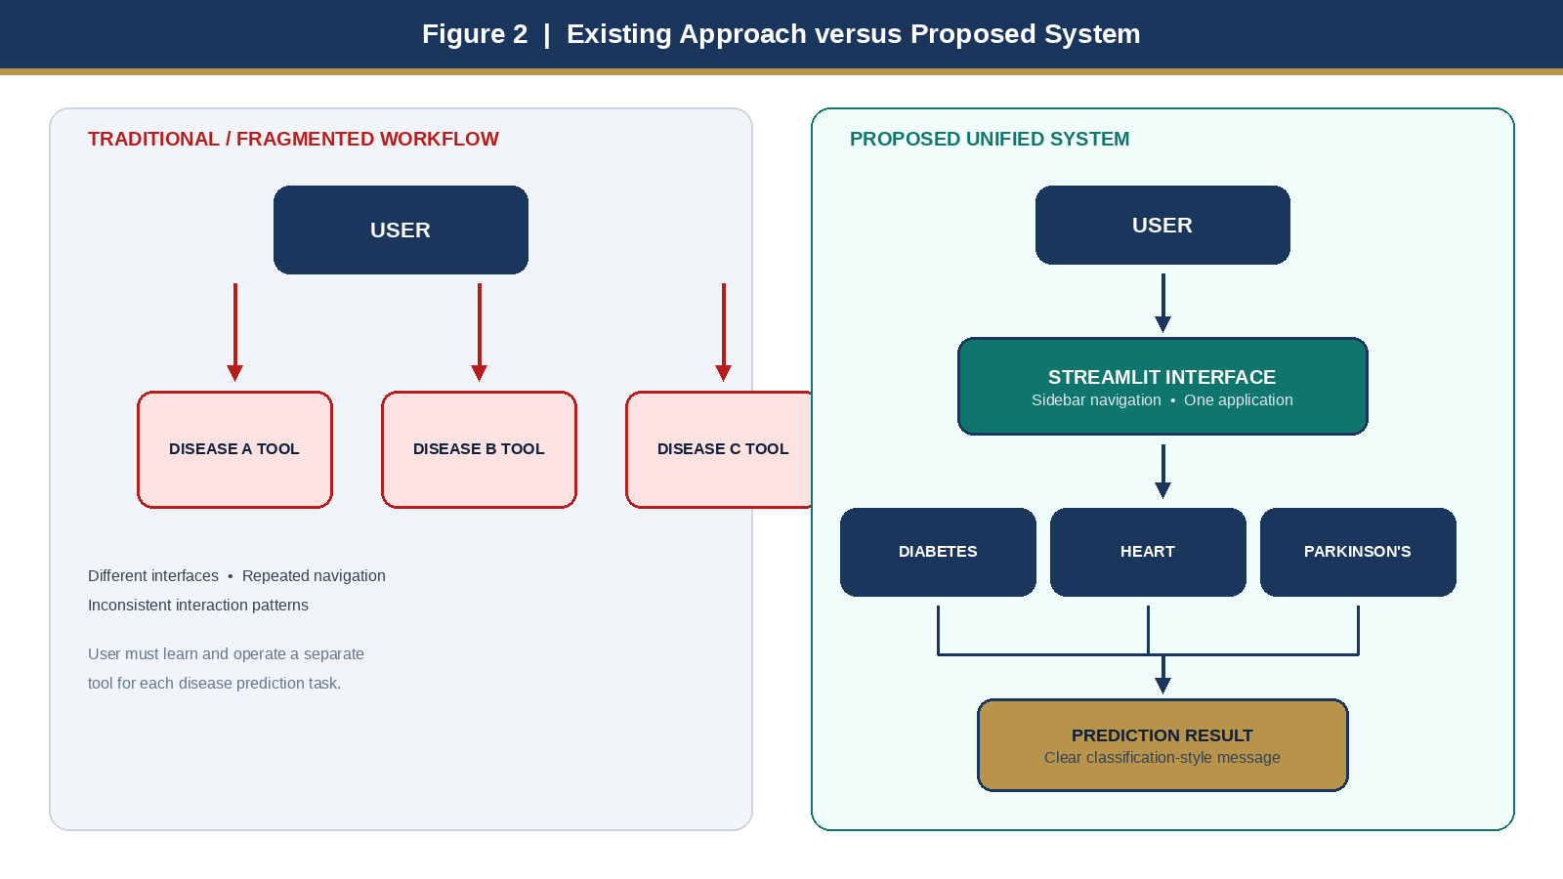
Figure 2: Existing fragmented workflow versus the proposed unified Multiple Disease Prediction System.

3.4 Project Modules
The project is organised into four major modules. Modules 1 to 3 correspond to the three disease pages in app.py. Module 4 covers training, evaluation and storage of the model artifacts that those pages consume.

Module 1: Diabetes Prediction
This module collects eight inputs: Number of Pregnancies, Glucose Level, Blood Pressure, Skin Thickness, Insulin Level, BMI, Diabetes Pedigree Function and Age. The values are converted to float, passed to diabetes_model.sav, and mapped to one of two messages: “The person is diabetic” or “The person is not diabetic”. The underlying estimator is a Support Vector Classifier with a linear kernel, trained on the PIMA diabetes dataset with target column Outcome (0 = non-diabetic, 1 = diabetic).

Module 2: Heart Disease Prediction
This module collects thirteen inputs used in standard heart-disease classification datasets: age, sex, chest-pain type, resting blood pressure, serum cholesterol, fasting blood sugar flag, resting electrocardiographic result, maximum heart rate, exercise-induced angina, ST depression (oldpeak), slope, number of major vessels (ca) and thal. The loaded model is a Logistic Regression estimator saved as heart_disease_model.sav. The output messages are “The person is having heart disease” or “The person does not have any heart disease”.

Module 3: Parkinson’s Disease Prediction
This module collects twenty-two voice-related numerical features, including fundamental frequency measures (Fo, Fhi, Flo), jitter measures, RAP / PPQ / DDP, shimmer measures, NHR / HNR, RPDE, DFA, spread1, spread2, D2 and PPE. The name column from the original dataset is not used as a predictive feature. The estimator is an SVM with a linear kernel saved as parkinsons_model.sav. The output messages are “The person has Parkinson’s disease” or “The person does not have Parkinson’s disease”.

Module 4: Model Training, Evaluation and Storage
Training is performed in Jupyter / Colab notebooks, not inside the Streamlit process. Each notebook loads a CSV file, inspects shape and class balance, splits features and target, fits the chosen estimator, prints training and test accuracy, demonstrates a sample prediction, and writes the fitted object to a .sav file with pickle.dump(). The application later reads those files with pickle.load() at startup. This separation keeps the user interface light and avoids retraining on every request.
Aspect | Diabetes | Heart Disease | Parkinson’s
Input count | 8 | 13 | 22
Input type | Clinical / demographic | Clinical / cardiac | Voice-related numerical
Model call | predict([x]) | predict([x]) | predict([x])
Result | Diabetic / not diabetic | Heart disease / no heart disease | Parkinson’s / no Parkinson’s
Table 1: Comparison of the three disease-prediction modules.

3.5 Context Diagram (High Level)
At the context level the system has one external actor — the user — and one process — the Multiple Disease Prediction App. The user supplies disease-specific input values. The app converts those values into a feature vector and sends it to the disease-specific model. The model returns a class label, which the app presents as a readable result. The same context flow applies to all three diseases; only the feature set and the loaded artifact change.
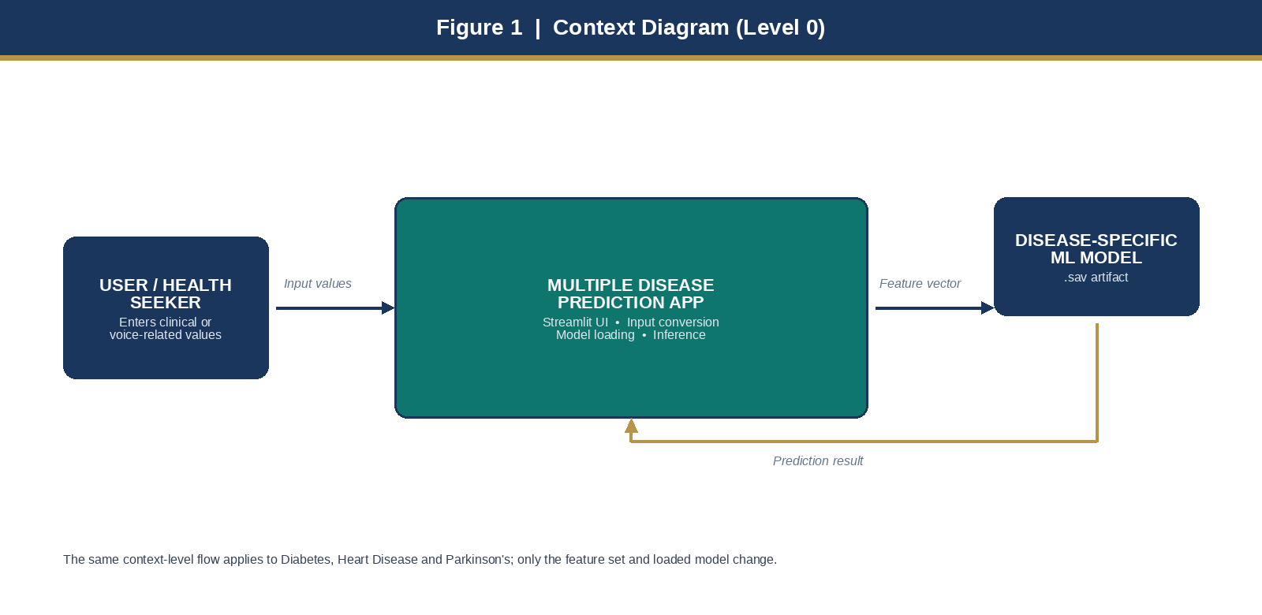
Figure 1: Context-level (Level 0) data flow of the Multiple Disease Prediction System.

4. IMPLEMENTATION METHODOLOGY
Implementation follows a sequential machine-learning methodology for training, and a fixed inference methodology for the deployed application. Training is performed once. Inference is performed every time the user clicks a test-result button.

4.1 Sequential Machine-Learning Methodology
The training and deployment sequence is as follows.
- Data collection — obtain diabetes.csv, heart.csv and parkinsons.csv.
- Data inspection — review shape, column names, missing values and class distribution.
- Feature / label separation — drop the target column (and the name column for Parkinson’s) to form X; keep the label as Y.
- Train–test split — 80% training and 20% testing, with a fixed random_state for reproducibility; stratification is used for diabetes and heart disease.
- Model training — fit SVC(kernel='linear') for diabetes and Parkinson’s; fit LogisticRegression() for heart disease.
- Model evaluation — compute accuracy_score on both the training set and the test set.
- Sample prediction — run a hand-crafted input through the fitted model to confirm the output mapping.
- Model serialization — pickle.dump() the fitted estimator to a .sav file.
- Application assembly — write app.py, load the three artifacts, and wire each form to predict().
- Interactive inference — convert form values to float, call predict(), and display a diagnosis message.
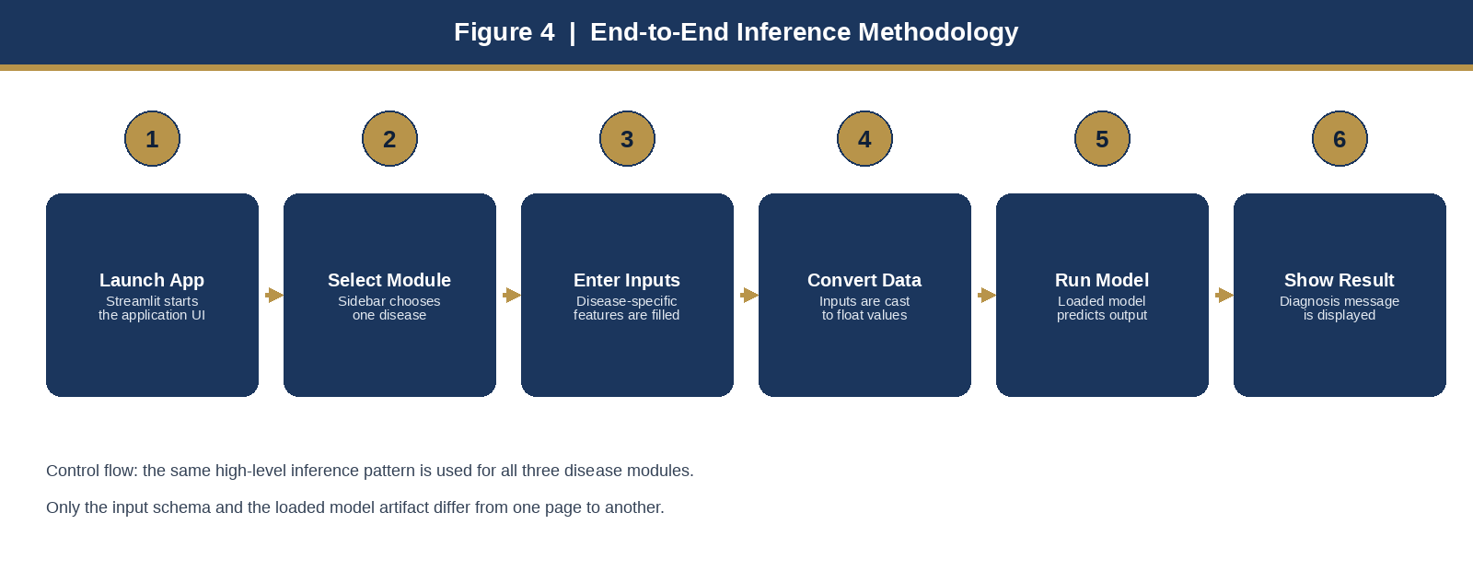
Figure 4: End-to-end inference methodology implemented in the Streamlit application.

4.2 Data Collection and Datasets
The project uses three publicly known tabular datasets that match the feature lists in app.py. The README of the source project states that the training notebooks and the datasets are provided in their respective folders. The dataset files are diabetes.csv, heart.csv and parkinsons.csv.
Dataset file | Common source | Records | Predictive features | Target
diabetes.csv | PIMA Indians Diabetes | 768 | 8 | Outcome (0/1)
heart.csv | UCI / Kaggle Heart Disease | 303 | 13 | target (0/1)
parkinsons.csv | UCI Parkinson’s (voice) | 195 | 22 (name dropped) | status (0/1)
Table 5: Datasets used for model training (record counts as observed in the training notebooks).
The PIMA diabetes dataset contains clinical measurements commonly used in educational machine-learning courses. The heart-disease dataset contains 14 columns including the target. The Parkinson’s dataset contains 24 columns in total; the patient name is an identifier and is removed before training, leaving 22 acoustic features plus the binary status label. In the Parkinson’s notebook the class distribution is 147 positive (status = 1) and 48 negative (status = 0), so the dataset is imbalanced. This is a known limitation of the training set.

4.3 Data Preprocessing
Preprocessing in the training notebooks is deliberately simple and matches a first-course machine-learning workflow:
- Load each CSV into a pandas DataFrame.
- Inspect the first rows, data types, descriptive statistics and target value counts.
- Confirm missing-value counts (the heart and Parkinson’s notebooks report no nulls).
- Separate X and Y. For Parkinson’s, drop both name and status from X.
- Apply sklearn.model_selection.train_test_split with test_size=0.2 and random_state=2.
- For diabetes and heart disease, set stratify=Y so that class proportions are preserved in the split.
No StandardScaler, imputation pipeline or explicit outlier treatment is applied in the notebooks that produce the saved models. The Streamlit app likewise performs only float() conversion. This keeps the student implementation short, but it also means that blank fields, non-numeric text or values far outside the training range can cause runtime errors or unreliable predictions. These points are treated as limitations and as future-work items.

4.4 Feature Design by Disease Module
Feature order is part of the contract between the training notebooks and app.py. The list passed to predict() must follow the column order of X. The application therefore builds user_input as a Python list in a fixed sequence, then casts every element to float.
Diabetes uses eight clinical features. Heart disease uses thirteen mixed numeric and encoded categorical features (for example sex, chest-pain type, fasting blood sugar, slope, ca and thal are stored as numbers). Parkinson’s uses twenty-two acoustic measures derived from voice recordings. The complete dictionaries are given in Chapter 6 and in Appendix A.

4.5 Model Training
Each disease has its own notebook and its own estimator. The choices below are those used in the project’s training notebooks, not invented for this report.

Diabetes — Support Vector Machine
The diabetes notebook imports svm from sklearn and creates classifier = svm.SVC(kernel='linear'). The linear kernel is appropriate for a moderately sized tabular problem and yields a maximum-margin linear decision boundary in the eight-dimensional feature space. After the 80:20 stratified split the training matrix has shape (614, 8) and the test matrix has shape (154, 8). The fitted classifier is written to diabetes_model.sav.

Heart disease — Logistic Regression
The heart notebook imports LogisticRegression from sklearn.linear_model and calls model.fit() on the training split. Logistic Regression estimates the probability of the positive class and is a standard baseline for this dataset. After the stratified 80:20 split the training matrix has shape (242, 13) and the test matrix has shape (61, 13). The original notebook records a convergence warning from the lbfgs solver (iteration limit reached). The fitted model is nevertheless saved as heart_disease_model.sav and is the artifact loaded by app.py. Increasing max_iter is a natural future improvement.

Parkinson’s — Support Vector Machine
The Parkinson’s notebook also uses svm.SVC(kernel='linear'). After dropping name and status, X has 22 columns. The 80:20 split (random_state=2, without stratify in the notebook) produces X_train of shape (156, 22) and X_test of shape (39, 22). The fitted model is saved as parkinsons_model.sav.
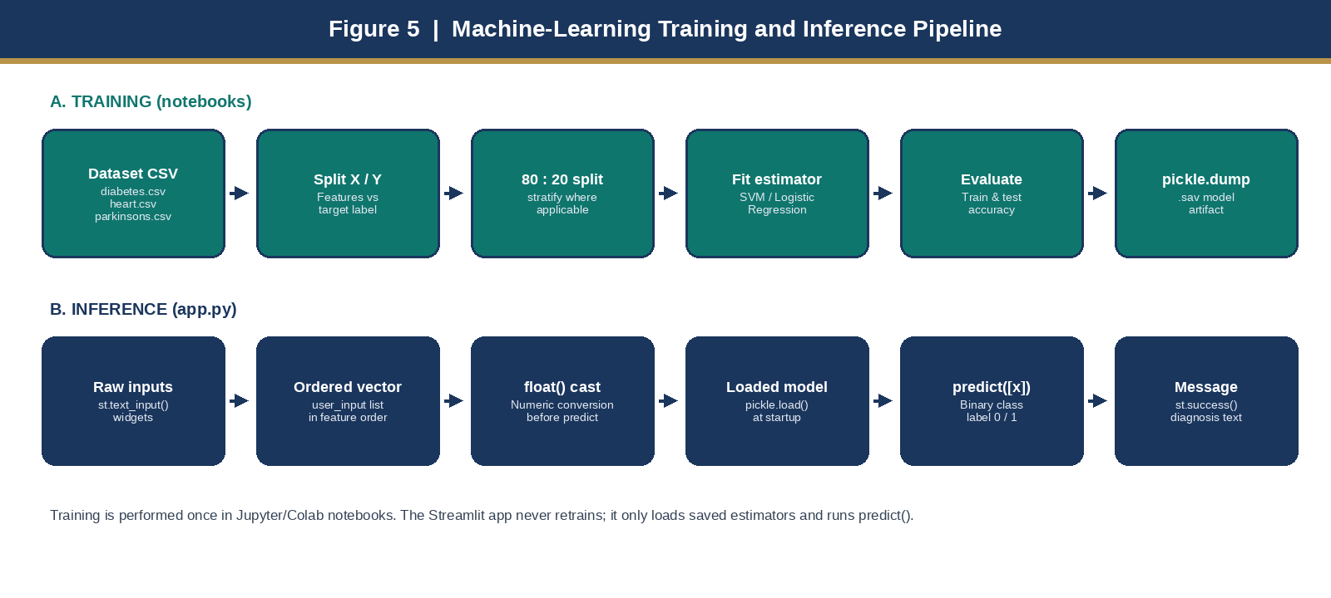
Figure 5: Training pipeline (notebooks) and inference pipeline (app.py).

4.6 Model Evaluation
The notebooks evaluate models with sklearn.metrics.accuracy_score on the training set and on the held-out test set. Precision, recall, F1-score, ROC-AUC and confusion matrices are not printed in those notebooks, and app.py does not display metrics to the end user. The accuracy figures below are taken from the notebook outputs so that this report does not invent validation statistics.
Disease | Algorithm | Train rows | Test rows | Train accuracy | Test accuracy
Diabetes | SVM (linear) | 614 | 154 | 78.34% | 77.27%
Heart disease | Logistic Regression | 242 | 61 | 85.12% | 81.97%
Parkinson’s | SVM (linear) | 156 | 39 | 87.18% | 87.18%
Table 6: Algorithms, split sizes and accuracy scores reported by the training notebooks.
Interpretation should remain cautious. Accuracy on a small and, in the Parkinson’s case, imbalanced test set can overstate operational quality. Equal train and test accuracy for Parkinson’s (both 87.18%) is possible on 39 test rows but is not by itself proof of robust generalisation. The Streamlit result is a class label, not a calibrated probability and not a medical diagnosis.

4.7 Model Serialization
Each notebook saves its estimator with pickle:
filename = 'diabetes_model.sav' # similarly heart_disease_model.sav, parkinsons_model.sav
pickle.dump(model, open(filename, 'wb'))
The application reloads the artifacts at import / startup time using paths relative to the directory of app.py:
working_dir = os.path.dirname(os.path.abspath(__file__))
diabetes_model = pickle.load(open(f'{working_dir}/saved_models/diabetes_model.sav', 'rb'))
heart_disease_model = pickle.load(open(f'{working_dir}/saved_models/heart_disease_model.sav', 'rb'))
parkinsons_model = pickle.load(open(f'{working_dir}/saved_models/parkinsons_model.sav', 'rb'))
Loading at startup means that a missing or corrupt .sav file will fail before any page is used. It also means that the three models remain in memory for the life of the Streamlit session, which is appropriate for small scikit-learn classifiers.

4.8 Application Inference Pipeline
Every disease page follows the same low-level sequence. This is the actual control flow implemented in app.py.
- Render the page title and a multi-column layout of st.text_input widgets.
- Initialise an empty diagnosis string.
- If the user clicks the test-result button, collect widget values into a Python list in training order.
- Convert the list with user_input = [float(x) for x in user_input].
- Call the loaded estimator: prediction = model.predict([user_input]).
- If prediction[0] == 1, set a positive diagnosis message; otherwise set a negative message.
- Display the message with st.success(diagnosis).
Because st.success() sits outside the button block, an empty green box is visible before the first click. After a successful click the message appears. Invalid or blank input raises a Python exception during float conversion; the present code does not catch that exception. Range checks and try/except handling are listed under future enhancements.

4.9 Data Flow Diagram
Data movement at runtime is one-way from the user to the model and back as a label. No database write occurs. No training data is read by app.py. The only persistent files involved at inference time are the three .sav artifacts.
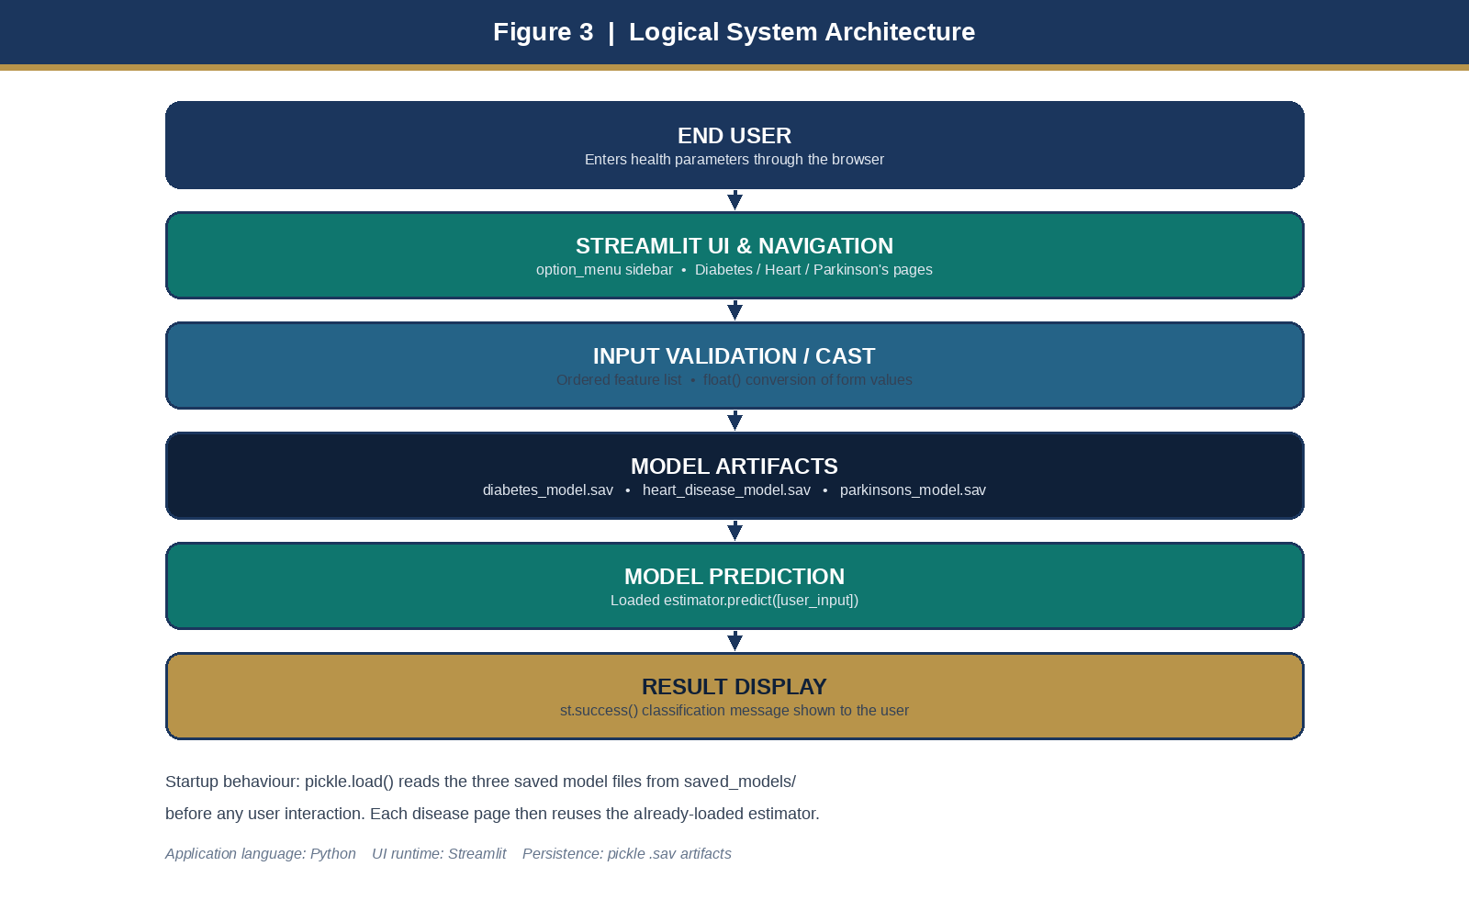
Figure 3: Logical architecture — user, Streamlit UI, input cast, model artifacts, prediction and result display.

4.10 Flow Chart
The flow chart records the operational path of the running application, from process start through model loading, sidebar selection, data entry, the test-result decision, prediction and message display. If the button is not clicked, the application simply continues to show the form.
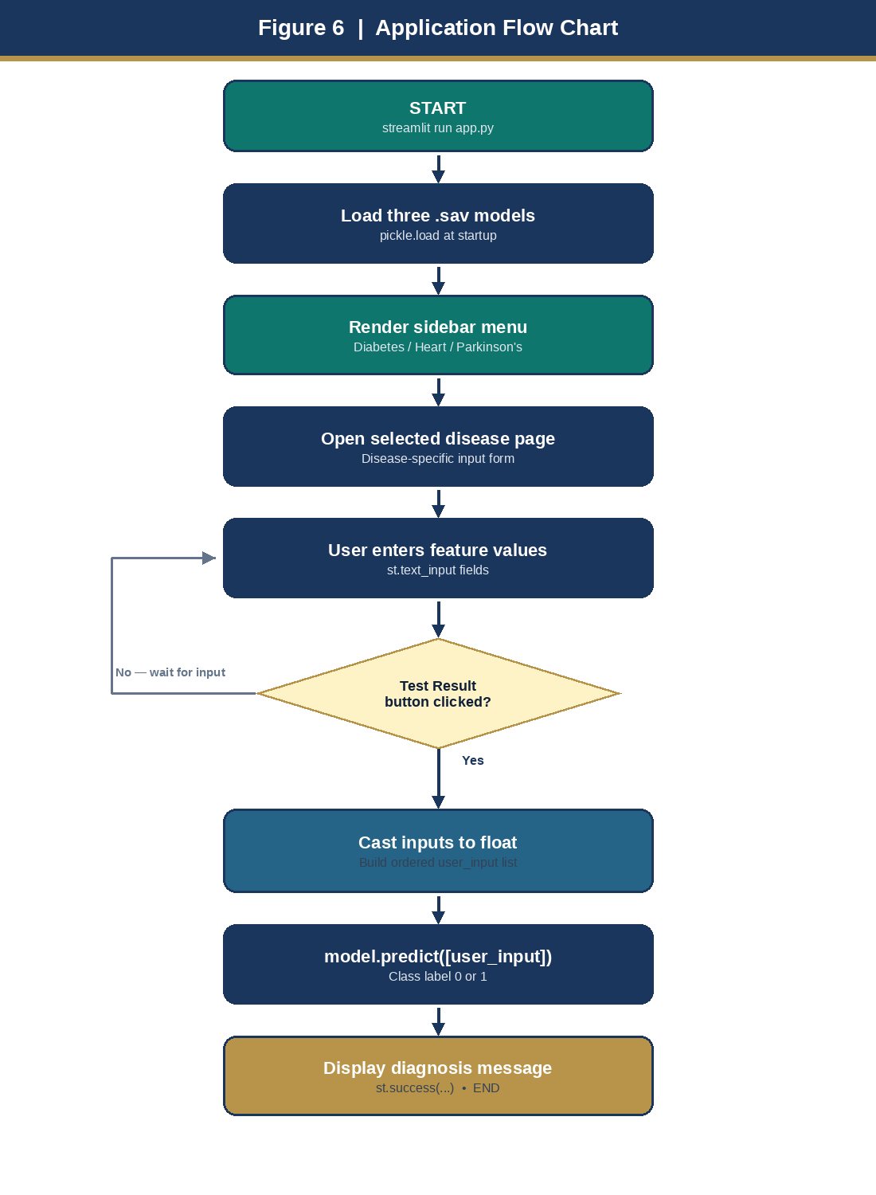
Figure 6: Application flow chart of the Multiple Disease Prediction System.

4.11 Use Case Diagram
The primary actor is a health user or student tester. The actor can select a disease module, enter the required inputs, request a prediction for diabetes, heart disease or Parkinson’s, and view the diagnosis message. Loading of saved models and execution of predict() are system-side use cases triggered by those requests.
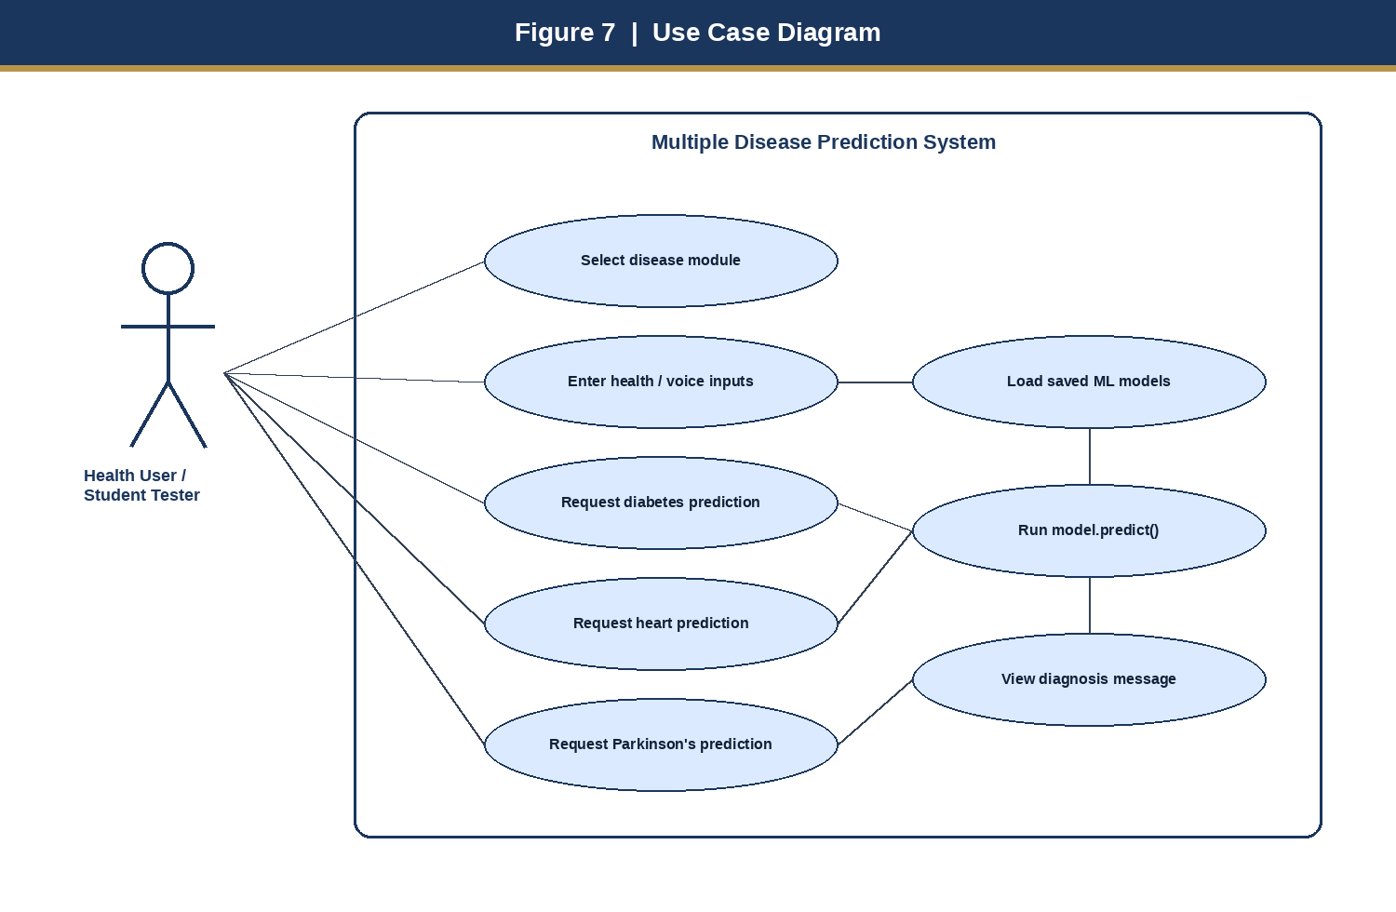
Figure 7: Use case diagram for the Multiple Disease Prediction System.
Main use cases:
- Select a disease prediction module from the sidebar.
- Enter clinical or voice-related numerical information.
- Request a diabetes, heart-disease or Parkinson’s prediction.
- Review the classification result. The result is a screening aid, not a prescription for treatment.

5. SYSTEM ARCHITECTURE (HLD AND LLD)
The high-level design (HLD) describes four logical layers. The low-level design (LLD) maps those layers onto the concrete calls found in app.py.
High-level design layers:
- UI / Navigation — Streamlit page configuration, wide layout, and streamlit-option-menu sidebar.
- Disease modules — three independent pages, each with its own widgets and feature list.
- Model layer — pickle-loaded estimators stored as .sav files and held in memory.
- Result layer — mapping of class label 0 / 1 to an English sentence shown with st.success().
Low-level design mapping:
- Input widgets — st.text_input() for every feature.
- Feature list — ordered user_input list that matches training column order.
- Conversion — float(x) applied to each list element.
- Inference — model.predict([user_input]).
- Output — st.success(message).
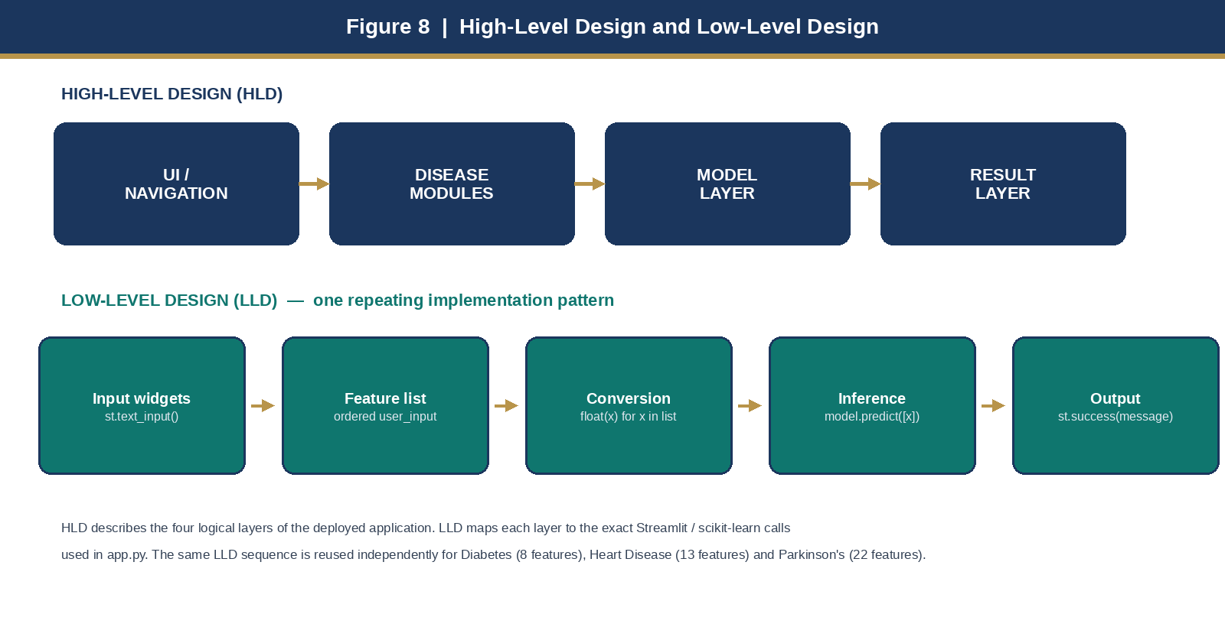
Figure 8: High-level design layers and the repeating low-level implementation pattern.

6. DISEASE MODULES AND FEATURE DESIGN
This chapter lists the features exactly as they appear in the Streamlit forms and in the training matrices. Keeping this list accurate is essential, because a permutation of inputs would silently produce a wrong prediction.

6.1 Diabetes — eight features
S.No. | Form label in app.py | Meaning / role
1 | Number of Pregnancies | Count of pregnancies (PIMA feature Pregnancies)
2 | Glucose Level | Plasma glucose concentration
3 | Blood Pressure value | Diastolic blood pressure
4 | Skin Thickness value | Triceps skin-fold thickness
5 | Insulin Level | 2-hour serum insulin
6 | BMI value | Body mass index
7 | Diabetes Pedigree Function value | Family-history based pedigree function
8 | Age of the Person | Age in years
Table 2: Diabetes module — input features in the order sent to diabetes_model.predict().

6.2 Heart disease — thirteen features
S.No. | Form label in app.py | Meaning / role
1 | Age | Age in years
2 | Sex | Encoded sex (dataset coding, typically 1 = male, 0 = female)
3 | Chest Pain types | Chest-pain type code (cp)
4 | Resting Blood Pressure | Resting blood pressure (trestbps)
5 | Serum Cholestoral in mg/dl | Serum cholesterol (chol)
6 | Fasting Blood Sugar > 120 mg/dl | Binary fasting blood-sugar flag (fbs)
7 | Resting Electrocardiographic results | Resting ECG result code (restecg)
8 | Maximum Heart Rate achieved | thalach
9 | Exercise Induced Angina | Binary flag (exang)
10 | ST depression induced by exercise | oldpeak
11 | Slope of the peak exercise ST segment | slope
12 | Major vessels colored by flourosopy | ca (0–3 / 4 depending on coding)
13 | thal: 0 = normal; 1 = fixed defect; 2 = reversable defect | thal code as labelled in the form
Table 3: Heart-disease module — input features in the order sent to heart_disease_model.predict().

6.3 Parkinson’s — twenty-two voice features
Parkinson’s page widgets are arranged in five columns. The names follow the MDVP / acoustic columns of the UCI Parkinson’s dataset.
S.No. | Form label in app.py | Group
1 | MDVP:Fo(Hz) | Fundamental frequency
2 | MDVP:Fhi(Hz) | Fundamental frequency
3 | MDVP:Flo(Hz) | Fundamental frequency
4 | MDVP:Jitter(%) | Jitter
5 | MDVP:Jitter(Abs) | Jitter
6 | MDVP:RAP | Jitter
7 | MDVP:PPQ | Jitter
8 | Jitter:DDP | Jitter
9 | MDVP:Shimmer | Shimmer
10 | MDVP:Shimmer(dB) | Shimmer
11 | Shimmer:APQ3 | Shimmer
12 | Shimmer:APQ5 | Shimmer
13 | MDVP:APQ | Shimmer
14 | Shimmer:DDA | Shimmer
15 | NHR | Noise-to-harmonics
16 | HNR | Harmonics-to-noise
17 | RPDE | Nonlinear dynamical complexity
18 | DFA | Signal-fractal scaling
19 | spread1 | Nonlinear frequency variation
20 | spread2 | Nonlinear frequency variation
21 | D2 | Dynamical complexity
22 | PPE | Pitch-period entropy
Table 4: Parkinson’s module — 22 voice-related features in predict() order.

7. USER INTERFACE AND NAVIGATION DESIGN
The interface is a Streamlit web page with layout='wide' and page title “Health Assistant”. Navigation is implemented with streamlit_option_menu.option_menu inside st.sidebar. The menu title is “Multiple Disease Prediction System”. The three items are Diabetes Prediction, Heart Disease Prediction and Parkinsons Prediction, with icons activity, heart and person and a hospital-fill menu icon. default_index is 0, so the diabetes page opens first.
Each disease page uses a multi-column grid of text inputs so that a large feature set still fits on one screen. Diabetes and heart disease use three columns; Parkinson’s uses five. A single primary button on each page triggers inference. Design strengths of the present UI are: wide page layout, disease-specific forms, a consistent submit action, immediate textual output, and a small learning curve.
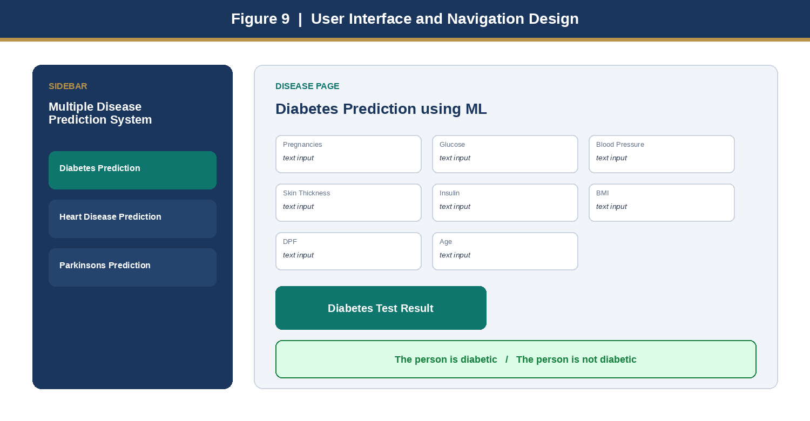
Figure 9: Sidebar navigation and the diabetes input form with test-result action and message area.
UI limitations that should be improved later include the use of free-text fields instead of number inputs or select boxes for coded features (sex, chest-pain type, thal, and so on), the absence of placeholder examples, the absence of allowed ranges, and the empty success box shown before the first prediction.

8. TECHNOLOGIES TO BE USED
The project uses a lightweight Python stack. No GPU, no database server and no separate front-end framework are required for the implemented application.

8.1 Software Platform
a) Front-end
- Streamlit: Used to develop the interactive web interface, page layout, input forms, buttons and result display.
- streamlit-option-menu: Used to render the sidebar navigation among the three disease modules.
b) Back-end / machine learning
- Python: Core programming language of app.py and of the training notebooks.
- NumPy: Numerical arrays used when a feature vector is passed to predict().
- scikit-learn: SVM and Logistic Regression estimators, train_test_split and accuracy_score.
- Pandas: Used in the notebooks for CSV loading, inspection and train/test frames.
- pickle: Serialization and loading of .sav model artifacts.
- Jupyter Notebook / Google Colab: Used for model development, evaluation and experiment tracking.
Component | Technology | Role in this project
Application language | Python 3 | Implements app.py and training notebooks
Web UI / runtime | Streamlit 1.29.0 | Browser forms, layout, result widgets
Sidebar navigation | streamlit-option-menu 0.3.6 | Module switching
ML library | scikit-learn 1.3.2 | SVM, Logistic Regression, metrics, split
Numerical computing | NumPy 1.26.3 | Numeric feature vectors
Model files | pickle .sav artifacts | Persist and reload trained estimators
Table 7: Software stack and the role of each component.

8.2 Hardware Platform
The project can be developed and executed on a standard personal computer or laptop capable of running a Python environment. Specialised GPU hardware is not required, because the models are conventional scikit-learn classifiers on small tabular datasets.
Item | Recommended specification
Processor | Intel Core i3 / i5 or equivalent
RAM | Minimum 8 GB
Storage | Minimum 10 GB of available space
Operating system | Windows, Linux or macOS
Internet | Required when installing Python packages
Table 8: Hardware platform recommended for development and demonstration.

8.3 Tools
The following tools may be used during implementation and documentation:
- Git for version control.
- GitHub for source-code repository management.
- Visual Studio Code / any Python IDE for editing app.py and the report.
- Jupyter Notebook / Google Colab for training and evaluation.
- Python virtual environment for isolated installation of requirements.txt.
- Office suite Microsoft Word, for editing this project report after generation.

9. FEASIBILITY ANALYSIS
Feasibility is examined under four headings that are commonly required in a BCA project synopsis: technical, operational, economic and scalability.
Dimension | Rating | Justification based on the implemented system
Technical | High | Python and Streamlit provide a lightweight web layer; saved model artifacts are loaded directly; no specialised hardware is required.
Operational | High | Users interact through forms and a sidebar. They never handle .sav files, notebooks or predict() calls themselves.
Economic | High | The application is built from common open-source Python packages and local model files. There is no licence cost for the implemented stack.
Scalability | Moderate | The modular structure can be extended with more diseases, but production scaling, authentication, monitoring and model serving would need extra engineering.
Table 9: Feasibility summary of the Multiple Disease Prediction System.

10. ADVANTAGES OF THIS PROJECT
The proposed system provides several practical advantages for an academic machine-learning deployment and for a first-level screening demonstration.
- Unified access. One application replaces three disconnected tools. The user learns a single navigation pattern.
- Standardised interaction. Sidebar choice plus a standard form-and-button pattern keeps interaction consistent.
- Accessible inference. A non-programmer can obtain a model output without opening notebooks or writing Python.
- Reusable models. Saved .sav files are reused on every run; the app does not retrain.
- End-to-end demonstration. The project shows the full path from CSV dataset to trained estimator to browser UI, which is a core BCA / ML learning outcome.
- Modular extension. A fourth disease can be added by training a new artifact and inserting one more sidebar page that follows the same LLD pattern.
- Low cost. Python, Streamlit and scikit-learn are free and well documented.

11. SECURITY, RELIABILITY AND LIMITATIONS
Current good practice reflected in the project:
- Keep model files in a controlled application directory (saved_models/) rather than allowing users to upload arbitrary pickle files.
- Do not expose model internals, coefficients or serialized bytes in the user interface.
- Convert inputs to numeric form before they reach predict(), so that the estimator receives the expected type.
Limitations identified from the implemented source:
- app.py does not contain training code. Training details in this report are taken from the accompanying notebooks and datasets, not from the UI file alone.
- The running app does not show accuracy, sensitivity, specificity or confidence.
- Direct float() conversion means that blank or non-numeric input can crash the page.
- The result is a prediction message, not a clinical diagnosis workflow, laboratory confirmation or treatment plan.
- No authentication, database, audit logging, rate limiting or monitoring is present in app.py.
- Pickle artifacts should be treated as trusted files. Loading untrusted pickle data is a security risk in general and must not be done in production.
- Parkinson’s training data is small (195 rows) and imbalanced (147 vs 48). Heart-disease test size is only 61 rows. These sample sizes limit claims of clinical reliability.
- Several heart-disease fields are integer codes. The UI currently asks for them as free text, so a user can easily enter a value the model never saw.
Important academic disclaimer: this system is a student project and a prototype decision-support interface. It must not be used as a substitute for professional medical advice, diagnosis or treatment.

12. ASSUMPTIONS
The implementation is based on the following assumptions:
- The three CSV datasets are sufficiently structured and labelled for supervised binary classification.
- The feature order used in the Streamlit forms matches the column order used to train each .sav file.
- Historical patterns in the public datasets contain information that a linear SVM or logistic model can use.
- An 80:20 split with a fixed random seed is an acceptable academic evaluation protocol for this demonstration.
- Accuracy is an acceptable primary metric for the notebooks, even though class imbalance (especially in Parkinson’s) would justify extra metrics in a stronger study.
- Users of the prototype can read the form labels and enter numeric values in the expected coding (for example 0/1 for sex).
- The application is operated in a trusted environment where the .sav files have not been tampered with.
- The system is used for learning, demonstration and prototype screening — not for unsupervised clinical decisions.

13. EXPECTED IMPACT AND BENEFITS
In compact numbers the delivered prototype offers three disease modules, forty-three input fields across those modules, one unified interface, and no need to expose model source code to the end user.
Benefits:
- Simplifies access to multiple ML predictors.
- Standardises navigation and interaction.
- Makes model inference accessible through a browser UI.
- Supports academic demonstration of end-to-end ML deployment.
Potential impact:
- Useful as an educational / prototype decision-support application in a BCA laboratory or project viva.
- Can be extended toward richer patient-facing workflows (history, PDF reports, range warnings).
- Can become a foundation for monitoring, analytics and comparison of alternative models (Random Forest, XGBoost, calibrated probabilities).

14. FUTURE SCOPE AND FURTHER ENHANCEMENT
The current implementation is a working prototype. Several enhancements can be introduced in later versions. They are grouped into five phases so that the roadmap remains practical.
Phase 1 — Robust validation
Replace free text with number inputs and select boxes. Add required-field checks, medical range limits, and try/except around float conversion so that the user sees a clear error instead of a crash.
Phase 2 — Better ML lifecycle
Add a documented training pipeline with preprocessing (imputation, scaling), additional metrics (precision, recall, F1, ROC-AUC, confusion matrix), class-imbalance handling, and versioned model files. Compare SVM and Logistic Regression with Random Forest, XGBoost or LightGBM. Address the Logistic Regression convergence warning by raising max_iter or scaling features.
Phase 3 — User platform
Introduce authentication, optional patient profiles, prediction history and secure storage. This phase should not begin until privacy and consent rules are defined.
Phase 4 — Clinical UX
Show prediction confidence, simple explanations (for example SHAP feature contributions), and a clear “not a diagnosis” banner. A clinician-review step would be required before any real-world health use.
Phase 5 — Deployment
Containerise the application, add logging and monitoring, and serve models through a controlled API rather than loading pickle files in the web process. Production serving should prefer a safer serialisation format than pickle where possible.

15. PROJECT REPOSITORY LOCATION
The project artifacts for this academic submission are maintained as follows. The Streamlit application structure, training notebooks and datasets follow the well-known open-source Multiple Disease Prediction Streamlit App, which is cited in the references. The present report, analysis, diagrams and college documentation have been prepared for Teerthanker Mahaveer University submission.
S# | Project artifact (soft copy) | Location | Verified by Project Guide | Verified by Lab In-Charge
1 | Project Report (this document, final version) | Device folder / student submission | Ms. Sneha
2 | Functional code — app.py, requirements.txt, saved models, datasets, training notebooks | Device folder / project workspace | Ms. Sneha
3 | Reference source repository (application structure and notebooks) | https://github.com/siddhardhan23/multiple-disease-prediction-streamlit-app | Ms. Sneha
Table 10: Project artifacts and repository location (edit the location column if you upload the code to your own GitHub account).
If you later publish your own GitHub copy, replace row 2 with that URL and keep row 3 as the cited reference implementation.

16. DEFINITIONS, ACRONYMS AND ABBREVIATIONS
Abbreviation | Description
AI | Artificial Intelligence
ML | Machine Learning
SVM | Support Vector Machine
SVC | Support Vector Classifier (scikit-learn class)
LR | Logistic Regression
UI | User Interface
HLD | High-Level Design
LLD | Low-Level Design
DFD | Data Flow Diagram
CSV | Comma-Separated Values
SAV / PKL | Serialized Python model file produced with pickle
BMI | Body Mass Index
DPF | Diabetes Pedigree Function
MDVP | Multi-Dimensional Voice Program (Parkinson’s acoustic features)
NHR / HNR | Noise-to-Harmonics Ratio / Harmonics-to-Noise Ratio
RPDE | Recurrence Period Density Entropy
DFA | Detrended Fluctuation Analysis
PPE | Pitch Period Entropy
PIMA | PIMA Indians Diabetes Database, the educational diabetes dataset used here
UCI | University of California, Irvine Machine Learning Repository
API | Application Programming Interface
OCR | Optical Character Recognition (future work only)
SHAP | SHapley Additive exPlanations (future explainability work)
BCA | Bachelor of Computer Application
TMU | Teerthanker Mahaveer University
Table 11: Definitions, acronyms and abbreviations used in this report.

17. CONCLUSION
The Multiple Disease Prediction System shows how three independent classification models can be delivered through one browser interface. The project starts from public tabular datasets, trains a linear SVM for diabetes, a logistic regression model for heart disease and a linear SVM for Parkinson’s, stores the fitted estimators as pickle artifacts, and serves them from a Streamlit application with sidebar navigation.
The application-level design is consistent: every module converts form values to float, calls predict() on the matching .sav file, and returns a short classification message. That consistency is the main engineering contribution of the interface. The notebooks report test accuracies of approximately 77.27% (diabetes), 81.97% (heart disease) and 87.18% (Parkinson’s). Those figures are academic baseline results on small public datasets; they are not a claim of clinical performance.
The implementation with Python, scikit-learn and Streamlit is lightweight and suitable for laboratory demonstration and for a BCA project viva. Successful further use would require input validation, richer evaluation metrics, safer model serving, and a clear separation between a screening prototype and a medical device. Within its declared scope — a unified ML interface for three prediction tasks — the project meets its aim and provides a practical starting point for later enhancement.

18. REFERENCES / BIBLIOGRAPHY
[1] Siddhardhan, Multiple Disease Prediction Streamlit App, source code, training notebooks and datasets, GitHub repository, https://github.com/siddhardhan23/multiple-disease-prediction-streamlit-app
[2] Project source file analysed for this report: app.py — Multiple Disease Prediction System (Streamlit application, page configuration, sidebar, three prediction forms, pickle model loading and predict() calls).
[3] Project README.md — description of the Streamlit application, requirement installation, and the presence of training notebooks and datasets in their respective folders.
[4] Project requirements.txt — numpy==1.26.3, scikit-learn==1.3.2, streamlit==1.29.0, streamlit-option-menu==0.3.6.
[5] Streamlit documentation, application development and execution, https://docs.streamlit.io/
[6] Python documentation, Python programming language, https://docs.python.org/
[7] scikit-learn documentation, SVM, Logistic Regression, model evaluation and persistence, https://scikit-learn.org/
[8] NumPy documentation, numerical computing in Python, https://numpy.org/doc/
[9] Pandas documentation, data analysis and CSV handling, https://pandas.pydata.org/docs/
[10] Smith, J. W., Everhart, J. E., Dickson, W. C., Knowler, W. C. and Johannes, R. S. (1988). Using the ADAP learning algorithm to forecast the onset of diabetes mellitus. Proceedings of the Symposium on Computer Applications and Medical Care, 261–265. (PIMA diabetes dataset lineage.)
[11] UCI Machine Learning Repository, Heart Disease Data Set, https://archive.ics.uci.edu/dataset/45/heart+disease
[12] Little, M. A., McSharry, P. E., Hunter, E. J., Spielman, J. and Ramig, L. O. (2009). Suitability of dysphonia measurements for telemonitoring of Parkinson’s disease. IEEE Transactions on Biomedical Engineering, 56(4), 1015–1022. (Parkinson’s voice-measurement dataset lineage.)
[13] Cortes, C. and Vapnik, V. (1995). Support-vector networks. Machine Learning, 20, 273–297.
[14] Hosmer, D. W., Lemeshow, S. and Sturdivant, R. X. (2013). Applied Logistic Regression. Wiley.
[15] Pedregosa, F. et al. (2011). Scikit-learn: Machine Learning in Python. Journal of Machine Learning Research, 12, 2825–2830.
[16] Pickle — Python object serialisation, https://docs.python.org/3/library/pickle.html
[17] World Health Organization resources on diabetes, cardiovascular disease and Parkinson’s disease (background motivation only; not used as a training source).
Note: Accuracy figures quoted in Chapter 4 are those printed by the project training notebooks. They are not invented for this report. Where app.py itself is silent (for example on algorithm class names), the notebooks that produce diabetes_model.sav, heart_disease_model.sav and parkinsons_model.sav have been used as the source of truth.

APPENDIX A — FEATURE DICTIONARY AND RESULT MESSAGES
This appendix restates the mapping from model output to on-screen text, as implemented in app.py.
Module | If predict() returns 1 | If predict() returns 0
Diabetes | The person is diabetic | The person is not diabetic
Heart disease | The person is having heart disease | The person does not have any heart disease
Parkinson’s | The person has Parkinson's disease | The person does not have Parkinson's disease
Appendix Table: Classification messages produced by app.py.
Sample predictive check used in the diabetes notebook (not a clinical case): input (5, 166, 72, 19, 175, 25.8, 0.587, 51) produced class 1 — “The person is diabetic”.
Sample predictive check used in the heart notebook: input (62, 0, 0, 140, 268, 0, 0, 160, 0, 3.6, 0, 2, 2) produced class 0 — “The Person does not have a Heart Disease”.

APPENDIX B — SOFTWARE DEPENDENCIES AND RUNTIME COMMAND
The Streamlit application dependencies, taken from requirements.txt, are:
Package | Pinned version | Purpose
numpy | 1.26.3 | Numerical arrays for feature vectors
scikit-learn | 1.3.2 | Saved SVM / Logistic Regression estimators
streamlit | 1.29.0 | Web application runtime and widgets
streamlit-option-menu | 0.3.6 | Sidebar navigation control
Table 12: Application dependencies from requirements.txt.
Typical local run (for laboratory demonstration):
pip install -r requirements.txt
streamlit run app.py
The training notebooks require additional libraries commonly used with Jupyter (pandas, and the same scikit-learn / NumPy stack). The README notes that extra libraries may be needed to run those notebooks.

MULTIPLE DISEASE PREDICTION SYSTEM
From user input → ML inference → understandable prediction output
DIABETES  8 features • SVM | HEART DISEASE  13 features • Logistic Regression | PARKINSON’S  22 features • SVM
UNIFIED MACHINE-LEARNING INTERFACE

THANK YOU
Questions and Discussion
Shorya Agarwal • TCA2568564 • Bachelors in Computer Application • Section G
Faculty of Engineering & Computing Sciences
Teerthanker Mahaveer University, Moradabad
September, 2026

