Development of an Automated Invoice Processing System Using AI and Machine . Learning Project Report .

Submitted in Partial fulfilment of the requirement for the degree of
Bachelors in Computer Application
(AI & Data Analytics)
By
FAHAD AHMAD KHAN(TCA2468176)
Semester – 5th , Section - G

September, 2026


FACULTY OF ENGINEERING & COMPUTING SCIENCES
TEERTHANKER MAHAVEER UNIVERSITY, MORADABAD

DECLARATION

I, Fahad Ahmad Khan, student of BCA, Semester-5, studying at Teerthanker Mahaveer University, Moradabad (U.P.), hereby declare that the Internship
Report/Dissertation on " Development of an Automated Invoice Processing System Using AI and Machine Learning" submitted in Partial fulfilment of BCA is the innovative exertion showed thru us.
The evidence in addition information specified in the description is faithful to the superlative of our knowledge.
The Description of Internship Report/Dissertation is not presence succumbed to any other
University for award of any other Degree, Diploma and Fellowship.
Date: 17-09-2026
Place: Moradabad

Submitted By:
Fahad Ahmad Khan (TCA2468176)

CERTIFICATE

This is to certify that Internship Report/Dissertation entitled " Development of an Automated Invoice Processing System Using AI and Machine Learning " has been succumbed in Partial fulfilment of the prerequisite for the degree of BCA is carried out by students, whose names are listed below under my supervision and guidance

Submitted By:
Fahad Ahmad Khan(TCA2468176)

Guide Name: Guide Signature:
MR. Savood Ahmad
MS. Sneha

ACKNOWLEDGEMENT

I am thankful and greatly acknowledge the numerous personalities involved in lending their help to make my internship report/Dissertation " Development of an Automated Invoice Processing System Using AI and Machine Learning " a successful one.
First, I want to express my gratitude to my Supervisor/Guide "Ms .Sneha & Mr. Savood Ahmad , who helped me from the beginning of my internship report/Dissertation. I was fully supported throughout the internship report/Dissertation duration with all the required data and related details to prepare this report.
I also take this opportunity to express my deep sense of gratitude to our Hon'ble Principal “ ", TMU, for providing an excellent academic climate in the college that made this endeavour possible
I give my wholehearted admiration and a deep sense of gratitude to " “ "College of Computer Science And Technology", TMU for his/her inspiration, valuable guidance, encouragement, suggestion and overall help throughout.
I express my sincere thanks to the Internship/Dissertation coordinator "Ms. Sneha", TMU, for his taken interest and invaluable help throughout the project.

Date: 17-09-2026
Fahad Ahmad Khan (TCA2468176)
Abstract
The Vendor Invoice Intelligence System is a machine learning-based solution designed to automate and improve the processing and verification of vendor invoices. Traditional invoice approval processes often require manual comparison of invoice information with purchase records, which can be time-consuming and may lead to inconsistencies in identifying invoices that require further review. This project addresses these challenges through two integrated machine learning pipelines: Freight Cost Prediction and Invoice Flagging.

The Freight Cost Prediction module estimates the expected freight cost using invoice dollar values and evaluates multiple regression models, including Linear Regression, Decision Tree Regression, and Random Forest Regression. The Invoice Flagging module combines vendor invoice information with purchase records using purchase order numbers and performs feature engineering on quantities, monetary values, processing delays, and related transaction information. A Random Forest Classifier with hyperparameter tuning using GridSearchCV is then used to identify invoices that may require manual approval.

The system is implemented using Python, Pandas, Scikit-learn, SQLite, Joblib, and Streamlit, with an interactive interface for submitting invoice information and viewing predictions. By combining structured data processing, machine learning, and automated decision support, the system provides a practical approach for assisting organizations in invoice verification and freight cost estimation while reducing repetitive manual analysis.

Table of Contents
1.Decleration
2.Certificate
3.Acknowledgement
4.Abstract

1 Project Title 6
2 Problem Statement 6
3 Project Description 6
3.1 Scope of the Work 6
3.2 Project Modules 6
3.3 Context Diagram (High Level) 6
4 Implementation Methodology 6
5 Technologies to be used 6
5.1 Software Platform 6
5.2 Hardware Platform 7
5.3 Tools, if any 7
6 Advantages of this Project 7
7 Assumptions, if any 7
8 Future Scope and further enhancement of the Project 7
9 Project Repository Location 7
10 Definitions, Acronyms, and Abbreviations 8
11 Conclusion 8
12 References 9

List of Figures

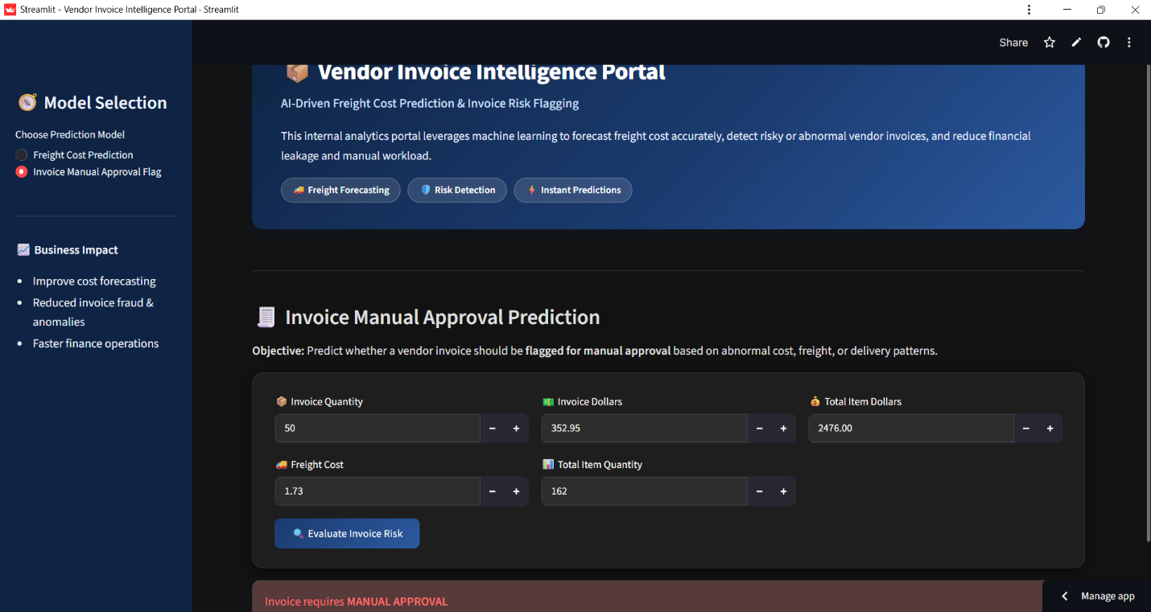
Figure 1: Invoice Risk Prediction Model

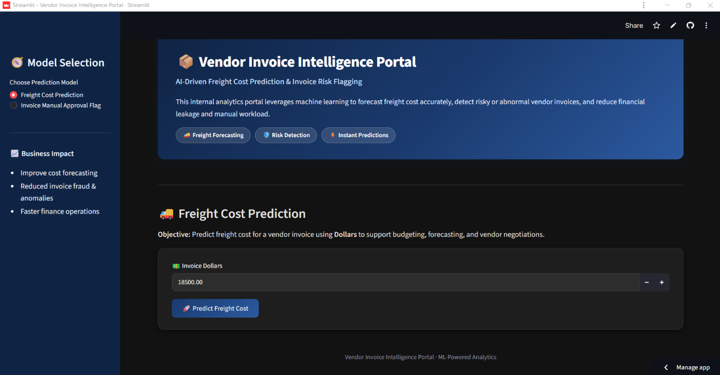
Figure 2: Freight Cost Prediction Model

Project Title
Design and Development of a Machine Learning-Based Intelligent Invoice Analysis and Risk Detection System

Problem Statement

Organizations process a large number of vendor invoices as part of their procurement and payment operations. Manual invoice verification can require considerable time and effort, particularly when invoice values need to be compared with purchase records and unusual transactions need to be identified.

Another challenge is the estimation of freight costs associated with invoices. Freight charges may vary according to invoice value and other transaction-related factors, making advance estimation difficult.

The proposed project addresses these challenges through a machine learning-based invoiceintelligence system consisting of two major functions: freight cost prediction and invoice risk classification. The system uses vendor invoice and purchase information stored in a SQLite database to prepare structured features, train machine learning models, evaluate their performance, and generate predictions.

Project Description
The Vendor Invoice Intelligence System is a machine learning project designed to analyze invoice-related data and assist in invoice processing and decision-making.
The system contains two independent but related machine learning pipelines:
- Freight Cost Prediction: Predicts the freight cost associated with an invoice using invoice dollar value and regression-based machine learning models.
- Invoice Risk Classification: Classifies invoices as safe or risky using invoice and purchase-level information and a Random Forest classification model.
The project uses Python, Pandas, SQLite3, Scikit-learn, and Joblib for data processing, model development, evaluation, and model persistence.

Scope of the Work
The scope of the project includes the development of a machine learning-based system for structured invoice analysis.
The major areas covered are:
- Collection of invoice and purchase data from a SQLite database.
- Data preprocessing and preparation for machine learning.
- SQL-based joining and aggregation of invoice and purchase records.
- Feature engineering from transaction-related information.
- Prediction of freight costs using regression algorithms.
- Identification of potentially risky invoices using classification techniques.
- Model comparison and evaluation using suitable performance metrics.
- Hyperparameter tuning of the Random Forest classifier using GridSearchCV.
- Saving trained
- models and preprocessing objects for subsequent use.

Project Modules

The project is divided into four major modules.

Module 1: Data Loading and Preprocessing

Invoice and purchase data is retrieved from a SQLite database. The data is cleaned, aggregated, and transformed into relevant features. The dataset is then divided into training and testing sets, with numerical features scaled using StandardScaler.

Module 2: Freight Cost Prediction

This module predicts freight cost using invoice Dollars as the input and Freight as the target. Three models are compared:

Linear Regression,Decision Tree Regression,Random Forest Regression

The models are evaluated using MAE, MSE, and R² Score, and the model with the lowest MAE is selected.

Module 3: Invoice Risk Classification

This module classifies invoices as Safe or Risky based on predefined risk conditions. It uses invoice and purchase-related features such as invoice amount, quantity, freight, and total item values.

A Random Forest Classifier is optimized using GridSearchCV with five-fold cross-validation, using F1-score for model selection.

Module 4: Model Evaluation and Storage

The trained models are evaluated using appropriate performance metrics and saved using Joblib. The freight prediction model, invoice risk model, and feature scaler are stored for future use.

Context Diagram (High Level)

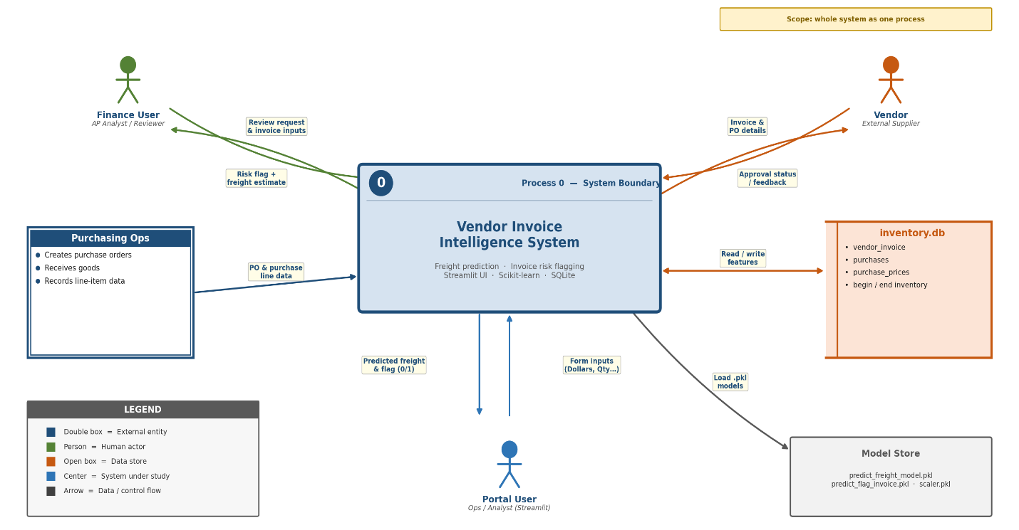

Implementation Methodology

The implementation follows a sequential machine learning methodology.

Step 1: Data Collection:

The system obtains vendor invoice and purchase information from the SQLite database. The invoice risk pipeline combines vendor invoice records with aggregated purchase information using the purchase order number.

Step 2: Data Preprocessing:

The extracted data is inspected and prepared for modeling. Relevant attributes are selected and derived variables are generated from the available transaction information.

Step 3: Feature Engineering:

For invoice risk analysis, transaction-level information is transformed into useful analytical features such as invoice quantity, invoice amount, freight, total item quantity, total item amount, receiving delay, and date-related differences.

Step 4: Risk Label Generation:

The invoice classification dataset is assigned a target label using predefined business rules based on invoice-to-purchase amount differences and receiving delays.

Step 5: Train-Test Splitting:

The datasets are divided into training and testing portions using an 80:20 split with a fixed random state to maintain reproducibility.

Step 6: Feature Scaling:

Numerical features used for invoice risk classification are standardized using StandardScaler. The fitted scaler is saved using Joblib so that the same preprocessing procedure can be reused.

Step 7: Model Training:

For freight prediction, Linear Regression, Decision Tree Regression, and Random Forest Regression are trained and compared.

For invoice classification, a Random Forest Classifier is used. Hyperparameters are optimized through GridSearchCV with five-fold cross-validation and F1-score as the scoring criterion.

Step 8: Model Evaluation:

Regression models are evaluated using MAE, MSE, and R² Score.

The classification model is evaluated using Accuracy, Precision, Recall, F1-score, and the classification report.

Step 9: Model Serialization:

The selected trained models and scaler are saved as .pkl files using Joblib. This makes the trained models available for subsequent prediction tasks without retraining from the beginning.

Data Flow Diagram:
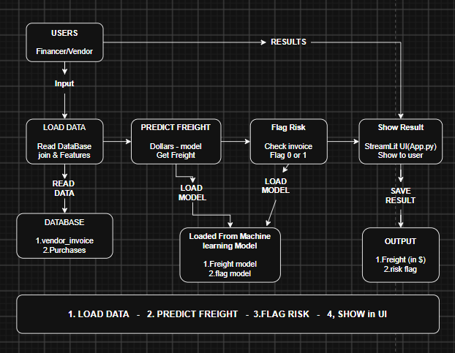

Flow Chart:

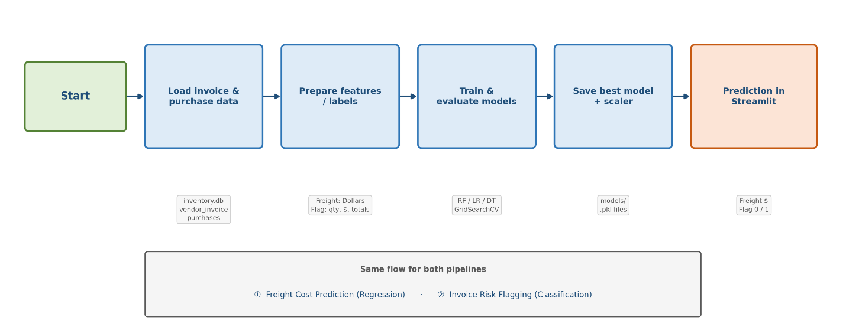

Use Case Diagram:

Finance / Operations
User
Enter invoice
information
Predict freight
cost
Check invoice
risk
Review result /
manual approval
Finance / Operations
User
Enter invoice
information
Predict freight
cost
Check invoice
risk
Review result /
manual approval

Main use cases
• Estimate freight cost
• Screen invoice risk
• Reduce repetitive checking
• Support faster review

Technologies to be used:
The project uses a Python-based machine learning technology stack for data processing, model development, evaluation, and storage.

Software Platform :

a) Front-end
Streamlit : Used to develop the interactive user interface for entering invoice details and displaying freight cost predictions and invoice risk classification results.

b) Back-end
Python: Core programming language used for implementing the project.
SQLite3: Used for storing and retrieving invoice and purchase data.
Pandas: Used for data loading, manipulation, aggregation, and preprocessing.
Scikit-learn: Used for machine learning models, feature scaling, model evaluation, and hyperparameter tuning.
Joblib: Used for saving and loading trained machine learning models and the feature scaler.
Jupyter Notebook / Python Environment: Used for development, experimentation, and data analysis.

Hardware Platform:
The project can be developed and executed on a standard personal computer or laptop capable of running a Python development environment.
Recommended hardware includes:
- Processor: Intel Core i3/i5 or equivalent
- RAM: Minimum 8 GB
- Storage: Minimum 10 GB of available space
- Operating System: Windows, Linux, or macOS
- Internet connection: Required when installing libraries or accessing remote development resources
Since the current project uses structured tabular data and conventional machine learning algorithms, specialized GPU hardware is not required for the implemented pipelines.

Tools, if any:
The following development tools and supporting technologies may be used during implementation:

- Git for version control
- GitHub for source-code repository management
- Visual Studio Code / Jupyter Notebook for development and experimentation
- Python virtual environment for dependency management
- SQLite database tools for inspecting and managing database records

Advantages of this Project:

The proposed system provides several practical advantages for invoice analysis and procurement-related operations.
- Reduced Manual Verification
The invoice classification pipeline can automatically identify invoices that meet predefined risk conditions, reducing the need for every transaction to be examined manually.
- Faster Invoice Analysis
Machine learning-based processing can analyze structured invoice information systematically and consistently.
- Freight Cost Estimation
The freight prediction module provides an estimated freight cost based on invoice information, supporting preliminary cost analysis and planning.
- Consistent Decision Support
The use of predefined risk conditions and trained machine learning models provides a standardized approach to invoice classification.
- Data-Driven Analysis
The project converts historical invoice and purchase data into predictive information that can support operational decision-making.
- Reusable Machine Learning Models
Trained models and preprocessing components are saved using Joblib, allowing them to be reused without retraining every time.

Assumptions, if any:
The implementation is based on the following assumptions:
- The invoice and purchase data stored in the SQLite database is sufficiently structured for analysis.
- Relevant invoice records can be associated with purchase information using the purchase order number.
- Historical invoice and purchase patterns contain useful information for predictive modeling.
- The predefined risk rules provide a reasonable basis for generating the training labels used by the invoice classification pipeline.
- The relationship between invoice value and freight cost is sufficiently useful for the implemented freight prediction models.
- Training and testing datasets are representative of the type of invoice records for which the system is intended to be used.
- The current system operates on structured data that has already been extracted into database tables.

Future Scope and further enhancement of the Project:

The current implementation provides a foundation for a broader intelligent invoice processing system. Several enhancements can be introduced in future versions.
Advanced Feature Engineering
Additional features such as purchase-order-level statistics, supplier information, historical vendor behavior, product characteristics, and other transaction-level variables can be incorporated to improve predictive performance.
Advanced Machine Learning Models
Models such as XGBoost and LightGBM can be investigated and compared with the currently implemented algorithms.
Invoice Document Processing
Future versions can incorporate OCR and document-processing technologies to extract information directly from invoice PDFs or images instead of depending only on structured database records.
Explainable AI
SHAP-based explainability can be integrated to help users understand which features contributed to an invoice being classified as risky. This can be particularly useful for audit and review workflows.
Dashboard Development
A user-friendly interface using technologies such as Streamlit or Flask can be developed to display predictions, flagged invoices, model results, and analytical summaries.
Continuous Model Improvement
With additional historical and verified invoice outcomes, the classification model can be retrained periodically to improve its ability to identify meaningful invoice exceptions.
Integration with Business Systems
The system could eventually be integrated with enterprise procurement, accounting, or ERP systems to support automated invoice-analysis workflows.

Project Repository Location:
The complete source code and project structure are maintained in the following GitHub repository:
S# | Project Artifacts (softcopy) | Location  (Mention Lab-ID, Server ID, Folder Name etc.) | Verified by Project Guide | Verified by Lab In-Charge
 | Project Synopsis Report (Final Version) | Device Folder | Ms. Sneha
 | Project Functional code | https://github.com/fahadahmad29/Invoice-Intelligence-Machine-Learning-Project | Ms. Sneha

Definitions, Acronyms, and Abbreviations

Abbreviation | Description
AI | Artificial Intelligence
ML | Machine Learning
SQLite | Lightweight relational database management system
MAE | Mean Absolute Error
MSE | Mean Squared Error
R² | Coefficient of Determination
F1-score | Harmonic mean of Precision and Recall
CV | Cross-Validation
RF | Random Forest
GridSearchCV | Hyperparameter search and cross-validation utility provided by Scikit-learn
OCR | Optical Character Recognition
PO | Purchase Order
ERP | Enterprise Resource Planning
CSV | Comma-Separated Values
PKL | Python serialized object/model file

Conclusion:

The Development of an Automated Invoice Processing System Using AI and Machine Learning demonstrates how machine learning can be applied to improve invoice-related business processes. The project addresses two important objectives: predicting freight costs and identifying potentially risky invoices from structured vendor and purchase data.
The freight cost prediction module compares multiple regression models using MAE, MSE, and R² Score, while the invoice risk classification module uses a Random Forest Classifier with GridSearchCV to classify invoices as safe or risky. These approaches can reduce repetitive manual analysis, provide faster insights, and support more consistent invoice verification.
The system also provides a practical foundation for further development. Implementing the project with Python, SQLite, Scikit-learn, Joblib, and Streamlit keeps the solution relatively lightweight and suitable for organizations that require a cost-effective analytical system. However, successful adoption would require reliable historical data, proper validation of risk rules, and periodic model monitoring to maintain prediction quality.
As a future recommendation, the system can be enhanced with OCR-based invoice data extraction, additional vendor and transaction features, advanced machine learning models, SHAP-based explainability, and integration with accounting or ERP systems. These improvements would increase automation and make the system more suitable for real-world organizational use while keeping implementation and operational costs manageable.
Overall, the project provides a practical starting point for applying machine learning to invoice analysis and demonstrates the potential of data-driven met

11.References/Bibliography:

• Scikit-learn Documentation, Machine Learning Algorithms and Model Evaluation, https://scikit-learn.org/

• Python Documentation, Python Programming Language, https://docs.python.org/

• Pandas Documentation, Data Analysis and Manipulation, https://pandas.pydata.org/docs/

• SQLite Documentation, SQLite Database Engine, https://www.sqlite.org/docs.html

• Joblib Documentation, Model Persistence and Utilities, https://joblib.readthedocs.io/

• GitHub Repository, Invoice Intelligence Machine Learning Project, Fahad Ahmad Khan, https://github.com/fahadahmad29/Invoice-Intelligence-Machine-Learning-Project

• Breiman, L. (2001). Random Forests. Machine Learning, 45, 5–32.

• Pedregosa, F. et al. (2011). Scikit-learn: Machine Learning in Python. Journal of Machine Learning Research, 12, 2825–2830.

