**HPC PROJECT – DELIVERABLE 1**

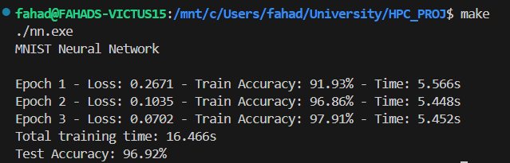**Execution Time:**

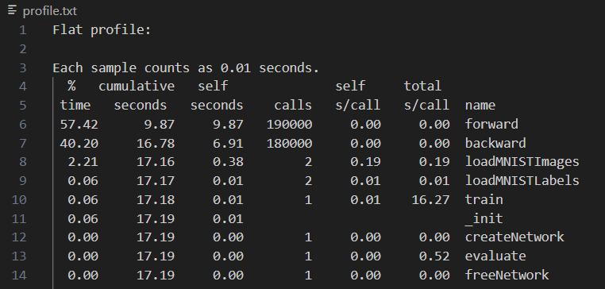**Gprof Profile:**

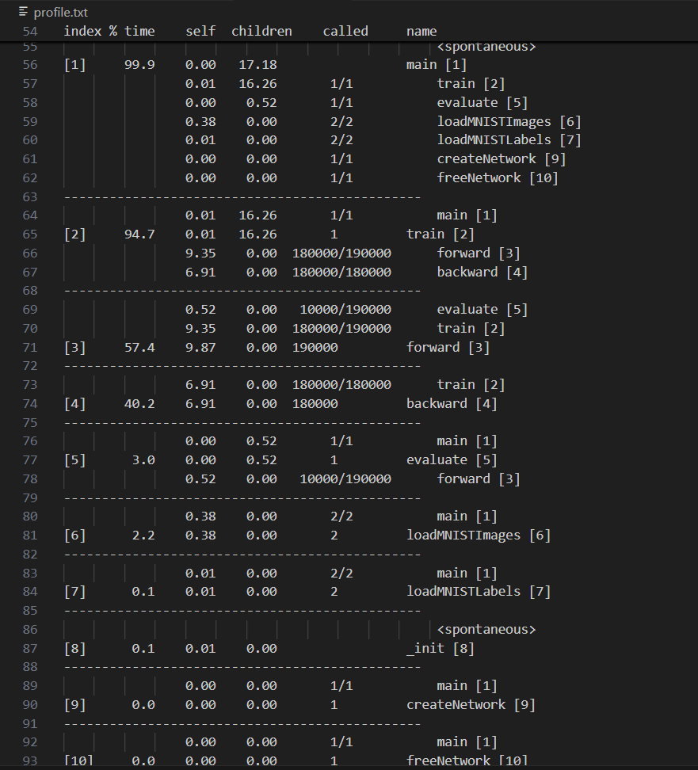

**Members:**  
Umer Mustafa 22i-1180

Fahad Ahmad 22i-1087