**Assignment 1**

**Group Members:** Fahad Alam (21i-2495), Fatima Imran (21i-2598), Hania Zahid (22i-1270)

**Project Title:** Final Year Project Management System

**Problem Statement:  
  
The problem** of manually managing the FYP management process

**Affects** the efficiency and accuracy of the overall project management processes

**The impact of which** results in prolonged time consumption and increased costs due to unnecessary paperwork.

**A successful solution would be** to develop a comprehensive web-based FYP management system that can reduce the steps in the work flow and facilitate collaboration between the users (FYP Committee, Project Supervisors, Panel Members, Project group members).

**List of Features:**

**1.** **Account management**

* create user accounts
* assigning user roles

**2.** **Notifications**

* Supervisor reaches maximum limit (committee member)
* Supervisor confirmation for project allocation (committee member)
* Notify regarding pending reviews (supervisor)

**3.** **Reports**

* Generate project reports
* Submit progress report (student)

**4.** **Deadlines**

* Set project deadlines (committee member)
* Checking deadlines (student)

**5.** **Panel management**

* Create project panels
* Assign FYP groups to panels

**6. Student management**

* View registered students list (committee member)
* View FYP groups’ details (committee member)
* View project details
* View assigned panel
* View reviews and suggestions
* Upload assignments/deliverables

**7.** **Project management**

* Access assigned FYPs (panel member)
* View all active FYPs
* View details of each FYP
* Review progress reports
* View FYP materials
* View deadlines for all FYP related assessments
* Communicate with assigned student groups
* Submit requests for extra materials
* Upload supplementary documents
* View reviews and suggestions
* Offer suggestions to FYP panel members

**8. Evaluations**

* View evaluation forms and grades (supervisor)
* Evaluate the FYPs (panel member)
* Handle missing evaluation (panel member)

**User Stories:**

**Story ID:** 1 **Story Title:** Create user accounts

**User Story:**

As an FYP committee member, I want to create the user accounts for students, supervisors and panel members of the FYP, so that I’m able to manage and control access to the system.

**Acceptance Criteria:**

* **Given:** that the FYP committee member is logged in
* **When:** the FYP committee member clicks on the “Create User” button
* **And:** enters details including name, email and role
* **Then:** system validates entered details
* **Given:** validation is successful
* **Then:** system creates new account according to entered details

**Importance:** Need to have feature

**-----------------------------------------------------------------------------------------------------------------------------------------**

**Story ID:** 2 **Story Title:** Assigning user roles

**User Story:**

As an FYP committee member, I want to give roles to the users such as Student, Panel Member and Supervisor, so I assign and give the correct required permissions.

**Acceptance Criteria:**

* **Given:** that the FYP committee member is logged in
* **And:** can access list of users
* **When:**  FYP committee member selects a particular user
* **And:** assigns them to a specific role
* **Then:** system updates the role of selected user
* **And:** message of successful role assignment is displayed

**Importance**: Need to have feature

**-----------------------------------------------------------------------------------------------------------------------------------------**

**Story ID:** 3 **Story Title:** Supervisor reaches maximum project allocation limit

**User Story:**

As an FYP committee member, I want to receive notifications whenever a project supervisor has reached their maximum project limit of 6 FYPs, so I can give the extra projects to some other Supervisor having less workload.

**Acceptance Criteria:**

* **Given:** a supervisor has reached maximum limit of 6 FYPs assigned
* **When:** FYP committee member attempts to assign a project to that supervisor
* **Then:** the system shows notification about the supervisor having reached the maximum number of FYPs assigned
* **And:** prevents further assignment of FYPs to that supervisor

**Importance:** Need to have feature

**-----------------------------------------------------------------------------------------------------------------------------------------**

**Story ID:** 4  **Story Title:** Supervisor confirmation for project allocation

**User Story:**

As an FYP committee member, I want to send notifications to the supervisors about their assigned student groups and get confirmation from them as well, so I can finalize the project allocation process.

**Acceptance Criteria:**

* **Given:** that the FYP committee member has assigned a student group to a supervisor
* **When:** the FYP committee member sends a notification to that specific supervisor
* **Then:** system should send this email to that specific supervisor
* **And:** let the supervisor confirm or decline this assignment
* **And:** update the record of allocated groups once confirmed

**Importance:** Need to have feature

**-----------------------------------------------------------------------------------------------------------------------------------------**

**Story ID:** 5  **Story Title:** Generate Project Reports

**User Story:**

As an FYP committee member, I want to be able to create reports for the project, including missing evaluations, list of FYPs supervised by faculty, and grades report, so I can assess progress and identify possible issues.

**Acceptance Criteria:**

* **Given:** that the FYP committee member is logged in
* **When:** the member clicks the ‘Reports’ button
* **And:** selects report type e.g. missing evaluations
* **Then:** system generates report according to the selected type
* **And:** allows member to download the report

**Importance:** Need to have feature

**-----------------------------------------------------------------------------------------------------------------------------------------**

**Story ID:** 6  **Story Title:**  Set project deadlines

**User Story:**

As an FYP committee member, I want to be able to set deadlines for the projects, for both submission and evaluation, so that I can ensure on time submissions and have a project timeline.

**Acceptance Criteria:**

* **Given:** that the FYP committee member is logged in
* **And:** accesses FYPs list
* **When:**  FYP committee member selects an FYP
* **And:** enters submission and evaluation deadlines
* **Then:** system saves the entered deadlines for that FYP
* **And:** displays the deadlines

**Importance:** Need to have feature

**-----------------------------------------------------------------------------------------------------------------------------------------**

**Story ID:** 7  **Story Title:** Create project panels

**User Story:**

As an FYP committee member, I want to create project panels composed of faculty members, so that I can ensure there is a diverse yet balanced team that will evaluate fairly.

**Acceptance Criteria:**

* **Given:** FYP committee member is logged in
* **And:** accesses faculty members list
* **When:**  FYP committee member clicks on the ‘Create Panel’ button
* **And:** adds faculty members to the created panel
* **Then:** system creates new project panel with the added faculty members
* **And:** display the panel details and members

**Importance:** Need to have feature

**-----------------------------------------------------------------------------------------------------------------------------------------**

**Story Id:** 8 **Story Title:** Assign FYP groups to panels

**User Story:**

As an FYP committee member, I want to allocate FYP groups to the created project panels, so that there is a smooth streamlined process of evaluating the projects.

**Acceptance Criteria:**

* **Given:** FYP committee member is logged in
* **And:** accesses FYP groups and project panels lists
* **When:** FYP committee member selects an FYP group
* **And:** assigns assigns it to a particular project panel
* **Then:** system updates FYP group list to show its assigned project panel
* **And:** show the panel on FYP group page

**Importance:** Need to have feature

**-----------------------------------------------------------------------------------------------------------------------------------------**

**Story ID:** 9 **Story Title:** View registered students list

**User Story:**

As an FYP committee member, I want to be able to see lists of all registered students in the FYP1, so that I can manage the allocation of projects accordingly.

**Acceptance Criteria:**

* **Given:** FYP committee member is logged in
* **When:** FYP committee member clicks on ‘Students’ button
* **Then:** system displays all registered students with their information

**Importance:** Need to have feature

**-----------------------------------------------------------------------------------------------------------------------------------------**

**Story ID:** 10 **Story Title:** View FYP groups’ details

**User Story:**

As an FYP committee member, I want to view the specific details of the FYP groups, members, the assigned supervisor etc., so that I can have information on each FYP as well as the group dynamics.

**Acceptance Criteria:**

* **Given:** FYP committee member is logged in
* **And:** accesses FYP groups list
* **When:** FYP committee member selects an FYP group
* **Then:** system displays Group Members and their information
* **And:** display the assigned supervisor and their details
* **And:** display project information including title and description

**Importance:** Need to have feature

**-----------------------------------------------------------------------------------------------------------------------------------------**

**Story ID:** 11 **Story Title :** Viewing project details

**User story:**

As a student, I want to view my group members, project title/description and the supervisor so that I can gain clarity on the details of the project

**Acceptance criteria:**

* **Given:** Student has enrolled for FYP
* **And:** have logged in
* **When:** student selects ‘My Project’
* **Then:** the system should display the project details, including the group members, supervisor and the project title/description

**Importance:** Need to have feature

**-----------------------------------------------------------------------------------------------------------------------------------------**

**Story ID:** 12 **Story Title :** Viewing assigned panel

**User story:**

As a student, I want to view the panel assigned to my FYP project so that I am aware of the assessment process

**Acceptance criteria:**

* **Given:** Student has enrolled for FYP
* **When:** student logs in
* **Then:** the system should display the panel assigned to the student to keep track of the assessment process

**Importance:** Need to have feature

**-----------------------------------------------------------------------------------------------------------------------------------------**

**Story ID:** 13 **Story Title :** Viewing reviews and suggestions

**User story:**

As a student, I want to view reviews and suggestions from the panel members so that I can improve the quality of my work

**Acceptance criteria:**

* **Given:** Student has enrolled for the FYP
* **And:** have logged in
* **When:** the student selects the ‘Reviews’ section
* **Then:** the system displays the reviews and suggestions related to the project from the panel members

**Importance:** Need to have feature

**-----------------------------------------------------------------------------------------------------------------------------------------**

**Story ID:** 14  **Story Title :** Checking deadlines

**User story:**

As a student, I want to view the deadlines of the presentations and document submissions so that I can make submissions within the given time

**Acceptance criteria:**

* **Given:** Student has enrolled for the FYP
* **And:** have logged in
* **When:** the student selects the ‘Assignments’ section
* **Then:** the system displays the deadlines for the work assigned

**Importance:** Need to have feature

**-----------------------------------------------------------------------------------------------------------------------------------------**

**Story ID:** 15 **Story Title :** Reviewing final grade

**User story:**

As a student, I want to view my final grade for the FYP so that I can understand how I have performed in the project

**Acceptance criteria:**

* **Given:** Student has completed the FYP
* **And:** have logged in
* **When:** student selects the ‘Transcript’ section
* **Then:** the system displays the final grade

**Importance:** Need to have feature

**-----------------------------------------------------------------------------------------------------------------------------------------**

**Story ID:** 16 **Story Title :** Uploading assignments/ deliverables

**User story:**

As a student, I want to submit the soft copies of the documents and presentations so that the need for unnecessary paperwork is minimized

**Acceptance criteria:**

* **Given:** Student has enrolled for the FYP
* **And:** have logged in
* **When:** student selects the ‘Assignments’ section
* **Then:** the system allows the student to submit the soft copies of the assignment

**Importance:** Need to have feature

**-----------------------------------------------------------------------------------------------------------------------------------------**

**Story ID:** 17  **Story Title :** Submitting progress report

**User story:**

As a student, I want to submit a progress report on my FYP so that I can provide an update on the status of the project

**Acceptance criteria:**

* **Given:** Student has enrolled for the FYP
* **And:** have logged in
* **When:** the student selects ‘Report’ section
* **Then:** the system redirects to another page
* **And:** allows the student to submit the progress report of the project

**Importance:** Need to have feature

**-----------------------------------------------------------------------------------------------------------------------------------------**

**Story ID:** 18 **Story Title :** Accessing assigned FYPs

**User story:**

As a panel member, I want to view the FYPs assigned to the panel so that I know which projects to evaluate

**Acceptance criteria:**

* **Given:** Panel member has logged in
* **When:** panel member selects the ‘Assigned Projects’ section
* **Then:** the system displays all the FYPs assigned to the panel of which this panel member is a part

**Importance:** Need to have feature

**-----------------------------------------------------------------------------------------------------------------------------------------**

**Story ID:** 19 **Story Title :** Evaluating the FYPs

**User story:**

As a panel member, I want to fill out the evaluation form so that I can participate in the assessment process.

**Acceptance criteria**

* **Given:** Panel member has logged in
* **When:** the panel member selects a specific FYP for evaluation
* **Then:** the system redirects the member to an evaluation form

**Importance:** Need to have feature

**-----------------------------------------------------------------------------------------------------------------------------------------**

**Story ID:** 20 **Story Title :** Handling missing evaluations

**User story:**

As a panel member, I want to receive notifications for missing evaluation forms so that I can complete the pending evaluations

**Acceptance criteria:**

* **Given:** Panel member has logged in
* **And:** have received a notification for missing form
* **When:** the panel member clicks on the notification
* **Then:** the system redirects the member to the evaluation form of the project that has not been evaluated yet

**Importance:** Nice to have feature

**-----------------------------------------------------------------------------------------------------------------------------------------**

**Story ID:** 21 **Story Title:** View All Active FYPs

**User story:**

As a supervisor, I want to view a list of all active FYPs that I am currently supervising so that I can better manage my workload and student groups.

**Acceptance criteria:**

* **Given:** That the Supervisor is logged in
* **And**: That the Supervisor is assigned to an FYP Student Group
* **When:** The Supervisor wants to view all the currently active FYPs they are supervising
* **Then:** The system should display a list of all the FYPs under this supervisor

**Importance:** Need to have feature

**-----------------------------------------------------------------------------------------------------------------------------------------**

**Story ID:** 22 **Story Title:** View Details of Each FYP

**User story:**

As a supervisor, I want to see the details of each FYP I am supervising, including project and group information, so I can guide them properly.

**Acceptance criteria:**

* **Given:** That the Supervisor is logged in
* **And**: That the Supervisor is assigned to an FYP Student Group
* **When:** The Supervisor wants to view details of each FYP project they are supervising
* **Then:** The system should display a list of all active FYPs under the supervision of that supervisor
* **And:** Let the supervisor access the project information of each FYP
* **And:** Let the supervisor access the group information of each FYP

**Importance:** Need to have feature

**-----------------------------------------------------------------------------------------------------------------------------------------**

**Story ID:** 23 **Story Title:** Review Progress Reports

**User story:**

As a supervisor, I want to review the progress reports that my student groups submit, so that I can monitor their progress.

**Acceptance criteria:**

* **Given:** That the Supervisor is logged in
* **And**: That the Supervisor is assigned to an FYP Student Group
* **When:** The Supervisor wants to view progress reports submitted by students
* **Then:** The system should list the project reports submitted by the relevant student group
* **And:** Allow the supervisor to view these reports

**Importance:** Need to have feature

**-----------------------------------------------------------------------------------------------------------------------------------------**

**Story ID:** 24 **Story Title:** View FYP Materials

**User story:**

As a supervisor, I want to be able to access FYP materials (proposals, final reports etc) submitted by my student groups so that I can examine them.

**Acceptance criteria:**

* **Given:** That the Supervisor is logged in
* **And**: That the Supervisor is assigned to an FYP Student Group
* **When:** The Supervisor wants to view materials submitted by students of each FYP project they are supervising
* **Then:** The system should let the supervisor access the various material each student group has submitted

**Importance:** Need to have feature

**-----------------------------------------------------------------------------------------------------------------------------------------**

**Story ID:** 25 **Story Title:** View Deadlines for All FYP Related Assessments

**User story:**

As a supervisor, I want to be able to see the deadlines for all FYP-related assessments (submissions, presentations, etc.) so that I can schedule my time effectively and remind my students of deadlines.

**Acceptance criteria:**

* **Given:** That the Supervisor is logged in
* **And**: That the Supervisor is assigned to an FYP Student Group
* **When:** The Supervisor wants to view deadlines of each FYP project they are supervising
* **Then:** The system should display a list of all active FYPs and their respective deadlines
* **And:** Let the supervisor see what assessment material the deadline is associated with

**Importance:** Need to have feature

**-----------------------------------------------------------------------------------------------------------------------------------------**

**Story ID:** 26 **Story Title:** Notify Regarding Pending Reviews

**User story:**

As a supervisor, I want to be notified whenever there are missing reviews for projects I supervise, so that I may prioritize completing them

**Acceptance criteria:**

* **Given:** That the Supervisor is logged in
* **And**: That the Supervisor is assigned to an FYP Student Group
* **When:** The Supervisor has not yet reviewed a specific FYP project
* **Then:** The system should notify the supervisor of the concerned FYP project
* **And:** Let the supervisor submit the review for that FYP project

**Importance:** Nice to have feature

**-----------------------------------------------------------------------------------------------------------------------------------------**

**Story ID:** 27 **Story Title:** Communicate With Assigned Student Groups

**User story:**

As a supervisor, I want to be able to communicate quickly with my student groups directly, so that I can answer any issues they may have.

**Acceptance criteria:**

* **Given:** That the Supervisor is logged in
* **And**: That the Supervisor is assigned to an FYP Student Group
* **When:** The Supervisor wants to communicate with a student group
* **Then:** The system should allow the supervisor to view any queries made by students
* **And:** Let the supervisor respond to them
* **And:** Send the responses to the student group

**Importance:** Need to have feature

**-----------------------------------------------------------------------------------------------------------------------------------------**

**Story ID:** 28 **Story Title:** Submit Requests For Extra Materials

**User story:**

As a supervisor, I want to submit requests for extra materials for FYP projects that I am supervising so that I have relevant material to aid my students.

**Acceptance criteria:**

* **Given:** That the Supervisor is logged in
* **And**: That the Supervisor is assigned to an FYP Student Group
* **When:** The Supervisor wants to request for extra helping material for a particular FYP project
* **Then:** The system should send this request to the panel members
* **And:** Let the panel members respond to this request
* **And:** Notify the supervisor once their request is responded to

**Importance:** Nice to have feature

**-----------------------------------------------------------------------------------------------------------------------------------------**

**Story ID:** 29 **Story Title:** Upload Supplementary Documents

**User story:**

As a supervisor, I want to upload supplementary documents for students, so that I may make sure students have what they need to be successful.

**Acceptance criteria:**

* **Given:** That the Supervisor is logged in
* **And**: That the Supervisor is assigned to an FYP Student Group
* **When:** The Supervisor wants to upload supplementary documents for a student group
* **Then:** The system should allow the supervisor to upload the relevant feedback
* **And:** Let the students view them

**Importance:** Nice to have feature

**-----------------------------------------------------------------------------------------------------------------------------------------**

**Story ID:** 30 **Story Title:** View Evaluation Forms and Grades

**User story:**

As a supervisor, I want to see the evaluation forms and grades submitted by panel members for my students' projects, so that I can understand how each of my assigned student groups was evaluated

**Acceptance criteria:**

* **Given:** That the Supervisor is logged in
* **And**: That the Supervisor is assigned to an FYP Student Group
* **When:** The Supervisor wants to view the evaluation forms and grades submitted by panel members for a specific student group
* **Then:** The system should display the relevant evaluations and grades

**Importance:** Need to have feature

**-----------------------------------------------------------------------------------------------------------------------------------------**

**Story ID:** 31 **Story Title:** View Review and Suggestions

**User story:**

As a supervisor, I want to be able to view any reviews and suggestions the panel members provide, so that I can guide my students accordingly

**Acceptance criteria:**

* **Given:** That the Supervisor is logged in
* **And**: That the Supervisor is assigned to an FYP Student Group
* **When:** The Supervisor wants to view the reviews and suggestions submitted by the panel members
* **Then:** The system should display this information for each student group
* **And:** Let the supervisor respond if necessary

**Importance:** Need to have feature

**-----------------------------------------------------------------------------------------------------------------------------------------**

**Story ID:** 32 **Story Title:** Offer Suggestions to FYP Panel Members

**User story:**

As a supervisor, I want to be able to offer suggestions to the FYP Panel Members on various areas of the FYP program, so that I can contribute to the overall improvement.

**Acceptance criteria:**

* **Given:** That the Supervisor is logged in
* **And**: That the Supervisor is assigned to an FYP Student Group
* **When:** The Supervisor wants to offer suggestions on various project aspects
* **Then:** The system should send these suggestions to the panel members
* **And:** Let the panel members view and respond to these suggestions

**Importance:** Nice to have feature

**Roles:**

**Product Owner:** Fahad Alam

**Duties:** defines the product backlog and communicates the product features to the Scrum team. It also decides on the deadlines.

**Scrum Master:** Fatima Imran, Hania Zahid

**Duties:** facilitates events such as sprint planning, sprint review, and sprint retrospective. It is responsible for enforcing the scrum principles.

**Scrum Team:** Fahad Alam, Fatima Imran, Hania Zahid

**Duties:** The team is cross-functional and works together to deliver the product increments in each sprint.

**Github Repository:**

**Link:** https://github.com/fahadalam24/FYP-Manager.git

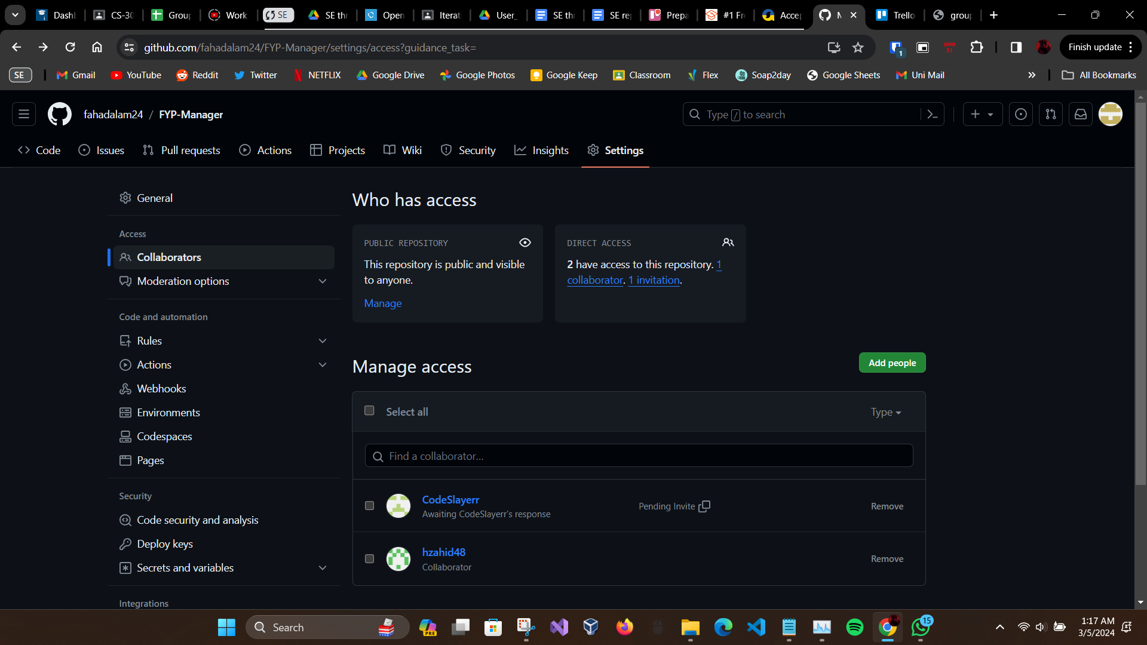

**Sprint Backlog Screenshot:**

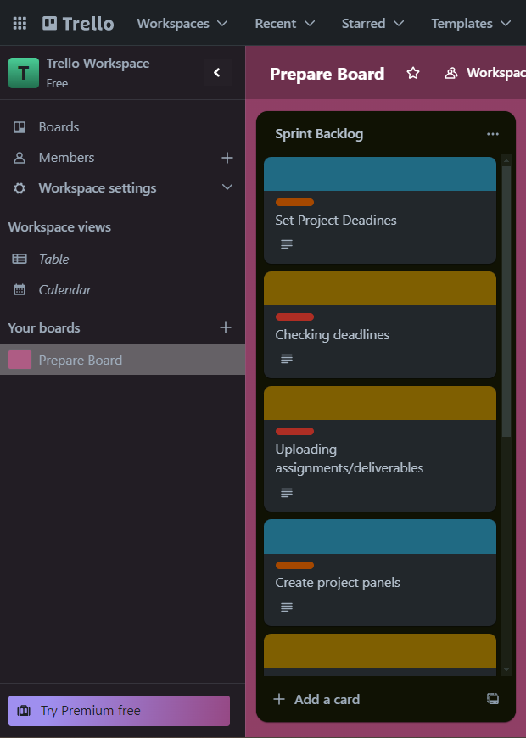

**Product Backlog Screenshot:**

