Multi-threaded Web Crawler - Test Documentation

1. Introduction
This document presents the test case structure and execution results for the Multi-threaded Web Crawler with Resume Capability. It demonstrates functionality, stability, and OS-level concepts such as threading, synchronization, and persistence.

2. Test Cases

3.1 Basic Crawl Test
Command:
./crawler
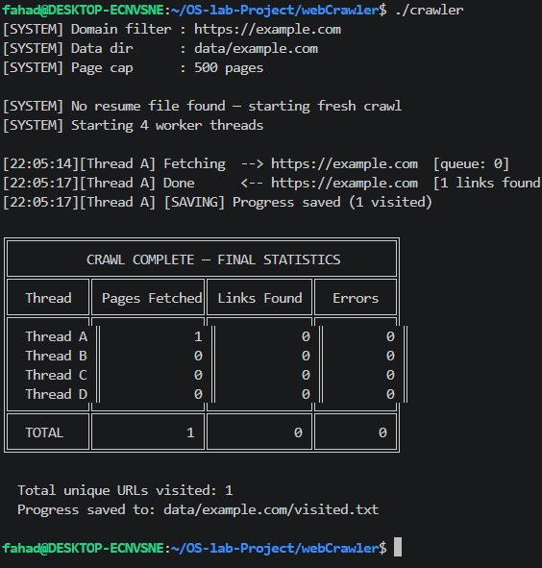

3.2 Domain Filtering Test
Command: ./crawler https://www.iana.org/help/example-domains
Expected Result: Only same-domain links are processed; external links ignored.
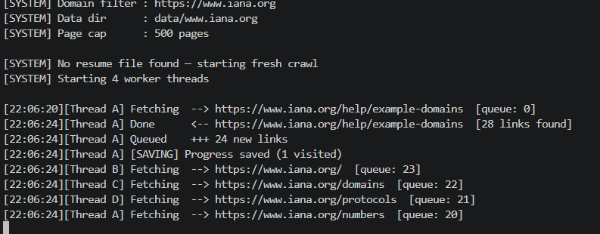

3.3 Resume Functionality Test
Steps:
1. Run crawler
2. Press Ctrl+C
3. Run again
Expected Result: Previously visited URLs are skipped and crawling resumes.
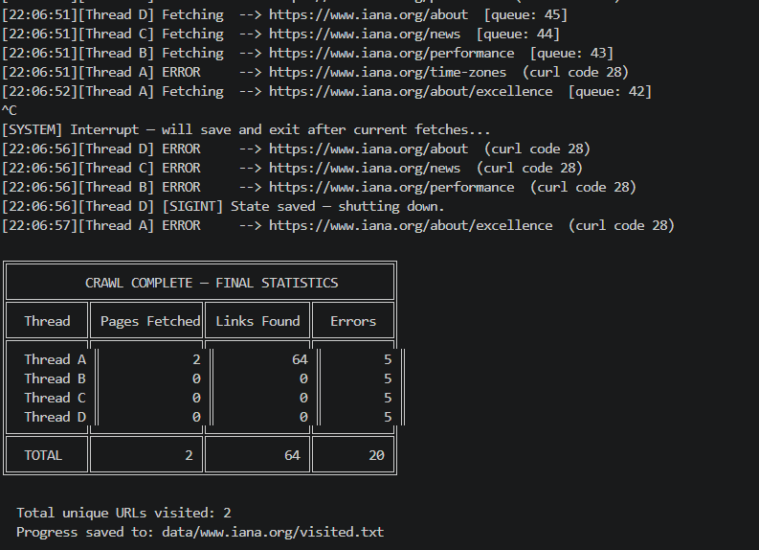

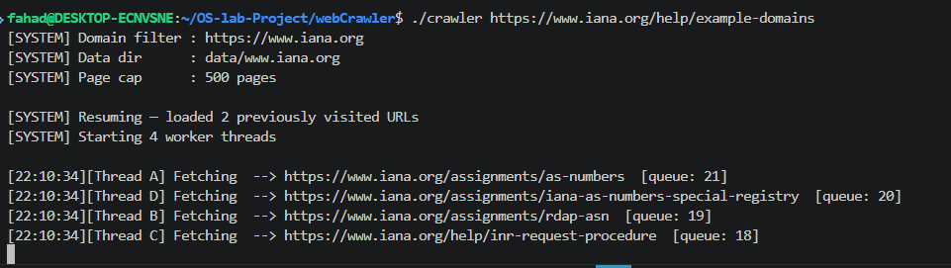

3.4 Stability Test
Command: ./crawler https://www.geekybugs.com
Expected Result: No crashes, proper logging, and stable execution.

4. Data Directory Mapping
Each test generates a corresponding folder in data/ directory containing visited.txt and crawler.log.
