ASSIGNMENT NO. 04
Machine Learning Model Application & Evaluation
Submitted by
Name | Fahad Baloch
Roll No. | 025
Section | 3A
Subject | Data Science
Assignment No. | 04

1. Introduction and Objective
The objective of this assignment is to select a real-world dataset, decide whether the underlying problem is classification or regression, apply at least three suitable machine learning models, evaluate them with the metrics appropriate to the problem type, and finally compare the models and justify which one is best for the problem.
This report follows exactly that sequence: dataset selection, problem identification, preprocessing, model application, evaluation, comparison and conclusion.

2. Dataset Selection

2.1 Dataset chosen
Breast Cancer Wisconsin (Diagnostic) Dataset - a real clinical dataset originally created at the University of Wisconsin and available in the UCI Machine Learning Repository. It is also bundled with scikit-learn (load_breast_cancer), which makes the experiment fully reproducible.

2.2 Why this dataset is suitable
- It is real-world medical data, not a synthetic toy example.
- It has a clear, meaningful target: whether a tumour is malignant (cancerous) or benign (non-cancerous).
- It is clean (no missing values) and entirely numeric, so the comparison between models is about the models and not about data-cleaning tricks.
- The classes are moderately imbalanced, so precision, recall and F1-score matter and accuracy alone is not enough - which is what the assignment asks us to look at.

2.3 Dataset description
Property | Value
Number of samples | 569 patients
Number of features | 30 numeric features
Feature source | Measurements computed from a digitised image of a fine-needle aspirate (FNA) of a breast mass, describing the cell nuclei
Feature groups | 10 base measurements (radius, texture, perimeter, area, smoothness, compactness, concavity, concave points, symmetry, fractal dimension), each given as mean, standard error and 'worst' (largest) value = 30 features
Target variable | diagnosis: 0 = Malignant, 1 = Benign
Class distribution | 212 malignant (37.3%) and 357 benign (62.7%)
Missing values | None (0)

3. Problem Identification: Classification or Regression?
This is a Binary Classification problem.
Reason: the value we want to predict is not a continuous number (like a price or a temperature). It is a category with exactly two possible outcomes - malignant or benign. Predicting a category from input features is classification. Therefore the classification metrics (Accuracy, Precision, Recall, F1-Score and Confusion Matrix) are used, and the regression metrics (MAE, RMSE, R-squared) are not applicable.

4. Methodology

4.1 Train/test split
The data was split 80% training (455 samples) and 20% testing (114 samples). A stratified split was used so that both sets keep the same malignant/benign proportion as the full dataset. A fixed random seed (42) makes the results repeatable. The test set (42 malignant, 72 benign) was kept unseen during training and used only for final evaluation.

4.2 Preprocessing
There were no missing values, so no imputation was needed. The 30 features are on very different scales (for example, 'area' is in the hundreds or thousands while 'smoothness' is around 0.1). Logistic Regression and SVM are sensitive to feature scale, so StandardScaler (zero mean, unit variance) was applied to them inside a pipeline, fitted on training data only so no information leaks from the test set. Random Forest is tree-based and does not need scaling, so it was trained on raw features.

4.3 Models applied
Three models from different families were chosen so that the comparison is meaningful:
Model | Family | How it works and settings used
Logistic Regression | Linear model | Learns a weighted sum of the features and passes it through a sigmoid function to output the probability of the benign class. Simple, fast and interpretable. Settings: max_iter = 1000, with feature scaling.
Random Forest | Ensemble of trees | Builds many decision trees on random subsets of data and features and takes a majority vote, which reduces overfitting. Handles non-linear relationships. Settings: 300 trees, no scaling needed.
Support Vector Machine (RBF) | Kernel method | Finds the boundary that separates the two classes with the maximum margin; the RBF kernel lets that boundary be non-linear. Settings: C = 1.0, gamma = 'scale', with feature scaling.

4.4 Evaluation metrics
Benign is treated as the positive class (label 1). The following were computed on the test set:
- Accuracy = (TP + TN) / total. The share of all predictions that are correct.
- Precision = TP / (TP + FP). Of all cases predicted benign, how many really are benign.
- Recall = TP / (TP + FN). Of all truly benign cases, how many were found.
- F1-Score = harmonic mean of precision and recall. A single number that balances both.
- Confusion Matrix - the table of TN, FP, FN and TP counts, which shows exactly what kinds of mistakes each model makes.
In addition, 5-fold stratified cross-validation accuracy was computed on the full dataset. A single 114-sample test set can be lucky or unlucky, so cross-validation gives a more stable view of each model's real performance.

5. Results

5.1 Test-set performance
Model | Accuracy | Precision | Recall | F1-Score
Logistic Regression | 98.25% | 98.61% | 98.61% | 98.61%
Random Forest | 94.74% | 95.83% | 95.83% | 95.83%
SVM (RBF kernel) | 98.25% | 98.61% | 98.61% | 98.61%

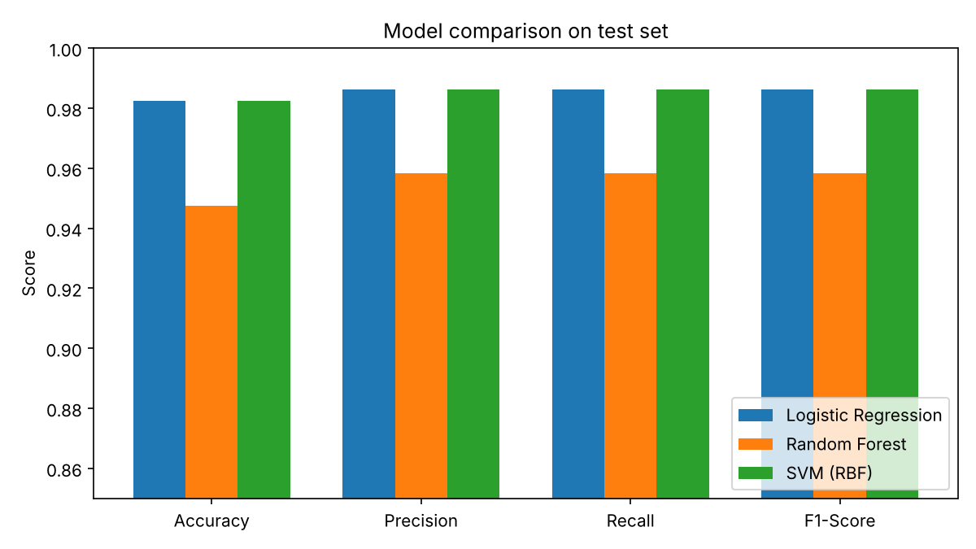
Figure 1: Test-set metrics for the three models (y-axis starts at 0.85 to make small differences visible)

5.2 Confusion matrices
Model | TN | FP | FN | TP
Logistic Regression | 41 | 1 | 1 | 71
Random Forest | 39 | 3 | 3 | 69
SVM (RBF kernel) | 41 | 1 | 1 | 71

How to read this: TN = malignant correctly identified; TP = benign correctly identified; FP = a malignant tumour wrongly predicted as benign; FN = a benign tumour wrongly predicted as malignant. The test set contains 42 malignant and 72 benign cases.
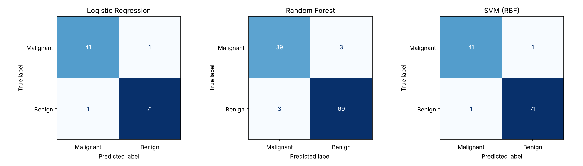
Figure 2: Confusion matrices (rows = actual class, columns = predicted class)
- Logistic Regression: 1 of 42 malignant cases missed and 1 of 72 benign cases flagged as malignant. Total 2 errors out of 114.
- Random Forest: 3 of 42 malignant cases missed and 3 of 72 benign cases flagged as malignant. Total 6 errors out of 114.
- SVM (RBF): 1 of 42 malignant cases missed and 1 of 72 benign cases flagged as malignant. Total 2 errors out of 114 - the same as Logistic Regression.

5.3 Cross-validation (5-fold)
Model | Mean accuracy | Std. deviation
Logistic Regression | 97.37% | 1.66%
Random Forest | 95.26% | 1.31%
SVM (RBF kernel) | 97.72% | 1.63%

Cross-validation agrees with the test-set picture: SVM and Logistic Regression are both around 97-98%, and Random Forest is lower at about 95%.

5.4 Extra insight: which features matter most
Random Forest also reports which features contributed most to its decisions. The most important ones are worst perimeter, worst area, worst concave points, mean concave points and worst radius. This matches medical intuition: larger and more irregular nuclei with more concave points are strongly associated with malignancy.
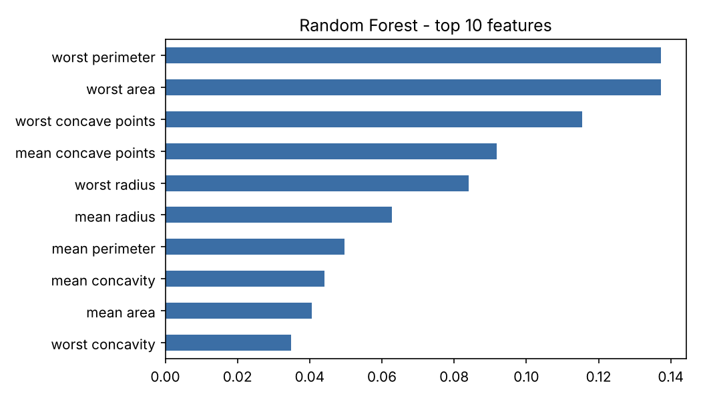
Figure 3: Top 10 features according to Random Forest

6. Model Comparison
Model | Test accuracy | Test F1 | Total errors (of 114) | Malignant missed | CV accuracy
Logistic Regression | 98.25% | 98.61% | 2 | 1 | 97.37%
Random Forest | 94.74% | 95.83% | 6 | 3 | 95.26%
SVM (RBF) | 98.25% | 98.61% | 2 | 1 | 97.72%

- Logistic Regression and SVM are tied on the test set - identical accuracy, precision, recall, F1 and the same confusion matrix. Both are clearly better than Random Forest.
- Random Forest is the weakest here - three times as many errors on the test set (6 vs 2) and the lowest cross-validation score. This is a small dataset with 30 strongly correlated features whose classes are almost linearly separable, a situation where smooth, scaled models like Logistic Regression and SVM do very well and a tree ensemble has no advantage.
- SVM has the highest cross-validation accuracy (97.72% vs 97.37% for Logistic Regression). This gap is tiny compared with the standard deviation (about 1.6%), so it should be read as a slight edge, not a proven difference.

7. Best Model and Justification
Best model: Support Vector Machine (RBF kernel).
Justification:
- It reached the top test performance (98.25% accuracy, 98.61% precision, recall and F1) with only 2 mistakes out of 114 patients.
- It has the highest cross-validation accuracy (97.72%), so its good test result is not just luck of one particular split.
- It missed only 1 of 42 malignant tumours. In cancer screening the most costly error is calling a malignant tumour benign, so a low count of this specific error matters more than raw accuracy; the SVM is as good as any model tested on this point.
- Its non-linear RBF kernel gives it extra flexibility over the purely linear Logistic Regression, while the margin-maximising objective keeps it from overfitting on a dataset of this size.
Honest note: Logistic Regression performed essentially the same as the SVM (identical test results; only 0.35 percentage points lower in cross-validation, well within the noise). If the priority is interpretability - being able to explain to a doctor how each feature pushes the prediction - Logistic Regression is an equally strong and simpler choice. Random Forest is not recommended for this particular problem because it was clearly less accurate.

8. Conclusion
The Breast Cancer Wisconsin dataset presents a binary classification problem. Three models - Logistic Regression, Random Forest and SVM - were trained on an 80/20 stratified split and evaluated with accuracy, precision, recall, F1-score, confusion matrices and 5-fold cross-validation. The SVM with an RBF kernel and Logistic Regression both achieved 98.25% test accuracy, Random Forest reached 94.74%, and the SVM had the best cross-validated accuracy (97.72%). The SVM is therefore selected as the best model for this problem, with Logistic Regression as a very close and more interpretable alternative.
Limitations: the test set has only 114 samples, so one extra mistake changes accuracy by almost 1 percentage point; models were used with default or lightly chosen settings without extensive hyperparameter tuning. Larger data and tuning (for example grid search over C and gamma) could refine the comparison further.

9. Tools and Reproducibility
Python 3 with scikit-learn, pandas, NumPy and Matplotlib. The complete code is provided in the accompanying file assignment4_ml.py; running it reproduces every number, table and figure in this report (random seed = 42).

