ISMCC-MAS: Integrated Sensing–Memory–Communication–Computation Multi-Agent System for Cognitive City Energy Management

This research introduces an intelligent energy management system for cognitive cities using a three-tier architecture. It distributes processing across building, district, and city levels to provide scalable and optimized control. Proposing a multi-agent system based on the ISMCC-MAS framework.

Architecture:
Diagram 1.

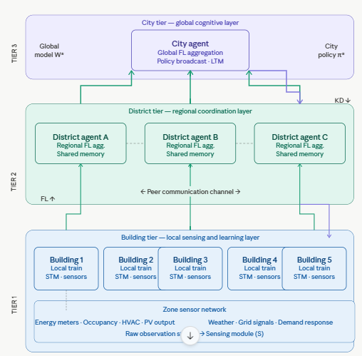
The overarching system is organized into a three-tier hierarchy, decoupling responsibilities for enhanced scalability. The Building tier at the lower edge performs local sensing and training, uploading gradients to the next level. Intermediary District agents then aggregate regional results and manage peer communication. Finally, the City agent at the top maintains the global model and broadcasts policies downward.
Algorithm 1: Three-Tier Hierarchical Communication
This describes the structural flow of data through the network.
Local Gradients ($\mathbf{g}_i$): Building agents compute gradients based on local data and send them to the District tier.
Partial Aggregation: District agents receive $\mathbf{g}_{i...n}$, perform a preliminary check, and forward a regional summary ($\mathbf{G}_d$) to the City tier.
Global Update: The City agent computes the final global model $\mathbf{W}_{t+1}$ using the regional summaries.
Direct Broadcast: To minimize latency, the City agent sends $\mathbf{W}_{t+1}$ directly back to all Building agents, skipping the District tier for the return trip.

Diagram 2.
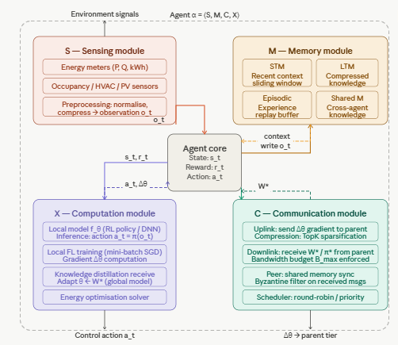
Figure 2 illustrates the formal, ISMCC model of a single agent. Environment signals pass through the Sensing module before reaching the Agent Core, which then directs data flow to Memory, Computation, and Communication modules. Solid lines represent forward data paths, while dashed read back lines diagram context retrieval and gradient feedback.
Algorithm 2: ISMCC Agent Core Processing
This explains how a single agent (Building or District) handles information internally.
Sensing & Input: Environmental signals are transformed into a digital state st.
Context Retrieval (Memory): The Agent Core queries the Memory module using a similarity function:
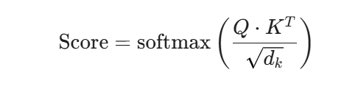This retrieves historical gradients or patterns relevant to the current state.
Computation (Local Update): The agent calculates the gradient update:
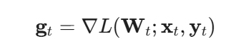Where L is the loss function, St is the sensing data, and Yt is the target.
Communication: The update gt is packaged with metadata (tier-ID) and sent to the next hierarchical level.

Diagram 3.
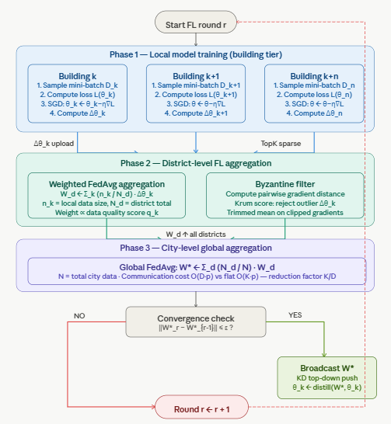
This traces the complete FL round: local SGD at buildings → Byzantine-filtered district aggregation → global city FedAvg → convergence gate → broadcast back or loop. Now let's render the memory module in depth and the tier-specific instantiation side by side.
Algorithm 3: Byzantine-Resilient Federated Round (Diagram 3)
This is the most complex part, focusing on security and convergence.
Step 1: Gradient Clipping (Defense)
Before aggregation, gradients are clipped to a threshold C to prevent a single malicious agent from "exploding" the model:

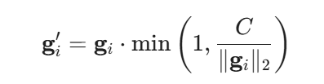
This ensures no update has an outsized influence.
Step 2: Byzantine Filtering (Krum Scoring)
The District agent identifies the most "trustworthy" gradient by calculating Euclidean distances between all received updates:
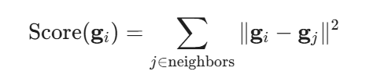
The agent with the lowest score (closest to the center of the "honest" cluster) is selected as the representative update to pass to the City.
Step 3: Global Aggregation
The City agent averages the filtered regional updates:
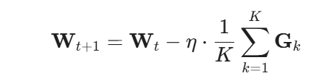$
Where n is the learning rate and K is the number of districts.
Step 4: Convergence Check
The system checks if the change in the global model is below a threshold E(summation):
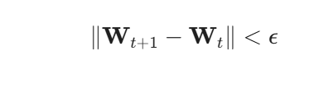
If True: The model has converged; the process stops.
If False: A new round begins, and W t+1 is broadcast to all buildings.

Diagram 4.
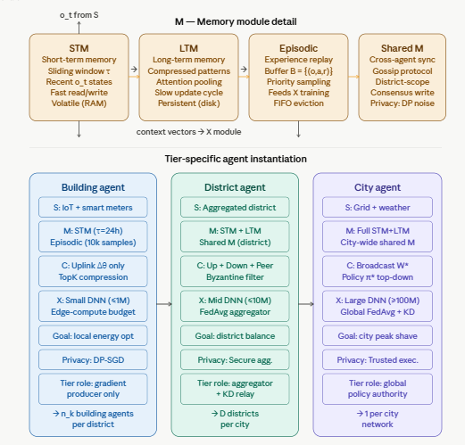
It breaks open the memory module into its four sub-stores and then shows how the same 4-tuple instantiates very differently at each tier - different model sizes, communication directions, privacy mechanisms, and roles. One final diagram now for the Byzantine-resilient aggregation and convergence analysis.
Algorithm 4: Memory Module Retrieval & Update (Diagram 4)
This algorithm governs how an agent stores historical context and retrieves it to improve current local training.
Query Generation (q): The Agent Core generates a query vector (q) based on the current sensing input (s). This vector represents what the agent is "looking for" in its past experiences.
Contextual Retrieval (Attention Mechanism): The module searches the memory bank M by calculating a similarity score between the query and stored keys (Kj):
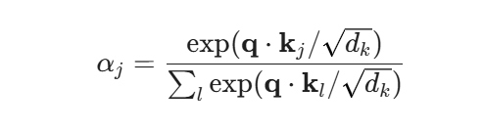

This formula (Scaled Dot-Product Attention) determines which past experiences are most relevant to the current environmental state.
Context Injection The retrieved context is combined with current data to adjust the training.
Formula: Context Vector = Sum(Score * Values)
Reasoning: By injecting this context, the agent can "remember" how it handled similar energy spikes or drops in the past, allowing it to bias its current gradient descent toward a faster, proven solution.

Memory Update Rule: After a training round, the memory is updated using a gated approach to prevent "catastrophic forgetting":

Where Linda is a decay factor that determines how quickly old information is phased out for new data.

Diagram 5.
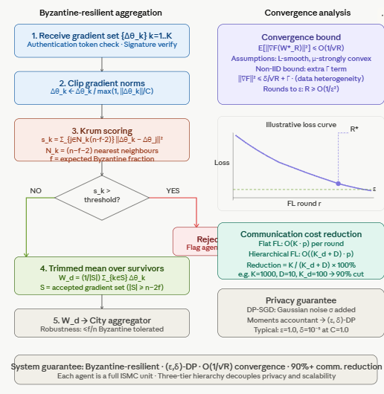Byzantine resilience and convergence (§3.5.4–3.5.5) gives the step-by-step Krum scoring pipeline on the left (receive → clip → score → filter → trimmed mean), and on the right shows the convergence bound O(1/√R), an illustrative loss curve with the ε threshold, the communication cost reduction formula (90%+ reduction in typical deployments), and the differential privacy guarantee.
Algorithm 5: Tier-Specific Configurations & LSTM Distillation
This explains the specialized roles of the Building, District, and City agents in the energy management system.
Building Tier (High-Frequency Forecasting):
Logic: Executes local LSTM passes every T minutes.
Local Loss (Llocal):
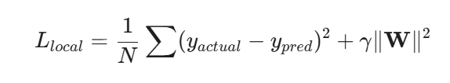
This focuses on minimizing Mean Squared Error (MSE) for specific building loads.
District Tier (Byzantine-Robust Aggregation):
Logic: Acts as a security firewall. It receives Building gradients and applies the Krum score filter (as detailed in Algorithm 3) to ensure that faulty or malicious energy data from one building does not corrupt the regional model.
City Tier (Global Knowledge Distillation):
Logic: Instead of just averaging, the City agent performs Distillation. It uses a high-capacity "Teacher" LSTM to refine the "Student" LSTMs at the building level.
Distillation Loss (Ltotal):
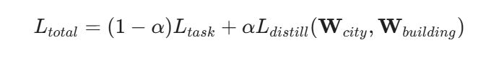Where Ldistill is the Kullback-Leibler (KL) divergence between the City’s global forecast and the Building’s local forecast. This forces building-level models to align with city-wide energy trends while maintaining local accuracy.

The SMC-MAS framework introduces a robust, hierarchical approach to energy management by integrating Federated Learning with LSTM-based forecasting. By structuring the system into Building, District, and City tiers, the model achieves a balance between local data privacy and global intelligence.
The inclusion of Byzantine-resilient aggregation at the district level ensures that the network remains secure against malicious or faulty data, while the Memory module and Knowledge Distillation processes allow individual agents to benefit from both historical context and city-wide trends. Ultimately, this multi-agent system provides a scalable and secure solution for modern energy grids, ensuring accurate power forecasting even in complex, large-scale urban environments.

References
[1] P. Blanchard, E. M. El Mhamdi, R. Guerraoui, and J. Stainer, "Machine learning with adversaries: Byzantine tolerant gradient descent," in Proc. Advances in Neural Information Processing Systems (NeurIPS), vol. 30, pp. 119–129, Dec. 2017.
[2] S. Li, E. C.-H. Ngai, and T. Voigt, "An experimental study of Byzantine-robust aggregation schemes in federated learning," IEEE Transactions on Big Data, vol. 9, no. 5, pp. 1362–1375, Oct. 2023.
[3] L. Liu, J. Zhang, S. Song, and K. B. Letaief, "Client-edge-cloud hierarchical federated learning," in Proc. IEEE International Conference on Communications (ICC), Jun. 2020, pp. 1–6.
[4] B. McMahan, E. Moore, D. Ramage, S. Hampson, and B. A. y Arcas, "Communication-efficient learning of deep networks from decentralized data," in Proc. 20th International Conference on Artificial Intelligence and Statistics (AISTATS), 2017, pp. 1273–1282.
[5] J. Shao, H. Luan, and S. Sun, "When federated learning meets knowledge distillation," IEEE Wireless Communications, vol. 31, no. 5, pp. 44–51, Oct. 2024.
[6] X. Wang et al., "Energy consumption prediction model for smart homes via decentralized federated learning with LSTM," IEEE Transactions on Consumer Electronics, vol. 69, no. 1, pp. 56–67, Feb. 2023.
[7] Y. Tao et al., "Byzantine-resilient federated learning at edge," IEEE Transactions on Computers, vol. 72, no. 9, pp. 2600–2614, Sep. 2023.

