Team meeting 24.05.2019: How can we do upsampling in APRNets?
Decisions are marked in bold.

Content
Deconvolution in general
Deconvolution in semantic segmentation
Upsampling in Super-resolution
Do we have to go back to the original APR representation or can we have a new tree structure as a result?
How to compare the old and the new tree?
How to build that new APR tree?
How do we propagate the unpooling through the tree?
How do we do bilinear interpolation on the APR?
How could we define the loss for validation of our approach/ training?
Working plan
Plan until next meeting

From last team meeting: we want to do deconvolution

→ What existing approaches for deconvolution are there?

Deconvolution in general (from https://datascience.stackexchange.com/a/20176)
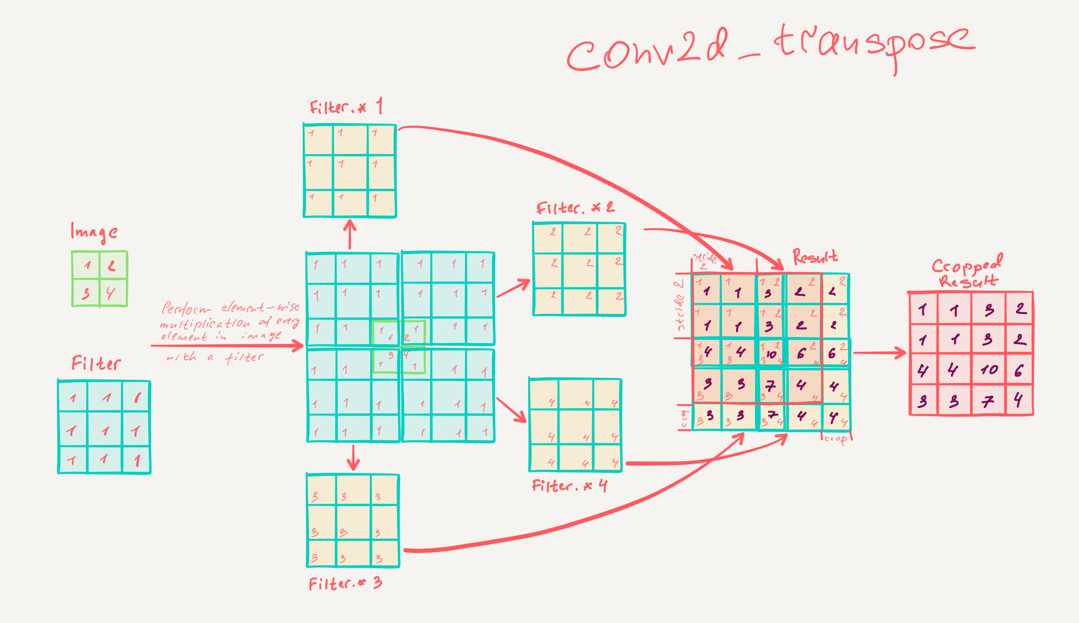

- what about the padding? → no padding first, maybe later
- where do we crop? → if needed, cropping according to gradient (crop where gradient is small because it contains less info)
- usually after convolutional layers cropping of the edges is performed to enhance learning speed of the network – Joel is not doing that, or is he? - might be of interest to him

Deconvolution in semantic segmentation

1. Noh et al.: Learning Deconvolution Network for Semantic Segmentation
- assume previously performed pooling
- they upsample in a 2-step process: „unpooling“ and „deconvolution“
- unpooling: remember the pixel from which the pool result came and simply reverse the pooling operation→ gives an image of bigger size, but sparse
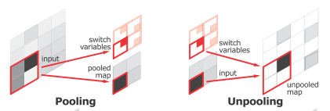
- deconvolution: as explained above, they perform cropping after deconvolution to maintain the size of the unpooled image
→ the way they play together according to Noh et al. Is: „Note that unpooling and deconvolu-
tion play different roles for the construction of segmentation
masks. Unpooling captures example-speciﬁc structures by
tracing the original locations with strong activations back
to image space. As a result, it effectively reconstructs the
detailed structure of an object in ﬁner resolutions. On the
other hand, learned ﬁlters in deconvolutional layers tend to
capture class-speciﬁc shapes. Through deconvolutions, the
activations closely related to the target classes are ampliﬁed
while noisy activations from other regions are suppressed
effectively.“

2. simple approach – https://datascience.stackexchange.com/questions/6107/what-are-deconvolutional-layers; answer https://datascience.stackexchange.com/a/12110
- gave the idea to an alternative to unpooling: don‘t remember where the values came from, just put them in some constant place (e.g. the upper left edge of a 4x4 plane)
- then do deconvolution

3. U-Nets (Nithya‘s paper I don‘t know the name of)
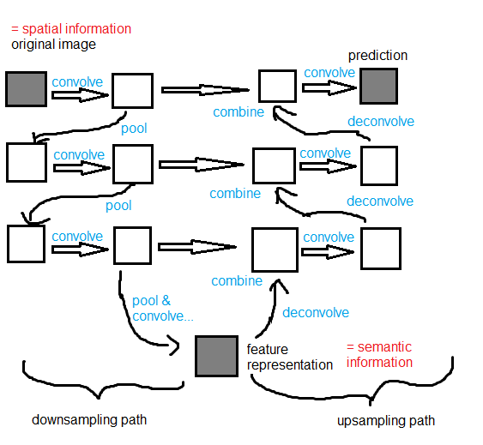
- they do not really explain what they did for „deconvolution“, but what we understood is:
- do „unpooling“ like in proposal 2.
- apply a convolutional layer to the result
- the result of both operations in sum is a deconvolution, according to Shibuya, Up-sampling with Transposed Convolution
(https://towardsdatascience.com/up-sampling-with-transposed-convolution-9ae4f2df52d0)
- then merge the „deconvolved“ image with a saved image from the downsampling path
- it comes at a cost (Shibuya): „As such, the transposed convolution is not a convolution. But we can emulate the transposed convolution using a convolution. We up-sample the input by adding zeros between the values in the input matrix in a way that the direct convolution produces the same effect as the transposed convolution. You may find some article explains the transposed convolution in this way. However, it is less efficient due to the need to add zeros to up-sample the input before the convolution.“
→ U-Nets capture the semantic information (features) from the deconvolved layer and the spatial information from the layer that was saved from the downsampling path → similar notion to proposal 1.
→ but they have a whole fuckload of parameters

Upsampling in Super-resolution

4. Dong et al., Image Super-Resolution Using Deep Convolutional Networks
- upsampling by bilinear interpolation
- then applying convolutional layers to improve quality of the result

→ we decided for the easiest way: bilinear interpolation enhanced by convolutional layers

How can we do that?
Do we have to go back to the original APR representation or can we have a new tree structure as a result? = What makes more sense: to retrieve the original APR structure or to create a new APR structure from the feature map? (we had lively discussions on that)
→ we now think we can/should have a new structure, because:
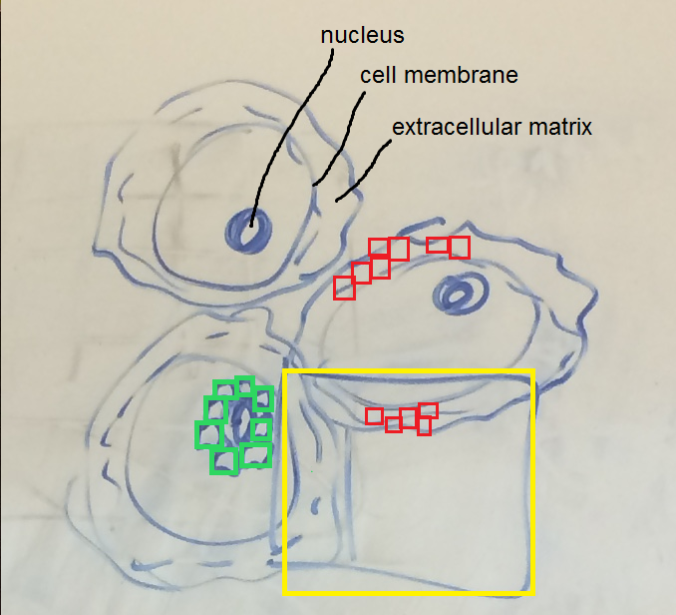
- suppose we want to segment out cell nuclei → green particles would be interesting = should be small. The APR of the original image contains small particles as well for the extracellular matrix because it has a lot of detail → red particles. But they are not of interest for the nuclei → yellow big particle would be sufficient for our segmentation
→ approaches trying to recover the old APR structures neglected from now on

New questions:
How to compare the old and the new tree? (this shouldn‘t be too hard because of the explicit space occupation of each particle)

How to build that new APR tree?
2 approaches came to mind:
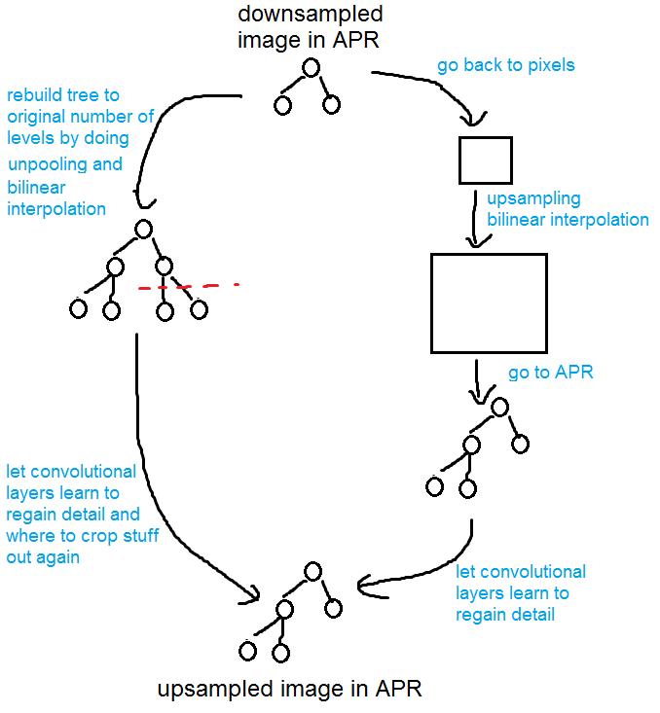
New questions:
How do we propagate the unpooling through the tree?
2 approaches came to mind:
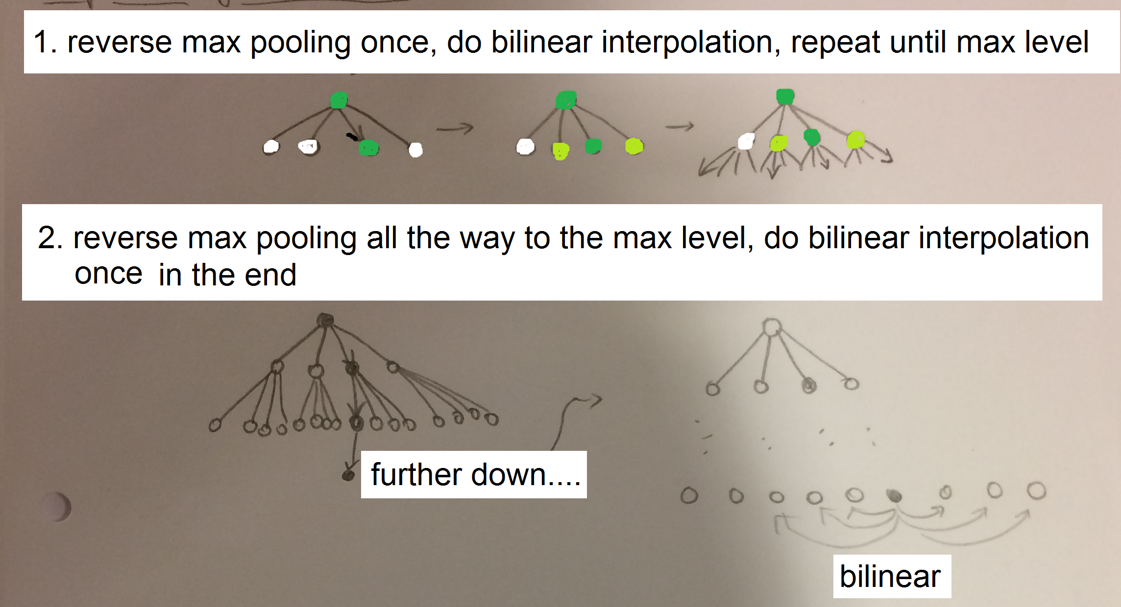
How do we do bilinear interpolation on the APR?
Problem: neighboring particles in tree do not necessarily mean they are neighbors in the picture
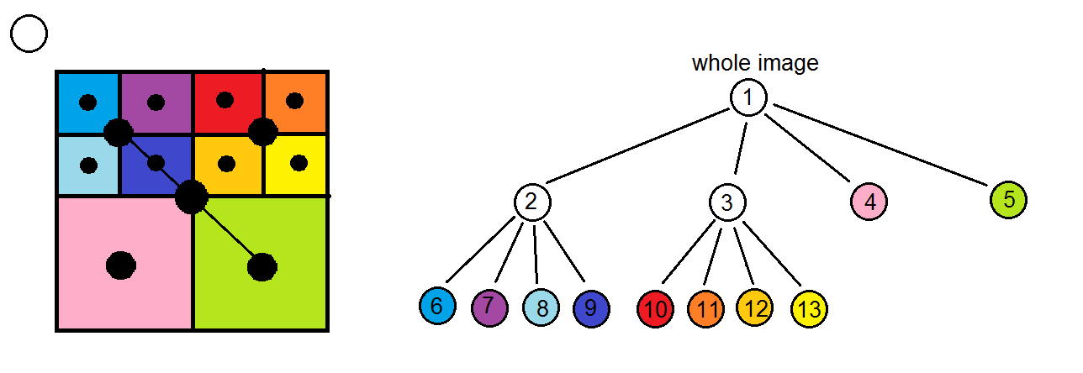
- each particle represents the intensity of its cell, represented by the black dots in the center
- to interpolate for node 9 we would have to consider node 2 and 5, using not half of the distance between them but ¼ (take care of the direction!)

How could we define the loss for validation of our approach/ training?
- pixelwise loss from Shelhamer et al. (Fully Convolutional Networks for Semantic Segmentation)
- key points from original image (e.g. SIFT), key points from upsampled image, compare; problem: error backpropagation? → idea: still use pixelwise loss but give more priority to pixels belonging to key points

Working plan
1. get Joel‘s code running
(wasn‘t completed… I guess: understand Joel‘s code, decide for an approach, design the algorithm together, code it, show it to Joel)

Plan until next meeting
- everyone chose what they wanted to do
- try to understand Joel‘s code to be better able to decide which approach would be best
- write up the protocol (done!)
- think about the open questions conceptually

