

**COMSATS University Islamabad**

**Abbottabad Campus**

**BSE-7B**

**Design Pattern**

***By***

**Muhammad Talah Khan CIIT/FA20-BSE-042/ATD**

**Fahad Farman CIIT/FA20-BSE-044/ATD**

***Lecturer*Mukhtiar Zamin**

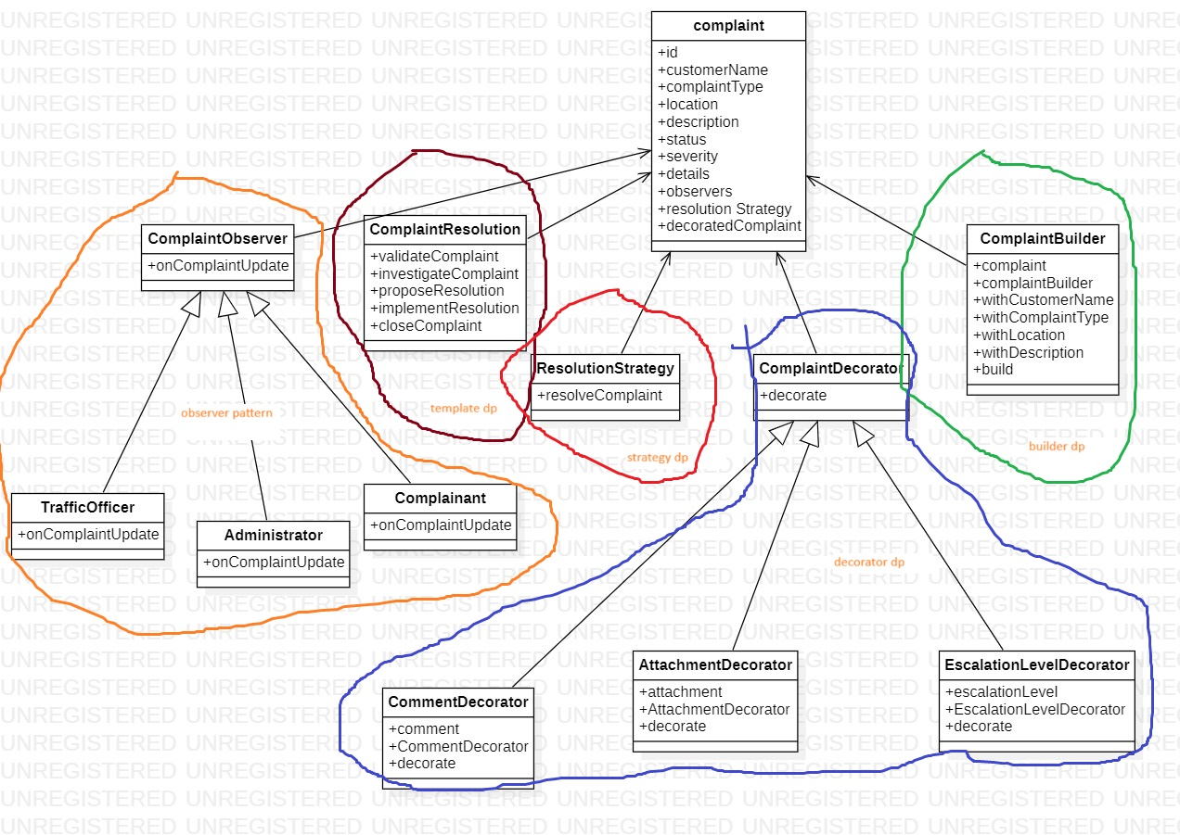

The class diagram provided illustrates the structure and relationships between classes in a Traffic Control Complaints Automation System. Let's break down the diagram and describe the key components and their relationships:

**Complaint Class:**

This is the central class in the system, representing a complaint filed in the traffic control system.

It has attributes such as id, customerName, complaintType, location, description, status, severity, details, observers, resolutionStrategy, and decoratedComplaint. These attributes store information related to the complaint, its status, and customization.

**ComplaintObserver Class:**

It represents an observer in the Observer pattern.

Observers, such as traffic officers or complainants, implement the onComplaintUpdate method to receive notifications about changes in complaints.

**ComplaintResolution Class:**

This class represents the Template Method pattern for handling complaint resolution.

It defines methods like validateComplaint, investigateComplaint, proposeResolution, implementResolution, and closeComplaint as part of a structured resolution process.

**ResolutionStrategy Class:**

This class represents the Strategy pattern for different complaint resolution strategies.

It includes the resolveComplaint method, which specific strategies (e.g., ThreeStarResolution) implement.

**ComplaintDecorator Class:**

This is the base class for the Decorator pattern.

It defines the decorate method used to customize a complaint with additional information.

CommentDecorator, AttachmentDecorator, and EscalationLevelDecorator Classes:

These are concrete decorator classes that extend ComplaintDecorator.

They customize complaints with specific details, such as comments, attachments, and escalation levels, using the decorate method.

**ComplaintBuilder Class:**

This class represents the Builder pattern for constructing complex complaint objects.

It includes methods like withCustomerName, withComplaintType, withLocation, and withDescription for setting complaint attributes and a build method to create the complaint.

**Relationships in the Diagram:**

The Complaint class has associations with various other classes. It has a one-to-many relationship with ComplaintObserver, indicating that multiple observers can be attached to a single complaint.

The Complaint class has a one-to-one relationship with ComplaintResolution and ResolutionStrategy, indicating that each complaint follows a specific resolution process and strategy.

The Complaint class has a composition relationship with ComplaintDecorator, which means that a complaint can be composed of multiple decorators to customize it.

The ComplaintBuilder class is responsible for constructing Complaint objects.