FahadFiaz\_303141

Q1:

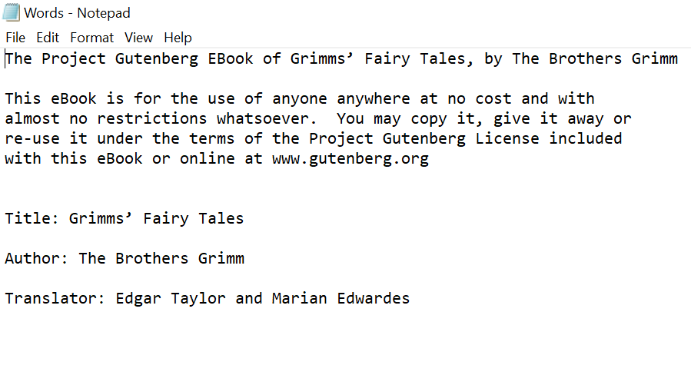E:\DDA\exercise_5\2.PNG

E:\DDA\exercise_5\3.PNG

E:\DDA\exercise_5\4.PNG

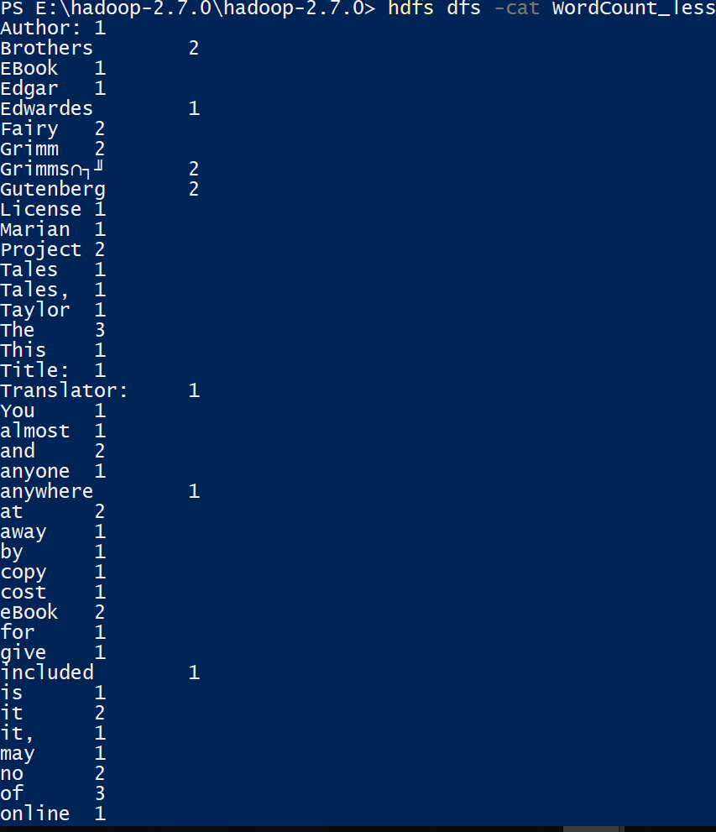

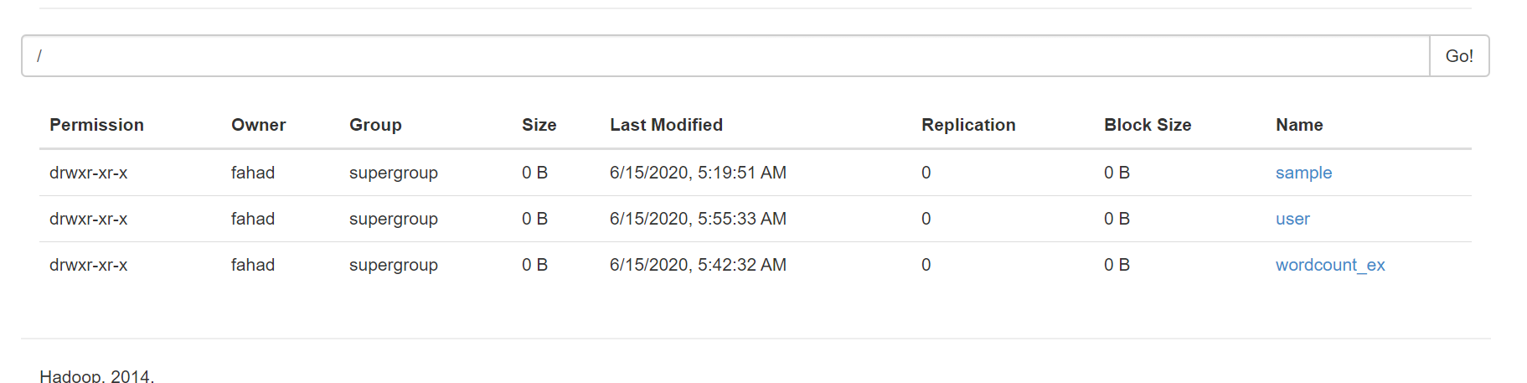

Q2: