CN Lab 1 Multithreaded Webserver  
Fahad Furniturewala

1001173992

The given lab has been implemented in python (version 3.5.2)

Various sites have been used for reference such as stackoverflow.com, python.org documentation

Steps to run the code:

Python 3.5.2 is needed to run this code.

Some modules such as socket, os, time etc. are part of python and have been imported to be used in the code.

Modules used:

1. socket – Creating client and server sockets
2. threading - Client and Server listeners run on thread for multiple connections
3. datetime – printing the current time when message is received on client and server
4. timeit – Used to calculate rtt

To run the code:

1. Open command prompt
2. Change directory to the current directory where client and server files are stored
3. Type: ‘python server.py’

In another command window repeat step 2 and in step 3 type ‘python client.py’

In the code for both client and server the IP has been set to local machine i.e. 127.0.0.1

And port is set to 9998

9998 is to set the connection. Once the connection has been established the server provides a new port number for each client for communication.

Screenshots of server and client files running on command prompt

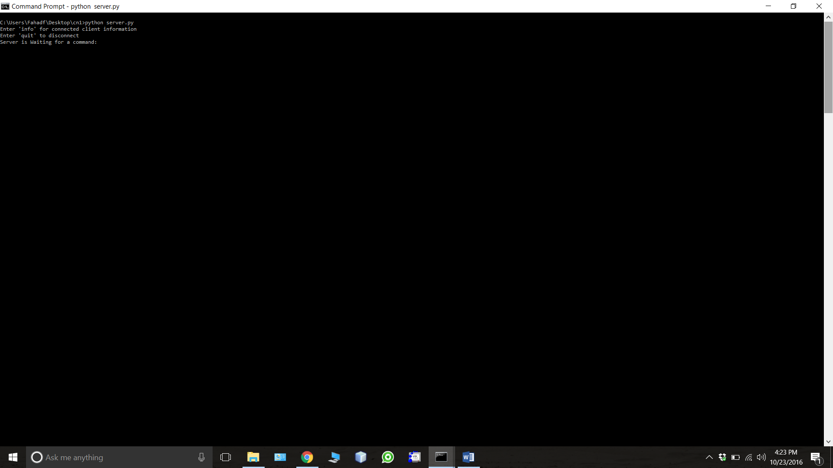

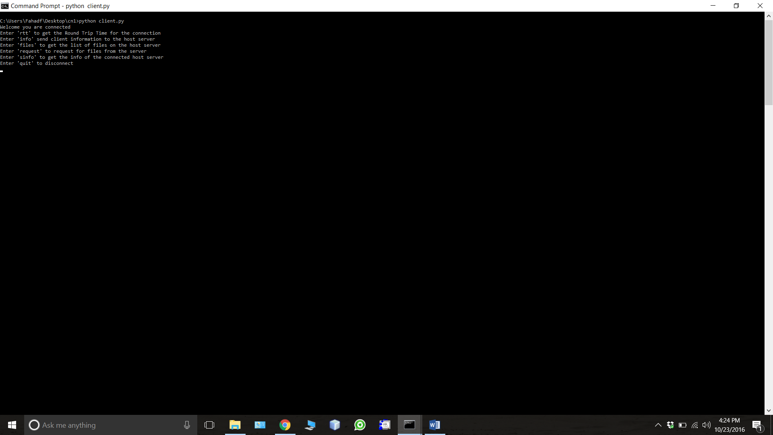

Once the server has started and is waiting for a command.

Open a browser and type this address in the address bar: ‘127.0.0.1:9998/index.html’

This is what we see on the browser:

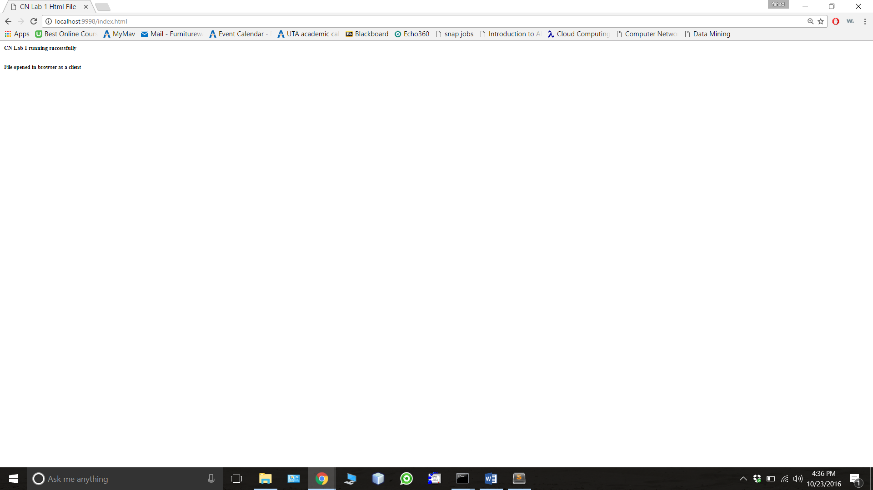

Next we connect a client to this server using a command prompt:

All other commands can be seen on the command prompt and all the functionality such as calculating rtt, getting client and server info, downloading files is done there and a menu provides all the options and commands to type to do it.

References:  
stackoverflow.com

https://pymotw.com/2/socket/addressing.html

https://docs.python.org/2/library/socket.html