SOC-Home-Lab
Application Downloaded:
Build a Windows SOC lab by installing and configuring Sysmon, Splunk Enterprise, and the Splunk Universal Forwarder to collect and analyse Windows Event Logs.
Tasks Completed
1. Installed Sysmon
- Downloaded Sysmon.
- Downloaded the Swift-On-Security Sysmon configuration.
- Installed Sysmon using the custom configuration.
- Verified Sysmon service installation.
- Confirmed Sysmon Operational logs in Event Viewer.

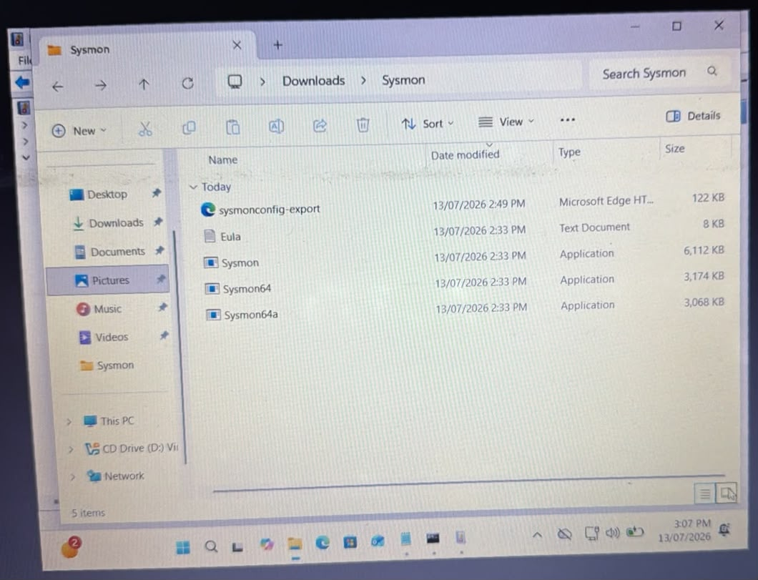

Event IDs Verified
- Event ID 1 – Process Creation
- Event ID 11 – File Creation
- Event ID 13 – Registry Modification
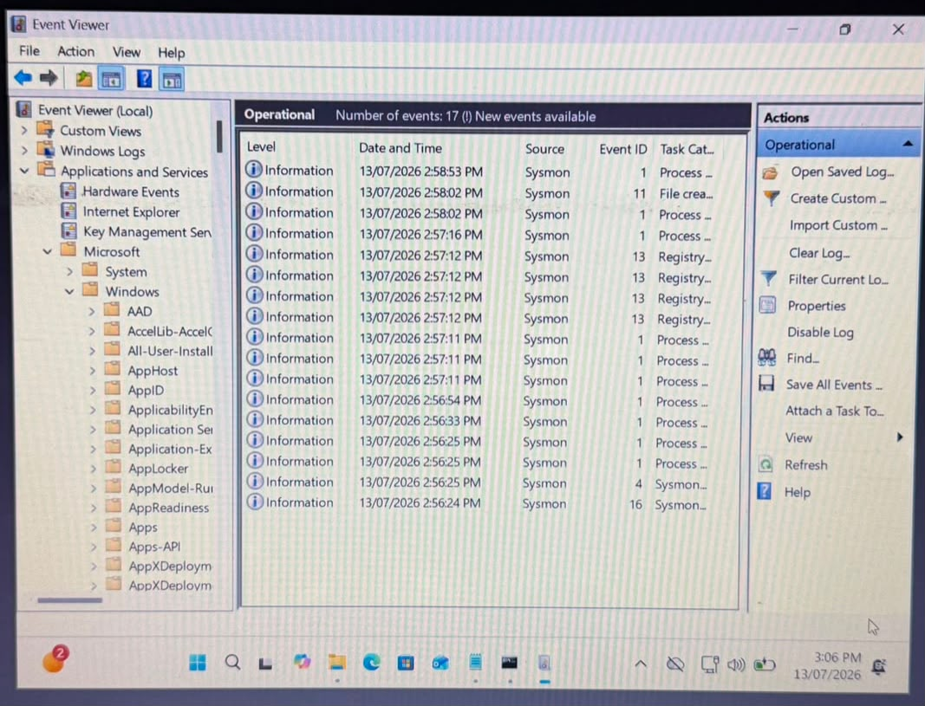

2. Generated Test Events
- Generated Windows activity to create logs:
- Opened Notepad
- Created files/folders
- Verified Process Creation events
- Verified File Creation events
- Verified Registry events
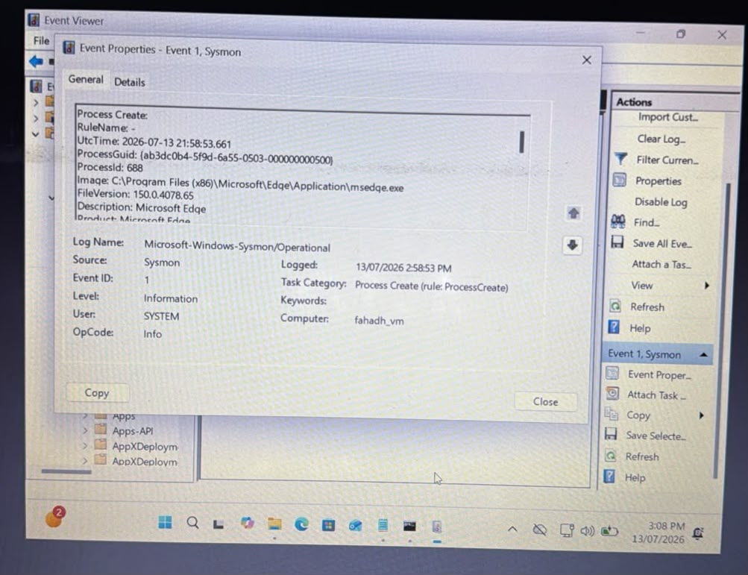
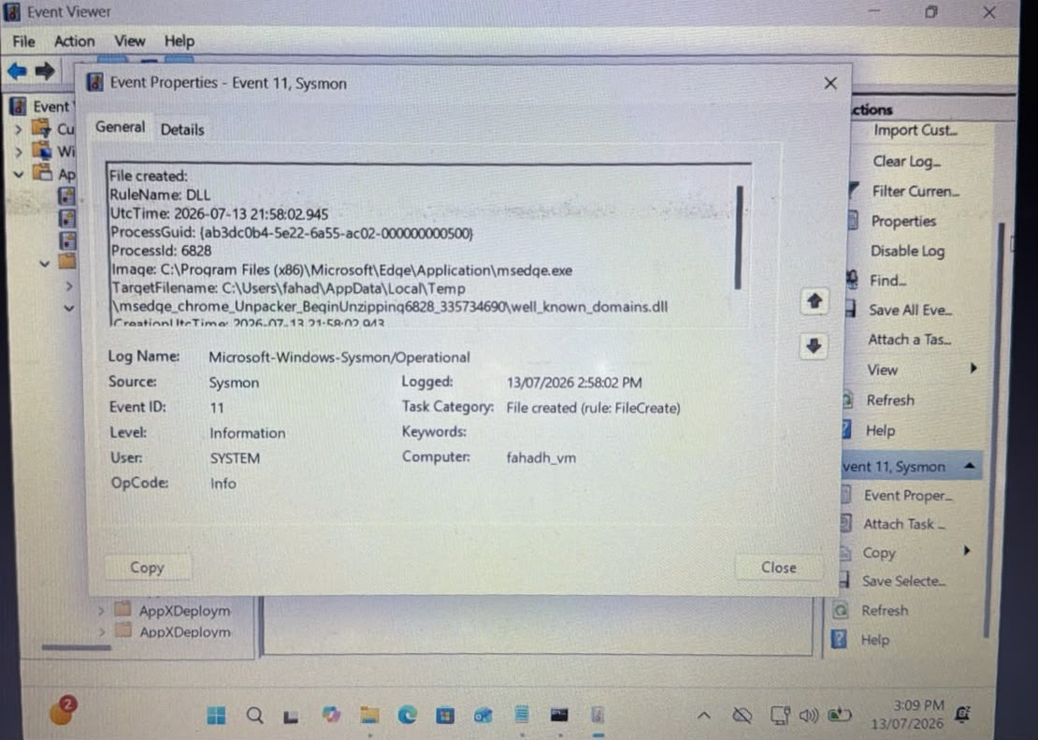
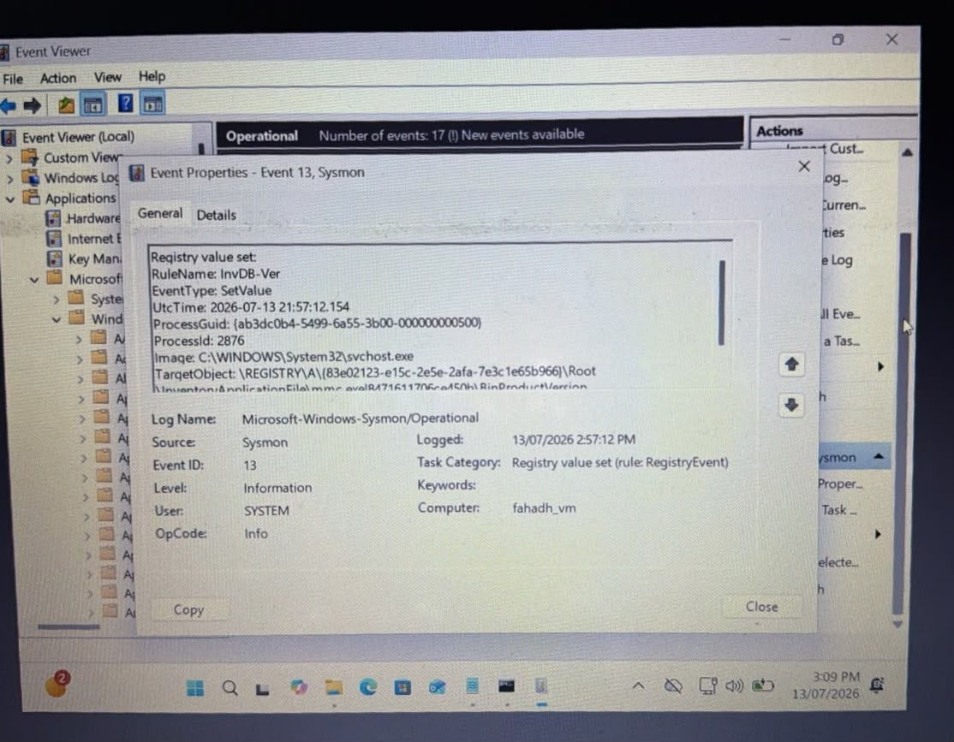

3. Installed Splunk Enterprise
- Downloaded Splunk Enterprise
- Installed successfully
- Configured Administrator account
- Resolved login issue
- Verified Splunk Web Interface
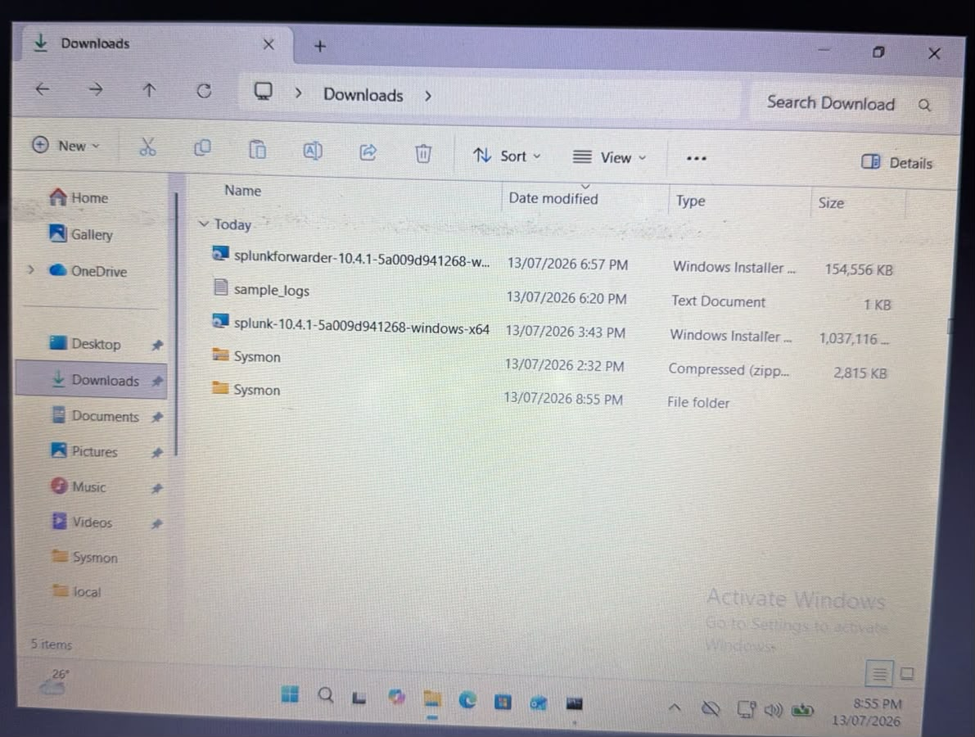

4. Installed Splunk Universal Forwarder
- Downloaded Universal Forwarder
- Installed successfully
- Configured Forwarder
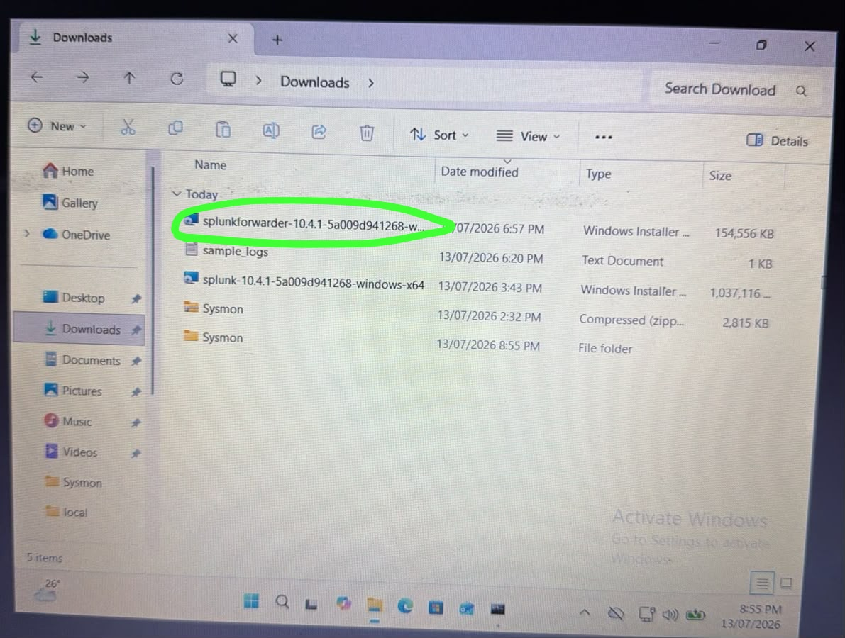

5. Configured Log Forwarding
Configured:
outputs.conf
Forwarded logs to:
127.0.0.1:9997
inputs.conf
Enabled collection of:
- Windows Application Logs
- Windows Security Logs
- Windows System Logs
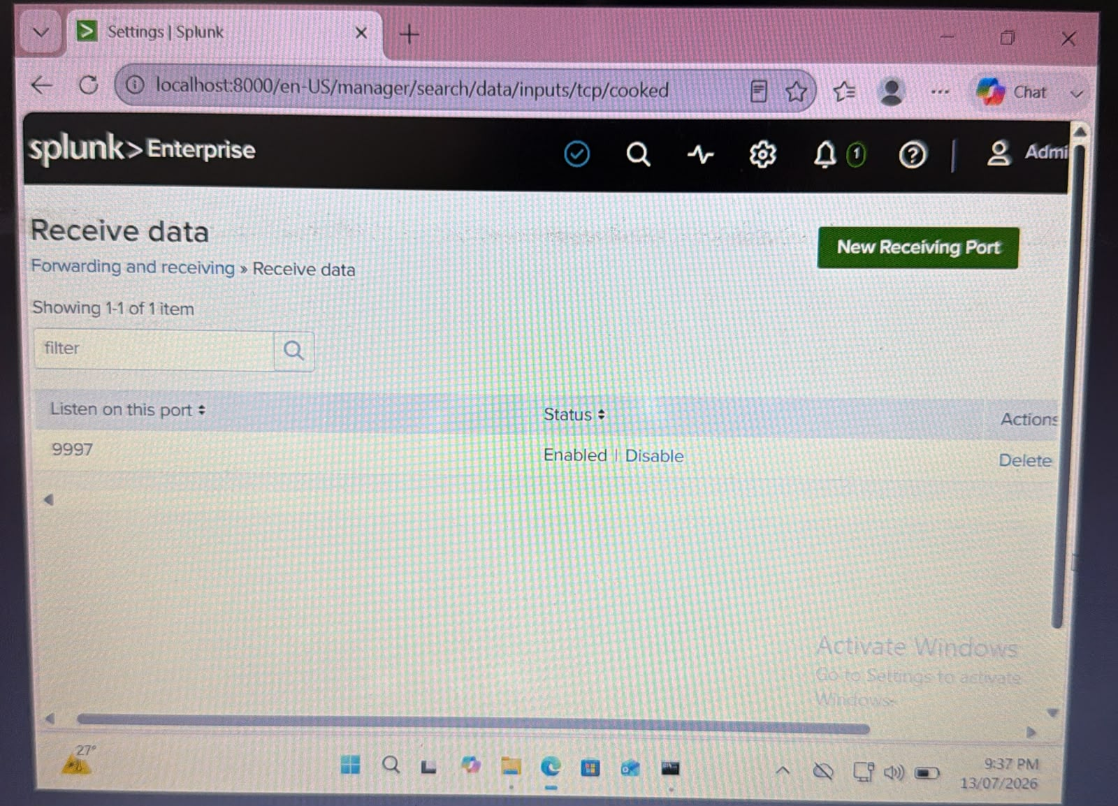

Troubleshooting
Resolved multiple issues including:
- Sysmon XML configuration download problem
- Edge saving XML as HTML
- Administrator permission issues
- Splunk login failure
- Splunk password reset
- Receiving Port configuration
- Universal Forwarder installation
- inputs.conf saved as TXT
- Universal Forwarder not loading configuration
- Restarting Splunk services
- Successfully forwarding Windows Event Logs

Verification:
Verified:
- Sysmon Operational Logs
- Windows Event Logs
- Splunk receiving data
- Successful SPL searches
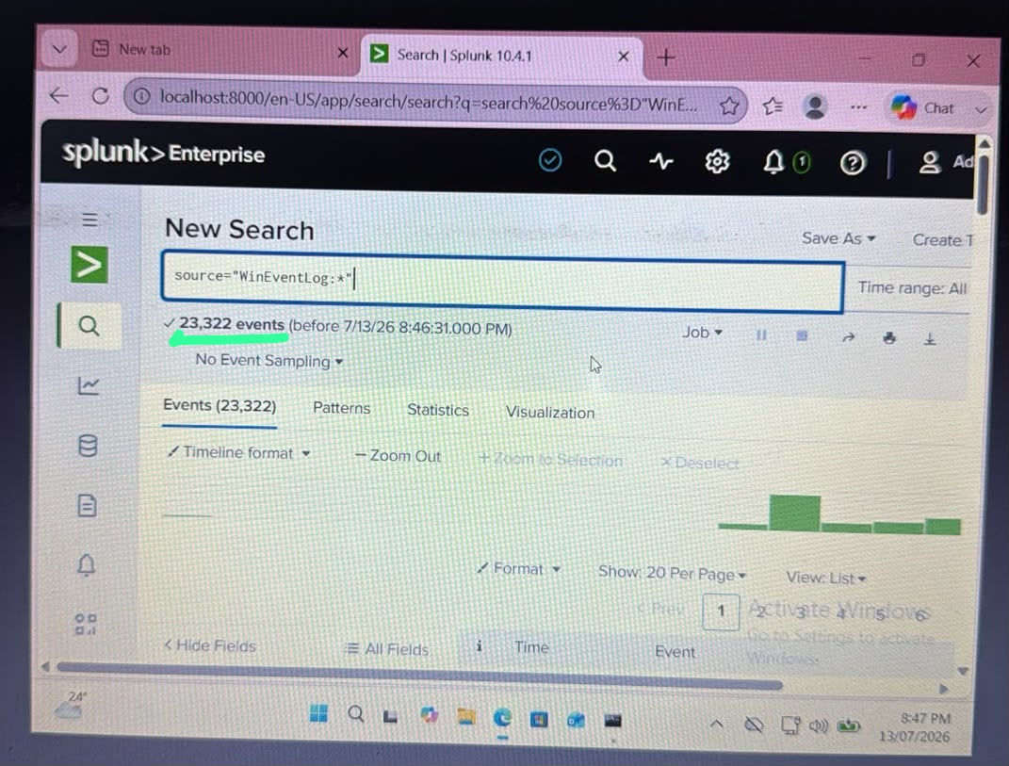
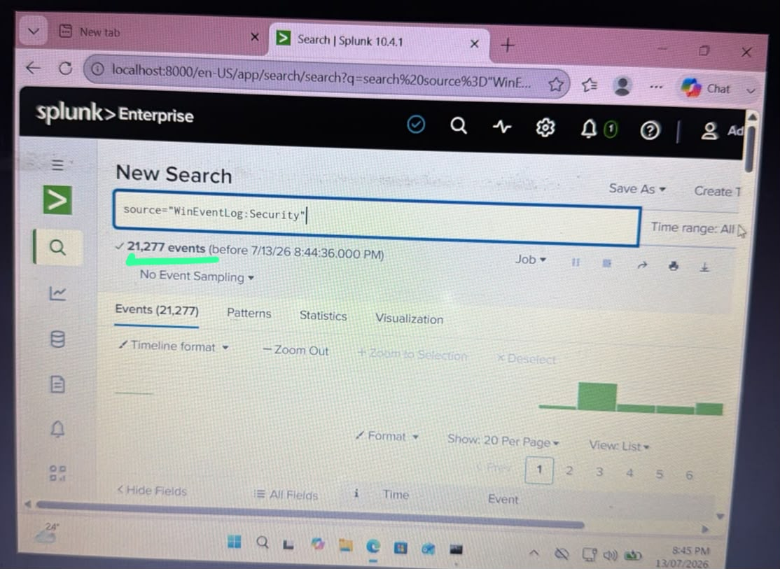
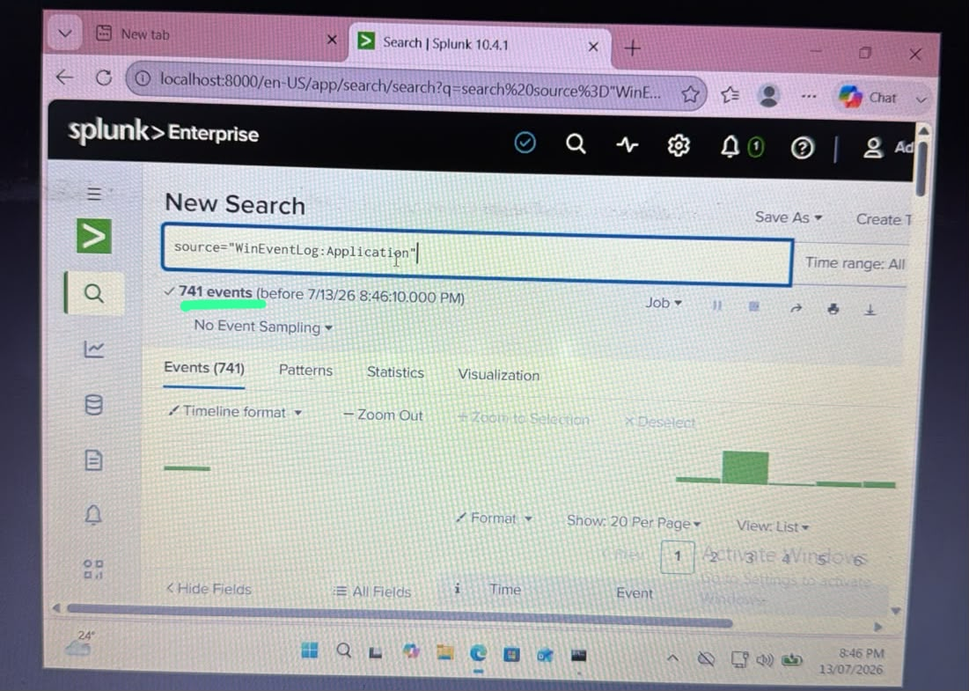
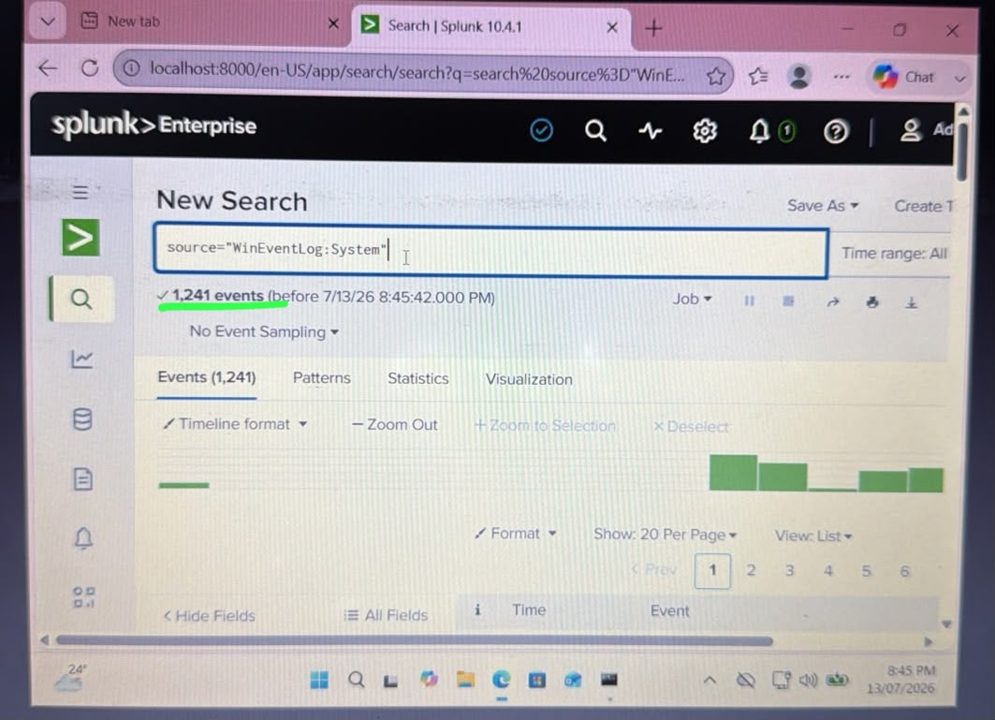

Tools Used
- Oracle VirtualBox
- Windows 11 VM
- Sysmon
- Splunk Enterprise
- Splunk Universal Forwarder
- Event Viewer
- Command Prompt
- Notepad

