Check username

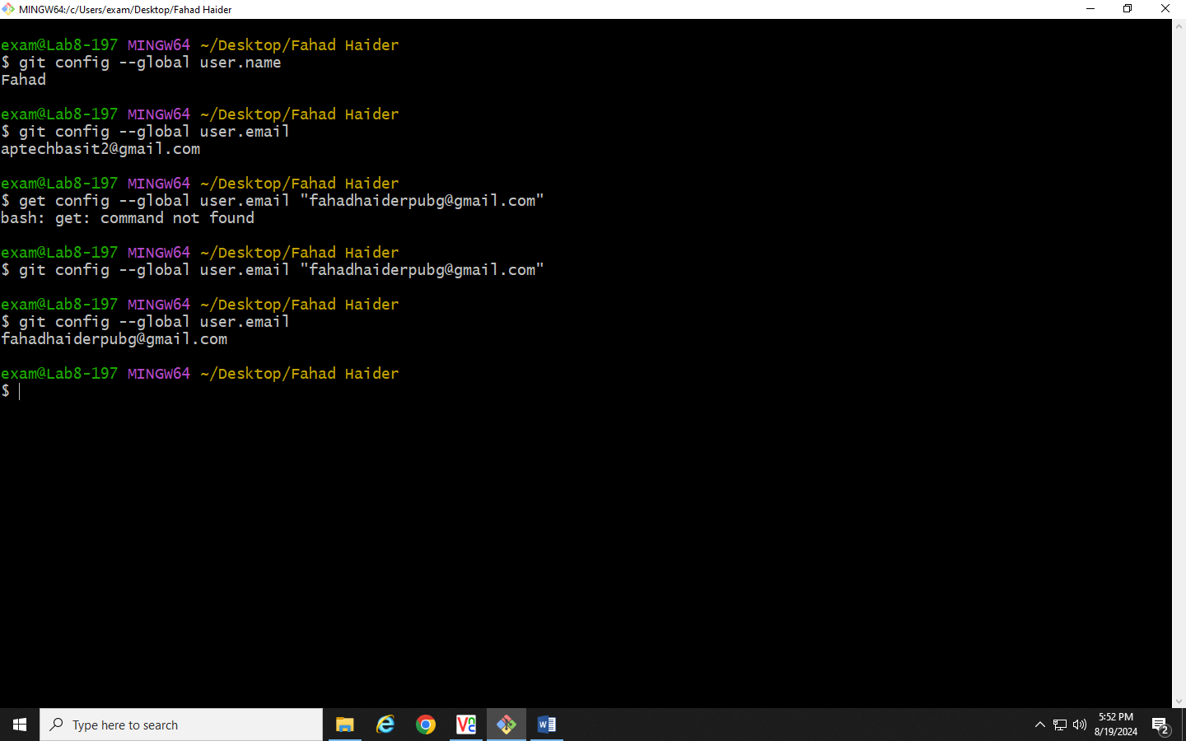

Change username

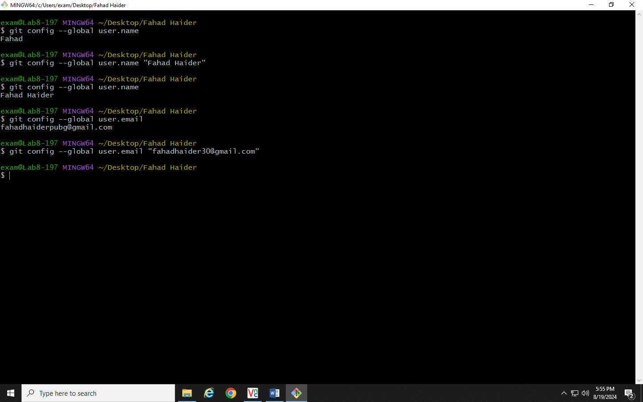

Check email



Change email



To open VS Code

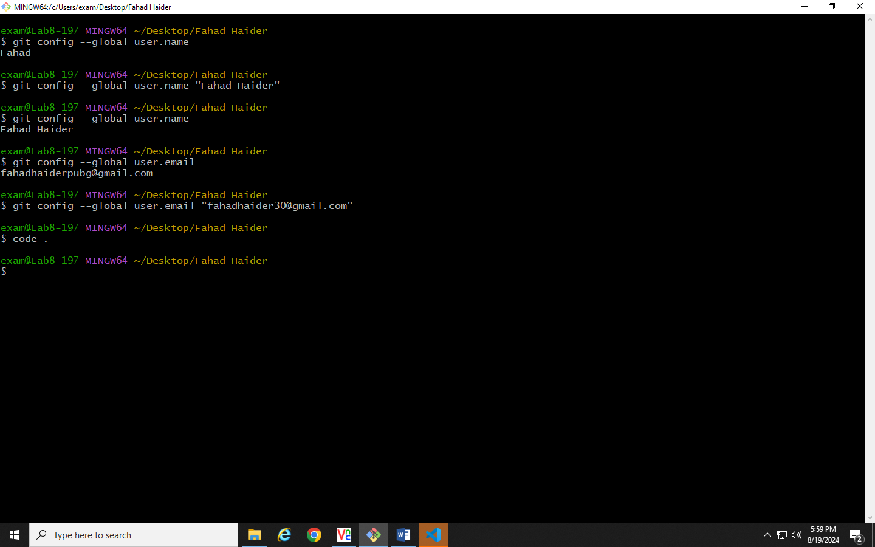

Initializing the folder

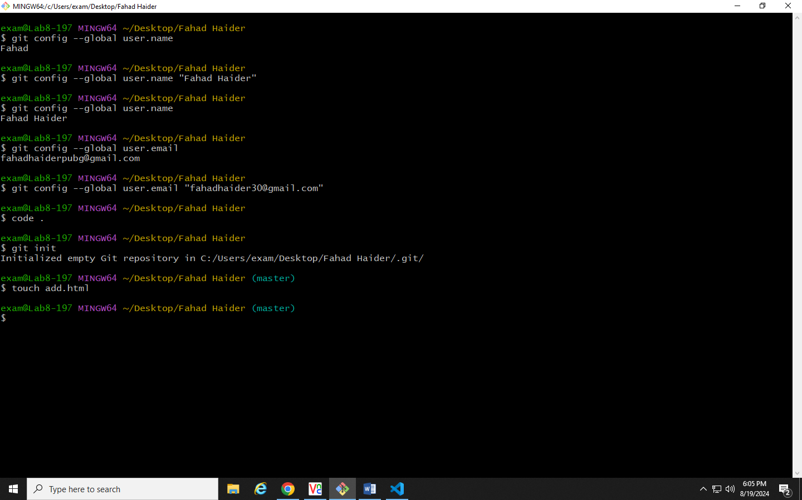

Adding new html file using git command



To show all hidden files

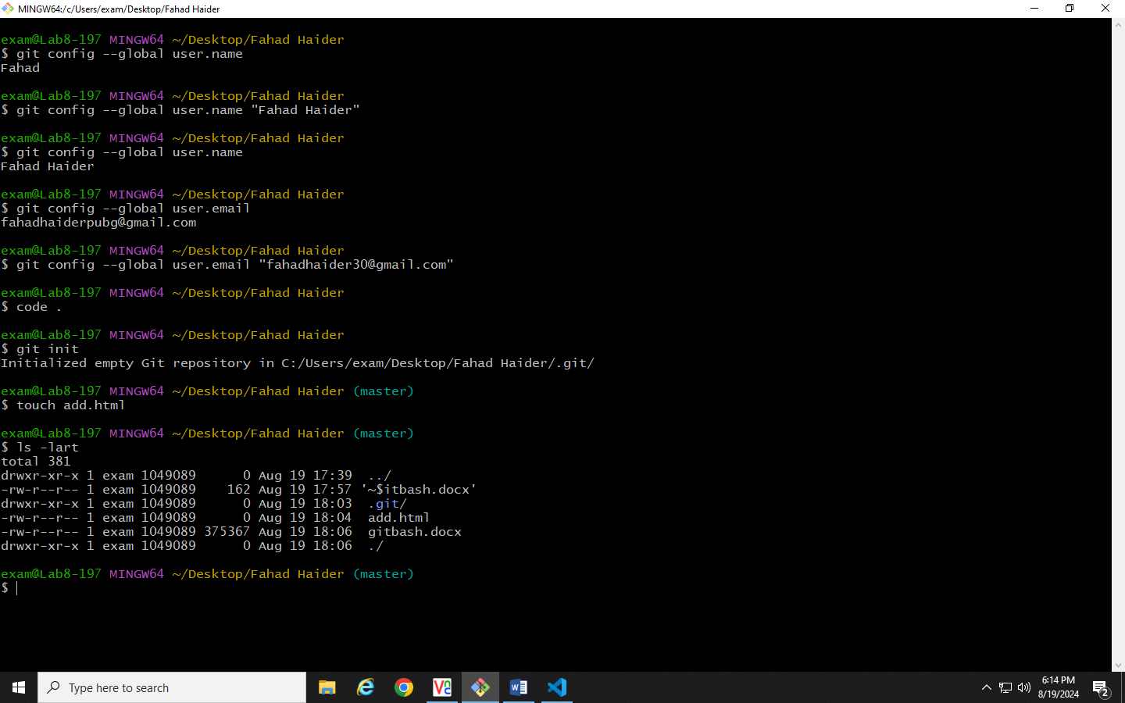

To add single file in staging area



To add all files in staging area



To check status

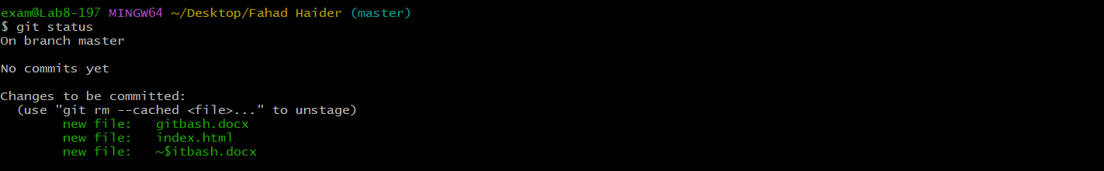

To comment file

