**Student Id:** BC200205312

**Name:** MISHAL RAHEEL

**Degree:** B.Ed. (elementary)2.5 years

**Supervisor:** Fiza Zia

|  |  |  |  |
| --- | --- | --- | --- |
| Sr. No | Grade/Class | Subject | Topic |
| 1 | 8th | Science | Classification of living things |
| 2 | 8th | Science | Vertebrates and invertebrates |
| 3 | 7th | Geography | Layered structure of the Earth |
| 4 | 7th | Geography | Types of plains |
| 5 | 6th | English | Reading and words meaning of The Ransom of the Red Chief |
| 6 | 6th | English | Exercise of The Ransom of the Red Chief |

***Subject-1***

***Lesson Plan-1***

1. **Subject:**

Science

1. **Grade level/ Class:**

8th

1. **Text Book:**

PCTB (Punjab Curriculum and Textbook Board)

1. **Topic & Sub Topic:**

Classification of living organisms

1. **Time duration:**

40 Minutes

1. **General Objectives:**

After reading this topic students will be able to describe the classification of living organisms.

1. **Specific/Instructional Objectives:**

By the end of the lesson, students will be able to:

* Distinguish between living and non-living things.
* Elaborate the tasks performed by the living things.
* Explain the importance of classification.

1. **Resources/Materials A.V aids:**

Following material will be used:

PCTB 8th grade Book, board marker, duster, white board, charts, pictures etc.

1. **Teaching Method:**

Lecture method: Hands on Learning

1. **Procedure:**

**Introduction**

* Explain the term classify (sort into groups of things that are alike) and its importance. It helps to make the study of things more systematic and organized, and therefore easier.
* Explain that living organisms have specific characteristics that allow their classification into specific groups.
* Discuss how we can learn the basic characteristics of all members of a group by examining only one member.
* Discuss the term cold blooded and warm blooded; give examples.
* Show pictures of animals that belongs to the different kingdoms.
* Write the names of the five kingdoms on the board and draw a flowchart to explain how to classify animals, giving two examples of each.

**11.Activity:**

Show pictures of some living things. Hold up each picture and ask students to identify each and give a few of its characteristics; write these on the board.

Stop after about a dozen examples and explain that you have a long list of living organisms. Ask the students to help classify them into groups.

**12.Students participation:**

I will involve students by performing an activity to identify the living organisms by thinking about it.

**13.Closure:**

I will summarize the lesson by elaborating the classification and its importance and about the five kingdoms of living organisms.

**14.Home work:**

Ask students to complete the following activities:

1.)

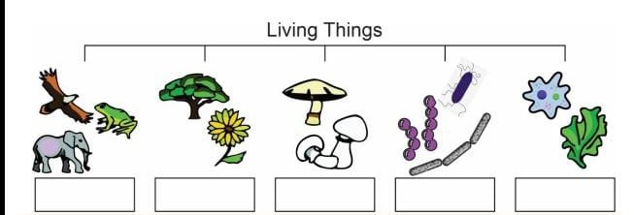

2.)

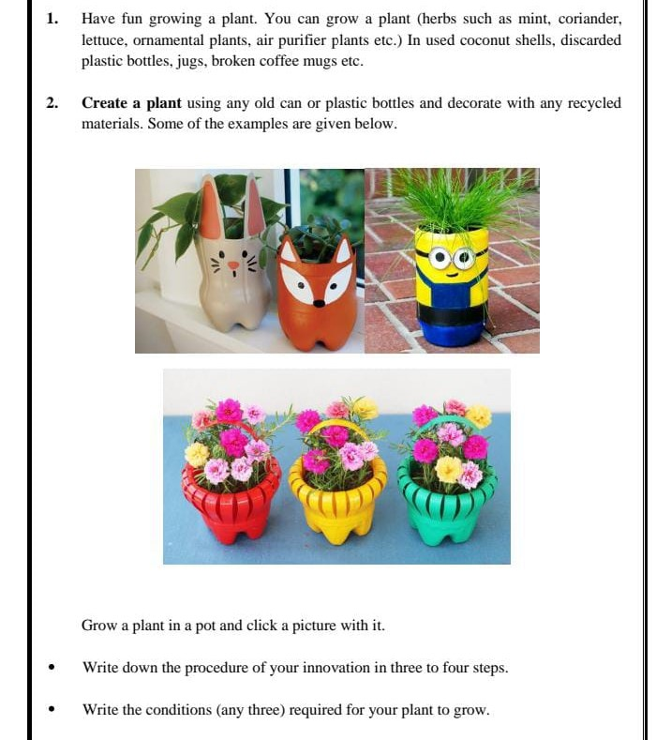

**15. Assessment:**

MCQs and questions will be given to check students’ understanding about the topic.

**MCQs:**

1.Which of the following is not one of the five kingdom?

1. Animals
2. Plants
3. Insects
4. Fungi

2.Which of the following is the example of Protista?

1. tiger
2. amoeba
3. mold
4. yeast

**Short question:**

1. What do you understand by classification and why do you think it is important?
2. Name the five kingdoms and give an example of a living thing from each kingdom.

***Subject-1***

***Lesson Plan-2***

1. Subject:

Science

1. Grade level/ Class:

8th

1. Text Book:

PCTB (Punjab Curriculum and Textbook Board)

1. Topic & Sub Topic:

Vertebrates and Invertebrates

1. Time duration:

40 minutes

### General Objectives:

By the end of the lesson, students will be able to differentiate between vertebrates and invertebrates.

### Specific Objectives:

By the end of this topic students will be able to:

* Identify the five classes of vertebrates
* Explain that there are more invertebrates than vertebrates on the Earth.
* Explain how invertebrates are classified according to their bodies structures.
* Describe the similarities between vertebrates and invertebrates

### Resources/Materials

White board, board marker, duster, charts, vertebrates or invertebrates etc.

### Teaching Method

Lecture method: Hands on Learning

### Procedure

**Introduction**

* Write the name of the five classes (mammals, fish, birds, amphibians, reptiles) on the board and revise the importance of classification.
* Discuss the main features of each class and show pictures of animals belonging to them.
* Revise the meaning of two terms, vertebrates and invertebrates, and then ask students to guess which group is more numerous.
* State that there are more invertebrates than vertebrates on Earth. Detail how invertebrates are classified according to the structure of their bodies.
* Explain some invertebrates are harmful such as the mosquito, and others are helpful such as the honeybee,
* Show the class an earthworm and discuss its importance for the fertility of the soil.
* Show a picture of a honeybee and explain how honey is made.
* Discuss social insects that live together in groups called colonies.

**Activity**

Show the charts to the students and explain the difference between vertebrates and invertebrates in details by using white board.

Write on the board: ‘Which class do I belong to?’ Divide the students into groups of three. Give each group a box containing pictures of living organisms and some living organisms in separate jars so students can see them.

I will ask the students to look at these pictures and organisms and then work together to determine what class the organisms belongs to.

After 5 minutes, ask the students to return to their seats and present their observations.

**Student participation**

I will ask the students to perform an activity in the classroom for their better understanding

Show pictures of invertebrates such as a spider, snail, mosquito, earthworm, fly and honeybee. Ask students to help identify each of them and write their characteristics on the board.

**Closure**

1. I will end the lecture after discussing the following conclusion

* Vertebrates are the living organisms that have backbone.
* Invertebrates are the living organisms that do not have backbone.
* Vertebrates are classified into five groups and invertebrates are classified according to their body structure.

### Assignment or Homework

Encourage students to make a bird feeder. This will provide a great way for them to observe the diversity of bird life in their own gardens.

Ask students to complete the following activity:

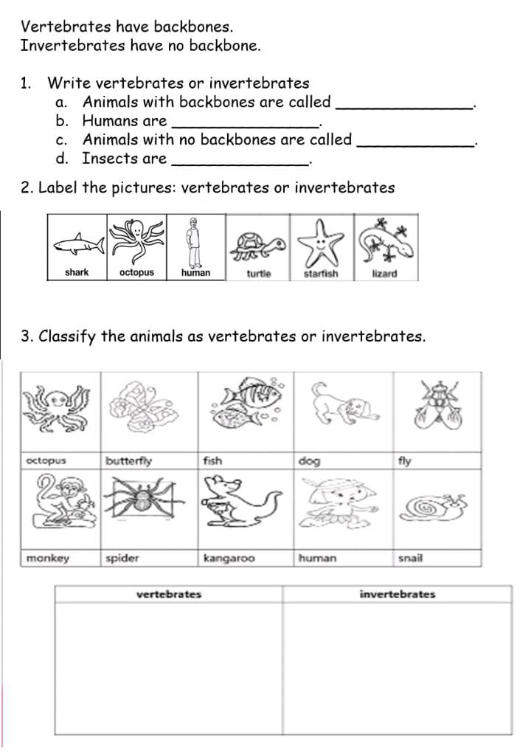

### Assessment of Student Learning

For assessment purpose I will ask the following questions to students

* Differentiate between vertebrates and invertebrates.
* Name the five major groups of vertebrates with their examples.

Cockroach is an example of…………

1. mammals b) insects c) invertebrates d) both b and c

***Subject-2***

***Lesson Plan-1***

**1.Subject:**

Geography

**2.Grade Level/Class:**

7th

**3.Text Book:**

PCTB (Punjab Curriculum and Textbook Board)

**4.Topic and Subtopic:**

Layered structure of the Earth

**5.Time Duration:**

40 minutes

**6.General Objectives:**

By the end of the lesson, students will be able to elaborate the layered structure of the Earth.

**7. Specific Objectives:**

After studying this topic, students will be able to:

* Describe different layers Of the earth
* Explain the composition of the Earth’s interior.
* Elaborate the diagram

**8.Resources/Materials:**

White board, board marker, duster, charts, models, pictures, text book, teacher guide etc.

**9.Teaching Method:**

Lecture method: Demonstration method

**10.Procedure:**

**Introduction**

* I will start my lesson by giving the introduction of the surface of the Earth and its core to the students.
* Write the three main parts/layers of the Earth on the board and ask the students to repeat them loudly so that they would be familiar to these layers of the Earth.
* Explain what are seismic waves and how they help human beings to understand the internal structure of the Earth.
* Elaborate the magnetic and gravitational forces of the Earth.
* Explain crust or outer surface and it’s two parts.
* Demonstrate mantle or middle layer with it’s parts.
* Explain the core or internal part with it’s parts.

**Activity:**

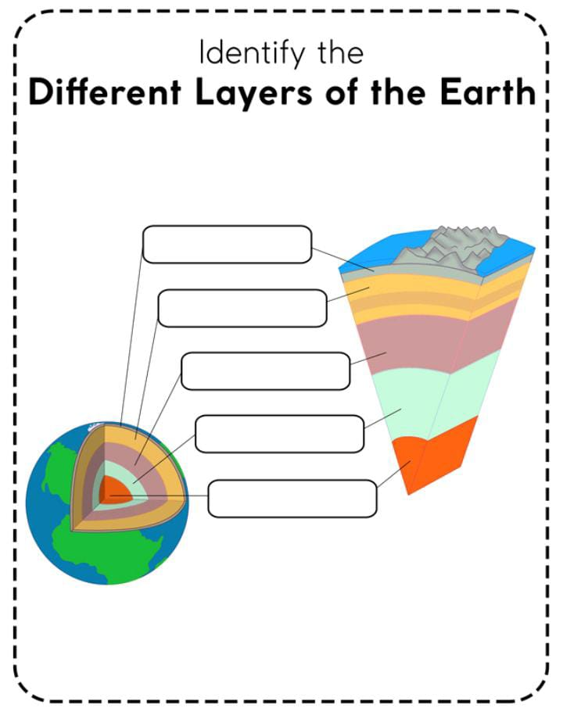

**11.Student Participation:**

I will ask the students to perform an activity in the classroom for their better understanding.

Show the charts in the classroom of the layered structure of the Earth to the students and ask them to identify the different layers of the Earth and tell anything about them.

**12.Closure:**

I will end the lesson by discussing the following conclusions:

* The layered structure of the Earth
* About Crust, mantle and core
* Explain the structure of these layers

**Assignment/ Homework:**

Encourage the students to make model of the layered structure of the Earth. By this student can understand the structure of the Earth more clearly.

**Assessment of Student learning:**

For assessment purpose I will ask the following questions to the students:

1.Which of the following is the thickness of the Crust:

a. 3-9 kilometers

b. 2-6 kilometers

c. 4-30 kilometers

d. 8-40 kilometers

2. Write a short note on the layer of mantle?

3. What do you understand by NIFE?

***Subject-2***

***Lesson Plan-2***

**Subject:**

Geography

**Grade Level/Class:**

7th

**Textbook:**

PCTB (Punjab Curriculum and Textbook Board)

**Topic and Subtopic:**

Types of Plains

**Time Duration:**

40 minutes

**General Objectives:**

After learning this lesson, students will be able to describe the physical features of Plains.

**Specific Objectives:**

By the end of the lesson, students will be able to:

* Differentiate plains from the other landforms.
* Describe the physical features of Plains.
* Identify some major types of Plains of the world.

**Resources/ Materials:**

White board, duster, board marker, text book, teacher guide, charts, models etc.

**Teaching Method:**

Lecture method: Demonstration method

**Procedure:**

**Introduction:**

* I will start the lesson by giving some introduction about plains and it’s types.
* Write three main types of the plains on the white board and ask a student to read it out loudly.
* Tell the students about Erosional plains and how they are formed.
* Show some charts in the class for better understanding of the students.
* Tell them about the formation of depositional and structural plains.
* I will explain the five main types of the depositional plains.

**Activity:**

I will ask the students to collect some interesting information about plains and its types and make posters or charts to present their information in the classroom.

Ask the students to complete the following activity:

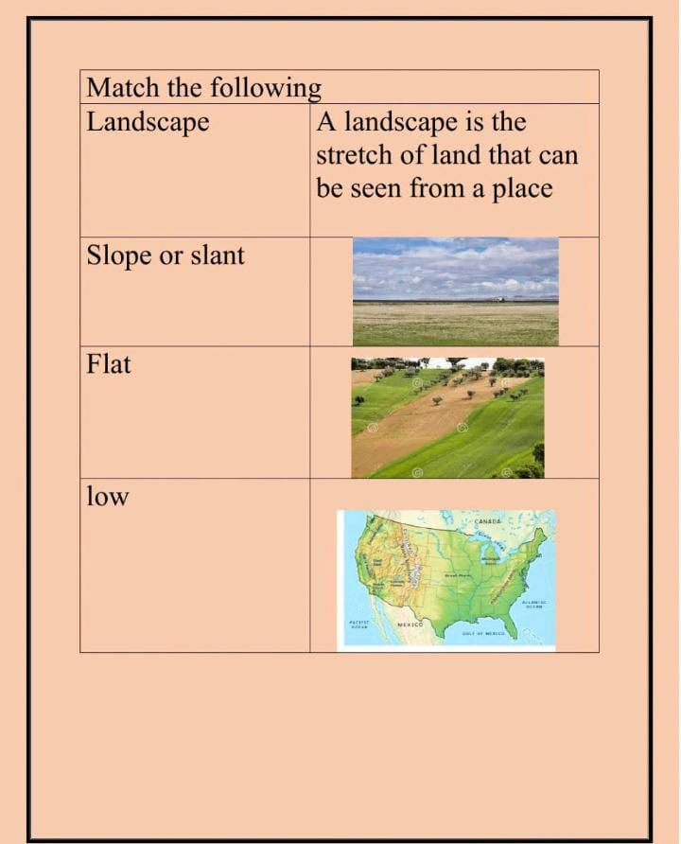

**Student participation:**

Make two groups in the classroom and held a quick quiz among these two groups. Rest of the students appreciate the winning team.

Encourage the students to ask open ended questions about the topic.

**Closure:**

I will summarize my lesson by highlighting the following points:

* Describing the physical features of Plains
* Difference between plains and landforms
* Elaborating the major types of Plains of the world.

**Assignment/ Homework:**

Encourage the students to make charts related to the types of Plains and show them in the classroom and explain it to the students.

**Assessment of Student learning:**

For assessment purpose, I will ask the following questions to the students:

1.The plains formed as a result of wind action are:

a. Peneplains

b. Pediplains

c. Outwash plains

d. Depositional plains

2. Define plain.

3. Explain three major types of Plains

4. How can we define flood plain?

***Subject-3***

***Lesson Plan-1***

**Subject:**

English

**Grade Level/ Class:**

6th

**Textbook:**

PCTB (Punjab Curriculum and Textbook Board)

**Topic and Subtopic:**

Reading and words meaning of The Ransom of Red Chief

**Time Duration:**

40 minutes

**General Objectives:**

By the end of the lesson, students will be able to understand the difficult words in the story with their English and Urdu meanings.

**Specific Objectives:**

At the end of this topic, students will be able to:

* Read the lesson fluently.
* Understand the concept of the lesson.
* Translate the English passage into Urdu.
* Describe the English and Urdu meanings of difficult words.

**Resources/ Materials:**

White board, duster, board marker, text book, teacher guide, charts, flashcards etc.

**Teaching Method:**

Lecture method: Communicative teaching method

**Procedure:**

**Introduction:**

* I will start my lesson by giving the introduction of the story “The Ransom of Red Chief” to the students.
* Write the difficult words on the board and ask the students to pronounce them.
* Explain the meanings of these words in English as well as in Urdu.
* Elaborate the story to the students for their better understanding.
* Explain the moral of the story to the students.
* Demonstrate the importance of wide vocabulary to the students.

**Activity:**

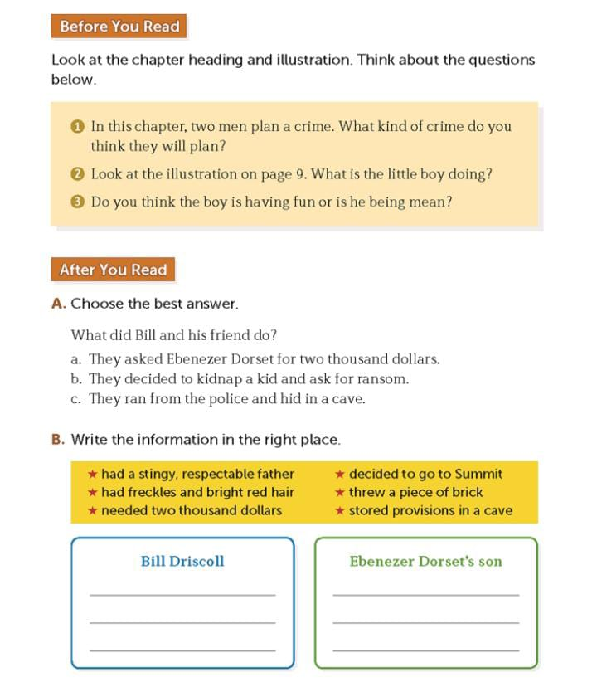

**Student participation:**

I will make groups of some students in the classroom and ask a group to explain some portion of the story to others in their own words.

Ask the students to tell the story in English to enhance their vocabulary.

**Closure:**

I will end the lesson by highlighting the following points of the lesson:

* Highlighting the importance of advance vocabulary.
* Explain the moral of the story.
* Ask the students about another lesson that they learn from the story.

**Assignment/ Homework:**

Encourage the students to write difficult meanings from the story and pronounce them fluently.

**Assessment of Student learning:**

For assessment purpose, I’ll ask the students to answer the following questions:

1.Write down the English meanings of the following words:

Foreclose

Scout

Treachery

Mortgage

Accede

1. Do practice of the difficult words for dictation.

***Subject-3***

***Lesson Plan-2***

**Subject:**

English

**Grade Level/ Class:**

6th

**Textbook:**

PCTB (Punjab Curriculum and Textbook Board)

**Topic and Subtopic:**

Exercise of The Ransom of the Red Chief

**Time Duration:**

40 minutes

**General Objectives:**

By the end of the lesson, students will be able to understand the difficult words in the story with their English and Urdu meanings. They also understand the grammar in this story.

**Specific Objectives:**

After learning this lesson, students will be able to:

* Read the lesson fluently.
* Understand the concept of the lesson.
* Answer the following questions.
* Describe the English and Urdu meanings of difficult words.
* Elaborate the English grammar in this lesson.

**Resources/ Materials:**

White board, duster, board marker, text book, teacher guide, charts, flashcards etc.

**Teaching Method:**

Lecture method: Communicative teaching method

**Procedure:**

**Introduction:**

* I will start my lesson by giving the introduction of the story “The Ransom of Red Chief” to the students.
* Write the difficult words on the board and ask the students to pronounce them.
* Explain the meanings of these words in English as well as in Urdu.
* Elaborate the story to the students for their better understanding.
* Explain the moral of the story to the students.
* Demonstrate the importance of wide vocabulary to the students.

**Activity:**

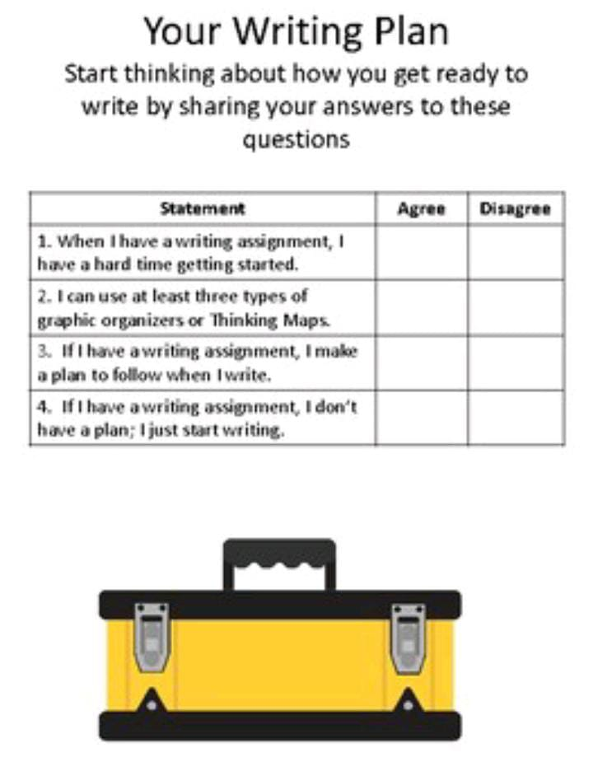

**Student participation:**

I will make groups of some students in the classroom and ask a group to explain some portion of the story to others in their own words.

Ask the students to tell the story in English to enhance their vocabulary.

**Closure:**

I will end the lesson by highlighting the following points of the lesson:

* Highlighting the importance of advance vocabulary.
* Explain the moral of the story.
* Ask the students about another lesson that they learn from the story.

**Assignment/ Homework:**

Encourage the students to write difficult meanings from the story and pronounce them fluently.

**Assessment of Student learning:**

For assessment purpose, I’ll ask the students to answer the following questions:

1.Write down the sentences of the following words:

Foreclose

Ransom

Treachery

Greed

Accede

Write a short note on the moral of the lesson.