Department of Electrical and Computer Engineering

Faculty Member: | <> | Date: | <>
Semester: | <> | Group: | <>

CS471 Machine Learing
Assignment: Naïve Bayes and K-NNs

Student Name | Reg. No

Introduction
This assignment will focus on the fundamentals of implementing the Naïve Bayes model for an application as well as K-nearest neighbors or K-NNs.

Objectives
The following are the main objectives of this assignment:
- Implement the Naïve Bayes theorem
- Perform pre-processing on a dataset
- Perform classification using the Naïve Bayes implementation
- Learn and implement K-NNs

Assignment Conduct
- Respect faculty and peers through speech and actions
- In the assignment, there are commented lines such as #YOUR CODE STARTS HERE# where you have to provide the code. You must put the code/screenshot/plot between the #START and #END parts of these commented lines. Do NOT remove the commented lines.
- Use the tab key to provide the indentation in python.
- When you provide the code in the report, keep the font size consistent
- Ensure proper structuring (headings, paragraphs etc.) of your report

Assignment Details _____________________________________________________________
In the first part of this assignment, you will implement Naïve Bayes model for classification. In the next part, you will implement K-nearest neighbors for classification. The focus of this assignment is primarily on self-study and understanding of the underlying mechanisms of these techniques. As such, there will be a great emphasis on building these classifiers from scratch. The programming part of the assignment is to be performed using Python and the only libraries allowed are NumPy, Pandas and MatplotLib.
The Naïve Bayes and K-NNs implementations must perform classification to solve at least one real-life problem which must be specified. Aside from the programs, you are required to showcase the working of K-NNs on paper with a dataset containing 2 features and at least 20 examples (you can implement binary or multi-class classification for this).
For the assignment submission, provide the explanations (for both of the pre-processing of the dataset and the working of techniques) and screenshots of your work in a report. The scans for the K-NNs on paper must also be uploaded in the report.
The datasets can be downloaded from Kaggle. Include the code files and the dataset you use as attachments in your submission.

Assignment Solution __________________________________________________________

1. Introduction and Real-Life Problem
Investors, banks and fund managers make decisions every day based on what they think a stock will do next. Two questions matter most: (a) will the price go up or down, and (b) how much will it move (how risky it will be). In this assignment we built K-Nearest Neighbours (K-NN) and Gaussian Naive Bayes classifiers completely from scratch (using only NumPy, Pandas and Matplotlib) and used them to try to answer these questions honestly for five large technology stocks: Apple (AAPL), Microsoft (MSFT), NVIDIA (NVDA), Alphabet (GOOGL) and Meta (META), using about 22 years of daily prices (January 2004 to October 2026).
Real-life problem solved: predicting whether the next month will be a high-volatility (risky) or low-volatility (calm) month for a stock. This is a real risk-management problem: a fund that knows a stormy month is coming can hold less of that stock, and an options trader can price insurance correctly. Along the way we also tested the harder question of predicting the direction of tomorrow's price, and report honestly that it cannot be done with these tools.

2. Technical Background

2.1 K-Nearest Neighbours (K-NN)
K-NN is the simplest machine-learning idea: similar situations tend to have similar outcomes. It does not learn any equation. It simply stores every training example (this is why it is called a "lazy learner"). To classify a new example it does three steps:
Step 1 - Distance: measure how far the new example is from every training example. We use Euclidean distance:
d(x, x′) = √( Σⱼ (xⱼ − x′ⱼ)² )
Step 2 - Neighbours: keep the K training examples with the smallest distance.
Step 3 - Vote / average: for classification, the most common class among the K neighbours is the prediction. For a number (regression), the prediction is the average of the neighbours' values. We use the average because it also gives a range: the spread of the neighbours' outcomes, which we plot as a shaded band.
Important details. (1) Scaling: distance is dominated by features with large numbers, so every feature is standardised (z = (x − mean) / standard deviation) using the mean and standard deviation of the training data only. (2) Choosing K: a small K follows noise (over-fitting); a large K smooths too much (under-fitting). We choose K on a separate validation period, never on the test data.

2.2 Gaussian Naive Bayes
Naive Bayes is based on Bayes' theorem. It asks: given the features I see today, what is the probability of each class?
P(class | x₁ … xₙ) ∝ P(class) × P(x₁ | class) × P(x₂ | class) × … × P(xₙ | class)
Prior P(class): how common each class is in the training data (for example, the share of high-volatility months).
Likelihood P(xⱼ | class): how typical a feature value is inside each class. For continuous features we assume a normal (Gaussian) distribution, so for every class and feature we only need to learn a mean μ and a variance σ²:
P(xⱼ | c) = 1/√(2πσ²꜀ⱼ) · exp( −(xⱼ − μ꜀ⱼ)² / (2σ²꜀ⱼ) )
"Naive" assumption: features are treated as independent of each other inside each class, which is what allows the likelihoods to be simply multiplied. This is rarely exactly true, and we will see its effect in the results.
Two implementation details: we add log-probabilities instead of multiplying (to avoid numbers becoming too small for the computer, called underflow), and we add a tiny variance floor so we never divide by zero.

2.3 K-NN vs Naive Bayes
Table 1: Comparison of the two classifiers
 | K-NN | Naive Bayes
What it learns | Nothing - stores the data | Class priors, means, variances
Prediction speed | Slow (compares to all data) | Very fast
Main assumption | Similar inputs → similar outputs | Features independent given the class
Needs feature scaling | Yes | No
Output | Class vote / average and spread | A probability for each class

3. Dataset and Pre-processing
Source. Daily adjusted closing prices were downloaded from Yahoo Finance (with the yfinance library) for AAPL, MSFT, NVDA, GOOGL and META from 2 January 2004 to 9 October 2026 (5,729 trading days). Adjusted prices already account for stock splits and dividends, so a price jump caused by a split does not look like a real return. GOOGL starts trading in August 2004 and META in May 2012, so they have shorter histories.
Cleaning. All stocks were aligned to the same New York Stock Exchange trading calendar. Gaps of at most 2 days were forward-filled (the last known price is carried forward); nothing was ever filled backwards, because that would copy future prices into the past. Days before a stock was listed were left empty.
Returns. Daily return r(t) = P(t) / P(t−1) − 1. Volatility = standard deviation of daily returns, multiplied by √252 so it is expressed per year (annualised %), which is how the industry quotes it.
Features (inputs) - all known at the close of day t:
Table 2: Input features
Feature | Meaning | Used in
ret1, ret5, ret21, ret63 | Return over the last 1, 5, 21 and 63 trading days | Problem 1
abs1 | Size of today's move |r(t)| | Problem 2
vol5, vol21, vol63, vol252 | Volatility over the last 5, 21, 63 and 252 days | Problems 2 & 3
ret21 | Return over the last month (falling prices tend to raise risk) | Problems 2 & 3

Targets (what we predict). Problem 1: will tomorrow be an up day (r(t+1) > 0)? Problem 2: will tomorrow's move |r(t+1)| be bigger than normal? Problem 3: will the volatility of the next 21 trading days be above this stock's normal (median) level?
Preventing leakage. The biggest mistake in financial machine learning is letting information from the future leak into training. We prevented it in four ways: (1) data was split by time, never shuffled; (2) scaling statistics and the "normal" threshold were computed from training data only; (3) a training example was only used once its outcome had fully happened before the prediction date (for 21-day targets this creates a 21-day gap, called an embargo); (4) K was selected on an earlier validation period, and the test period was evaluated only once.

4. What We Were Trying to Find
We asked three questions, from hardest to easiest:
Problem 1 - Direction: Can K-NN or Naive Bayes predict if a tech stock will go up or down tomorrow?
Problem 2 - Size of tomorrow's move: Can they predict if tomorrow will be a big or a small move?
Problem 3 - Next month's risk regime: Can they predict if the next month will be high- or low-volatility?
For each question the honest test is not "is accuracy above 50%?" but "does the model beat a simple rule that needs no machine learning?" We used two such baselines:
Always-majority: always guess the most common class of the test period (chosen in hindsight, so it is a generous baseline).
Persistence: assume the future looks like the present (for example, "next month will be as volatile as this month").
To check whether a difference is real or just luck we used a one-sided z-test on the accuracy: z = (accuracy − baseline) / √(baseline × (1 − baseline) / n). A p-value below 0.05 means the improvement is unlikely to be luck.

5. How We Did It (Method)
Walk-forward testing. Instead of training once, the models are re-trained at the start of every month on all data available up to that day, then used to predict. Then we step forward one month and repeat. This is exactly how a model would be used in real life, and it means the model never sees the period it is predicting.
Table 3: Set-up of the three experiments
 | Problem 1: Direction | Problem 2: Next-day size | Problem 3: Next-month regime
Target | Up / down tomorrow | |r(t+1)| above median | 21-day vol above median
Training data | 2004 → day before | 2004 → day before | 2004 → finished 21-day outcomes
K chosen on | 2025 | 2025 | 2008-2011
Chosen K | 200 | 400 | 100
Test period | Jan-Oct 2026 | Jan-Oct 2026 | Jan 2012-Sep 2026
Predictions | 193 days × 5 stocks | 193 days × 5 stocks | 843 stock-months

K was chosen from {5, 10, 20, 50, 100, 200, 400} by the lowest mean squared error of K-NN's prediction on the validation period. In Problem 3 one prediction is made per stock per month (on the first trading day), so the 21-day outcomes do not overlap and each prediction is a separate, independent test.
Problems 1 and 2 were tested only on 2026. After seeing that they failed, we checked why (Section 7) and only then designed Problem 3, fixing all its settings before running it. The longer 2012-2026 test was chosen because it contains several calm and stormy periods, which a one-year test does not.

6. Results

6.1 Problem 1 - Predicting tomorrow's direction (Jan-Oct 2026)
Table 4: Direction accuracy and 2026 returns of following each model (no trading costs)
Stock | K-NN acc. | Naive Bayes acc. | Always-up acc. | Buy & hold | Follow K-NN | Follow NB
AAPL | 49.2% | 53.4% | 53.4% | +24.6% | -5.0% | +17.6%
MSFT | 43.5% | 46.1% | 50.3% | +13.9% | -37.3% | +10.4%
NVDA | 48.7% | 51.8% | 51.8% | +21.7% | -14.1% | +26.9%
GOOGL | 46.6% | 48.7% | 51.3% | +11.8% | -24.0% | +3.4%
META | 42.5% | 48.2% | 51.8% | +10.8% | -61.3% | -29.6%

Neither model beat the simple baseline on any stock (all p-values ≥ 0.50). K-NN was below 50% on every stock. Following the models' signals (buy when they say up, short-sell when they say down) lost money compared to just holding the stock.
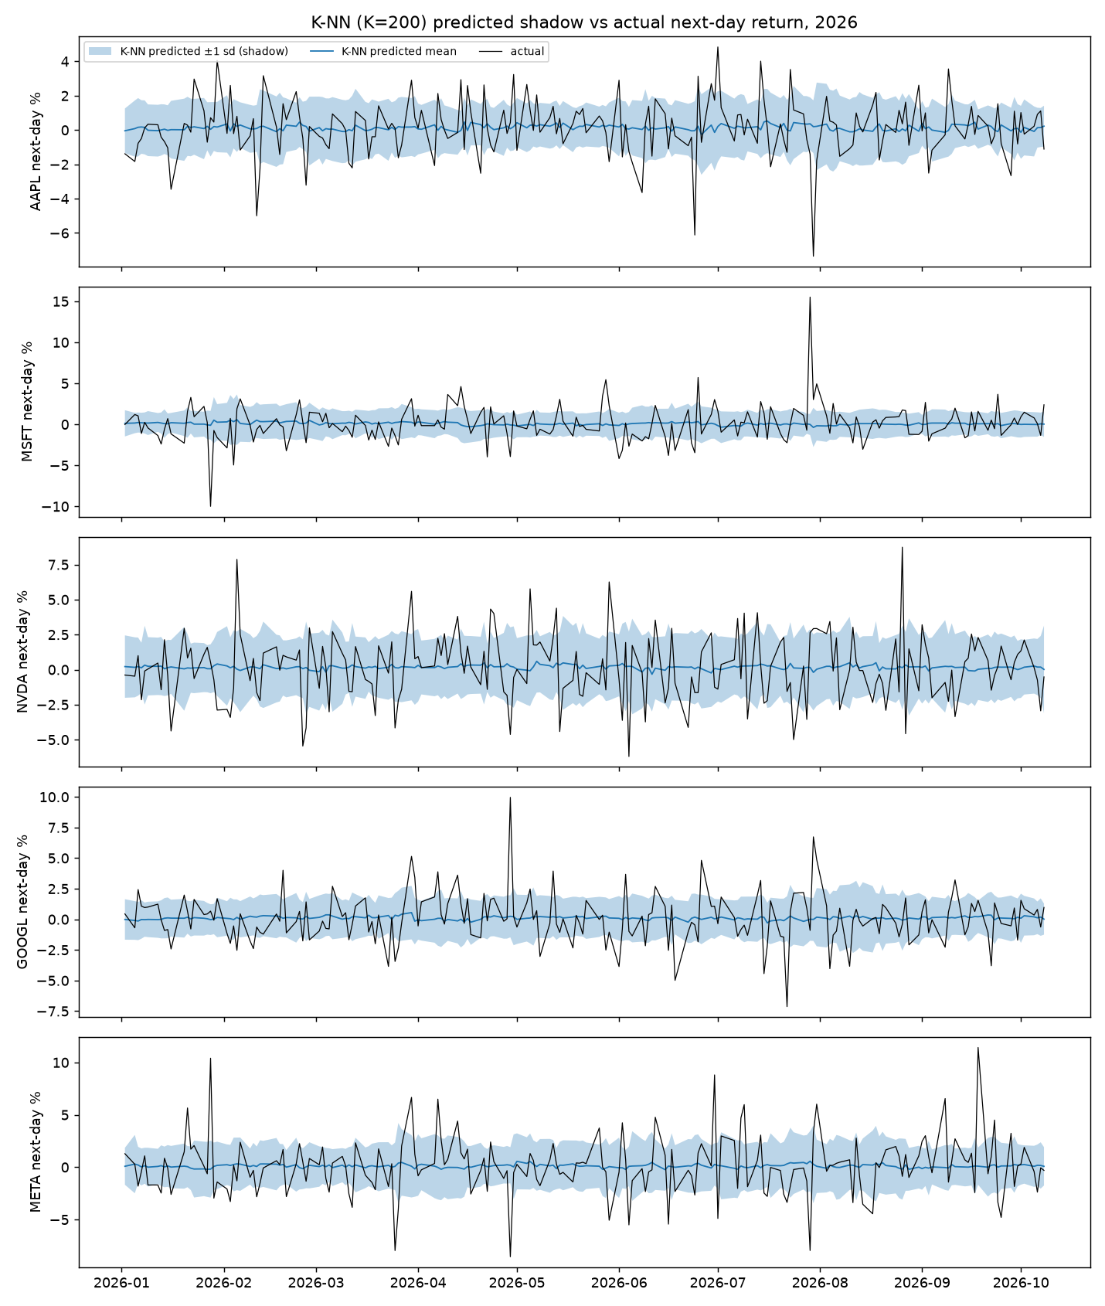
Figure 1: K-NN predicted next-day return (blue line and shaded ±1 standard deviation band) vs actual return (black), 2026
What the graph shows: The blue predicted line stays almost flat near zero, while the actual returns (black) jump between roughly −9% and +15%. The model has learned that on average tomorrow is close to zero, and that is all it knows. The shaded band is simply the normal daily noise of the stock, so the actual line falls inside it about 70% of the time by chance, not because the model is skilful. K-NN's error (MAE) was slightly worse than just predicting 0% every day.
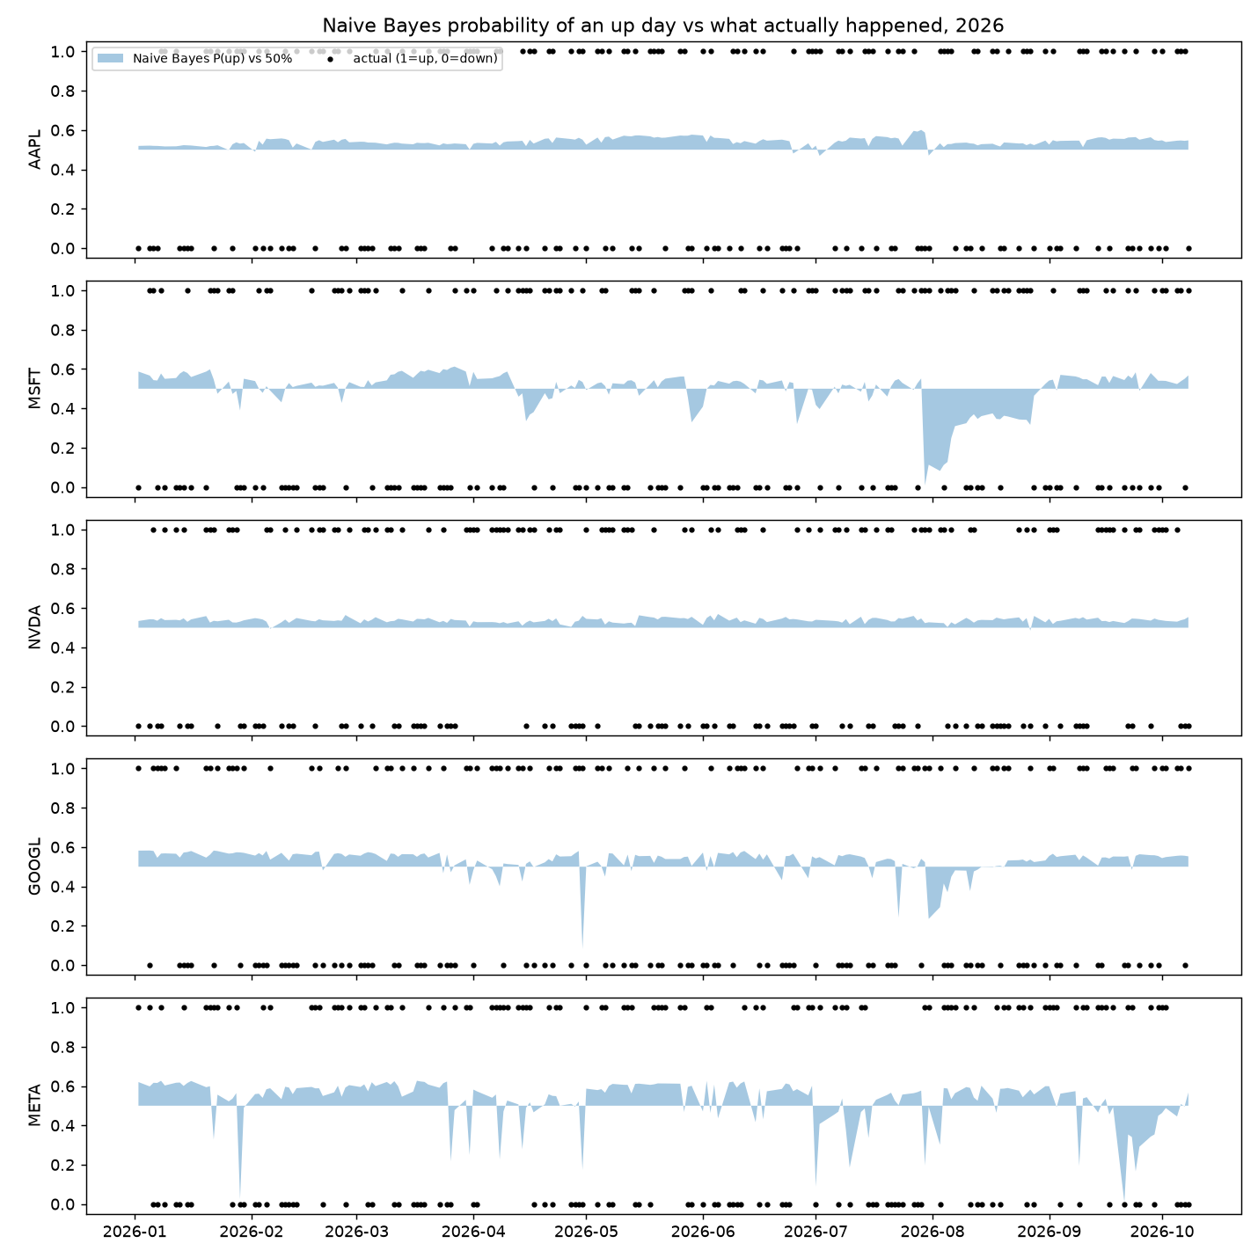
Figure 2: Naive Bayes probability of an up day (orange) vs actual up (1) / down (0) days, 2026
What the graph shows: The orange area shows how far Naive Bayes' probability of an up day is above or below 50%. It stays very close to 50% almost every day, which means the model is unsure. The black dots (actual up or down) are scattered randomly with no relation to the orange area: high-probability days are not more often up.
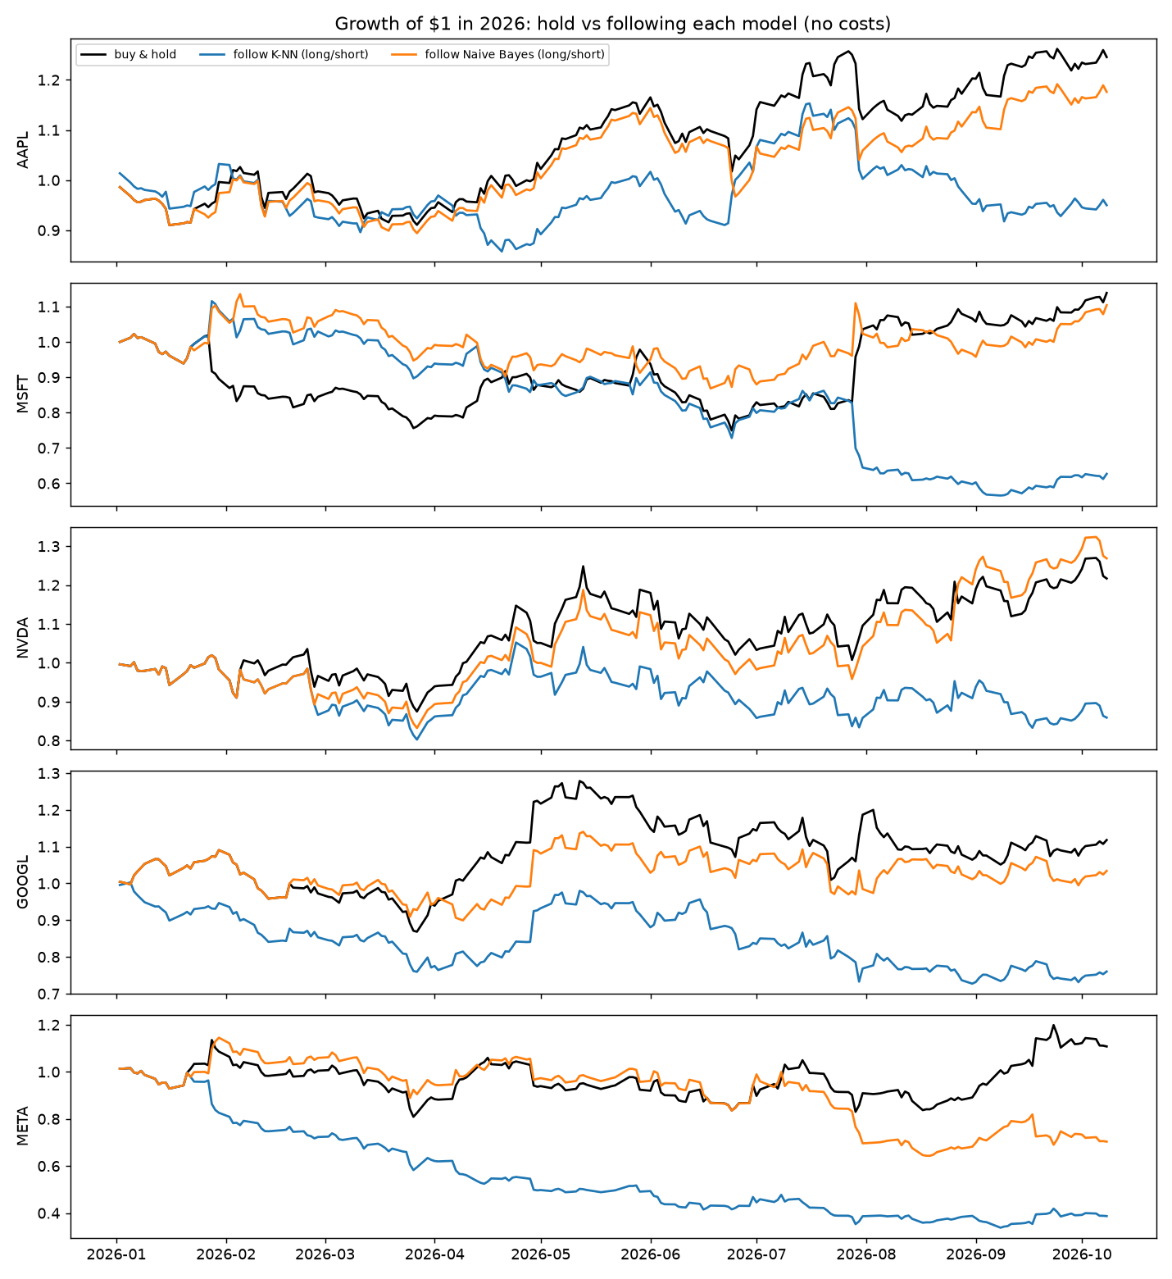
Figure 3: Growth of $1 in 2026: holding the stock (black) vs following each model's signal
What the graph shows: If the models had real skill, the coloured lines would end above the black line. Instead, K-NN's line ends below on all five stocks (as low as −61% for META) and Naive Bayes is mixed. This is the money view of the same result: no usable prediction of direction.

6.2 Problem 2 - Predicting the size of tomorrow's move (Jan-Oct 2026)
Table 5: Accuracy of calling a big vs small move tomorrow
Stock | K-NN acc. | Naive Bayes acc. | Always-majority | Persistence
AAPL | 45.6% | 56.5% | 53.9% | 52.8%
MSFT | 64.8% | 57.5% | 64.8% | 56.5%
NVDA | 51.3% | 52.3% | 50.8% | 48.2%
GOOGL | 59.1% | 47.2% | 59.1% | 49.7%
META | 53.9% | 50.3% | 53.9% | 51.8%
All pooled | 54.9% | 52.8% | 54.6% | 51.8%

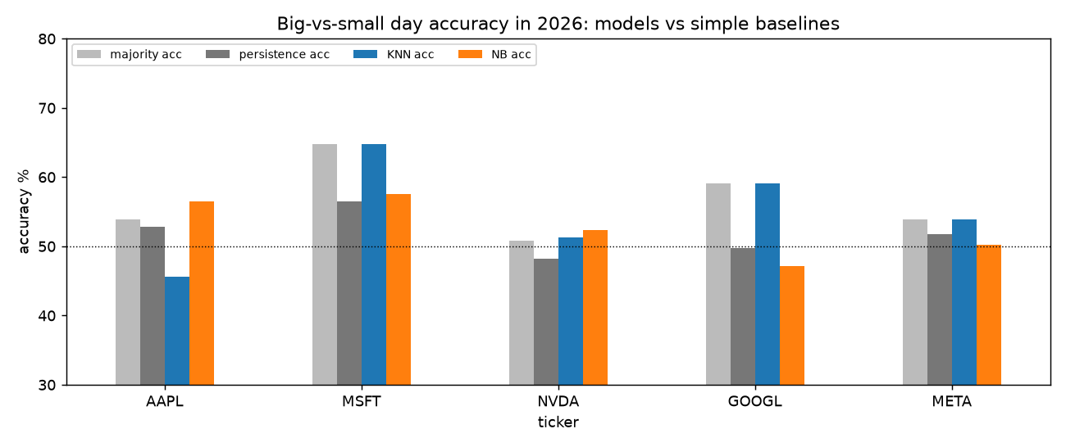
Figure 4: Big-vs-small day accuracy in 2026: models (blue, orange) vs baselines (grey)
What the graph shows: For every stock the coloured bars (models) are about the same height as, or lower than, the grey bars (baselines). Pooled over all stocks K-NN reached 54.9% against 54.6% for always guessing the majority - no real difference. Predicting the size of one single day was also not possible in 2026.

6.3 Problem 3 - Predicting next month's volatility regime (2012-2026)
Table 6: High vs low next-month volatility: accuracy, and p-value that the model beats always-majority (NB = Naive Bayes)
Stock | Months | Majority | Persist. | K-NN | NB | p K-NN | p NB
AAPL | 177 | 67.8% | 69.5% | 68.9% | 73.4% | 0.374 | 0.054
MSFT | 177 | 50.8% | 58.2% | 61.0% | 63.3% | 0.003 | <0.001
NVDA | 177 | 58.2% | 69.5% | 69.5% | 70.6% | 0.001 | <0.001
GOOGL | 177 | 50.8% | 66.7% | 63.8% | 68.4% | <0.001 | <0.001
META | 135 | 54.8% | 63.7% | 68.9% | 63.7% | <0.001 | 0.019
ALL (pooled) | 843 | 54.7% | 65.6% | 66.3% | 68.1% | <0.001 | <0.001
2026 only (pooled) | 45 | 64.4% | 60.0% | 66.7% | 55.6% | 0.378 | 0.894

Table 7: Extra measures for Problem 3
Measure (all stocks pooled) | Value
K-NN error on the volatility level (MAE) | 9.2 vol points
Persistence error on the volatility level (MAE) | 11.1 vol points
p-value: K-NN accuracy > persistence | 0.33
p-value: Naive Bayes accuracy > persistence | 0.06
Actual inside K-NN's 25-75% band (expected 50%) | 43.4%

Here both models clearly work: 66% (K-NN) and 68% (Naive Bayes) against 55% for always-majority, with p-values below 0.001. Four of the five stocks are significant on their own (AAPL is the exception, explained in Section 7). However, the simple persistence rule reaches 66% too, so the models do not clearly beat it on accuracy (p = 0.33 and 0.06). K-NN's real extra value is in the size of the forecast: its volatility estimate is about 17% more accurate than persistence (9.2 vs 11.1 points). In 2026 alone (45 predictions) no method was significant.
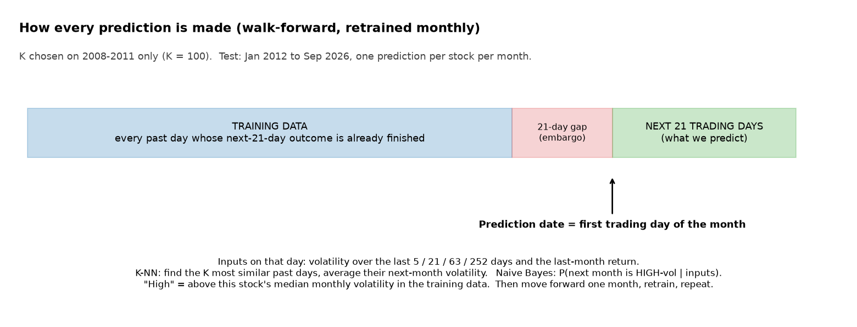
Figure 5: How every prediction in Problem 3 is made
What the graph shows: The blue block is the training data, the red block is the 21-day gap (embargo) and the green block is the next month we are predicting. Only past days whose 21-day result had completely finished before the prediction date are used to train, so the model cannot peek at the future. After each prediction we move forward one month, re-train and repeat.
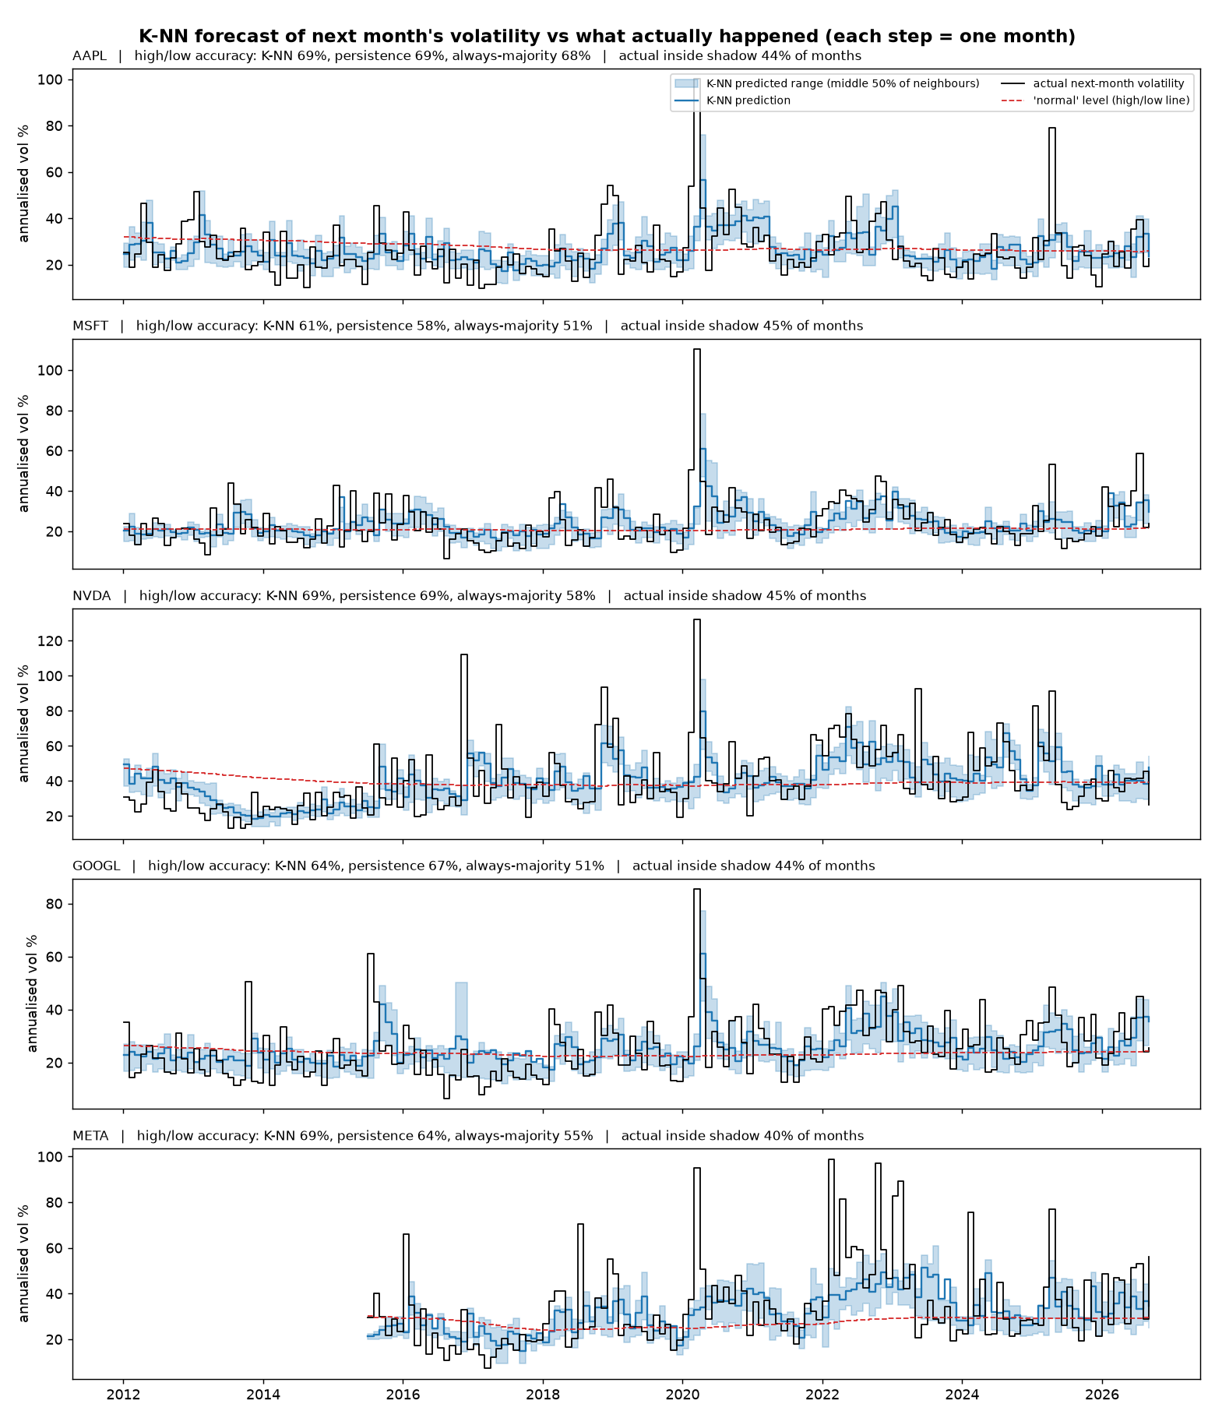
Figure 6: K-NN predicted next-month volatility (blue line and shaded range) vs actual (black), 2012-2026
What the graph shows: Each step is one month. The blue line and shaded band are K-NN's forecast; the black line is what really happened; the red dashed line is the stock's normal level, which separates high and low months. The blue line follows the big waves: it rises in 2020 (COVID crash), stays high through 2022 (interest-rate shock for tech stocks) and falls in calm years such as 2017. What it cannot do is predict the first month of a sudden shock - the tall black spikes (e.g. March 2020, NVIDIA's November 2016 earnings jump) appear before the blue line reacts. The actual value falls inside the 25-75% band 43% of the time, slightly less than the 50% you would expect, because sudden shocks are bigger than anything the neighbours suggest.
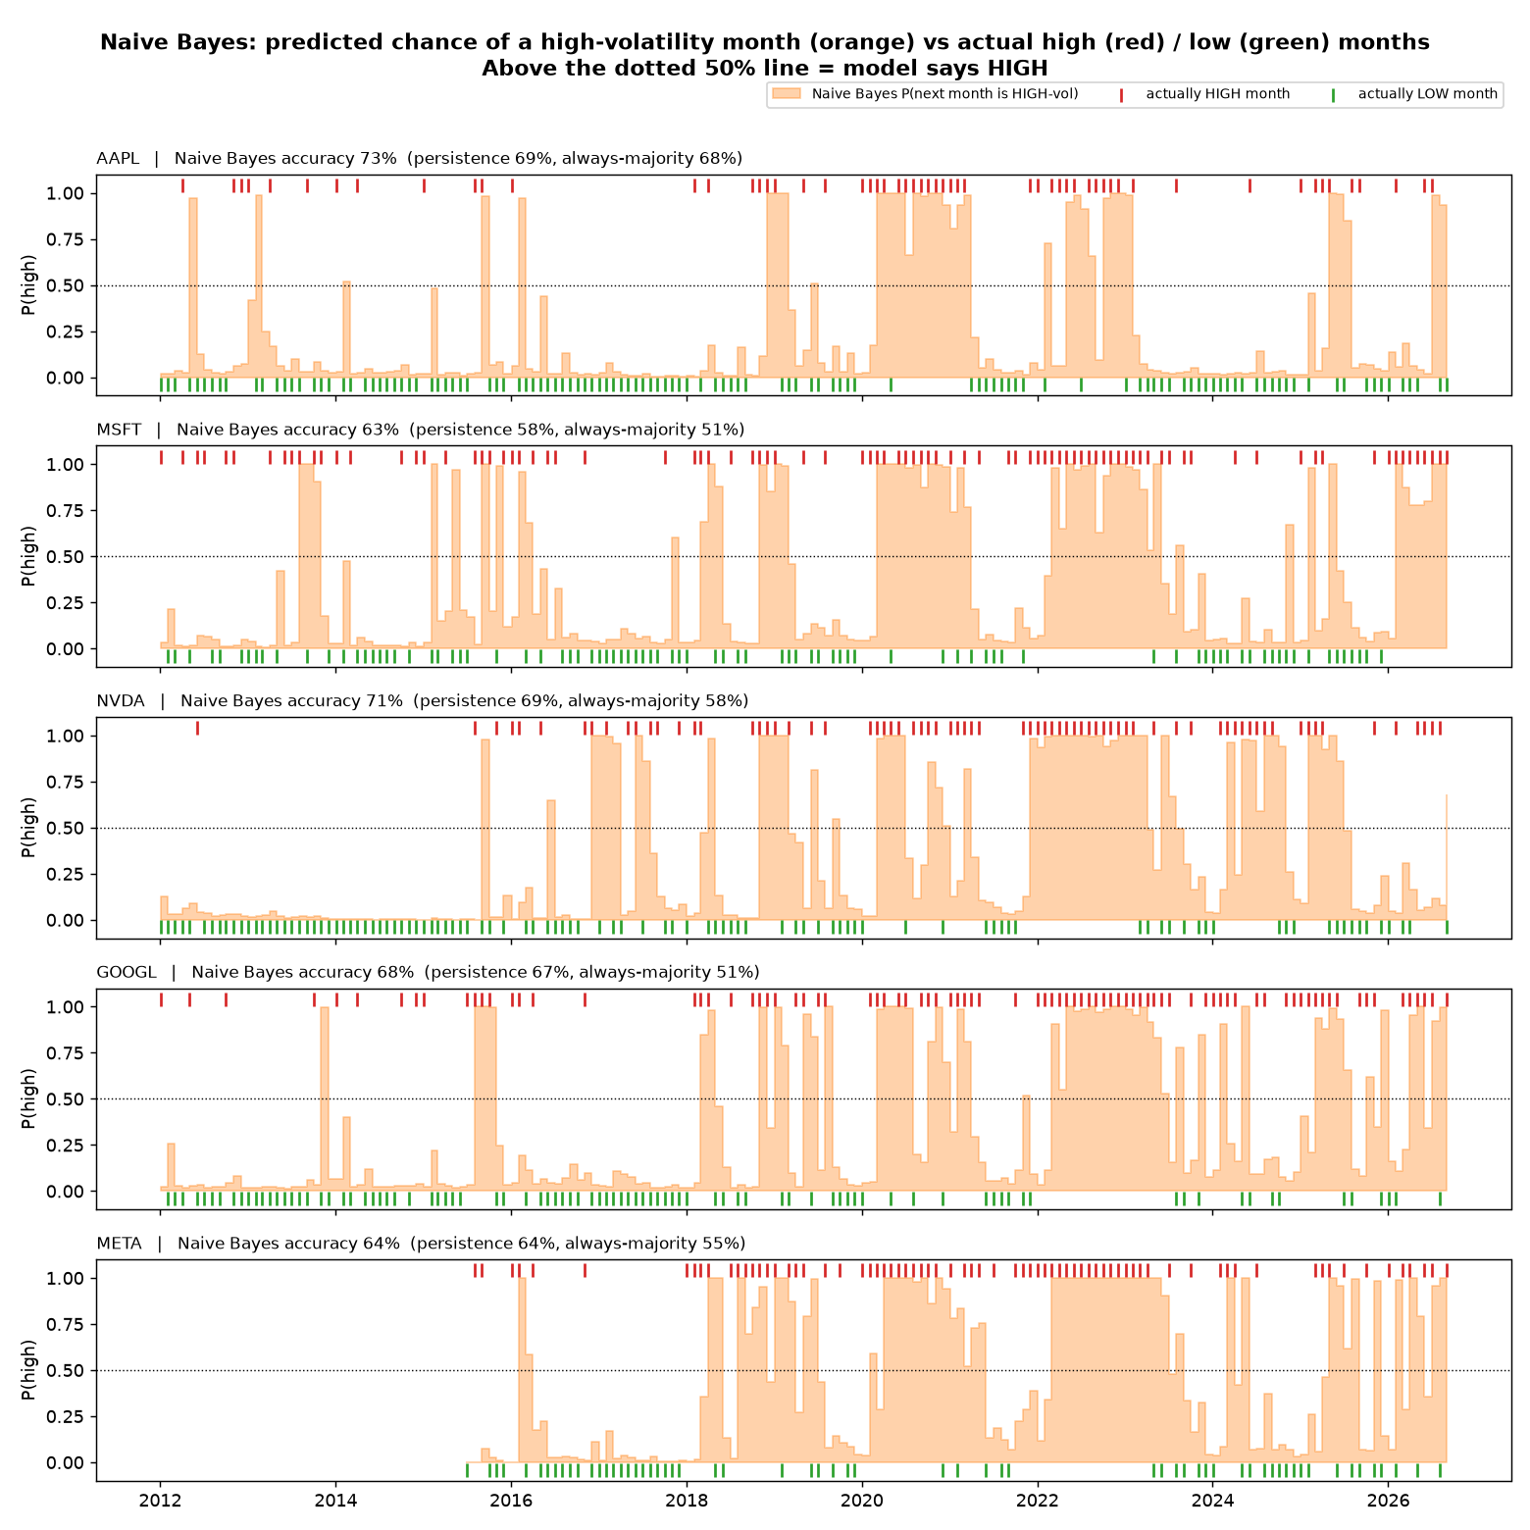
Figure 7: Naive Bayes probability of a high-volatility month (orange) vs actual high (red) / low (green) months
What the graph shows: Where the orange area is above the dotted 50% line the model predicts a HIGH month. The long orange blocks (2020, 2022, 2025) sit above long runs of red marks (actually high months), and the flat low periods (2013-2014, 2017) sit above green marks (actually low months), so the model is right most of the time. The orange area is almost always close to 0 or 1: Naive Bayes is very sure of itself, even when it is wrong.
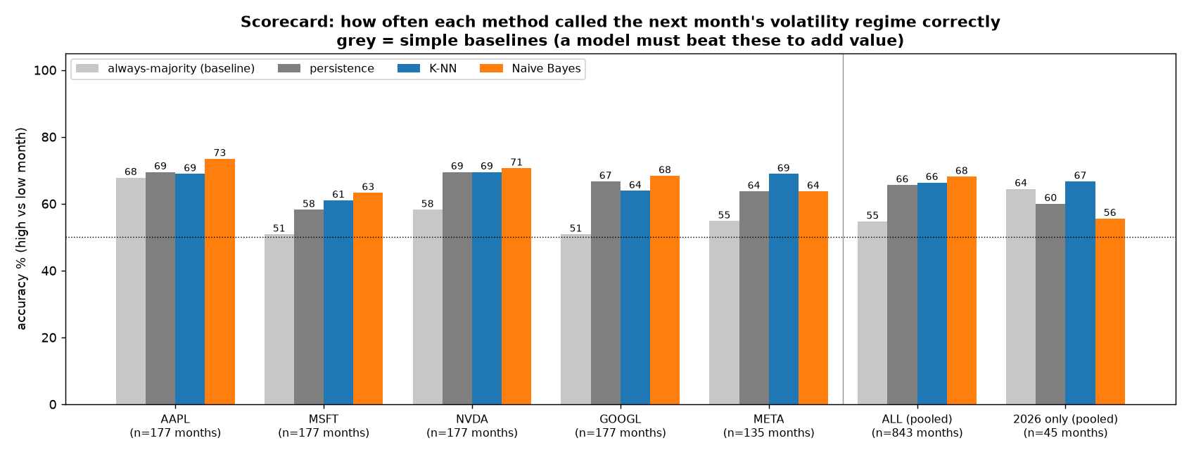
Figure 8: Scorecard: accuracy of each method vs the two baselines
What the graph shows: Every coloured bar (K-NN, Naive Bayes) is well above the light-grey bar (always-majority), which shows there is something real to predict. But the dark-grey bar (persistence) is almost as tall as the model bars, which shows that most of the skill comes from the simple fact that volatility persists. The right-most group (2026 only) shows that in one calm year the advantage disappears.
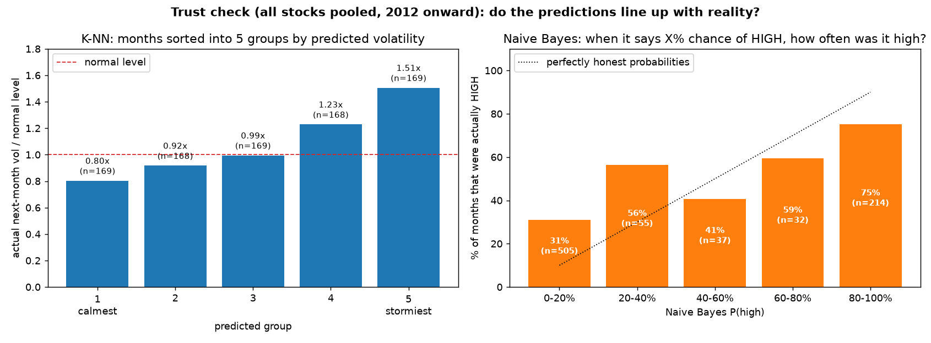
Figure 9: Trust check: do the predictions line up with what really happened?
What the graph shows: Left: all 843 predictions sorted into 5 equal groups from "calmest" to "stormiest" according to K-NN. The months K-NN called calmest really were calm (0.80× the normal level) and the months it called stormiest really were stormy (1.51× normal) - a clean staircase means the ranking is trustworthy. Right: when Naive Bayes says 0-20% chance of a high month, 31% were actually high; when it says 80-100%, 75% were. The direction is right, but the probabilities are too extreme (over-confident) compared to the dotted line.

7. Comparison with Real Life - Why These Percentages?

7.1 Why direction is about 50% (a coin flip)
Stock prices are watched by millions of traders and computer programs. If yesterday's pattern really predicted tomorrow's direction, these traders would buy or sell on it immediately, and the pattern would disappear. This is the idea of an efficient market. What moves a price tomorrow is new information - an earnings report, a product launch, an interest-rate decision - which by definition is not in yesterday's data. So a model that only sees past prices cannot do better than a coin flip, and that is exactly what we found.
The "always up" baseline is a bit above 50% (51-53%) because tech stocks rose over time: on average there are slightly more up days than down days. A model that sometimes says "down" loses this small advantage, which is why following the signals in Figure 3 did worse than just holding. K-NN's accuracy below 50% is mostly bad luck in a small sample: with 193 days, normal random variation is about ±3.6 percentage points.

7.2 Why the size of one single day is also unpredictable
Over the whole history, a calm period is followed by calm days and a stormy period by stormy days. But one single day is dominated by random news, so the link from today to tomorrow is weak (correlation about 0.25). In 2026 it was even weaker (about 0): 2026 was one steady market with no big crisis, and the volatility of the five stocks moved only 2-4 times between its lowest and highest month, compared with 14-21 times over 2005-2025. If the thing you predict hardly changes, there is nothing to forecast.

7.3 Why next month's risk is predictable (66-68%)
This is a well-known real-world fact called volatility clustering: periods of uncertainty last for weeks or months. When COVID hit in March 2020, markets stayed wild for months; during 2022, rising interest rates kept tech stocks nervous for the whole year. Averaging over a month removes the day-to-day noise, so the link between this month's and next month's volatility is strong (correlation about 0.5-0.6). The whole finance industry relies on this fact: the VIX "fear index", option prices, GARCH models and bank risk limits all assume that today's risk tells you about tomorrow's risk.
Why not higher than about 70%? (1) Shocks arrive without warning - the first month of every crisis is missed, as the black spikes in Figure 6 show. (2) Many months are close to the normal level, and for these a small error flips the high/low label, so they are almost a coin flip.
Why the models only tie with persistence? All the useful information is "how volatile has it been recently", and the persistence rule already uses exactly that. K-NN and Naive Bayes do not have any new information; they can only use it a little more smoothly. That is why K-NN's forecast of the volatility level is better (it averages 100 similar past months instead of copying one noisy month), while the high/low accuracy is about the same.
Why is Naive Bayes over-confident? Its "naive" assumption says the five features are independent. In reality volatility over 5, 21, 63 and 252 days are strongly related - they all describe the same thing. Naive Bayes therefore counts the same evidence several times, which pushes its probabilities towards 0% or 100% (Figures 7 and 9). The class decision is still good, but the probability should not be trusted as a real percentage.
Why does AAPL have a 68% majority baseline? Apple was a much riskier stock in 2004-2011 (when it was a smaller company) than after 2012. The "normal" level is learned from all the past, so most months after 2012 count as "low", and simply guessing "low" is already right 68% of the time. That leaves little room for a model to improve, which is why AAPL is the only stock where the improvement is not significant.

8. Conclusion
We implemented K-NN and Gaussian Naive Bayes from scratch and tested them honestly with walk-forward testing, a leakage gap, simple baselines and significance tests on 22 years of tech-stock data. The findings are:
1. Tomorrow's direction cannot be predicted from past prices (≈50%, no model beat the baseline).
2. The size of tomorrow's move could not be predicted in 2026 either.
3. Next month's risk regime can be predicted: 66-68% accuracy vs 55% for guessing, highly significant over 2012-2026. Most of this comes from volatility persisting; K-NN adds a more accurate size forecast, and Naive Bayes gives good decisions but over-confident probabilities.
The main lesson is that machine learning cannot find a signal that is not in the data. The value of these models in finance is in measuring and forecasting risk, not in predicting whether a price will go up or down.

9. K-NN Worked on Paper
[Insert the scanned pages of the hand-worked K-NN example here: a dataset with 2 features and at least 20 examples, showing the distance calculation, the K nearest neighbours and the final vote.]

10. Code
All code uses only NumPy, Pandas and Matplotlib. The full files (knn.py, naive_bayes.py, run.py, run_vol.py, run_regime.py) and the dataset are attached with the submission. The core parts are shown below.
10.1 knn.py - K-NN from scratch
#YOUR CODE STARTS HERE#
"""K-NN from scratch (NumPy only). Regression-style: neighbours' next-day returns are averaged."""
from __future__ import annotations

import numpy as np

class KNN:
def __init__(self, k: int = 50):
self.k = k

def fit(self, X: np.ndarray, y: np.ndarray) -> "KNN":
# "lazy learner": training = standardise with train stats, then memorise
self.mu, self.sd = X.mean(0), X.std(0) + 1e-12
self.X = (X - self.mu) / self.sd
self.y = np.asarray(y, float)
return self

def neighbours(self, x: np.ndarray) -> np.ndarray:
z = (x - self.mu) / self.sd
d = np.sqrt(((self.X - z) ** 2).sum(1)) # Euclidean distance to every training day
return self.y[np.argsort(d)[: self.k]] # next-day returns of the K closest days

def predict(self, x: np.ndarray) -> tuple[float, float, float]:
"""Returns (predicted return, spread of neighbours, share of neighbours that were up)."""
nb = self.neighbours(x)
return nb.mean(), nb.std(), (nb > 0).mean()
#YOUR CODE ENDS HERE#

10.2 naive_bayes.py - Gaussian Naive Bayes from scratch
#YOUR CODE STARTS HERE#
"""Gaussian Naive Bayes from scratch (NumPy only). Classes: 1 = up day, 0 = down day."""
from __future__ import annotations

import numpy as np

class GaussianNB:
def __init__(self, var_floor: float = 1e-9):
self.var_floor = var_floor

def fit(self, X: np.ndarray, y: np.ndarray) -> "GaussianNB":
self.classes = np.array([0, 1])
self.prior = np.array([(y == c).mean() for c in self.classes])
self.mean = np.array([X[y == c].mean(0) for c in self.classes])
self.var = np.array([X[y == c].var(0) + self.var_floor for c in self.classes])
return self

def log_joint(self, x: np.ndarray) -> np.ndarray:
# log P(class) + sum_j log N(x_j | mean_cj, var_cj) (logs avoid underflow)
ll = -0.5 * (np.log(2 * np.pi * self.var) + (x - self.mean) ** 2 / self.var).sum(1)
return np.log(self.prior) + ll

def prob_up(self, x: np.ndarray) -> float:
lj = self.log_joint(x)
lj -= lj.max()
p = np.exp(lj)
return float(p[1] / p.sum())
#YOUR CODE ENDS HERE#

10.3 Pre-processing: features and target (run_regime.py)
#YOUR CODE STARTS HERE#
def build(t: str) -> pd.DataFrame:
p = px[t].dropna()
r = p.pct_change()
f = pd.DataFrame({
"vol5": r.rolling(5).std() * ANN, "vol21": r.rolling(21).std() * ANN,
"vol63": r.rolling(63).std() * ANN, "vol252": r.rolling(252).std() * ANN,
"ret21": p.pct_change(21) * 100,
})
f["target"] = r.rolling(H).std().shift(-H) * ANN # vol of days t+1 .. t+21
f["tdate"] = pd.Series(p.index, index=p.index).shift(-H) # day the outcome is complete
return f.dropna(subset=FEATS)

#YOUR CODE ENDS HERE#

10.4 Walk-forward training and prediction (run_regime.py)
#YOUR CODE STARTS HERE#
def walk(d: pd.DataFrame, start: str, end: str | None, k: int) -> pd.DataFrame:
known = d.dropna(subset=["target"])
te = known[(known.index >= start) & ((known.index < end) if end else True)]
month_starts = te.groupby(te.index.to_period("M")).head(1)
rows = []
for dt, row in month_starts.iterrows():
tr = known[known["tdate"] < dt] # outcome finished before we predict = embargo
if len(tr) < MIN_TRAIN:
continue
normal = tr["target"].median() # the stock's "normal" monthly vol, train only
X, y = tr[FEATS].values, tr["target"].values
knn = KNN(k).fit(X, y)
nb = GaussianNB().fit(X, (y > normal).astype(int))
x = row[FEATS].values.astype(float)
nbh = knn.neighbours(x)
rows.append((dt, row["target"], normal, nbh.mean(), np.percentile(nbh, 25), np.percentile(nbh, 75),
nb.prob_up(x), row["vol21"]))
cols = ["date", "actual", "normal", "knn", "knn_lo", "knn_hi", "nb_phigh", "vol21_now"]
return pd.DataFrame(rows, columns=cols).set_index("date")

#YOUR CODE ENDS HERE#

