Explaination:

Following modifications have been done to previous model:

We can predict three things:

This model has two functions named as **increase_sales() which predicts opti*mal price if we want to increase sale by certain percentage for ex I have taken 10 %***

***Second function is named as increase_sales_by_many() which takes multiplke percentages such as 10,20 etc. and predicts optimal price accordingl which takes multiplke percentages such as 10,20 etc. and predicts optimal price accordingl***



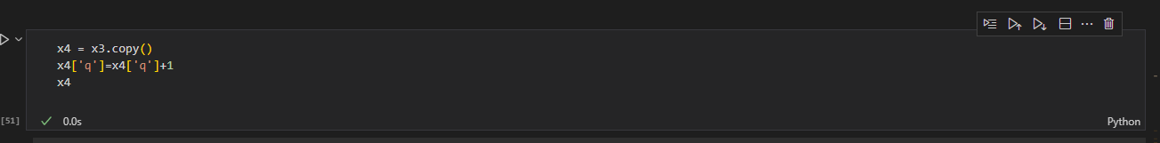

***Above code snippet*** is for prediction of sales for the quarter whose sale is not yet started.

It takes data from previous quarter and then predicts optimal price.

For example in above code it takes data of 3rd quarter and predicts optimal price for the 4th one. Assuming 4th quarter has not yet started sales.