Introduction
This project presents a Decentralized Application (DApp) built using Solidity, React.js, and
Ethers.js, deployed on the Ethereum blockchain. The system combines Know Your Customer
(KYC) verification with Crowdfunding campaign management, ensuring that only verified users
can create fundraising campaigns while maintaining transparency for all participants.
The complete source code is available at:
https://github.com/fahadsaleem1678/Crowdfunding-DApp-using-Hardhat-and-React.git
The DApp consists of two main smart contracts:
1. KYCRegistry_FahadSaleem.sol: Handles user identity verification and admin
approval.
2. Crowdfunding_FahadSaleem.sol: Manages campaign creation, contributions,
and withdrawals.
The purpose of this integration is to provide a secure, transparent, and tamper-proof platform for decentralized fundraising.

System Architecture
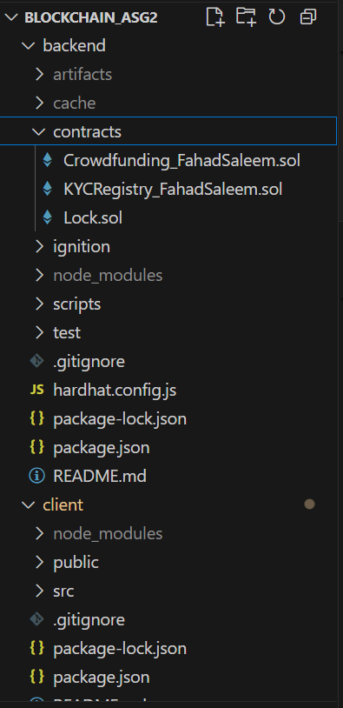

KYC Verification Process
- User Registration: A user submits a KYC request with their Name and CNIC.
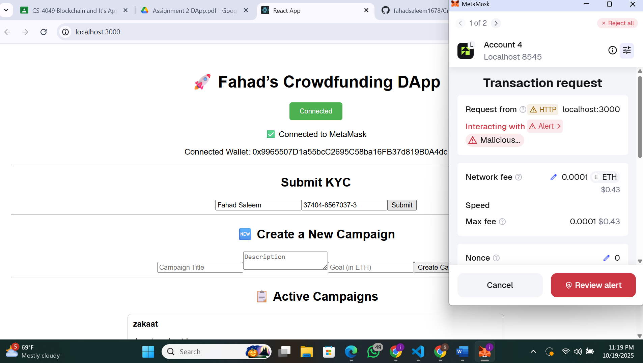

Admin Approval: The admin views all pending requests and can approve or reject them.
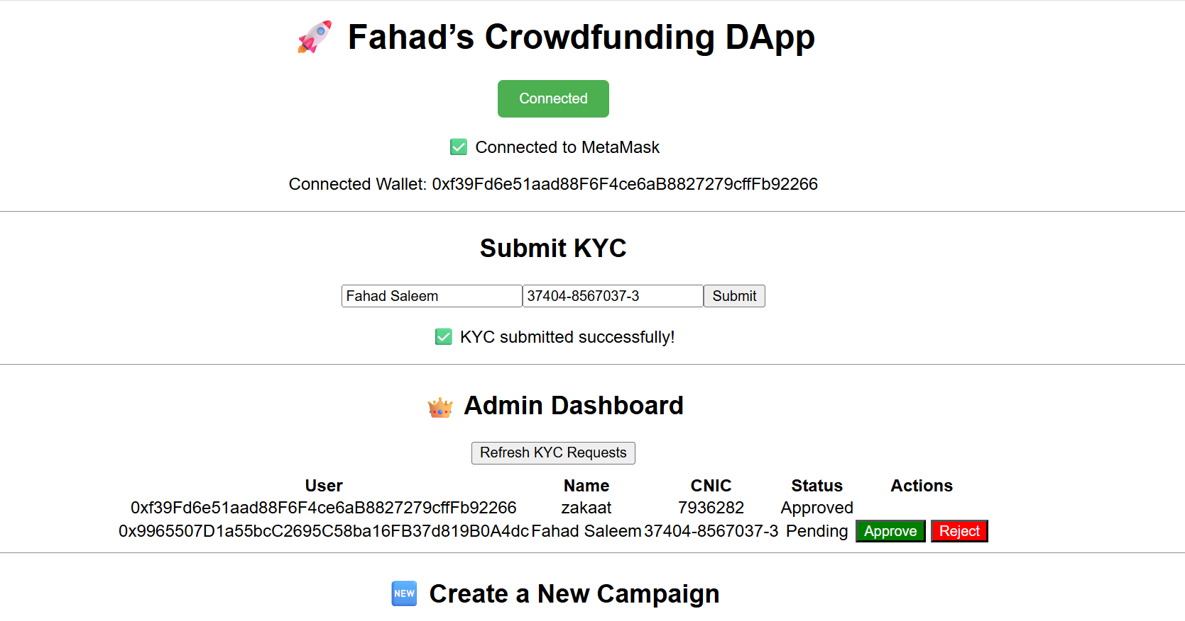
- Verification Status: A user's KYC status is checked before they can create a campaign; only users with an "Approved" status are permitted to do so.
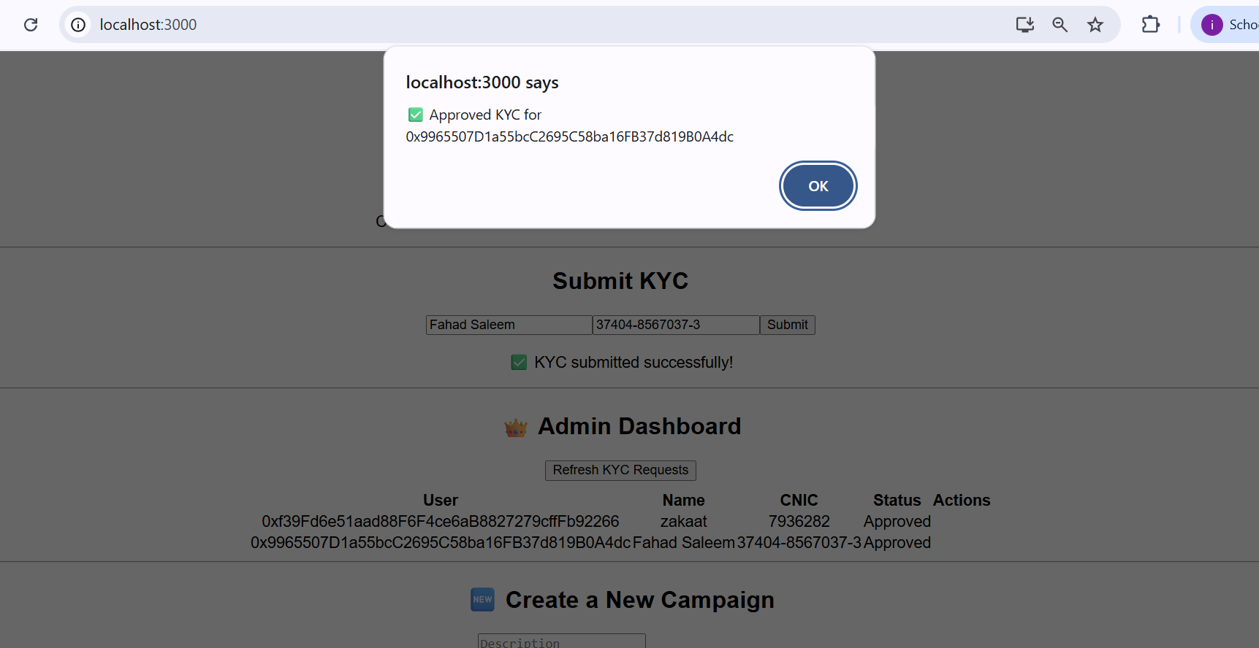

Campaign Creation
Once a user is verified, they gain the ability to create new fundraising campaigns through the Crowdfunding_FahadFaisal.sol contract.
• Process: On the "Create Campaign" form, the verified user must provide a Campaign Title, a Description, and a Funding Goal specified in ETH.
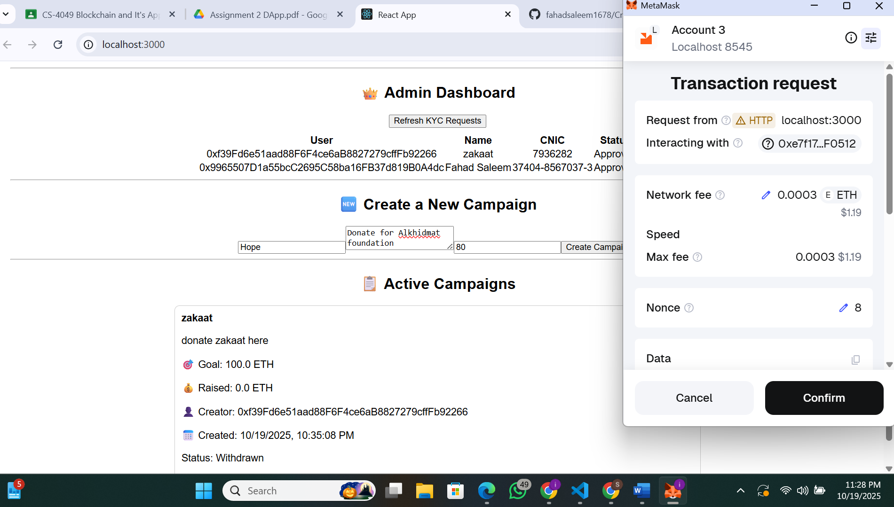

Event Emission: Upon successful creation of the campaign on the blockchain, the smart contract emits a Campaign Created event to log the new campaign's details.
Interaction: Every active campaign card also features a "Contribute" button, allowing users to easily participate.
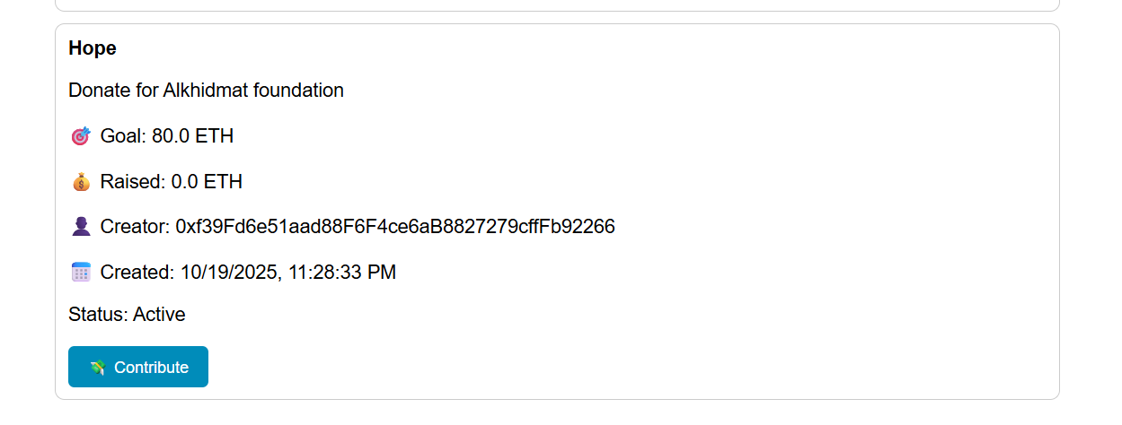

Contributions and Progress: Any user (even unverified) can contribute ETH to an active campaign. Each contribution updates the raised amount in real time on the frontend.
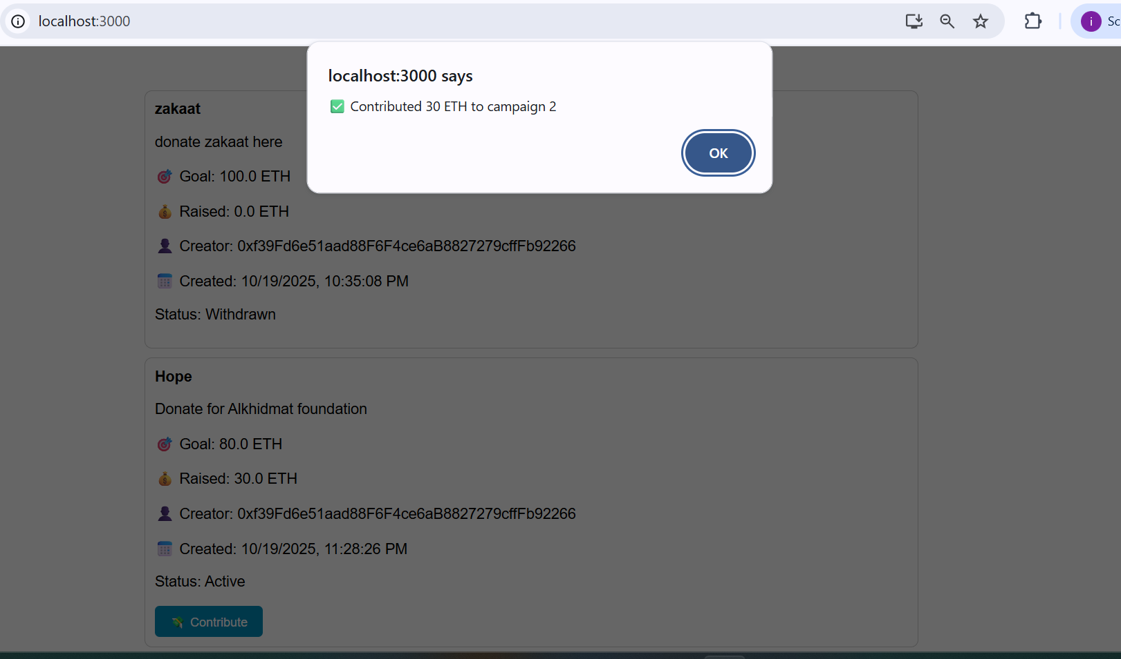

Goal Completion: The smart contract automatically checks if a contribution pushes the total raised funds to or over the campaign's goal. If it does, the campaign's status is immediately updated from "Active" to "Completed".
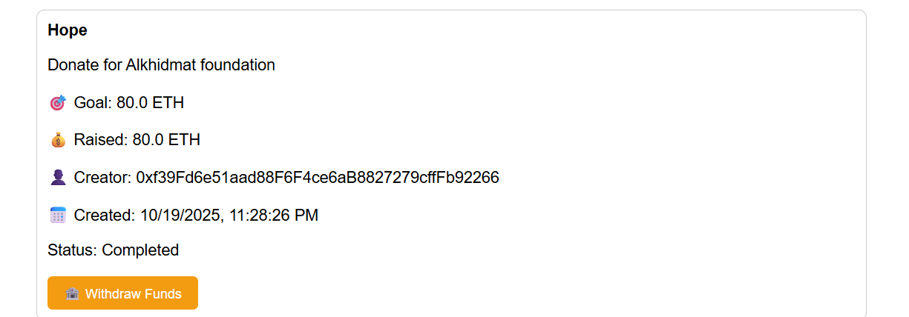

Funds Withdrawal: Only the campaign creator can withdraw funds once the campaign is completed. Note that withdraw funds button only appears when status changes to completed.
Process: When the creator clicks this button, they sign a transaction that transfers the entire balance of raised funds from the contract to their personal wallet.
