**CS324: Advanced Programming in Java**

**Homework No. 8**

**Due on Sunday 14 November**

**This HW can be done in a group of 2 persons.**

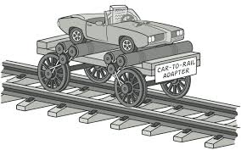

**ADAPTER PATTERN** works as a bridge between two incompatible interfaces. This type of design pattern comes under structural pattern as this pattern combines the capability of two independent interfaces.

This pattern involves a single class which is responsible to join functionalities of independent or incompatible interfaces. A real life example could be a case of card reader which acts as an adapter between memory card and a laptop. You plug in the memory card into card reader and card reader into the laptop so that memory card can be read via laptop.

In this homework you are going to implement an adapter pattern. Sample code is provided with this homework. When you run it a window opens and three sprites appear; two begin to animate, the third is under user control, which you can move with arrow keys. One of the sprites is highlighted; clicking the tab key causes the highlight to switch among the sprites.

Examining the code, you can see that EastWestSprite, NorthSouthSprite, and BlueSprite are being drawn on the Canvas (look for the corresponding java files).

There is a RedSprite class, which need to be included in Canvas. However, RedSprite doesn’t follow the Sprite interface that is the basis for sprites in Canvas class. You don’t want to change the RedSprite class, rather a better idea is to create an adapter design pattern class, which would be able to integrate RedSprite class in Canvas.

**How to run the program:**

Compile all the files, and run Test:

javac *.java

java Test