Device Setup Page
Path - lib/Frontend/pages/device_setup.dart

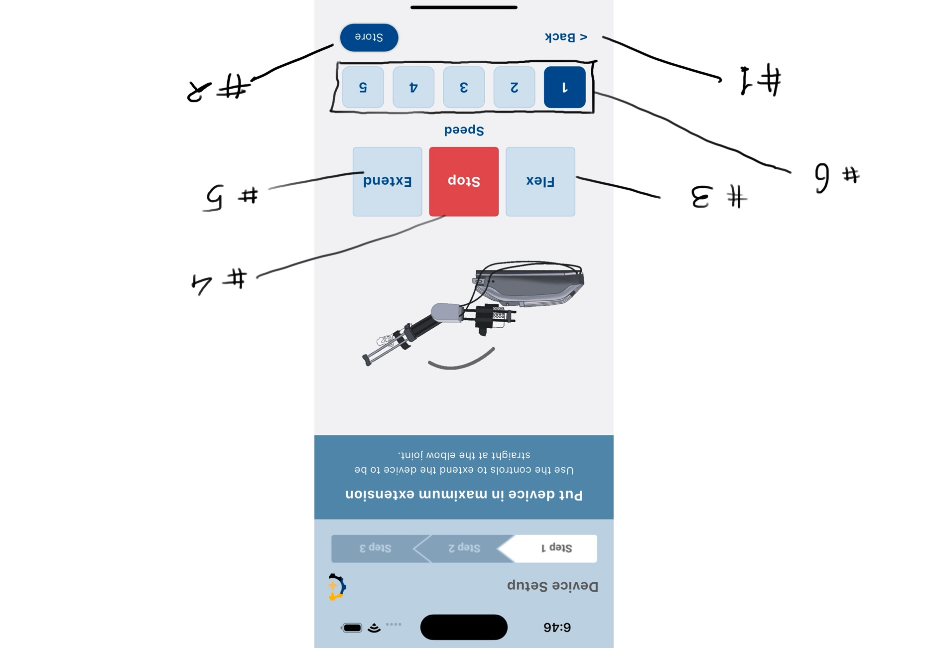

Manual Mode page
Path - lib/Frontend/pages/manual_Mode.dart
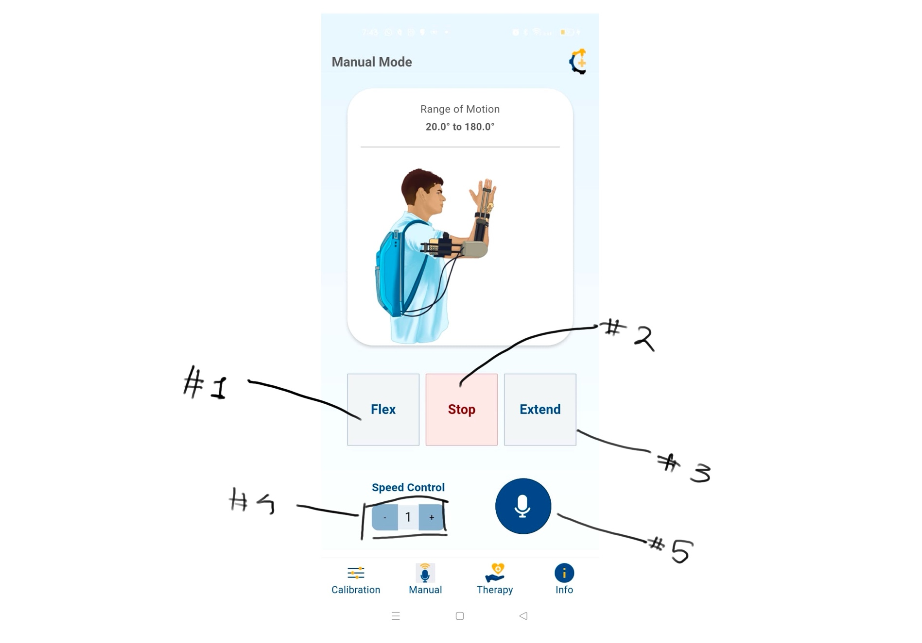

Calibration Page
Path - lib/Frontend/pages/calibration_Page.dart
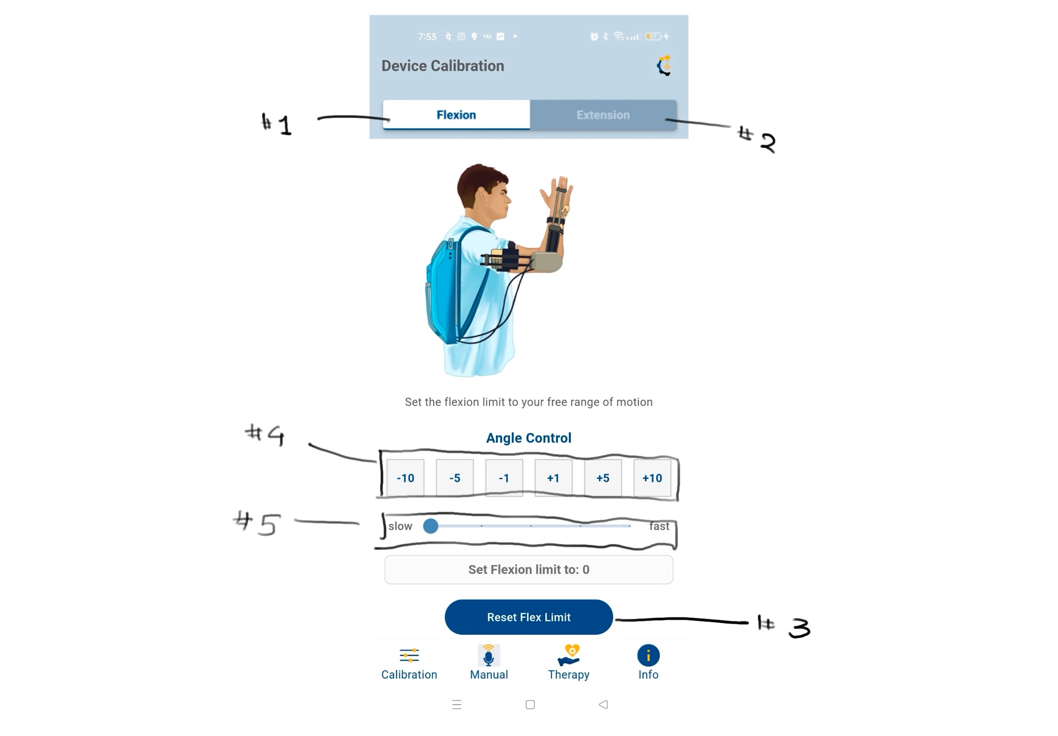

Therapy Mode
Path - lib/Frontend/pages/therapymode.dart
