Page 3

URL | https://shellharbourskin.com.au/treatment-services/aesthetic-consults/comprehensive-facial-assessment/
Meta Title | Comprehensive Facial Assessment & Consultation | Shellharbour Skin
Meta Description | Book a thorough, individualised facial assessment at Shellharbour Skin. Discuss your unique skin health concerns, facial anatomy, and suitability for treatment.
Navigation | Rename the nav item to “Comprehensive Facial Consultations”  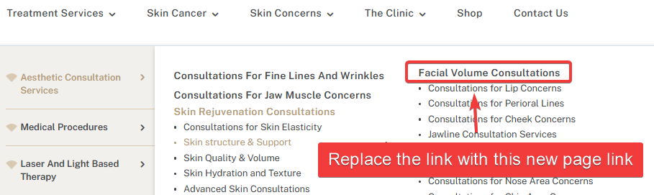

Comprehensive Facial Assessment

Overview
A Comprehensive Facial Assessment is a consultation that provides an opportunity to discuss concerns relating to skin health, facial changes over time, and your individual concerns and preferences.
The purpose of the consultation is to understand your concerns, review relevant aspects of your medical history, and determine whether any management recommendations may be appropriate for your individual circumstances.
Recommendations are individualised and are only made following a clinical assessment. Not all individuals will be suitable candidates for treatment, and treatment may not be recommended.

Our Consultation Approach
At Shellharbour Skin, we believe informed decision-making begins with a thorough assessment and open discussion.
Our consultations are designed to provide information, explore your concerns, and assist you in understanding factors that may influence suitability for treatment or ongoing management. Every individual has different concerns, medical histories, preferences, and expectations, and recommendations are tailored accordingly.
The consultation process is intended to support informed and considered decision-making and to provide information relevant to your individual circumstances.

What Happens During Your Consultation?
During your appointment, your clinician may discuss:
- Your concerns and reasons for seeking a consultation
- Relevant medical history, including medications, supplements, allergies, and previous treatments or procedures
- Lifestyle and other factors that may influence suitability considerations
- Your expectations, concerns, and preferences
- The potential benefits, limitations, risks, and alternatives associated with any management recommendations that may be considered appropriate
Where relevant to your concerns, a clinical assessment may include an evaluation of skin health and facial anatomy.
The consultation also provides an opportunity to ask questions and receive information to support informed decision-making.

Individualised Assessment and Recommendations
Recommendations are based on:
- Clinical assessment findings
- Medical history and suitability considerations
- Individual concerns and preferences
- Potential risks and limitations
- Whether a management approach is considered appropriate in your circumstances
Management recommendations may include education, skincare advice, review appointments, referral pathways, or other approaches considered clinically appropriate.
Recommendations vary significantly between individuals. The information and recommendations discussed with one person may not be suitable or appropriate for another.
In some circumstances, no treatment or procedure may be recommended.

Shared Decision-Making
We encourage patients to take an active role in decisions regarding their care.
Your consultation provides an opportunity to:
- Ask questions
- Discuss your concerns and preferences
- Consider the information provided
- Understand the potential risks, limitations, and alternatives associated with any proposed management approach
- Take time to make informed decisions regarding your care
Patients are encouraged to consider all information provided before deciding whether to proceed with any recommended management plan.

Commitment to Patient Safety
Patient safety is central to our consultation process.
When assessing suitability, our clinicians may consider factors including:
- Medical history
- Current medications and supplements
- Allergies and sensitivities
- Previous treatments or procedures
- Pregnancy or breastfeeding
- Active skin conditions or infections
- General health considerations
These factors may influence whether treatment is appropriate and may affect the recommendations discussed during your consultation.

Risks and Limitations
All medical procedures carry potential risks and limitations.
Relevant risks, benefits, alternatives, and recovery considerations will be discussed where applicable during your consultation to assist you in making an informed decision regarding your care.
Individual responses and outcomes vary significantly between people, and no treatment outcome can be guaranteed.

Frequently Asked Questions

Who may choose to book a Comprehensive Facial Assessment?
Individuals who would like information regarding skin health, facial changes over time, or who wish to discuss their concerns and preferences may choose to book a consultation.
Booking a consultation does not guarantee that treatment will be recommended or considered appropriate.

Will treatment be performed during my first appointment?
This will depend on your individual circumstances and whether any treatment is considered clinically appropriate following assessment.
In some situations, additional information, further assessment, a review appointment, or referral may be recommended before any treatment decisions are made.

What recommendations may be discussed during my consultation?
Recommendations vary according to an individual's concerns, medical history, preferences, and clinical assessment findings.
Any recommendations discussed will be based on what is considered appropriate for your individual circumstances.

Are outcomes guaranteed?
No. Individual responses and outcomes vary significantly between people, and no treatment outcome can be guaranteed.

Page 4

URL | https://shellharbourskin.com.au/treatment-services/aesthetic-consults/comprehensive-skin-consultation/
Meta Title | Comprehensive Skin Consultation & Assessment | Shellharbour Skin
Meta Description | Explore your skin concerns with a personalized clinical evaluation. Get tailored advice on skin management, education, and health-focused referral pathways.
Navigation | Replace the 2 links in the two screenshots with this new page link. Rename the anchor text to “Comprehensive Skin Consultations”  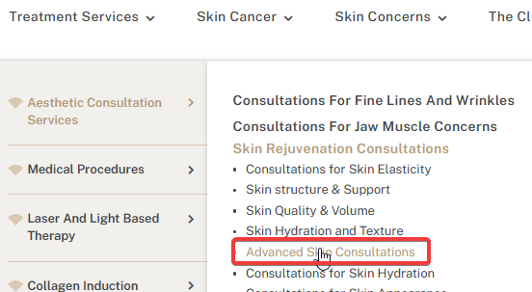  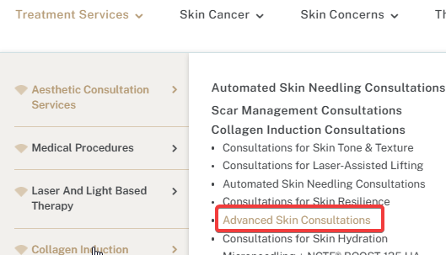

Comprehensive Skin Consultation

Overview
A Comprehensive Skin Consultation provides an opportunity to discuss your concerns, review relevant aspects of your medical history, and consider whether any management recommendations may be appropriate for your individual circumstances.
The consultation is intended to support informed decision-making through education and clinical assessment.
Recommendations are individualised and are only made following assessment. Not all individuals will be suitable candidates for treatment, and treatment may not be recommended.

Our Consultation Approach
At Shellharbour Skin, we believe informed decision-making begins with a thorough assessment and open discussion.
Our consultations are designed to provide information, explore your concerns, and assist you in understanding factors that may influence treatment considerations and ongoing skin management. Every individual has different concerns, medical histories, preferences, and expectations, and recommendations are tailored accordingly.
The consultation process is intended to provide information relevant to your individual circumstances and support informed and considered decision-making.

What Happens During Your Consultation?
During your appointment, your clinician may discuss:
- Your concerns and reasons for seeking a consultation
- Relevant medical history, including medications, supplements, allergies, and previous treatments or procedures
- Lifestyle and other factors that may influence treatment considerations
- Information relevant to your concerns and individual circumstances
- The potential benefits, limitations, risks, and alternatives associated with any management recommendations that may be considered appropriate
Where relevant, a clinical assessment may include an evaluation of your skin and general treatment considerations.
The consultation also provides an opportunity to ask questions and receive information to support informed decision-making.

Individualised Assessment and Recommendations
Recommendations are based on:
- Clinical assessment findings
- Medical history and treatment considerations
- Individual concerns and preferences
- Potential risks and limitations
- Whether a management approach is considered appropriate in your circumstances
Management recommendations may include:
- Education and information
- Skincare advice
- Review appointments
- Referral pathways where appropriate
- Other recommendations considered clinically appropriate following assessment
Recommendations vary significantly between individuals. The information and recommendations discussed with one person may not be suitable or appropriate for another.
In some circumstances, no treatment or procedure may be recommended.

Shared Decision-Making
We encourage patients to take an active role in decisions regarding their care.
Your consultation provides an opportunity to:
- Ask questions
- Discuss your concerns and preferences
- Consider the information provided
- Understand potential risks, limitations, and alternatives
- Take time to make informed decisions regarding your care
Patients are encouraged to consider all information provided before deciding whether to proceed with any recommended management plan.

Commitment to Patient Safety
Patient safety is central to our consultation process.
When considering suitability, our clinicians may take into account factors including:
- Medical history
- Current medications and supplements
- Allergies and sensitivities
- Previous treatments or procedures
- Pregnancy or breastfeeding
- Active skin conditions or infections
- General health considerations
These factors may influence whether a management approach is considered appropriate and may affect the recommendations discussed during your consultation.

Risks and Limitations
All medical procedures carry potential risks and limitations.
Relevant risks, benefits, alternatives, and recovery considerations will be discussed where applicable during your consultation to assist you in making an informed decision regarding your care.
Individual responses and outcomes vary significantly between people, and no treatment outcome can be guaranteed.

Frequently Asked Questions

Who may choose to book a Comprehensive Skin Consultation?
Individuals who wish to discuss their concerns and obtain information relevant to their individual circumstances may choose to book a consultation.
Booking a consultation does not guarantee that treatment will be recommended or considered appropriate.

Will treatment be performed during my first appointment?
This will depend on your individual circumstances and whether any treatment is considered clinically appropriate following assessment.
In some situations, additional information, further assessment, a review appointment, or referral may be recommended before any treatment decisions are made.

What recommendations may be discussed during my consultation?
Recommendations vary according to an individual's concerns, medical history, preferences, and clinical assessment findings.
Any recommendations discussed will be based on what is considered appropriate for your individual circumstances.

Are outcomes guaranteed?
No. Individual responses and outcomes vary significantly between people, and no treatment outcome can be guaranteed.

