On https://shellharbourskin.com.au/our-team/dr-barney-gordon/, update information to:
Dr Barnaby Gordon-Hall
AHPRA: MED0001663685,
General Practitioner, Medical Director
FRACGP, BMedSc, MBBS, ACCSCMS, ACCD, DHC, ACAM, ACD
Dr Barney Gordon | Skin Cancer Doctor & General Practitioner | Shellharbour Skin
Meaning following updates have to be made:
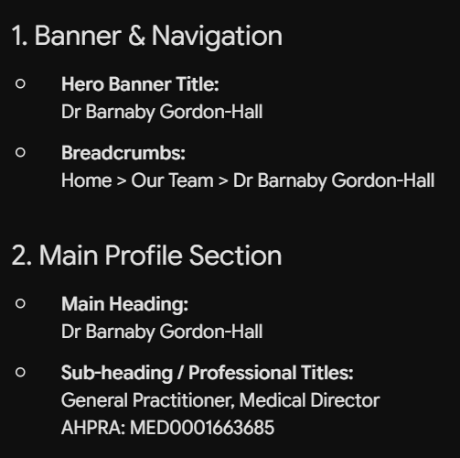
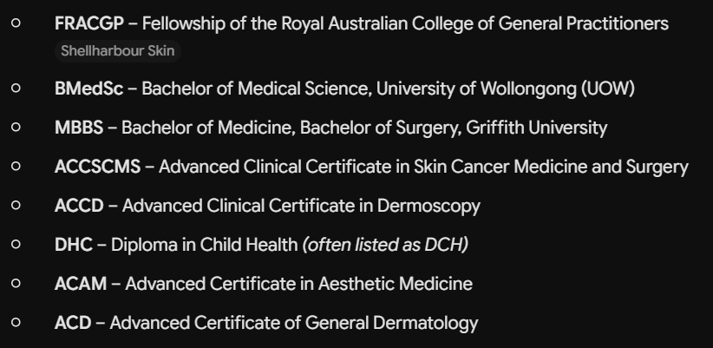


Change two references of “Dr Barney” to “Dr Barnaby”. The word “Barney” should not be on the page.

On https://shellharbourskin.com.au/our-team/amanda/, update information to:
Amanda Whitty
AHPRA: NMW0001660276
Registered Nurse, Bachelor of Nursing
Amanda| Registered Nurse | Shellharbour Skin
Meaning following updates have to be made:
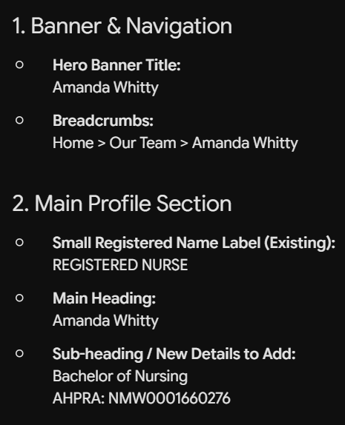
Change:
“Amanda assists Dr Barney Gordon”
To:
“Amanda assists Dr Barnaby Gordon-Hall”
The word “Barney” should not be on the page.

On https://shellharbourskin.com.au/our-team/cayley/, update information to:
Cayley Weber
AHPRA: NMW0002801012
Registered Nurse, Bachelor of Nursing
Cayley | Registered Nurse | Shellharbour Skin
Meaning following updates have to be made:
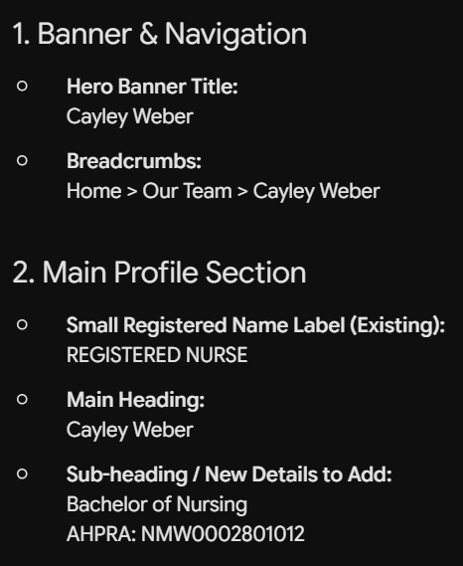
Change:
“Cayley is a Registered Nurse who works closely with Dr. Barney Gordon”
To:
“Cayley is a Registered Nurse who works closely with Dr Barnaby Gordon-Hall”
The word “Barney” should not be on the page.

