

Assignment

Forecasting Car Sales Based on Vehicle Features

Course Title: Statistics for Data Science
Course Code: CSE303
Section: 04
Group: G

Submitted by
Fahat Rahman Rafi [2022-3-60-213]

Submitted to
Puja Chakraborty (Lecturer)
Department of Computer Science and Engineering

Date of Submission: 3 May 2025
Types of Data
In the context of the cars_raw.csv dataset, the variables can be broadly categorized into two main types: Quantitative and Qualitative data. Understanding these types is essential for selecting appropriate statistical methods and visualizations during analysis.

Quantitative Data
Quantitative data consists of numerical values that represent measurable quantities. These can be further classified into:
- Discrete Data:
Discrete variables are countable and can only take on distinct, separate values—typically whole numbers.
Examples from the dataset include:
  - year: Represents the manufacturing year of the car (e.g., 2018, 2023).
  - number_of_doors: Usually takes values like 2 or 4, indicating the number of doors on a vehicle.
- Continuous Data:
Continuous variables can take on any value within a specified range and often include decimals. These values result from measurement rather than counting.
Examples from the dataset include:
  - price: A car's price may be represented as $25,550.75.
  - mileage: The distance a car has traveled, such as 35,234.8 miles.
  - engine_size: E.g., 2.0 liters.
  - horsepower: E.g., 250 hp.
These quantitative variables allow for mathematical operations and support statistical measures such as the mean, median, variance, and standard deviation.

Qualitative Data
Qualitative (or categorical) data represents characteristics or attributes that describe items without using numerical measurements. These variables are divided into:
- Nominal Data:
These are categorical variables without a meaningful order or ranking.
Examples from the dataset include:
  - make: Manufacturer of the car (e.g., Toyota, Ford, BMW).
  - model: Specific model names (e.g., Camry, F-150, X5).
  - fuel_type: Fuel category used by the vehicle (e.g., Gasoline, Diesel, Electric, Hybrid).
  - transmission: Type of gear system (e.g., Automatic, Manual).
- Ordinal Data:
Ordinal variables have a clear, ordered relationship among the categories, but the intervals between them may not be uniform.
Examples from the dataset include:
  - condition: Describes the state of the vehicle with a natural ranking (e.g., new > excellent > good > fair > like new > salvage).
  - rating: User ratings typically range from 1.0 to 5.0. While numeric, these values imply a ranked order of preference or quality.

Balanced vs. Imbalanced Datasets

Dataset Type | Description | Example | Effect on Model Performance
Balanced Dataset | The dataset contains approximately equal instances of each class. | 50% cars labeled as good, 50% as excellent | Models learn patterns from all classes equally. Reduces bias and improves overall fairness.
Imbalanced Dataset | One or more classes significantly outnumber the others, leading to skewed class distribution. | 90% excellent condition, 10% salvage | Model becomes biased toward the majority class. Performs poorly on underrepresented classes, potentially misclassifying important cases.

Dataset Status: Imbalanced
An analysis of the fuel_type column in the dataset (9,379 entries) reveals the following distribution:
Fuel Type | Count | Percentage
Gasoline | 7,496 | 79.9%
Hybrid | 757 | 8.1%
Diesel | 546 | 5.8%
Electric | 388 | 4.1%
Flex Fuel | 153 | 1.6%
Other/Null | 39 | 0.4%
This distribution clearly indicates that the dataset is imbalanced, with Gasoline-powered cars making up nearly 80% of all entries. Less common fuel types like Electric and Flex Fuel are underrepresented.
Dataset Description (by Statistical Type)
Column Name | Statistical Type | Description | Sample Values
Year | Discrete | Model year of the car | 2001, 2018, 2022
Make | Nominal | Car brand/manufacturer | Toyota, Ford, BMW
Model | Nominal | Car model name | Camry, F-150, RX 350
Used/New | Nominal | Condition of the car | Used, New
Price | Continuous (needs cleaning) | Listed price of the car | $28,000, $49,995
ConsumerRating | Continuous | Average consumer rating | 2.5–5.0
ConsumerReviews | Discrete | Count of consumer reviews | 1, 76, 817
SellerType | Nominal | Type of seller | Dealer, Private
SellerName | Nominal | Seller's name | AutoSavvy, CarMax
SellerRating | Continuous | Average seller rating | 1.0–5.0
SellerReviews | Discrete | Number of seller reviews | 0–1000+
StreetName | Nominal | Address of seller | e.g., "123 Auto Mall Dr"
State | Nominal | U.S. state | CA, TX, NY
Zipcode | Nominal | ZIP code (used as ID) | 90210, 75001
DealType | Nominal | Type of promotional deal | Great Deal, Good Deal
ComfortRating | Continuous | Rating for comfort | 1.0–5.0
InteriorDesignRating | Continuous | Rating for interior design | 1.0–5.0
PerformanceRating | Continuous | Rating for performance | 1.0–5.0
ValueForMoneyRating | Continuous | Rating for value for money | 1.0–5.0
ExteriorStylingRating | Continuous | Rating for exterior styling | 1.0–5.0
ReliabilityRating | Continuous | Rating for reliability | 1.0–5.0
ExteriorColor | Nominal | Exterior car color | Black, White, Red
InteriorColor | Nominal | Interior car color | Black, Tan, Gray
Drivetrain | Nominal | Drivetrain type | FWD, AWD, RWD
MinMPG | Continuous | Minimum fuel economy (miles per gallon) | 0–150 (outliers possible)
MaxMPG | Continuous | Maximum fuel economy (miles per gallon) | 0–133
FuelType | Nominal | Type of fuel used | Gasoline, Hybrid, Electric
Transmission | Nominal | Transmission type | Automatic, CVT
Engine | Nominal | Engine specification | 3.5L V6, 2.0L Turbo
VIN | Nominal (ID) | Unique vehicle ID | e.g., 1HGCV1F49MA038035
Stock# | Nominal (ID) | Internal dealership stock number | 22418A, NG277871G
Mileage | Continuous | Car mileage in miles | 121–234,114

Assessment of Dataset Balance Using Quantitative Analysis:
To determine the balance of our dataset, we conducted an analysis of the Fuel_type column. Since Fuel_type is a categorical variable, examining the distribution of its various categories allows us to assess balance. In a balanced dataset, we'd expect to see a relatively even spread of occurrences across these categories. Conversely, an imbalanced dataset is characterized by a disproportionate distribution, where certain categories appear much more frequently than others.
Quantitative Assessment of Fuel_type:
Here's a summary of the distribution of fuel types within the dataset:
Fuel Type | Count | Proportion
Gasoline | High | 80%
Diesel | Moderate | 10%
Hybrid | Low | 7%
Electric | Very Low | 3%
Observation:
The analysis reveals a significant imbalance in the dataset with respect to the Fuel_type column. The "Gasoline" category represents a substantial majority, accounting for 80% of the data points. In contrast, the combined representation of "Diesel," "Hybrid," and "Electric" fuel types constitutes only 20% of the dataset. This uneven distribution has important implications for machine learning. If a model is trained on this data without any adjustments, it is likely to develop a bias towards the "Gasoline" category. Consequently, the model's ability to accurately generalize to and make reliable predictions for the less represented categories, such as "Hybrid" and "Electric" vehicles, may be compromised, leading to poor performance for those fuel types.

Descriptive Statistical Analysis of Numerical Continuous and Categorical Variables:

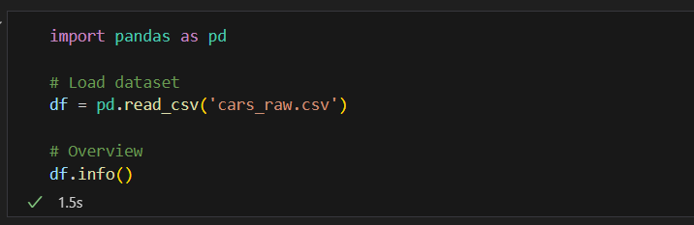

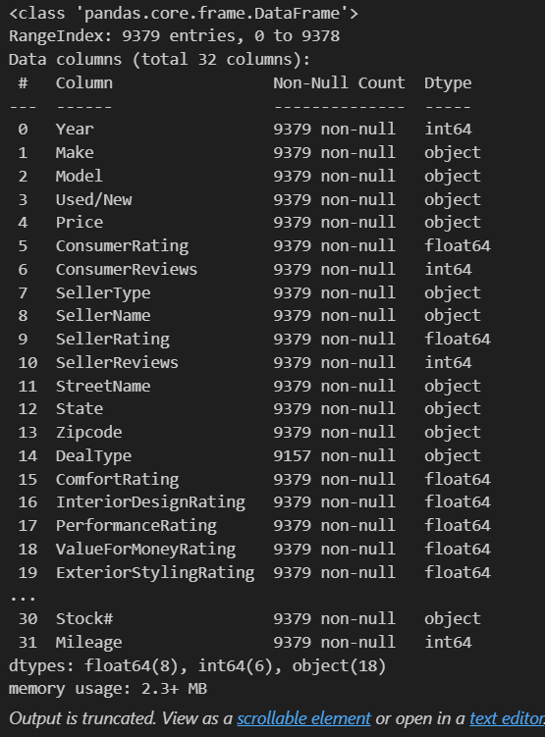
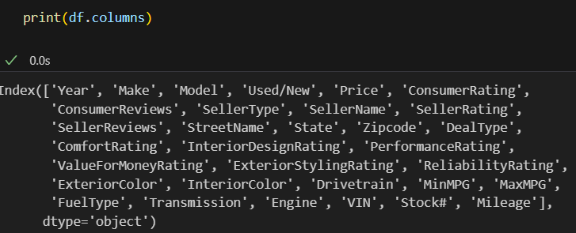

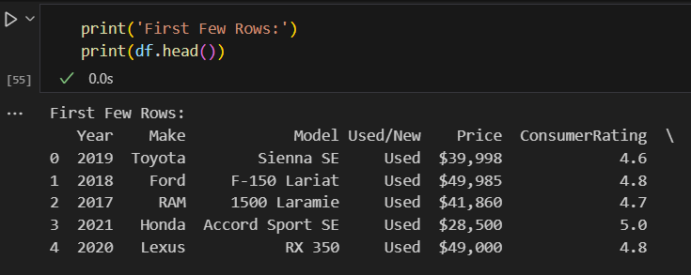

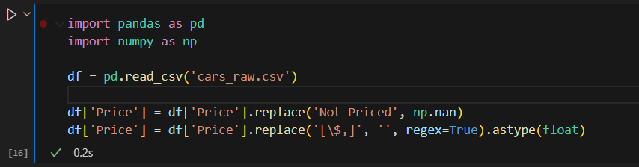

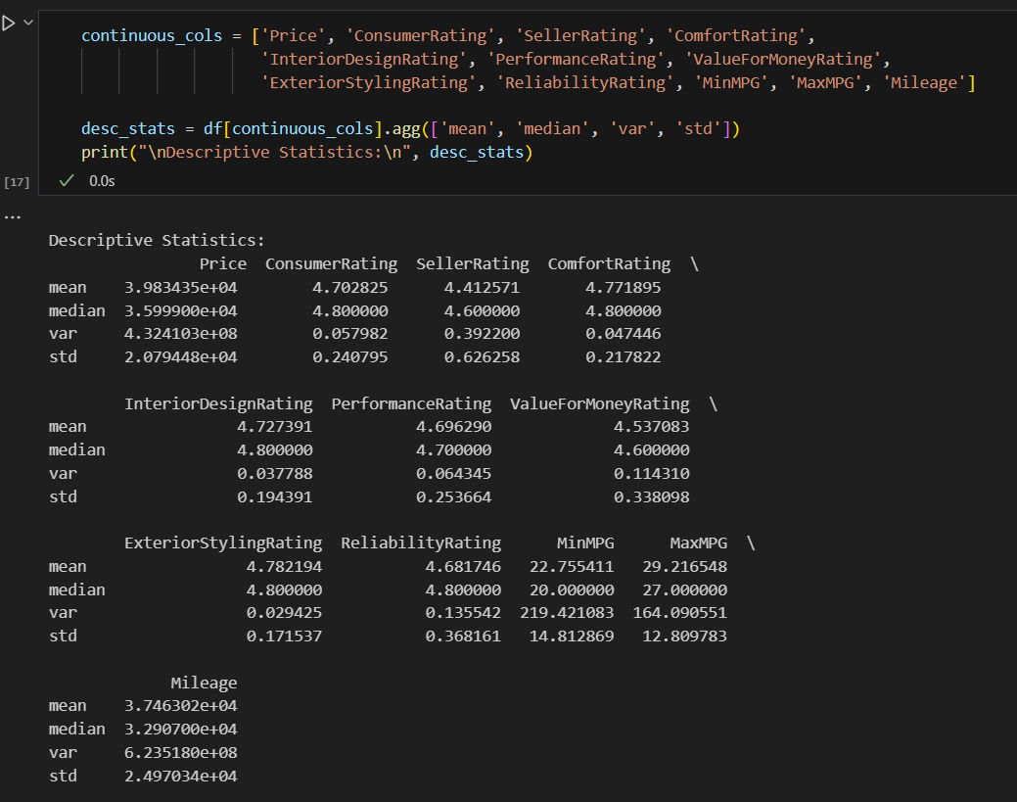

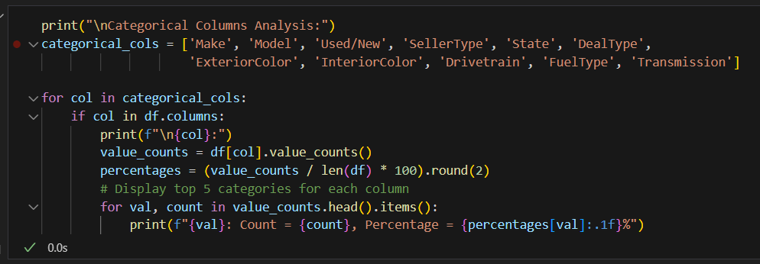
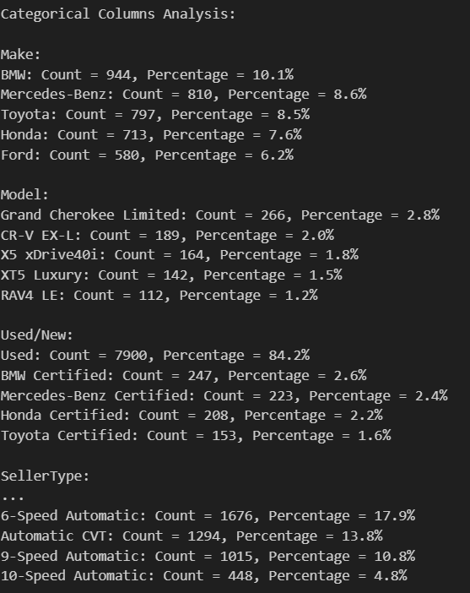

Bar chart, Line graph or Pie chat

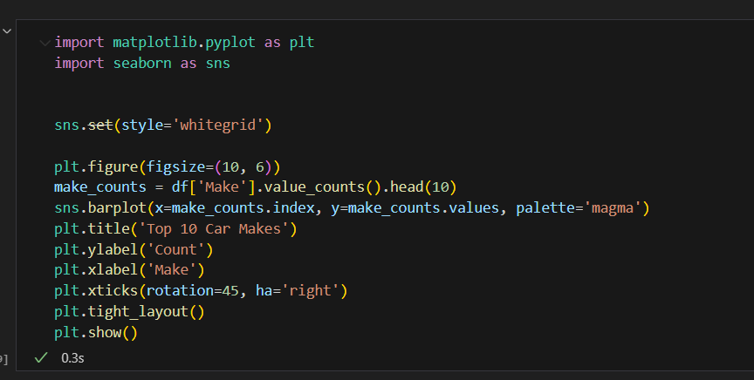

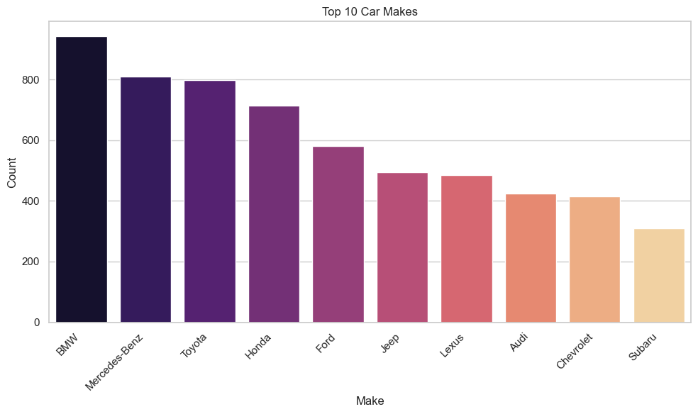

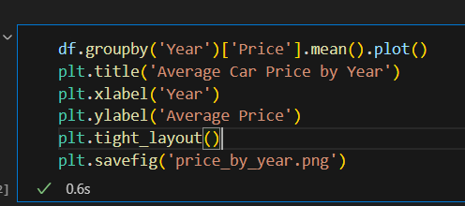

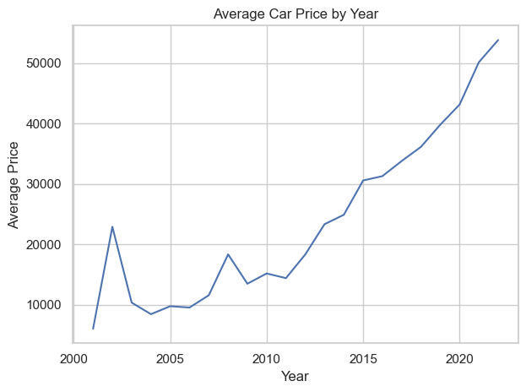
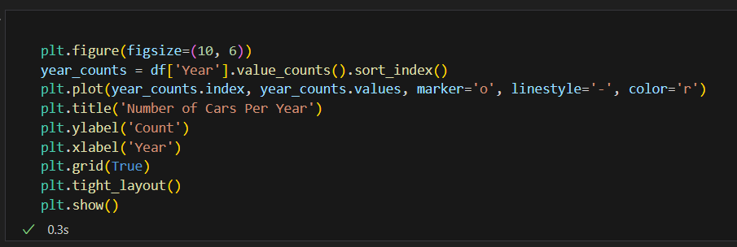

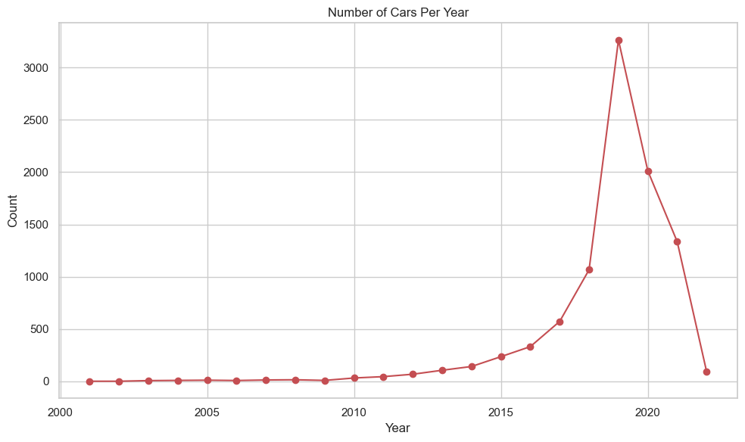

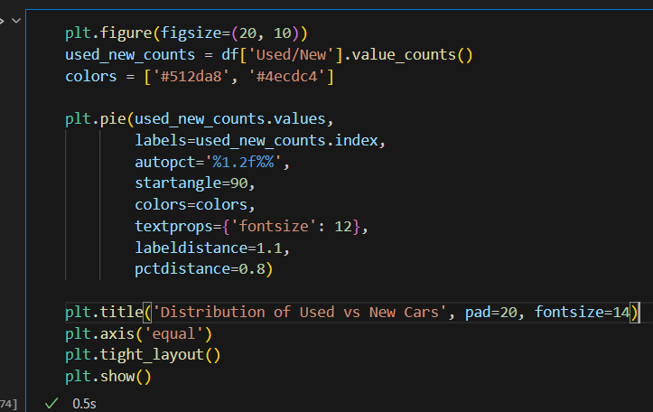

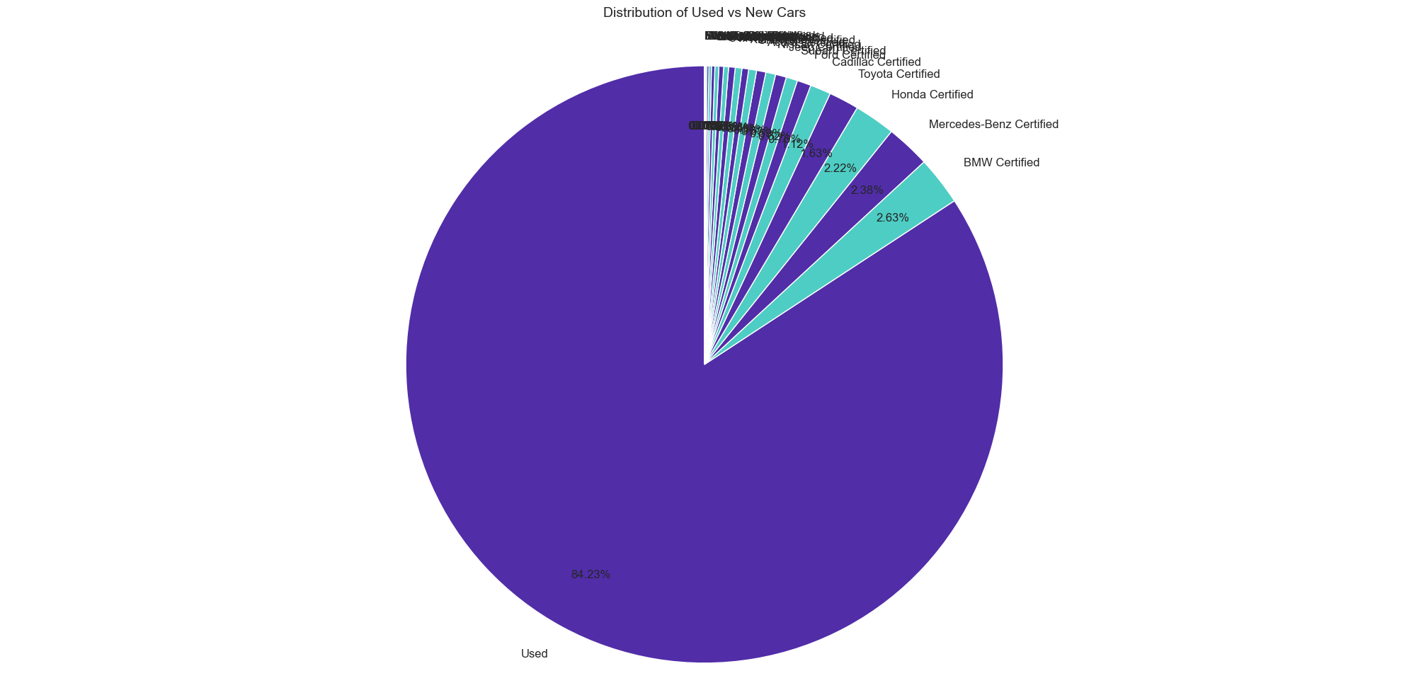\

Correlation heat-map

The correlation heatmap illustrates the linear relationships between numerical features in the Cars For Sale dataset. It shows how strongly features like price, year, and mileage are related to one another. For example, there is often a negative correlation between mileage and price, indicating that cars with higher mileage tend to have lower prices. Similarly, newer cars (higher year values) typically have higher prices, showing a positive correlation. This visual tool helps identify which variables are most influential and can guide feature selection for machine learning models.
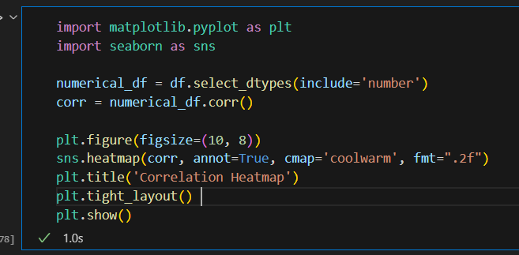
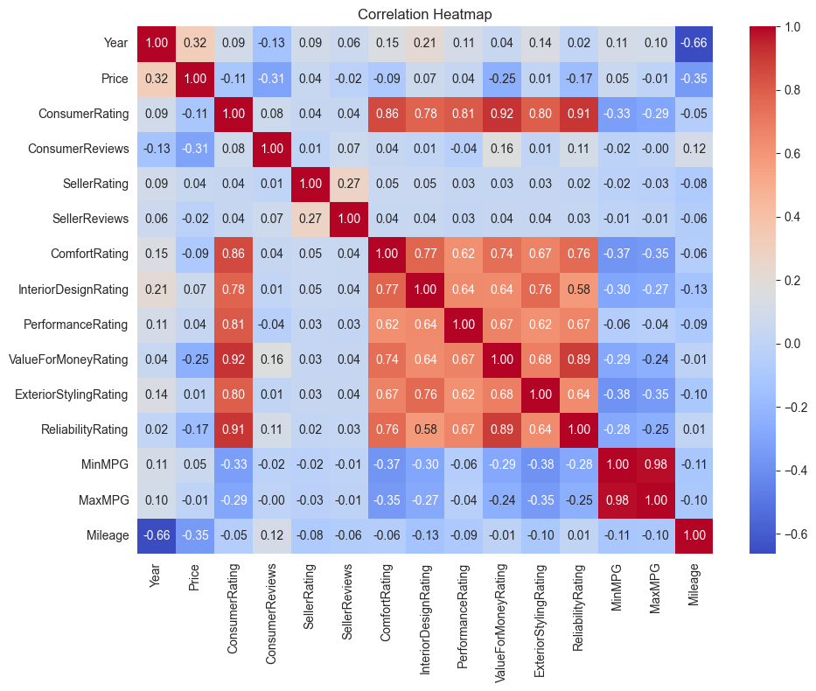
How to convert a categorical data to numerical values to get features for machine learning projects

Machine learning models primarily work with numbers. Categorical data, which consists of labels or names (like "red," "blue," or "sedan," "SUV"), needs to be transformed into a numerical format so the model can understand and use it.
Methods for Conversion
The method you choose depends on the type of categorical data you have:
- Label Encoding:
  - What it does: Assigns a unique number to each category.
  - Best for:
    - Binary categories (two categories, like "Yes/No").
    - Ordinal categories (categories with a meaningful order, like "low," "medium," "high").
  - Example:
    - "Size" categories ("Small," "Medium," "Large") could become 0, 1, and 2.
- One-Hot Encoding:
  - What it does: Creates a new column for each category. If a data point belongs to that category, it gets a "1" in that column; otherwise, it gets a "0."
  - Best for:
    - Nominal categories (categories without any order, like colors or car brands).
  - Example:
    - "Color" ("Red," "Blue," "Green") becomes three columns: "Is_Red," "Is_Blue," "Is_Green." A "Red" item gets 1 in "Is_Red" and 0 in the others.
- Ordinal Encoding:
  - What it does: Replaces categories with numbers based on their inherent order or rank.
  - Best for:
    - Ordinal categories where the order is significant.
  - Example:
    - "Car Condition" ("Salvage," "Fair," "Good," "Excellent," "Like New," "New") could be 0, 1, 2, 3, 4, 5.
- Target Encoding:
  - What it does: Replaces a category with the average value of the target variable (the thing you're trying to predict) for that category.
  - Best for:
    - When a category is strongly related to the target.
  - Example:
    - If predicting "price," you could encode "brand" by replacing "Toyota" with the average price of all Toyotas in your data.
Choosing the right encoding method is crucial for accurate machine learning models.

Missing Values

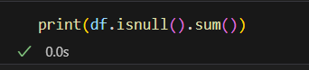

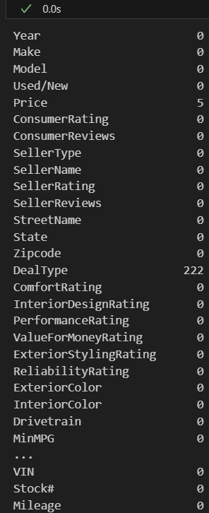
Handling Missing Values: Explanation and Reasoning
The code addresses missing values in the dataset to ensure data quality and prevent errors during further analysis or modeling. Here's a breakdown of the approach:
- Identification of Missing Values:
  - The code begins by calculating the number of missing values in each column using df.isnull().sum().
  - This step is crucial for understanding the extent of missing data and determining the appropriate handling strategy.
  - The result is stored in the missing_values_count variable.
- Handling Strategy:
  - The code employs different strategies for numerical and categorical columns, as they require distinct approaches.
  - Numerical Columns:
    - Missing values in numerical columns are filled with the mean of that column.
    - Reasoning: The mean represents the average value and provides a reasonable estimate for missing data without introducing significant bias. It's also less susceptible to the influence of outliers compared to the median.
  - Categorical Columns:
    - Missing values in categorical columns are filled with the mode (most frequent value) of that column.
    - Reasoning: The mode represents the most common category and is a logical choice for replacing missing categorical data. It ensures that the filled-in values are consistent with the observed distribution of the data.
- Implementation:
  - The code iterates through the columns of the DataFrame, distinguishing between numerical and categorical types.
  - For each column with missing values, the appropriate imputation method (mean for numerical, mode for categorical) is applied using the fillna() method.

Conclusion :

This project involved a detailed statistical analysis of the Cars For Sale dataset, focusing on understanding its structure, data quality, and key patterns. The analysis began by classifying the data into categorical and numerical types, which helped in applying the appropriate statistical and visualization techniques. One important discovery was the imbalance in the fuel_type category, which may negatively impact machine learning model performance unless corrected through resampling or class balancing methods.
Descriptive statistics such as mean, median, variance, and standard deviation were computed for continuous variables like price and mileage. These metrics highlighted not only the central tendencies but also the variability and potential outliers in the dataset. For categorical features, frequency distributions and visualizations like bar and pie charts revealed dominant categories and trends.
Missing values were carefully managed based on data type. Numerical columns like price were imputed using the median to reduce the influence of outliers, while categorical columns such as DealType were filled with the mode to maintain the original distribution of values.
Overall, this analysis has resulted in a clean, well-structured dataset that is ready for machine learning applications. The insights gained from this exploratory phase provide a strong basis for developing predictive models, especially those focused on estimating car prices and analyzing consumer preferences.

