LALA
THE MILKVERSE
WEBSITE VISUAL REFERENCE BOOK
A rich visual direction for an immersive, scroll-driven WebGL experience
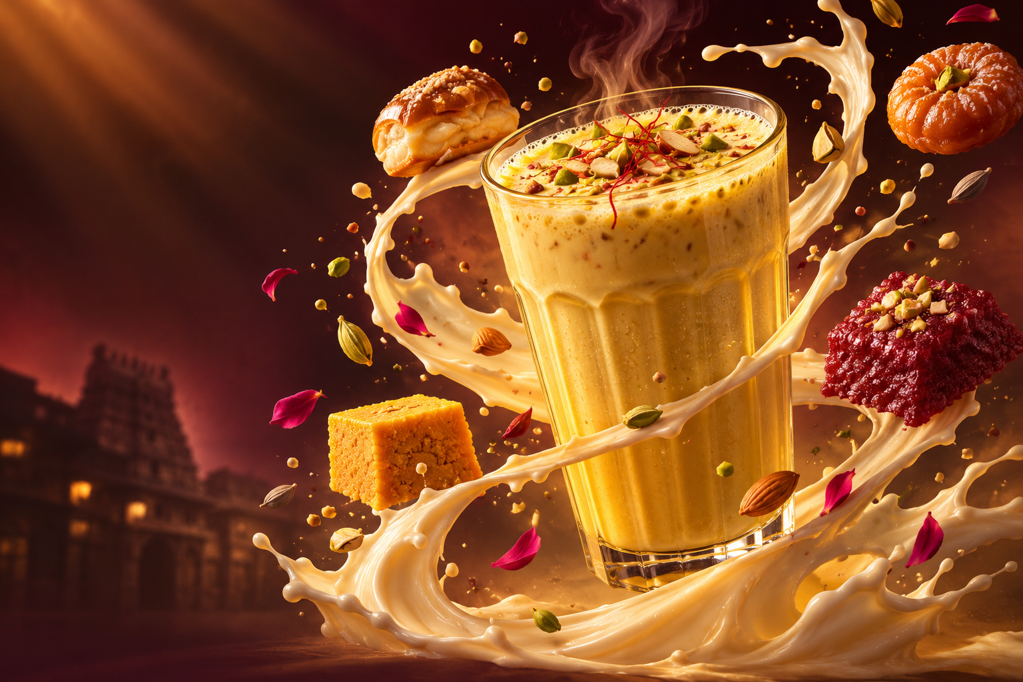
Concept hero artwork generated for this project — use as visual direction, not as a photograph of the actual shop.

1. Brand and creative direction
The proposed direction is a premium, cinematic Indian dessert world: deep burgundy, saffron gold, creamy ivory, dark chocolate and restrained pistachio accents. The site should feel indulgent and memorable, while keeping the menu, ordering and contact information fast and easy to use.

Core palette
Colour | Hex | Recommended use
Deep Burgundy | #4A0D17 | Primary background
Maroon | #861E2C | Accent panels and transitions
Saffron Gold | #D4AF37 | Highlights, thin borders and details
Cream | #F8E6D1 | Typography and light surfaces
Milk Brown | #A77A4E | Warm secondary neutral
Pistachio | #3F5C29 | Small ingredient accent

Typography
Headlines: Playfair Display, Cormorant Garamond or another expressive editorial serif. Interface and menu: Inter, Manrope or a clean modern sans-serif. Keep display type large, spacious and confident.

2. Moodboard and visual system
The following board combines concept branding, 3D asset directions, texture ideas, product-photo categories and the proposed scroll sequence. Treat it as an art-direction reference. Confirm the real logo and shop identity with the owner.
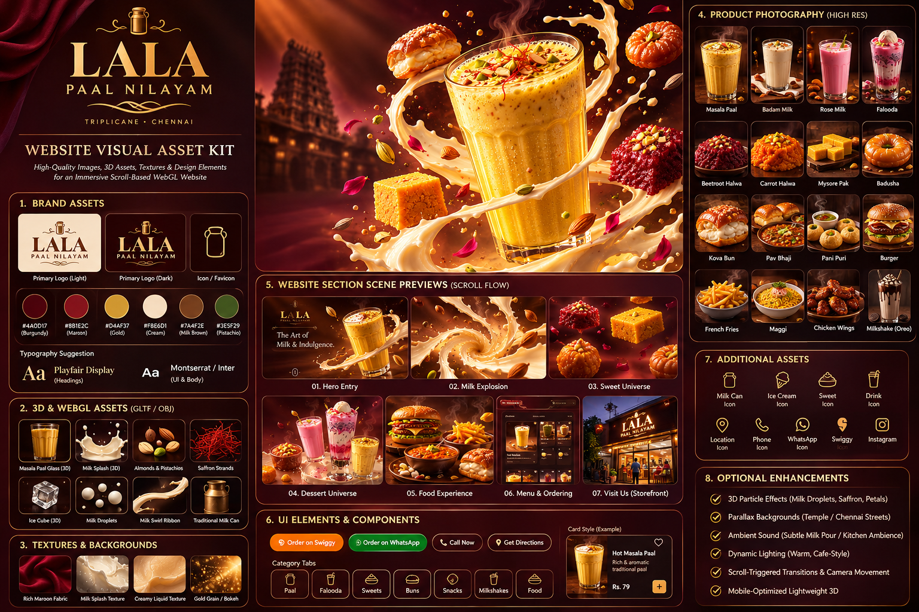
Generated concept moodboard — all logo and storefront depictions are placeholders until replaced with owner-approved assets.

3. Web image references and inspiration
The web image results below are visual references for food styling and composition. Most are not photographs of La La Paal Nilayam. They should not be copied into the live website without checking the image licence and obtaining permission where required. For the final site, prioritise original photos supplied by the shop.
- Falooda — layered dessert glass — Akshay Global Cuisine | Open image / source
- Rose falooda — rose, vermicelli and nuts — Cadbury Desserts Corner | Open image / source
- Traditional falooda — creamy layered drink — Swiggy image result; unrelated listing | Open image / source
- Badam milk — almond garnish and creamy colour — SnapCalorie | Open image / source
- Badam milk in clay cups — dark premium styling — Zomato image result; unrelated listing | Open image / source
- Indian sweets assortment — mithai colour and texture — Asha Sweet Center | Open image / source
- Indian street food spread — chaats and snacks — Grubhub image result; unrelated listing | Open image / source
- Pani puri and chaat composition — Grubhub image result; unrelated listing | Open image / source
- Free milk-and-almond still life — Pexels — page states free download; check current licence | Open image / source
- Free milk still life — Unsplash — page states Unsplash License | Open image / source
- Masala paal reference and regional context — Chitra's Food Book | Open image / source
- Food photography portfolio inspiration — mytribe / Abhishek Khanna | Open image / source

4. Google Images search links for the asset hunt
Use these searches to find additional references and, importantly, actual photos of the business. Google Images is a discovery tool, not a licence to reuse images.
- La La Paal Nilayam Triplicane — actual shop photos
- La La Paal Nilayam Instagram images
- Masala paal / Madras masala milk
- Royal falooda / rose falooda
- Beetroot halwa and carrot halwa
- Mysore pak, badusha and Indian sweets
- Kova bun / muska bun
- Pani puri / dahi puri / bhel puri
- Pav bhaji / Indian street snacks
- Premium milkshake product photography
- Luxury food brand visual identity

5. Asset checklist for the website

Brand and store (must obtain from owner)
- ☐ Official logo in SVG or transparent PNG, light and dark versions.
- ☐ Actual shopfront in daylight and at night, with readable signboard.
- ☐ Interior, display counter, seating and kitchen/service details.
- ☐ Packaging, cups, takeaway containers and staff uniforms if branded.
- ☐ Owner-approved photos and permission to use Instagram content.

Signature drinks
- ☐ Hot Masala Paal, Royal Badam Malai Paal, Hot Kova Paal.
- ☐ Badam milk, rose milk, fruit mix and pal sharbat.
- ☐ Mini Falooda, Ice Cream Falooda, Fruit Falooda and Special Royal Falooda.
- ☐ Oreo, KitKat, strawberry, mango, butterscotch, vanilla and chocolate milkshakes.

Sweets and bakery
- ☐ Beetroot halwa, carrot halwa, Mysore Pak, badusha, kalakand and laddu.
- ☐ Rasmalai, gulab jamun and assorted sweets.
- ☐ Kova bun, muska bun, carrot bun, beetroot bun and bun butter jam.

Snacks and cafe food
- ☐ Pav bhaji, pani puri, dahi puri, bhel puri, samosa and murukku sandwich.
- ☐ French fries, burgers, chicken wings, Maggi and cheese balls.

3D / WebGL assets
- ☐ Hero glass model with separate glass and liquid meshes.
- ☐ Milk ribbon / splash geometry, droplets and animated liquid shader.
- ☐ Almond, pistachio, saffron, cardamom and rose-petal models.
- ☐ Falooda glass with separate layered ingredients.
- ☐ Selected hero sweet models; use real photos for the wider menu.
- ☐ Burgundy velvet, creamy liquid and gold-grain textures.

6. Suggested image specifications
Asset type | Recommended specification
Hero desktop | 3840 × 2160 master; export responsive WebP/AVIF; keep clear negative space for headline.
Hero mobile | 1080 × 1440 or 1080 × 1920 alternate crop; keep the main glass centred.
Product photography | 1600 × 1600 or larger master; same camera angle, lighting and crop for all menu items.
Section banners | 2400 × 1350 master, with mobile-specific crops.
Transparent overlays | PNG/WebP with alpha; use GLB/GLTF for actual 3D objects.
3D models | Optimised GLB/GLTF, compressed textures, sensible polygon counts and mobile LODs.

7. Image-generation prompts for missing assets

Hero key visual
Photorealistic luxury Indian dessert campaign, a tall elegant transparent glass filled with thick golden saffron almond masala milk, creamy surface, pistachio slivers, almonds and saffron threads, dramatic swirling ribbon of milk wrapping around the glass, floating droplets and ingredients, deep oxblood burgundy background, warm amber rim light, premium editorial food photography, highly detailed glass condensation, no text, no logo, wide 16:9.

Royal falooda
Luxury editorial food photograph of a tall Indian royal falooda glass with rose syrup, vermicelli, basil seeds, chilled milk and vanilla ice cream, layered translucent colours, pistachio garnish, condensation on glass, burgundy and warm gold studio setting, dramatic lighting, no text, no logo, square.

Traditional sweets
Premium Indian mithai product photography: beetroot halwa, carrot halwa, Mysore Pak, badusha, kalakand and laddu arranged on a dark stone platter, rich natural textures, warm directional lighting, deep maroon backdrop, refined editorial food styling, no text, no logo.

Milk splash element
Photorealistic creamy milk splash frozen in a graceful circular arc, fine droplets, translucent edges, warm studio highlights, isolated on transparent background if supported, high-speed beverage advertising photography, no glass, no text.

Ingredient cutouts
Photorealistic floating pistachios, almonds, saffron threads, cardamom pods and rose petals, individually separated with clean edges, soft warm highlights, high detail, isolated on transparent background if supported, no text.

Storefront placeholder
Authentic contemporary Indian dairy and sweets shop in Triplicane Chennai, warm welcoming shopfront lighting, clean glass display counter, traditional sweets and milk beverages visible, realistic Indian urban street context, documentary architectural food retail photography, no invented signage or readable brand name.

8. Important usage and accuracy notes
- The web images linked in this document are inspiration and research references, not confirmed photographs of La La Paal Nilayam.
- Do not publish third-party images without checking their licence and obtaining permission where required. Google Images does not grant usage rights.
- The Swiggy page is the strongest current menu reference found in this research. Verify prices, availability, names and descriptions with the shop before publishing.
- The actual storefront address in the supplied Google listing is 150, Bharathi Salai, Ellis Puram, Padupakkam, Triplicane, Chennai 600005. Swiggy's listing also references Door No. 225 / Bharathi Salai; confirm the correct public-facing address with the owner.
- The Google business result returned 4.9 from 97 reviews at research time; review counts and ratings can change.
- Use generated imagery as concept art only. Do not imply generated food or storefront images are actual photographs of the shop.

9. Business and research links
- Instagram: https://www.instagram.com/lala_paalnilayam/
- Swiggy menu and ordering: https://www.swiggy.com/city/chennai/lala-paal-nilayam-royapettah-rest1385944
- Justdial listing: https://www.justdial.com/Chennai/La-La-Pal-Nilayam-Triplicane/044PXX44-XX44-251129210124-J3P2_BZDET
- Google Maps search: https://www.google.com/maps/search/?api=1&query=La+La+Paal+Nilayam+Triplicane+Chennai

