Week 3 — Advanced Data Analysis and Visualization
Logistics Data Analytics Internship Submission

1. Exploratory Data Analysis
The 1,500-order synthetic dataset is analyzed using descriptive statistics, trends, segment comparisons and correlations.

2. Descriptive Statistics
Metric | Mean | Std | Min | Median | Max
Shipment_Volume | 10.15 | 5.79 | 1.0 | 10.0 | 20.0
Distance_km | 764.01 | 426.14 | 21.0 | 771.5 | 1500.0
Scheduled_Days | 4.24 | 0.91 | 1.7 | 4.2 | 6.3
Actual_Delivery_Days | 5.53 | 1.4 | 2.0 | 5.5 | 9.7
Delivery_Delay_Days | 1.3 | 0.79 | -0.8 | 1.2 | 4.1
Transport_Cost | 133.73 | 41.3 | 25.0 | 131.86 | 241.18

3. Monthly Order Volume
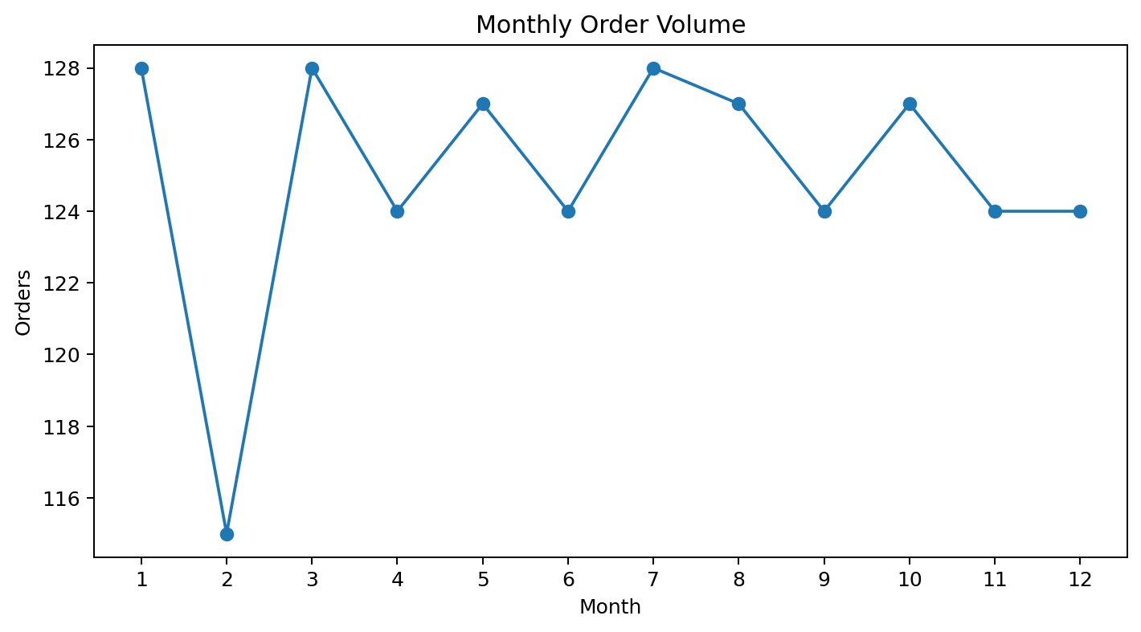
Monthly volume helps identify workload peaks that may create warehouse or carrier capacity pressure.

4. Late Delivery by Shipping Mode
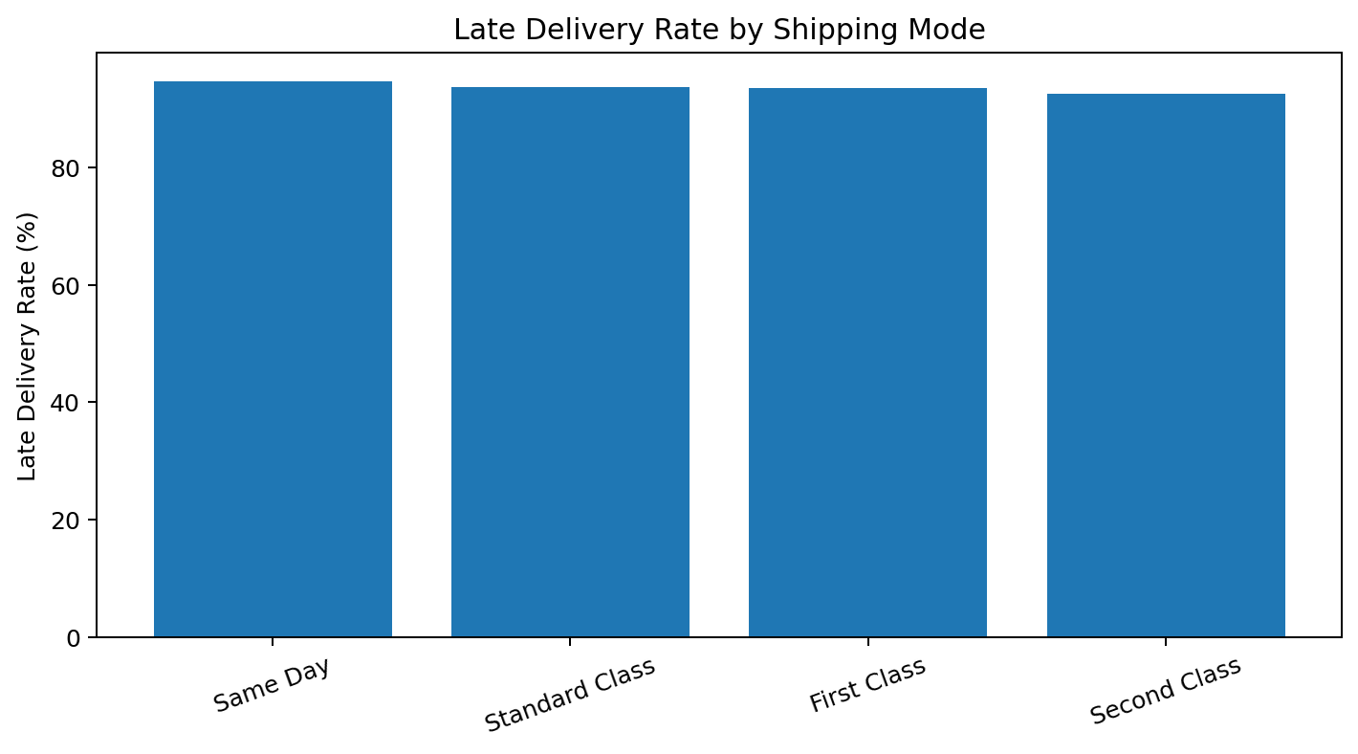
The highest late-delivery rate in this simulation is observed for Same Day (94.7%). This is a diagnostic signal rather than proof of causation.

5. Distance vs Delivery Time
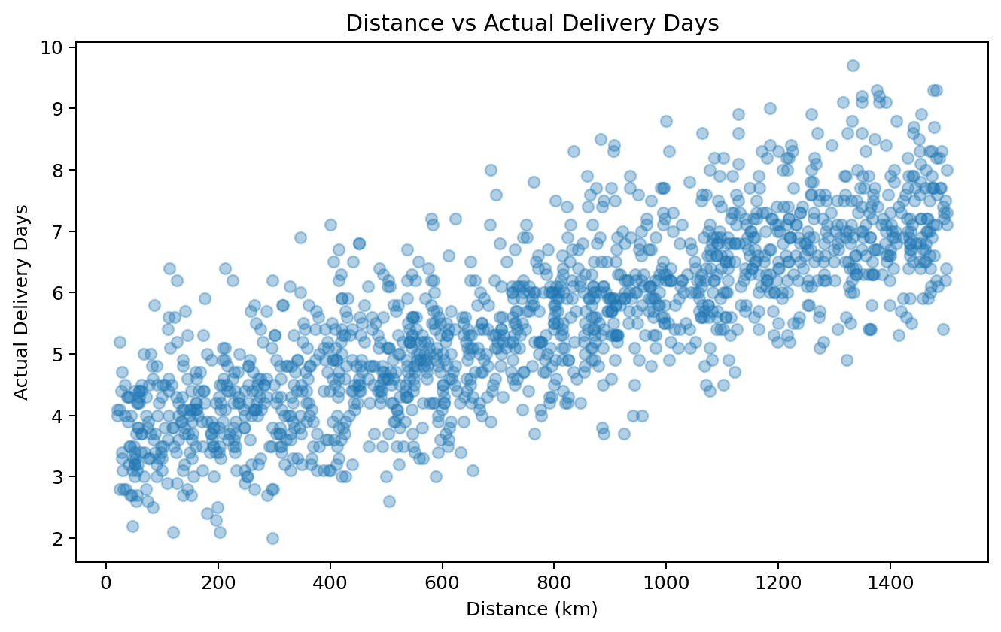
The simulated correlation between distance and actual delivery days is 0.79, supporting distance as a candidate predictive feature.

6. Correlation Matrix
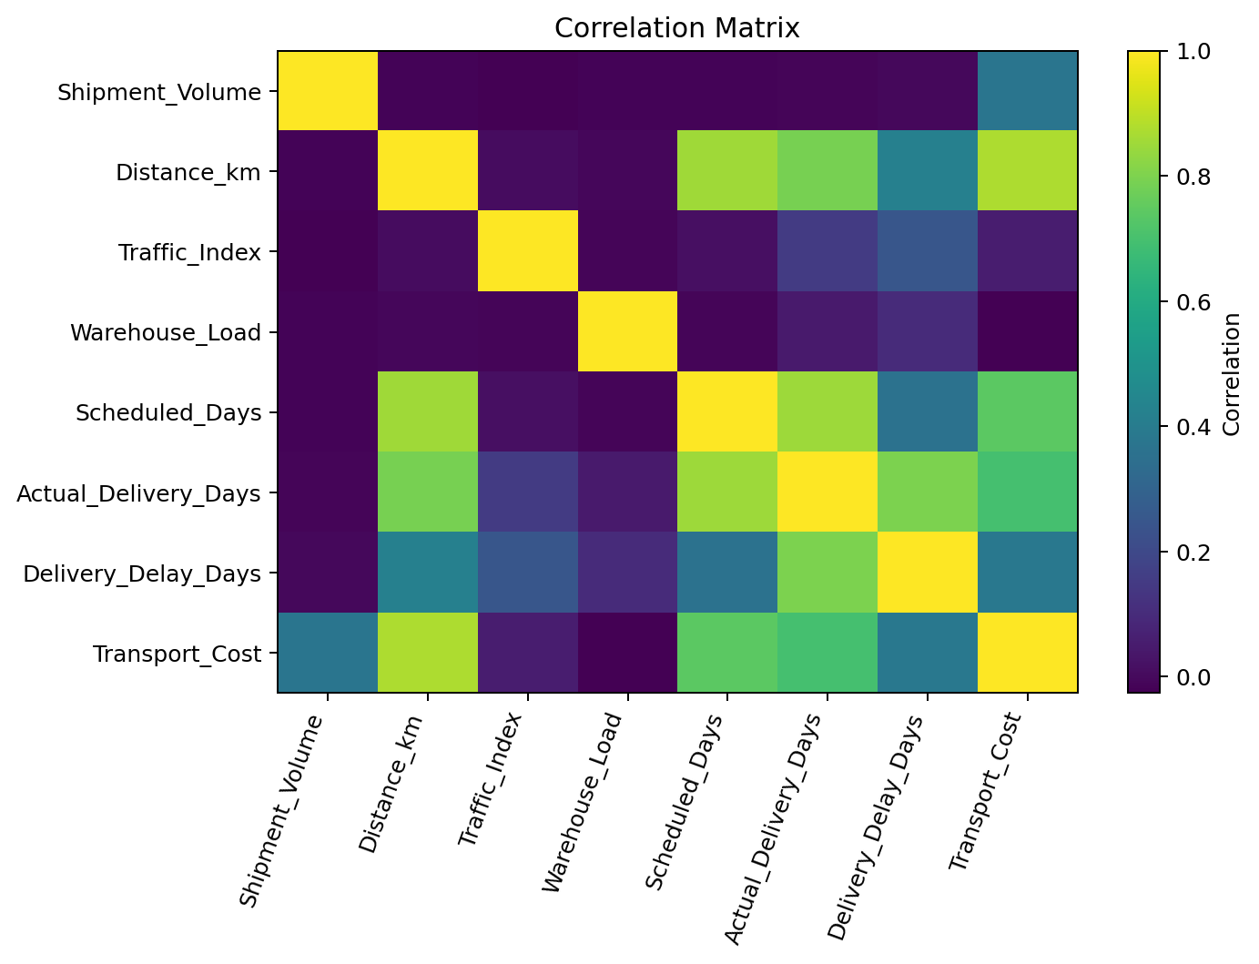
Correlation is used to screen relationships and guide feature selection; it does not establish causality.

7. Recommendations
- Track KPIs by region, shipping mode and month.
- Use distance and traffic indicators in forecasting.
- Investigate high late-rate segments before changing service promises.
- Combine volume and warehouse-load monitoring for early capacity planning.
- Evaluate service and cost together.

8. Python Visualization Code
monthly = df.groupby(df["Order_Date"].dt.month)["Order_ID"].count()
plt.plot(monthly.index, monthly.values, marker="o")
plt.title("Monthly Order Volume")
plt.show()

9. Submission Description (200+ words)
This Week 3 report demonstrates exploratory data analysis and visualization for a logistics operation. The analysis uses a reproducible synthetic dataset containing order dates, regions, shipping modes, shipment volume, distance, traffic, warehouse load, scheduled delivery time, actual delivery time, delay and transportation cost. The purpose is to show how an analyst converts operational records into management-level insights.
The report begins with descriptive statistics and then uses four visual perspectives: monthly order volume, late-delivery rate by shipping mode, distance versus actual delivery time, and a correlation matrix. Each visualization addresses a specific business question. Volume trends help with capacity planning; shipping-mode comparisons identify segments requiring investigation; the distance plot supports feature selection for prediction; and correlation analysis provides a compact screening tool.
The findings are deliberately treated as signals rather than causal conclusions. For example, a high late-delivery rate for a shipping mode should lead to investigation of carrier capacity, route mix and promised service windows. Recommendations include segment-level KPI monitoring, early capacity planning and joint evaluation of service and cost. Python code is included so the analysis can be reproduced and extended.

References
Public DataCo Smart Supply Chain references; pandas and matplotlib documentation.

