Week 4 — Predictive Modeling and Optimization in Logistics
Logistics Data Analytics Internship Submission

1. Prediction Problem
Forecast actual delivery days before completion using distance, shipment volume, traffic, warehouse load, scheduled days, shipping mode, weather risk and region.

2. Model Selection
Linear Regression provides a transparent baseline; Random Forest captures non-linear relationships and interactions. Categorical variables are one-hot encoded and numerical variables standardized.

3. Model Evaluation
Model | MAE | RMSE | R²
Linear Regression
 | 0.296
 |  | 0.377
 |  |  | 0.921
Random Forest
 | 0.314
 |  | 0.398
 |  |  | 0.913
The lower-MAE model in this simulation is Linear Regression. MAE is measured in days; RMSE emphasizes larger errors; R² summarizes explained variance.
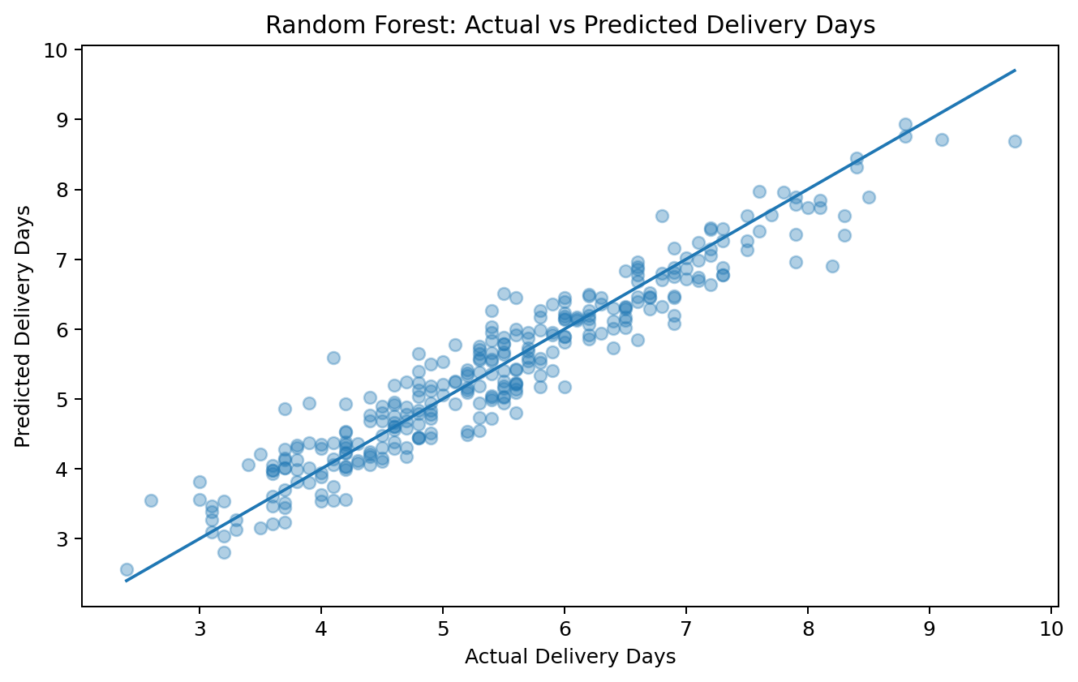

4. Validation
- Use an 80/20 train-test split for the baseline.
- Use cross-validation during model selection.
- Tune hyperparameters only on training data.
- Check errors by region and shipping mode.
- Exclude post-delivery variables to avoid leakage.

5. Python Modeling Code
model = Pipeline([
("preprocessor", preprocessor),
("regressor", RandomForestRegressor(n_estimators=250, random_state=42))
])
model.fit(X_train, y_train)
pred = model.predict(X_test)
print(mean_absolute_error(y_test, pred))

6. Optimization
A linear program allocates exactly 100 shipment units across four transport modes while minimizing expected cost under capacity and weighted late-risk constraints. The values are illustrative and should be replaced with validated operational inputs.
Mode | Cost/unit | Late risk | Capacity
Standard
 | 72
 |  | 18%
 |  |  | 70
Second
 | 84
 |  | 12%
 |  |  | 45
First
 | 101
 |  | 8%
 |  |  | 30
Same Day
 | 128
 |  | 4%
 |  |  | 20
Scenario | Cost | Weighted late risk
Baseline
 | 8,495
 |  | 13.60%
Optimized
 | 9,330
 |  | 10.50%
Optimized allocation: Standard 12, Second 45, First 30, Same Day 13. This meets the 10.5% weighted late-risk limit.

7. Optimization Code
result = linprog(
c=np.array([72,84,101,128]),
A_ub=np.array([[.18,.12,.08,.04]]),
b_ub=[10.5],
A_eq=np.ones((1,4)),
b_eq=[100],
bounds=[(0,70),(0,45),(0,30),(0,20)],
method="highs"
)
print(result.x)

8. Recommendations
- Use predictions to identify high-risk orders early.
- Run constrained allocation during high-volume periods.
- Monitor MAE/RMSE and segment-level errors.
- Re-estimate costs, capacities and risk probabilities as conditions change.
- Use the model as decision support before automation.

9. Submission Description (200+ words)
This Week 4 report completes the logistics analytics workflow by combining predictive modeling with optimization. The forecasting problem is defined as predicting actual delivery days before the shipment is completed. The synthetic dataset contains operational predictors including distance, shipment volume, traffic index, warehouse load, scheduled delivery days, shipping mode, weather risk and region. Linear Regression is used as a transparent baseline and Random Forest is used to capture non-linear patterns and interactions.
The models are evaluated using Mean Absolute Error, Root Mean Squared Error and R-squared. MAE is useful because it expresses typical prediction error directly in days, while RMSE gives additional importance to larger mistakes. The report uses an 80/20 train-test strategy and recommends cross-validation and segment-level checks before deployment. Data leakage is explicitly considered because variables known only after delivery would make a model appear accurate while being unusable operationally.
The second component is prescriptive optimization. A linear programming example allocates exactly 100 shipment units across four transport modes while minimizing expected cost subject to capacity and service-risk constraints. This demonstrates how predictive information can feed operational decisions rather than stopping at a forecast. The optimization is illustrative because real deployment would require validated carrier costs, capacities and service probabilities.
Together, the predictive and optimization components provide a practical framework for earlier intervention, improved resource allocation and more consistent logistics service. The recommended approach is to deploy the workflow as decision support, monitor performance continuously and update optimization inputs as conditions change.

References
scikit-learn metrics documentation; SciPy linear-programming documentation; public DataCo Smart Supply Chain references.

