
UNIVERSITY OF SINDH, JAMSHORO
Faculty of Engineering and Technology

BPE-ASSIGNMENT
Digital Transformation of University of Sindh
E-Portal Fee Submission Process

FAHEEM AHMED
2K23/SWE/48
Software Engineering

Executive Summary
The University of Sindh uses an online system called the E-Portal for tasks like downloading challans and submitting fees. Although digital, students still face delays, confusion, and manual work like bank visits, challan printing, and verification. This project studies the current (“As-Is”) process, analyzes its problems, and proposes a digital redesign (“To-Be”) that makes the system faster, more accurate, and easier to use. The redesign uses automation, online payment gateways, and real-time status updates to improve student experience and university workflow.

1. Problem Statement & Objectives
Problem Statement
The current University of Sindh fee submission process, even though it uses an E-Portal, still relies on students printing challans, paying at banks, and waiting for verification. This causes queues, time wasted, and students unsure about payment status. (Result.pk)
Objectives
- To map current process steps
- To identify delays and non-value work
- To redesign using better digital tools
- To improve speed, accuracy, and satisfaction
- To reduce manual verification and errors

2. Process Identification & Scope
Process Name:
University of Sindh E-Portal Fee Submission
Stakeholders
- Students
- Accounts Office
- Bank Staff
- IT Support
- University Admin
Scope
Starts when a student logs into the E-Portal and ends when fee status is marked “Paid” in the system.

3. As-Is Process Modeling
Current Steps
- Student logs into the E-Portal using CNIC/password
- Student downloads and prints the fee challan
- Students visit a bank (supporting online 1Bill payment)
- Students wait in bank queue
- Student pays fee using challan at bank
- Bank issues printed receipt
- Students return to university (or wait for system update)
- Accounts Office manually verifies the payment
- System updates fee status after verification

Student logs into E-Portal
Visit Bank
Download & Print Fee Challan

Get Printed Receipt
Pay Fee at Counter
Wait in Bank Queue

Accounts Office Verifies Manually
Fee Status Updated in System
Wait for Verification

Issues
- Students still have to print challans
- Bank queues waste time
- Manual verification delays updates
- Students don’t always know payment status quickly

4. Process Analysis
Value-Adding Activities
- Fee payment
- Confirmation of payment
- Updating student record
Non-Value Activities
- Printing papers
- Going to bank physically
- Waiting in lines
- Manual verification by staff
Bottlenecks
- Long wait times at banks
- Delay between payment and status update
- Errors from manual data entry

5. To-Be Process Redesign
Redesign Goals
- Remove paperwork
- Automate verification
- Provide instant feedback
To-Be Steps
- Student logs into E-Portal
- Student selects “Online Payment” in portal
- Portal connects with bank/payment gateway
- Students pay instantly inside portal (Debit/Credit, mobile wallet, or 1Bill)
- Payment gateway sends automatic confirmation
- System marks status “Paid” immediately
- Student and accounts team get real-time notifications
Payment Gateway (1Bill / Bank / Wallet)
Student logs into E-Portal
Select "Online Payment"

System Updates Fee Status Instantly
Online Payment Done
Auto Confirmation Received

Notification Sent to Student & Accounts

Benefits
- No printing challans
- No physical bank visits
- Instant fee confirmation
- Less manual work for staff

6. Implementation & Change Management Plan
IMPLEMENTATION STRATEGY
Phased Rollout
- Phase 1: Build and test online payment feature
- Phase 2: Pilot with one department (Faculty of Engineering & Technology)
- Phase 3: Full rollout across all departments
CHANGE MODEL
Lewin’s Change Model
- Unfreeze: Communicate benefits to students and staff
- Change: Deploy portal update + training sessions
- Refreeze: Make online payment the standard method

7. Monitoring & Improvement Plan
KPIs (Key Metrics)
- Average fee submission time
- Percentage of successful online payments
- Number of complaints about fee process
- Delay hours between payment and system update
- Student satisfaction rate
Dashboard
- Real-time payment counts
- Pending payments list
- Daily cash reports
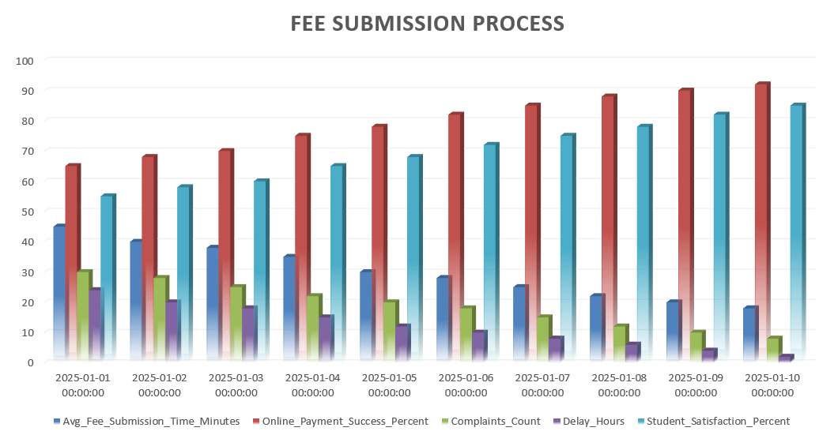
Dummy 10 days process success rate mockup…
Continuous Improvement
Use student feedback and Kaizen to improve the portal and add features like chatbot help and mobile alerts.

8. Role of Information Technology
IT in Redesign
- Online payment integrations (1Bill, mobile banking)
- Automated verification tools
- Notification systems (email/SMS)
- Secure database updates
Future Enhancements
- AI chatbot for student queries
- SMS alerts when payment is done
- App version of the portal

9. Reflection
I learned how a real system like the Sindh University E-Portal works and where delays happen. It was clear that even digital systems can have manual steps that slow things down. Redesigning it taught me how automation and integration can make things better for students and staff. The challenge was imagining changes that are practical but still doable.

10. Recommendations & References
The redesigned online fee submission makes the process faster, safer, and more user-friendly. Removing paperwork and manual verification improves accuracy and saves time. I recommend the university fully adopt online payments through the portal with real-time updates and notifications.
University of Sindh E-Portal — Fee submission & login page Link. (ITS Center)
University of Sindh fee schedule and portal notice Link. (Result)

