WEEK – 1
TASK-1:Digit Sum
public class DigitSum {
static int digitSum(int num, boolean even) {
int sum = 0;
while (num > 0) {
int digit = num % 10;
if (even && digit % 2 == 0) {
sum += digit;
} else if (!even && digit % 2 != 0) {
sum += digit;
}
num /= 10;
}
return sum;
}
public static void main(String[] args) {
int num = 12345;
System.out.println("Even digit sum = " + digitSum(num, true));
System.out.println("Odd digit sum = " + digitSum(num, false));
}
}

OUTPUT:
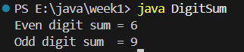
TASK 2:Fibonacci
public class Fibonacci {
static int nthFibonacci(int n) {
if (n <= 1) return n;
int a = 0, b = 1;
for (int i = 2; i <= n; i++) {
int c = a + b;
a = b;
b = c;
}
return b;
}
public static void main(String[] args) {
int n = 7;
System.out.println(nthFibonacci(n));
}
}
OUTPUT:
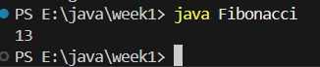

TASK 3:LastDigitSum
public class LastDigitSum {
static int sumOfLastDigits(int a, int b) {
return Math.abs(a % 10) + Math.abs(b % 10);
}
public static void main(String[] args) {
int a = 123;
int b = 789;
System.out.println(sumOfLastDigits(a, b));
}
}
OUTPUT:
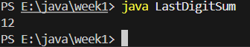

TASK 4:PalindromeNumber
public class PalindromeNumber {
public PalindromeNumber() {
}
static boolean isPalindrome(int var0) {
if (var0 < 0) {
return false;
} else {
int var1 = var0;
int var2;
for(var2 = 0; var0 > 0; var0 /= 10) {
int var3 = var0 % 10;
var2 = var2 * 10 + var3;
}
return var1 == var2;
}
}
public static void main(String[] var0) {
byte var1 = 121;
System.out.println(isPalindrome(var1));
}
}
OUTPUT:
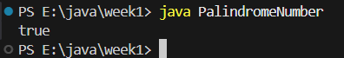

TASK 5:Prime Count
public class PrimeCount {
static boolean isPrime(int n) {
if (n <= 1) return false;
if (n <= 3) return true;
if (n % 2 == 0 || n % 3 == 0) return false;
for (int i = 5; i * i <= n; i += 6) {
if (n % i == 0 || n % (i + 2) == 0)
return false;
}
return true;
}
static int countPrimes(int L, int R) {
int count = 0;
for (int i = L; i <= R; i++) {
if (isPrime(i)) count++;
}
return count;
}
public static void main(String[] args) {
int L = 10, R = 30;
System.out.println(countPrimes(L, R));
}
}
OUTPUT:
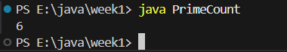

TASK6: Sum of Power of Digits
public class Solution {
public static int sumOfPowerOfDigits(int input1) {
String num = String.valueOf(input1);
int sum = 0;
for (int i = 0; i < num.length(); i++) {
int currentDigit = num.charAt(i) - '0';
int power;
if (i == num.length() - 1) {
power = 0; // Last digit raised to power 0
} else {
power = num.charAt(i + 1) - '0';
}
sum += (int) Math.pow(currentDigit, power);
}
return sum;
}
public static void main(String[] args) {
int input = 582109;
System.out.println(sumOfPowerOfDigits(input));
}
}
Output:
Input:
582109
output:
390693
TASK7: Sum of Power of Digits
import java.util.HashSet;
public class task7{
public static int uniqueDigitCount(int input){
HashSet<Integer> set=new HashSet<>();
while(input>0){
int digit=input%10;
set.add(digit);
input /=10;
}
return set.size();
}
public static void main(String[] args){
int input=582109;
System.out.println(uniqueDigitCount(input));
}
}
Output:
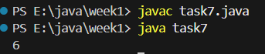

TASK7: MOST FREQUENT DIGIT
public class task8 {
public static int mostFrequentDigit(int input) {
int[] freq = new int[10];
// Count frequency of each digit
while (input > 0) {
int digit = input % 10;
freq[digit]++;
input /= 10;
}
int maxFreq = 0;
int result = 0;
// Find digit with highest frequency
for (int i = 0; i < 10; i++) {
if (freq[i] > maxFreq) {
maxFreq = freq[i];
result = i;
}
}
return result;
}
public static void main(String[] args) {
int input = 1223334444;
System.out.println(mostFrequentDigit(input));
}
}

OUTPUT:
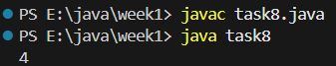

TASK 9: Calculate sum of non-prime index values
public class task9 {
// Function to check if index is prime
public static boolean isPrime(int num) {
if (num <= 1) return false;
for (int i = 2; i * i <= num; i++) {
if (num % i == 0)
return false;
}
return true;
}
// Function to calculate sum of non-prime index values
public static int sumOfNonPrimeIndexValues(int[] arr) {
int sum = 0;
for (int i = 0; i < arr.length; i++) {
if (!isPrime(i)) {
sum += arr[i];
}
}
return sum;
}
public static void main(String[] args) {
int[] arr = {10, 20, 30, 40, 50, 60};
System.out.println(sumOfNonPrimeIndexValues(arr));
}
}
Output:
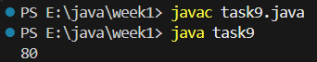

TASK10: SECOND WORD TO UPPERCASE
public class task10 {
public static String secondWordUpperCase(String input) {
String[] words = input.split(" ");
if (words.length < 2) {
return "No second word";
}
return words[1].toUpperCase();
}
public static void main(String[] args) {
String str = "Java is powerful";
System.out.println(secondWordUpperCase(str));
}
}
Output:
