WEEK 2
TASK 1 & 2:JAVA LAMDA EXPRESSION
import java.io.*;
import java.util.*;
interface PerformOperation {
boolean check(int a);
}
class MyMath {
public static boolean checker(PerformOperation p, int num) {
return p.check(num);
}
public PerformOperation isOdd() {
return a -> a % 2 != 0;
}
public PerformOperation isPrime() {
return a -> {
if (a <= 1) return false;
for (int i = 2; i <= Math.sqrt(a); i++) {
if (a % i == 0) return false;
}
return true;
};
}
public PerformOperation isPalindrome() {
return a -> {
int original = a;
int reversed = 0;
while (a > 0) {
reversed = reversed * 10 + (a % 10);
a /= 10;
}
return original == reversed;
};
}
}
public class Solution {
public static void main(String[] args) throws IOException {
MyMath ob = new MyMath();
BufferedReader br = new BufferedReader(new InputStreamReader(System.in));
int T = Integer.parseInt(br.readLine());
while (T-- > 0) {
StringTokenizer st = new StringTokenizer(br.readLine());
int ch = Integer.parseInt(st.nextToken());
int num = Integer.parseInt(st.nextToken());
PerformOperation op;
boolean result;
String ans = "";
if (ch == 1) {
op = ob.isOdd();
result = MyMath.checker(op, num);
ans = result ? "ODD" : "EVEN";
}
else if (ch == 2) {
op = ob.isPrime();
result = MyMath.checker(op, num);
ans = result ? "PRIME" : "COMPOSITE";
}
else if (ch == 3) {
op = ob.isPalindrome();
result = MyMath.checker(op, num);
ans = result ? "PALINDROME" : "NOT PALINDROME";
}
System.out.println(ans);
}
}
}
OUTPUT:
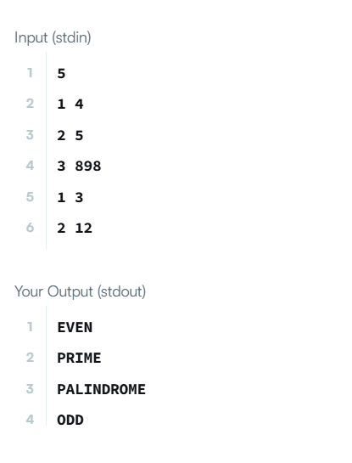

TASK 3 & 4:MINI-MAX SUM
import java.io.*;
import java.math.*;
import java.security.*;
import java.text.*;
import java.util.*;
import java.util.concurrent.*;
import java.util.function.*;
import java.util.regex.*;
import java.util.stream.*;
import static java.util.stream.Collectors.joining;
import static java.util.stream.Collectors.toList;

class Result {
/*
* Complete the 'miniMaxSum' function below.
*
* The function accepts INTEGER_ARRAY arr as parameter.
*/
public static void miniMaxSum(List<Integer> arr) {
long totalSum = 0;
long min = Long.MAX_VALUE;
long max = Long.MIN_VALUE;
for (int num : arr) {
totalSum += num;
min = Math.min(min, num);
max = Math.max(max, num);
}
long minSum = totalSum - max;
long maxSum = totalSum - min;
System.out.println(minSum + " " + maxSum);
}
}
public class Solution {
public static void main(String[] args) throws IOException {
BufferedReader bufferedReader = new BufferedReader(new InputStreamReader(System.in));
List<Integer> arr = Stream.of(bufferedReader.readLine().replaceAll("\\s+$", "").split(" "))
.map(Integer::parseInt)
.collect(toList());
Result.miniMaxSum(arr);
bufferedReader.close();
}
}
Output:
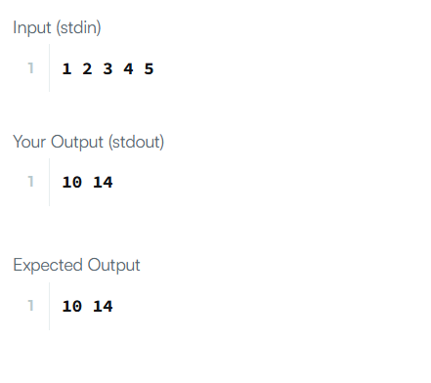

task 5: is palindrome:
class UserMainCode
{
public int isPalindrome(String input1){

input1 = input1.toLowerCase();

int left = 0;
int right = input1.length() - 1;

while (left < right) {
if (input1.charAt(left) != input1.charAt(right)) {
return 1;
}
left++;
right--;
}

return 2;
}
}
output:
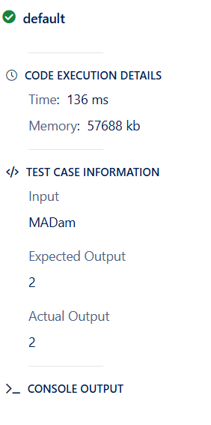

task 6:ALL DIGITS COUNT
public int allDigitsCount(int input1){
int count = 0;
while (input1 > 0) {
input1 = input1 / 10;
count++;
}
return count;
}
output:
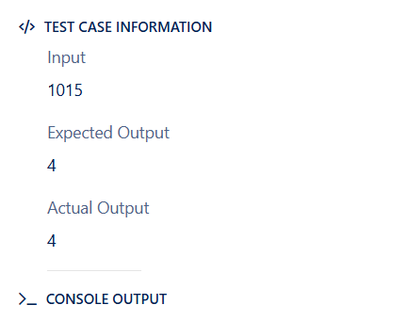
Task 7:date and time:
import java.io.*;
import java.util.*;
import java.time.LocalDate;
import java.time.format.TextStyle;

class Result {

public static String findDay(int month, int day, int year) {

LocalDate date = LocalDate.of(year, month, day);

return date.getDayOfWeek()
.getDisplayName(TextStyle.FULL, Locale.US)
.toUpperCase();
}
}
public class Solution {
public static void main(String[] args) throws IOException {
BufferedReader bufferedReader = new BufferedReader(new InputStreamReader(System.in));
BufferedWriter bufferedWriter = new BufferedWriter(new FileWriter(System.getenv("OUTPUT_PATH")));

String[] firstMultipleInput = bufferedReader.readLine().replaceAll("\\s+$", "").split(" ");

int month = Integer.parseInt(firstMultipleInput[0]);

int day = Integer.parseInt(firstMultipleInput[1]);

int year = Integer.parseInt(firstMultipleInput[2]);

String res = Result.findDay(month, day, year);

bufferedWriter.write(res);
bufferedWriter.newLine();

bufferedReader.close();
bufferedWriter.close();
}
}

Output:
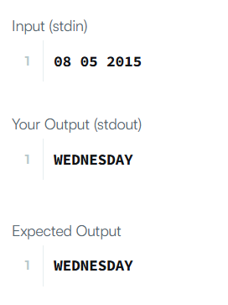
task 8:weight of a hill pattern
public int totalHillWeight(int input1, int input2, int input3){
int total = 0;
for (int i = 1; i <= input1; i++) {
int levelWeight = input2 + (i - 1) * input3;
total += i * levelWeight;
}
return total;
}
output:
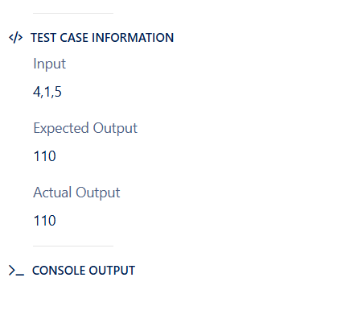

Task 9:sum of digits in cyclic order:
public int sumOfSumsOfDigits(int input1){
String num = String.valueOf(input1);
int totalSum = 0;
for (int i = 0; i < num.length(); i++) {
int currentSum = 0;
for (int j = i; j < num.length(); j++) {
currentSum += num.charAt(j) - '0';
}
totalSum += currentSum;
}
return totalSum;
}

